Reactive Programming

What is Reactive Programming
- Reactive Programming (RP) is programming with asynchronous data streams.
- Streams are cheap and ubiquitous, anything can be a stream: variables, user inputs, properties, caches, data structures, etc.
- We listen to a stream and react accordingly.
- RP provides a toolbox of functions to create, combine and filter any streams:
  - One or more streams can be used as input to another stream. We can merge two streams.
  - A stream can be filtered to get another stream that has only those events we have specified.
  - We can map data values from one stream to another new stream.
  - See http://reactivex.io/documentation/operators.html
  - See http://rxmarbles.com

Data Streams
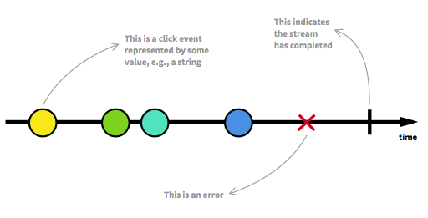Figure 1: Data streams consists of events ordered in time.
A stream is a sequence of ongoing events ordered in time. It can emit three different things:
- A value (of some type),
- An error
- A completed signal.
We capture these emitted events only asynchronously, by defining a function that will execute when a value is emitted, another function when an error is emitted, and another function when 'completed' is emitted.

The Observer Design Pattern
The "listening" to the stream is called subscribing. The functions we are defining are observers. The stream is the subject or observable being observed. This is precisely the Observer Design Pattern.

Figure 2: Classic Observer Design Pattern.
The reactive observer design pattern is slightly different from the classical observer pattern.
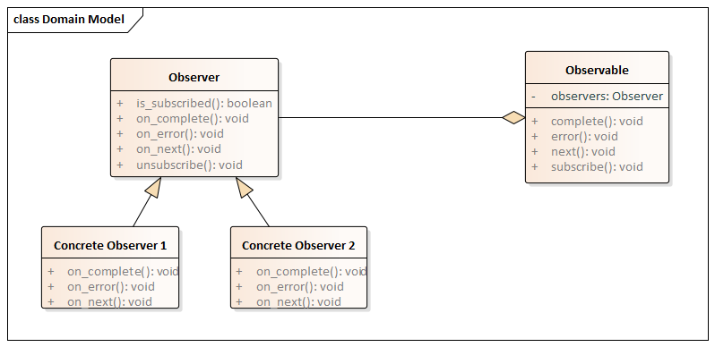
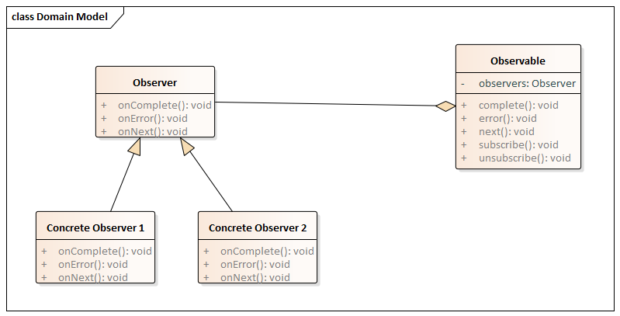Figure 3: Reactive Observer Design Pattern

Reactive Programming != Reactive System
Probably the most confusing part. Using reactive programming does not build a reactive system. Reactive systems, as defined in the reactive manifesto, are an architectural style to build responsive distributed systems. Reactive Systems could be seen as distributed systems done right. A reactive system is characterized by four properties:
- Responsive: a reactive system needs to handle requests in a reasonable time (I let you define reasonable).
- Resilient: a reactive system must stay responsive in the face of failures (crash, timeout, 500 errors… ), so it must be designed for failures and deal with them appropriately.
- Elastic: a reactive system must stay responsive under various loads. Consequently, it must scale up and down, and be able to handle the load with minimal resources.
- Message driven: components from a reactive system interacts using asynchronous message passing.

The Promises of Reactive Programming
- Functional
Avoid intricate stateful programs, using clean input/output functions over observable streams.
- Less is more
ReactiveX's operators often reduce what was once an elaborate challenge into a few lines of code.
- Async error handling
Traditional try/catch is powerless for errors in asynchronous computations, but ReactiveX is equipped with proper mechanisms for handling errors.
- Concurrency made easy
Observables and Schedulers in ReactiveX allow the programmer to abstract away low-level threading, synchronization, and concurrency issues.

Examples
See https://github.com/henrik7264/RxROS/blob/master/src/rxros_lang/src/rxcpp_examples.cpp

See https://gist.github.com/staltz/868e7e9bc2a7b8c1f754
See https://dzone.com/articles/5-things-to-know-about-reactive-programming
See http://reactivex.io/

