UXUI ASSIGNMENT 4

1. The Flat UI color palate has a light and dark shade of the same color because. It is a Flat UI principle to combine a dark color with a another light color. Therefore I think following the same principle a color has two shades so that the darker shade of the color will be combined with a light shade of another and vice versa.

2. The empty state, or zero data state — as well as the onboarding process often get ignored until the app is nearly compete and someone realizes that when no data exists, the app simply displays a blank screen. Or, you notice that when a user first signs up, they are just thrown into the app without much instruction at all. Both cases are less than ideal

The empty state or zero data state is the state an app when there is no content. This is often at the first use of an app, when no data exists and the app simply displays a blank screen. Or, you notice that when a user first signs up that the dashboard is empty. Till the user populates data.
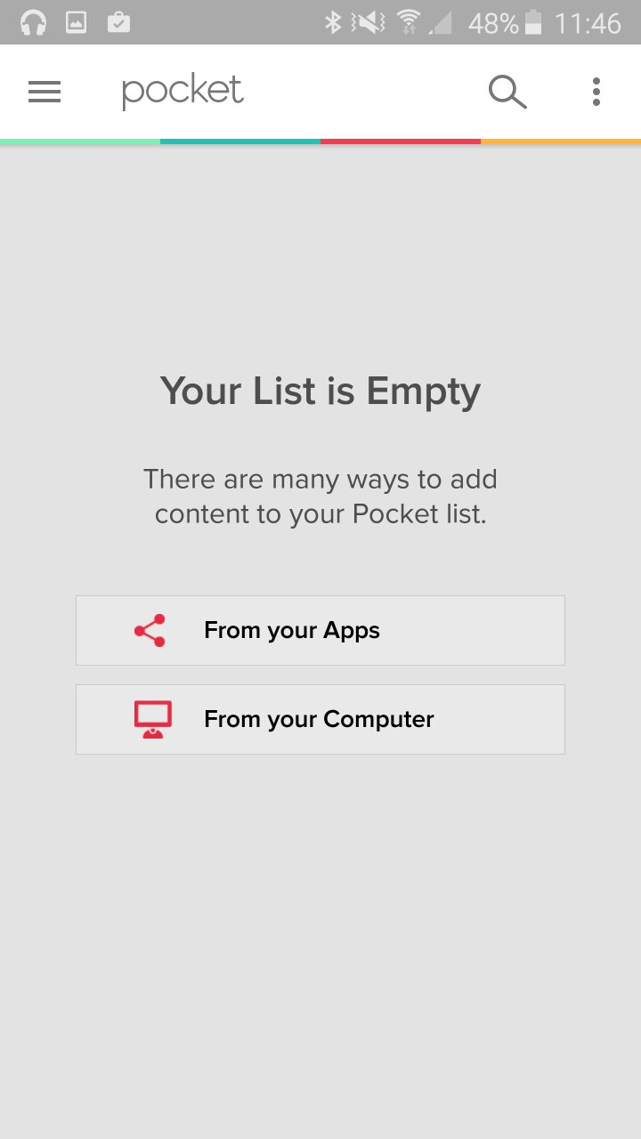

EXAMPLE: POCKET's zero data state



3 . THE UI OF AN INTERCTIVE INFOGRAPIC

