

DATA ANALYSIS – FINAL ASSIGNMENT

Prediction of kidney failure

JASSEM THOMAS / HENRI DESQUESSES

[thomas.jassem@alumnos.upm.es](mailto:thomas.jassem@alumnos.upm.es)

[henri.desquesses@alumnos.upm.es](mailto:henri.desquesses@alumnos.upm.es)

2017/2018

Table des matières

SCOPE 3

BUSINESS GOAL 3

WORK PLAN 3

Milestones 3

GANT 4

RISK PLAN 4

DATA UNDERSTANDING 4

Explanation of each feature in detail: 5

EXPLORING THE DATA 6

DATA PREPARATION 7

ISSUE 9

MODELING 9

VARIABLE REMOVING 9

MODELING TECHNIQUE 10

TEST DESIGN 10

KNIME GRAPH 10

EVALUATION 10

FEATURES IMPORTANCE 10

ROC CURVE 12

ACCURACY 12

BUSINESS GOAL OBJECTIVES 12

Table of illustrations

Figure 1 - Gant of the project 4

Figure 2 - Correlation 6

Figure 3 - Proportion of kidney failure 6

Figure 4 - Knime graph of the model 10

Figure 5 - Attribute statistics - Random Forest Learner 11

Figure 6 - Importance of the features (table) 11

Figure 7 - Importance of each features (Graph) 11

Figure 8 - ROC CURVE 12

Figure 9 - Results 12

# SCOPE

Kidney failure is the last stage of chronic kidney disease. When your kidneys fail, it means they have stopped working well enough for you to survive without dialysis or a kidney transplant. In that sense it is important when you create a new drug to be sure that it cannot be take when there is a metric that is too high or too slow or when another drug is incompatible.

There are two main goal in trying to apply Big Data / Data Science tools to identify this type of patients. The first goal is to help the physicians of the nephrology department to decide if a patient will have a kidney failure or not. The second is to help to classify which features scientist must in priority concentrate on.

# BUSINESS GOAL

|  |  |  |
| --- | --- | --- |
| Business Goal | Description | Indicator of success |
| BG1 | Decrease the number of exams to detect if a patient will have a kidney failure or not. | We decrease the number of exams by 20%. |
| BG2 | Detect patient who will have a kidney failure | We detect 10% more than before. |

|  |  |  |  |
| --- | --- | --- | --- |
| Data Mining Goals | Description | Indicator | Maps to BG |
| DM1 | Detect most importants exams/drugs. | Reduce the number of features by 20%. | BG1 |
| DM2 | Create a boolean to know if someone will have kidney failure or not. | It works at 60% on test datasets. | BG2 |

# WORK PLAN

## Milestones

|  |  |  |  |
| --- | --- | --- | --- |
| Phase | Due Date | Responsible | Risks |
| Business Understanding | 10/12/2017 | Thomas JASSEM | Some advance on the subject has been done. |
| Data Understanding | 17/12/2017 | Thomas JASSEM | Data problems |
| Data Preparation | 31/12/2017 | Henri DESQUESSES | Data problems, technology problems |
| Modelling | 7/01/2018 | Thomas JASSEM | Inability to build adequate model |
| Evaluation | 10/01/2018 | Thomas JASSEM | Inability to implement results |
| Report | 14/01/2018 | Henri DESQUESSES | Lack of time |

## GANT

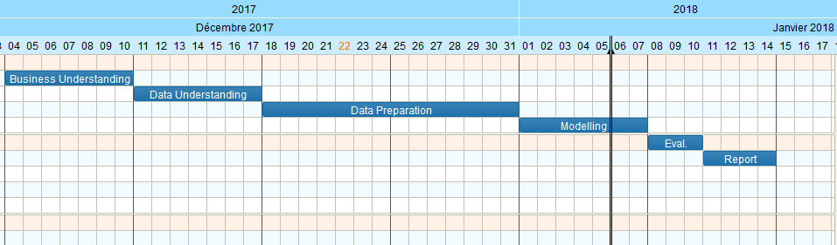

Figure 1 - Gant of the project

# RISK PLAN

We should consider that the data comes from an hospital where they do not necessarily have a great system of information.

|  |  |  |
| --- | --- | --- |
| Risk | Probability | Plan |
| Blanc values. | 100% | If the blank is for a continuous variable, we replace the null with the mean of this one. |
| Different names for a same thing. | 75% | Try to score if two drugs are the same with their names. |
| Error in units | 50% | Plot the different values of the exams to set |

# DATA UNDERSTANDING

|  |  |  |
| --- | --- | --- |
| Name | Number of attributes | Number of entries |
| kidney_fail_dataset.csv | 20 | 957 |
| drugs.csv | 10 | 957 |

kidney_fail_dataset:

|  |  |  |  |
| --- | --- | --- | --- |
| Name of the attribute | Values expected | Description | Type |
| patient_id | Numbers | Unique Identifier of an encounter | Nominal |
| height | Numbers | Height in inches | Numeric |
| weight | Numbers | Weight in pounds | Numeric |
| kidney_absortion_test |  |  |  |
| urea | Numbers | Urea level | Numeric |
| monocytes | Numbers | Monocytes level | Numeric |
| granulocytes | Numbers | Granulocytes level | Numeric |
| kidney_enzyme_test |  |  |  |
| eosinophils | Numbers | Number of eosinophils | Numeric |
| basophils | Numbers | Number of basophils | Numeric |
| kidney_suffering_test |  |  |  |
| platelets | Numbers | Platelets levels | Numeric |
| trgld | Numbers | ? | Numeric |
| tflr | Numbers | ? | Numeric |
| mean_platelet_volume | Numbers | Mean value of platelet volume | Numeric |
| leukocytes | Numbers | Leukocytes value | Numeric |
| glucose | Numbers | Glucose level | Numeric |
| Kidney failure | Boolean | The patient suffered a kidney failure. | Flag |

drugs.csv:

|  |  |  |  |
| --- | --- | --- | --- |
| patient_id | Numbers | Number of basophils | Numeric |
| drugX | Name | Name of the drug number X that the patient took. | Nominal |

## Explanation of each feature in detail:

**Urea level**: Urea is a waste product formed from the breakdown of proteins. It is eliminated from the body almost exclusively by the kidneys in urine.

**Monocytes**: Monocytes are a type of white blood cell. There are some articles that link Monocytes level and kidney diseases: <https://www.ncbi.nlm.nih.gov/pubmed/20649681>

**Granulocytes:** Granulocytes are a category of white blood cells. Some articles talk about the granulocyte colony-stimulating factor as a link with some kidney diseases.

**Eosinophils**: Eosinophils are a variety of white blood cells, we can find articles about the fact to have a rate high of eosinophils and kidney diseases: <https://www.ncbi.nlm.nih.gov/pubmed/21239387>

**Basophils**: Basophils are a type of white blood cells. Some article exists too: <https://www.ncbi.nlm.nih.gov/pmc/articles/PMC3227736/>

**Platelets**: Platelets are a component of blood whose function (along with the coagulation factors) is to stop bleeding by clumping and clotting blood vessel injuries. They are linked with kidney diseases: <https://www.ncbi.nlm.nih.gov/pubmed/15497100>

**Leukocytes**: Most known as white blood cells.

So, we expect that the Leukocyte feature is correlated with Basophils, Eosinophils, Monocytes and Granulocytes.

# https://scontent-mad1-1.xx.fbcdn.net/v/t35.0-12/25991401_586734408333839_214873803_o.png?oh=11393855f1595918daa6e97b595ced6c&oe=5A3FFB19EXPLORING THE DATA

Figure 2 - Correlation

In the figure above, we can see the correlation of the different features. We can deduce that, as expected, leukocytes are quite correlated to monocytes, granulocytes …

Granulocytes correspond to eosinophils and basophils and neutrophils so as expected they are correlated



Figure 3 - Proportion of kidney failure

We can see on the figure 2 above that the dataset is balanced with 48% of kidney failure.

Distribution of the different features:

|  |  |  |
| --- | --- | --- |
| FEATURE | GRAPH | COMMENT |
| UREA |  | Two values that seems to be aberrant. Because of that the feature seems unbalanced. |
| HEIGHT |  | Seems quite balanced. |
| WEIGHT |  | Seems quite unbalanced, there is one person who has a weight of 400 pounds and the next biggest one is 270 pounds. |
| MONOCYTES |  | Monocytes are quite balanced because variables are almost continuous until the maximum. |
| GRANULOCYTES |  | Granulocytes are balanced too. |
| Eosinophils |  | Unbalanced, there are two values above 14 that makes it like this. |
| BASOPHILS |  | Unbalanced because of one value which is really high compared to the others. |
| GLUCOSE |  | Glucose graph is unbalanced but there is a continuity until the maximum. |
| PLATELETS |  | Platelets graph is a little bit unbalanced because of a value quite high: 610 vs 490 for the second max. |
| MEAN PLATELET VOLUME |  | Again, a value is high and makes the graph unbalances. |
| LEUKOCYTES |  | Same analysis as platelets. |
| tgrid |  | Here the value is continuous until the maximum. |
| tflr |  | Again here, a value is really high but the graph will be unbalanced even without this value that we will change. |

# DATA PREPARATION

We chose to replace the maximums that seemed abberant by the second maximum to avoid distorting the data. Then, for numeric values ​​that were not present we replaced them with the average. We used here OpenRefine to find the two maximums.

|  |  |  |
| --- | --- | --- |
| FEATURE | MAX | NEW MAX |
| UREA | 227.7 | 160.6 |
| WEIGHT | 396.3 | 265.8 |
| EOSINOPHILS | 19.055 | 13.184 |
| BASOPHILS | 2.08 | 1.248 |
| PLATELETS | 600.08 | 486.72 |
| MEAN PLATELET VOLUME | 15.708 | 13.464 |
| LEUKOCYTES | 18.824 | 14.456 |
| TFLR | 6135.38 | 4939.12 |

Now that aberrant values have been changed we can replace blanks by the mean. I used spark to calculate the average:

import org.apache.spark.sql.Row

val inputDf = spark.read.format("csv").option("delimiter",",").option("header","true").load("C:\\Users\\tjass\\Documents\\Data_Analysis\\Projet\\merged_without_max.csv")

val avg_height = inputDf.select(avg($"height")).first.getDouble(0)

val avg_weight = inputDf.select(avg($"weight")).first.getDouble(0)

val avg_urea = inputDf.select(avg($"urea")).first.getDouble(0)

val avg_monocytes = inputDf.select(avg($"monocytes")).first.getDouble(0)

val avg_granulocytes = inputDf.select(avg($"granulocytes")).first.getDouble(0)

val avg_eosinophils = inputDf.select(avg($"eosinophils")).first.getDouble(0)

val avg_basophils = inputDf.select(avg($"basophils")).first.getDouble(0)

val avg_glucose = inputDf.select(avg($"glucose")).first.getDouble(0)

val avg_platelets = inputDf.select(avg($"platelets")).first.getDouble(0)

val avg_mean_platelet_volume = inputDf.select(avg($"mean_platelet_volume")).first.getDouble(0)

val avg_leukocytes = inputDf.select(avg($"leukocytes")).first.getDouble(0)

val avg_trgld = inputDf.select(avg($"trgld")).first.getDouble(0)

val avg_tflr = inputDf.select(avg($"tflr")).first.getDouble(0)

val df = inputDf.na.fill(Map("urea"->avg_urea, "monocytes"->avg_monocytes, "granulocytes"->avg_granulocytes, "eosinophils"->avg_eosinophils, "basophils"->avg_basophils,"glucose"->avg_glucose, "platelets"->avg_platelets, "mean_platelet_volume"-> avg_mean_platelet_volume, "leukocytes"->avg_leukocytes, "trgld"->avg_trgld, "tflr"->avg_tflr))

df.coalesce(1).write.format("com.databricks.spark.csv").option("header","true").save("C:\\Users\\tjass\\Documents\\Data_Analysis\\Projet\\sample.csv")

With this code scala we used Spark to compute the average and replace blanks by this average in the dataset with the fill method.

The next step was to replace with OpenRefine the blanks in drug1, drug2, … by “na” to process everything easier in Pyhton.

Now the data is clean we merged the two “datasets drug.csv” and “kidney_fail_dataset.csv”:

a = pa.read_csv("C:/Users/Max/Documents/UPM/Data_Analysis/Projet/src/Data/drugs.csv")

b = pa.read_csv("C:/Users/Max/Documents/UPM/Data_Analysis/Projet/src/Data/kidney_fail_dataset.csv")

b = b.dropna(axis=1)

merged = a.merge(b, on='patient_id')

merged.to_csv("C:/Users/Max/Documents/UPM/Data_Analysis/Projet/src/Data/merged_dataset.csv", index=False)

We chose to use Pandas DataFrames in Python to process the data, so we put the merged csv into a panda dataframe:

df = pa.read_csv('C:/Users/Max/Documents/UPM/Data_Analysis/Projet/src/data/sparkFilled.csv');

We wanted to have the list of drugs that exists in the dataset so we decided to put the names of drugs of each column into a list. Then we used the function “get_close_matches” to group all the drug names that are similar with a probability of 40% and replace by the name of the group into the dataframe.

We wanted to help the algorithm to converge so we decided to create **new features.**

The first one is the number of drugs, so for each patient we added the number of drugs that it took.

Then we wanted to add the IMC or BMC (Body Mass Index) in English which is a variable that can be used to estimate a person's body size. This index is calculated as a function of height and body mass. We decided to put the IMC in categories:

|  |  |
| --- | --- |
| IMC | INTERPRETATION |
| +40 | morbid obesity |
| 35 to 40 | severe obesity |
| 30 to 35 | moderate obesity |
| 25 to 30 | overweight |
| 18.5 to 25 | normal corpulence |
| 16.5 to 18.5 | thinness |
| -16.5 | famine |

The last step is the normalization of the data, then we exported everything as csv named dataset2.0 that we will use in Knime.

## ISSUE

We wanted to put each drug as a column to know exactly which drug is important or not but the problem is that we have only 900 records for a number of distinct drugs of approximately 1600. So, the model will not be good because the number of records is not big enough.

# MODELING

## VARIABLE REMOVING

As the IMC is really correlated to weight and height we decided to remove them.

Leukocytes which are white cells feature is correlated with other subcategories of white cells so we deleted it and then the granulocytes too because there are correlated with eosinophils and basophils.

Then we tried to put in knime all the features but the problem is that there are too much different drugs against the number of patient so at the end drugs are almost unique per patient. In fact, the algorithm is warning us that the model cannot take in account columns drug1, drug2, drug3, …, drug9.

## MODELING TECHNIQUE

We have to determine a Boolean value and we have continuous and categorial features. The random forest seems for us to be the more adapted to our model because the first idea would be to use the logistic regression but we have categorical variables that would not be taken into account.

We tested different parameters for the depth of the tree, we arrived to the conclusion that 10 is good because it gives the best accuracy.

## TEST DESIGN

We decided to use cross-validation to validate our model, we use 10 folds built randomly.

## KNIME GRAPH

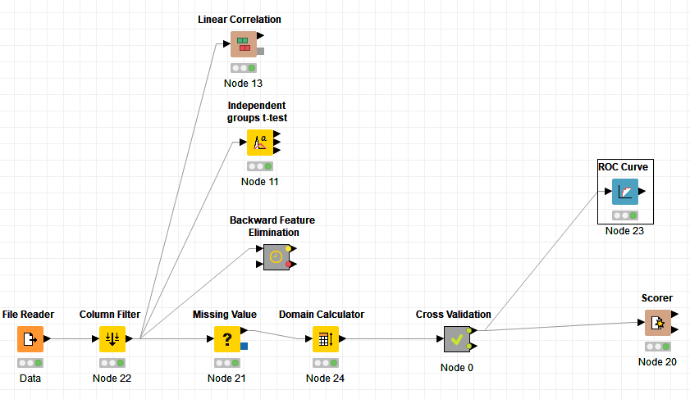

Figure 4 - Knime graph of the model

# EVALUATION

## FEATURES IMPORTANCE

As a measure for variable importance we took a look into the “attribute statistics” part of the random forest learner. Here we can see how often a variable was used for building a decision three at the first second or third level. To rank the features, we divided the splits with its candidate and sum the three.

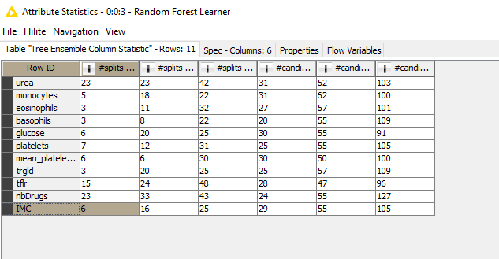

Figure 5 - Attribute statistics - Random Forest Learner

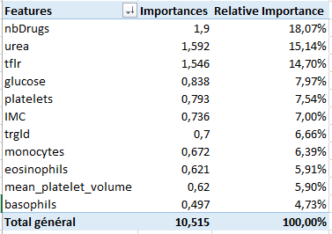

Figure 6 - Importance of the features (table)

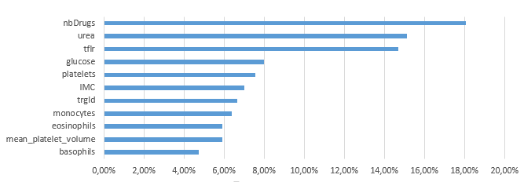

Figure 7 - Importance of each features (Graph)

## ROC CURVE

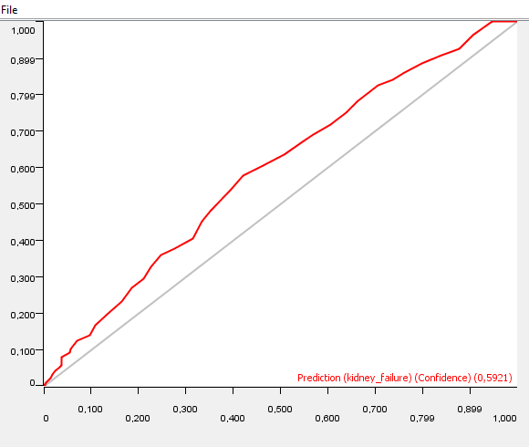

Figure 8 - ROC CURVE

The roc curve is a measure of the performance of a binary classifier, It gives the rate of true positives (fraction of positives that are actually detected) based on the rate of false positives (fraction of negatives that are incorrectly detected).

Here we can see than the curve (in red) the further the curve deviates from the random classifier line and approaches the elbow of the ideal classifier (which goes from (0, 0) to (0, 1) to (1, 1)). So we can conclude that our model is quite good.

## ACCURACY



Figure 9 - Results

We can see that we have an accuracy of 60,1%. It is not very high but considering that we only have 900 entries and that we cannot use the name of the drugs taken by the patient, it remains suitable.

## BUSINESS GOAL OBJECTIVES

The Business Goal 1 was decrease the number of exams by 20%, we have deleted leukocytes and granulocytes tests and we have deleted all the drugs taken and replaced them by the number of drugs so we have deleted 2+9-1=10 features over a number total of initial features of 23 features so 43% of the features. So, the Business Goal 1 **is validated**.

For the Business Goal 2, if we consider that before we had only 50% of chance (randomly) to find if a patient will have it or not we can say that yes with 62% of patient detected the business goal 2 **is validated**.