quero usar essa paleta de cores
https://21st.dev/@serafimcloud/themes/perpetuity
:root {
--card: #f2f7f7;
--ring: #06858e;
--input: #d9eaea;
--muted: #e0eaea;
--accent: #c9e5e7;
--border: #cde0e2;
--radius: 0.125rem;
--chart-1: #06858e;
--chart-2: #1e9ea6;
--chart-3: #37b6be;
--chart-4: #5dc7ce;
--chart-5: #8ad8dd;
--popover: #f2f7f7;
--primary: #06858e;
--sidebar: #daebed;
--font-mono: Courier New, monospace;
--font-sans: Courier New, monospace;
--secondary: #d9eaea;
--background: #e8f0f0;
--font-serif: Courier New, monospace;
--foreground: #0a4a55;
--destructive: #d13838;
--shadow-blur: 2px;
--shadow-color: hsl(185 70% 30% / 0.15);
--sidebar-ring: #06858e;
--shadow-spread: 0px;
--shadow-opacity: 0.15;
--sidebar-accent: #c9e5e7;
--sidebar-border: #cde0e2;
--card-foreground: #0a4a55;
--shadow-offset-x: 1px;
--shadow-offset-y: 1px;
--sidebar-primary: #06858e;
--muted-foreground: #427a7e;
--accent-foreground: #0a4a55;
--popover-foreground: #0a4a55;
--primary-foreground: #ffffff;
--sidebar-foreground: #0a4a55;
--secondary-foreground: #0a4a55;
--destructive-foreground: #ffffff;
--sidebar-accent-foreground: #0a4a55;
--sidebar-primary-foreground: #ffffff;
}

.dark {
--card: #0c2025;
--ring: #4de8e8;
--input: #164955;
--muted: #0f3039;
--accent: #164955;
--border: #164955;
--radius: 0.125rem;
--chart-1: #4de8e8;
--chart-2: #36a5a5;
--chart-3: #2d8a8a;
--chart-4: #19595e;
--chart-5: #0e383c;
--popover: #0c2025;
--primary: #4de8e8;
--sidebar: #0a1a20;
--font-mono: Source Code Pro, monospace;
--font-sans: Source Code Pro, monospace;
--secondary: #164955;
--background: #0a1a20;
--font-serif: Source Code Pro, monospace;
--foreground: #4de8e8;
--destructive: #e83c3c;
--shadow-blur: 2px;
--shadow-color: hsl(180 70% 60% / 0.2);
--sidebar-ring: #4de8e8;
--shadow-spread: 0px;
--shadow-opacity: 0.2;
--sidebar-accent: #164955;
--sidebar-border: #164955;
--card-foreground: #4de8e8;
--shadow-offset-x: 1px;
--shadow-offset-y: 1px;
--sidebar-primary: #4de8e8;
--muted-foreground: #36a5a5;
--accent-foreground: #4de8e8;
--popover-foreground: #4de8e8;
--primary-foreground: #0a1a20;
--sidebar-foreground: #4de8e8;
--secondary-foreground: #4de8e8;
--destructive-foreground: #f2f2f2;
--sidebar-accent-foreground: #4de8e8;
--sidebar-primary-foreground: #0a1a20;
}

@theme inline {
--color-card: var(--card);
--color-ring: var(--ring);
--color-input: var(--input);
--color-muted: var(--muted);
--color-accent: var(--accent);
--color-border: var(--border);
--color-radius: var(--radius);
--color-chart-1: var(--chart-1);
--color-chart-2: var(--chart-2);
--color-chart-3: var(--chart-3);
--color-chart-4: var(--chart-4);
--color-chart-5: var(--chart-5);
--color-popover: var(--popover);
--color-primary: var(--primary);
--color-sidebar: var(--sidebar);
--color-font-mono: var(--font-mono);
--color-font-sans: var(--font-sans);
--color-secondary: var(--secondary);
--color-background: var(--background);
--color-font-serif: var(--font-serif);
--color-foreground: var(--foreground);
--color-destructive: var(--destructive);
--color-shadow-blur: var(--shadow-blur);
--color-shadow-color: var(--shadow-color);
--color-sidebar-ring: var(--sidebar-ring);
--color-shadow-spread: var(--shadow-spread);
--color-shadow-opacity: var(--shadow-opacity);
--color-sidebar-accent: var(--sidebar-accent);
--color-sidebar-border: var(--sidebar-border);
--color-card-foreground: var(--card-foreground);
--color-shadow-offset-x: var(--shadow-offset-x);
--color-shadow-offset-y: var(--shadow-offset-y);
--color-sidebar-primary: var(--sidebar-primary);
--color-muted-foreground: var(--muted-foreground);
--color-accent-foreground: var(--accent-foreground);
--color-popover-foreground: var(--popover-foreground);
--color-primary-foreground: var(--primary-foreground);
--color-sidebar-foreground: var(--sidebar-foreground);
--color-secondary-foreground: var(--secondary-foreground);
--color-destructive-foreground: var(--destructive-foreground);
--color-sidebar-accent-foreground: var(--sidebar-accent-foreground);
--color-sidebar-primary-foreground: var(--sidebar-primary-foreground);
}
algo como esse efeito para tela inicial e transição para os produtos
https://21st.dev/@Legacy/components/glyph-portal
"use client";

/**
* Glyph Portal © 2026 Christian Katzmann. MIT.
* Origin: UsefulPortal.astro on https://ktzm.dk → UsefulPortal.tsx → ClarityPortal.tsx.
* A scroll-driven camera through live type. Keep this notice with copies.
*/
import { useId, useLayoutEffect, useRef, type CSSProperties, type ReactNode } from "react";

export type GlyphPortalStyle = CSSProperties & {
"--gp-paper"?: string;
"--gp-ink"?: string;
"--gp-field"?: string;
"--gp-foreground"?: string;
};

export type GlyphPortalProps = {
word?: string;
/** First matching character. Omit to choose the largest safe patch of ink. */
focusChar?: string;
/** Hover, tap, or use arrow keys to choose a letter before scrolling. */
interactive?: boolean;
/** Decorative, inert, mounted once. Fill its parent with an image, video, or canvas. */
background?: ReactNode;
/** Optional foreground composition for the opening frame, above the clipped scene. */
front?: ReactNode;
children?: ReactNode;
/** Scroll travel in visible container heights, clamped to 1–8. */
scrollLength?: number;
fontFamily?: string;
fontWeight?: number;
annotations?: boolean;
enterLabel?: string;
className?: string;
style?: GlyphPortalStyle;
/** Called once per rendered scroll frame, never through React state. */
onProgress?: (progress: number) => void;
};

const clamp = (n: number, a = 0, b = 1) => Math.min(b, Math.max(a, n));
const smooth = (a: number, b: number, n: number) => {
const t = clamp((n - a) / (b - a));
return t * t * (3 - 2 * t);
};
const DEFAULT_FONT = '"Arial Black", "Arial", sans-serif';
type Ink = { x: number; y: number; radius: number; index: number };
type Letter = { index: number; x: number; y: number; width: number; height: number };

/** Largest opaque square, in linear time. Unlike a stem guess, it works in O, S and Ø. */
function interior(context: CanvasRenderingContext2D, char: string, font: string): Omit<Ink, "index"> | null {
const canvas = context.canvas;
context.font = font;
const m = context.measureText(char);
const pad = 8;
const left = Math.ceil(m.actualBoundingBoxLeft);
const ascent = Math.ceil(m.actualBoundingBoxAscent);
canvas.width = Math.max(1, Math.ceil(m.actualBoundingBoxLeft + m.actualBoundingBoxRight) + pad * 2);
canvas.height = Math.max(1, Math.ceil(m.actualBoundingBoxAscent + m.actualBoundingBoxDescent) + pad * 2);
context.font = font;
context.fontKerning = "none";
context.fillText(char, pad + left, pad + ascent);
const { width, height } = canvas;
const pixels = context.getImageData(0, 0, width, height).data;
const rows = new Uint16Array(width + 1);
let size = 0, bx = 0, by = 0;
for (let y = 0; y < height; y++) {
let diagonal = 0;
for (let x = 0; x < width; x++) {
const above = rows[x + 1];
rows[x + 1] = pixels[(y * width + x) * 4 + 3] > 245
? Math.min(above, rows[x], diagonal) + 1 : 0;
diagonal = above;
if (rows[x + 1] > size) { size = rows[x + 1]; bx = x; by = y; }
}
}
if (size < 3) return null;
// Scan at 3× SVG size. Inscribe a disk in the square, with room for raster disagreement.
return { x: (bx + 1 - size / 2 - pad - left) / 3,
y: (by + 1 - size / 2 - pad - ascent) / 3, radius: (size / 2 - 1) / 3 };
}

function scrollParent(element: HTMLElement): HTMLElement | null {
for (let p = element.parentElement; p; p = p.parentElement) {
if (/(auto|scroll|hidden)/.test(getComputedStyle(p).overflowY) && p !== document.body && p !== document.documentElement) return p;
}
return null;
}

export default function GlyphPortal({
word = "SUBLIME", focusChar, interactive = true, background, front, children, scrollLength = 2.4,
fontFamily = DEFAULT_FONT, fontWeight = 900, annotations = false,
enterLabel = "Enter section", className, style, onProgress,
}: GlyphPortalProps) {
const uid = `gp-${useId().replace(/[^a-zA-Z0-9]/g, "")}`;
const clipId = `${uid}-clip`;
const sectionRef = useRef<HTMLElement>(null);
const progressRef = useRef(onProgress);
useLayoutEffect(() => { progressRef.current = onProgress; }, [onProgress]);
const text = word.trim().normalize("NFC") || "SUBLIME";
let characterOffset = 0;
const characters = Array.from(text, (char) => {
const index = characterOffset; characterOffset += char.length;
return { char, index };
});
const length = Number.isFinite(scrollLength) ? clamp(scrollLength, 1, 8) : 2.4;
const weight = Number.isFinite(fontWeight) ? clamp(fontWeight, 1, 1000) : 900;
const hasFront = front != null;
const q = `:where(#${uid})`;

useLayoutEffect(() => {
const section = sectionRef.current!;
const pin = section.querySelector<HTMLElement>("[data-gp-pin]")!;
const field = section.querySelector<HTMLElement>("[data-gp-field]")!;
const art = section.querySelector<SVGSVGElement>("[data-gp-art]")!;
const clip = section.querySelector<SVGClipPathElement>(`#${clipId}`)!;
const glyph = section.querySelector<SVGTextElement>("[data-gp-glyph]")!;
const marks = section.querySelector<SVGGElement>("[data-gp-marks]")!;
const choices = section.querySelector<HTMLElement>("[data-gp-choices]")!;
const buttons = Array.from(choices.querySelectorAll<HTMLButtonElement>("button"));
const picker = section.querySelector<HTMLSelectElement>("[data-gp-select]")!;
const root = scrollParent(section);
const motion = window.matchMedia("(prefers-reduced-motion: reduce)");
const canvas = document.createElement("canvas");
const context = canvas.getContext("2d", { willReadFrequently: true });
let disposed = false, raf = 0, dirty = true, active = true, ready = false;
const mountedAt = performance.now();
let browserFrameSeen = false, stalled = false;
let W = 1, H = 1, travel = 1, startScale = 1, endScale = 1;
let center = { x: 0, y: 0 }, target: Ink | null = null;
let lastProgress = -1;
let candidates: Ink[] = [], letters: Letter[] = [];
let choosing = false;
let bounds = { x: 0, y: 0, width: 1, height: 1 };
let fontDirty = true;
// Freeze an available face for this mount. Late font swaps move the ink under the camera.
// Preload custom faces before mounting; pending/failed faces use the supplied fallback stack.
glyph.style.fontFamily = fontFamily;
const computedFamily = getComputedStyle(glyph).fontFamily;
const families = computedFamily.match(/(?:[^,"']+|"[^"]*"|'[^']*')+/g) ?? [];
const available = families.filter((family) => {
try { return document.fonts.check(`${weight} 100px ${family.trim()}`, text); }
catch { return false; }
});
glyph.style.fontFamily = [...available, DEFAULT_FONT].join(",");
// A pending requested face may also hold WebKit's render loop. Keep that mount static.
stalled = available.length < families.length;

const readInk = () => {
if (!context) return false;
const font = getComputedStyle(glyph);
const scanFont = `${font.fontWeight} 300px ${font.fontFamily}`;
context.font = `${font.fontWeight} 100px ${font.fontFamily}`;
context.fontKerning = "none";
const metrics = context.measureText(text);
const advances = Array.from({ length: text.length }, (_, i) => context.measureText(text.slice(0, i)).width);
// SVG getBBox includes the font's line box in some engines. Frame visible ink instead.
bounds = { x: -metrics.actualBoundingBoxLeft, y: -metrics.actualBoundingBoxAscent,
width: metrics.actualBoundingBoxLeft + metrics.actualBoundingBoxRight,
height: metrics.actualBoundingBoxAscent + metrics.actualBoundingBoxDescent };
if (!bounds.width || !bounds.height) return false;
center = { x: bounds.x + bounds.width / 2, y: bounds.y + bounds.height / 2 };
const requested = focusChar ? text.indexOf(focusChar.normalize("NFC")) : -1;
let offset = 0;
candidates = []; letters = [];
for (const char of Array.from(text)) {
context.font = `${font.fontWeight} 100px ${font.fontFamily}`;
const m = context.measureText(char);
letters.push({ index: offset, x: advances[offset] - m.actualBoundingBoxLeft,
y: -m.actualBoundingBoxAscent, width: m.actualBoundingBoxLeft + m.actualBoundingBoxRight,
height: m.actualBoundingBoxAscent + m.actualBoundingBoxDescent });
const found = interior(context, char, scanFont);
if (found) candidates.push({ ...found, x: found.x + advances[offset], index: offset });
offset += char.length;
}
target = candidates.find((candidate) => candidate.index === requested) ?? [...candidates].sort((a, b) => b.radius - a.radius || Math.abs(a.x - center.x) - Math.abs(b.x - center.x))[0] ?? null;
return true;
};

const select = (next: Ink | null) => {
target = next;
endScale = target ? Math.max(startScale, Math.hypot(W, H) / (target.radius * 1.35)) : startScale;
section.dataset.gpFocus = target ? Array.from(text.slice(target.index))[0] : "";
section.dataset.gpFocusIndex = String(target?.index ?? -1);
for (const button of buttons) {
const selected = Number(button.dataset.gpLetter) === target?.index;
button.disabled = !candidates.some((candidate) => candidate.index === Number(button.dataset.gpLetter));
button.setAttribute("aria-checked", String(selected));
button.tabIndex = selected ? 0 : -1;
}
if (picker.value !== "") picker.value = String(target?.index ?? -1);
for (const option of Array.from(picker.options)) option.disabled = option.value === "" || !candidates.some((candidate) => candidate.index === Number(option.value));
const u = 1 / startScale;
const y = bounds.y + bounds.height + 25 * u;
const x = bounds.x;
const right = x + bounds.width;
const cross = target ? `M${target.x - 9 * u} ${target.y}h${18 * u}M${target.x} ${target.y - 9 * u}v${18 * u}` : "";
const annotationPath = marks.querySelector("path")!;
annotationPath.setAttribute("d", `M${x} ${y}H${right}M${x} ${y - 5 * u}v${10 * u}M${right} ${y - 5 * u}v${10 * u}${cross}`);
annotationPath.setAttribute("stroke-width", String(u));
};

const position = () => {
const origin = root ? root.getBoundingClientRect().top + root.clientTop : 0;
return clamp((origin - section.getBoundingClientRect().top) / travel);
};

const paint = (progress: number) => {
const isStatic = motion.matches || !browserFrameSeen || stalled || !target;
const p = isStatic ? 0 : progress;
const t = clamp(p / 0.78);
const eased = t < 0.5 ? 4 * t ** 3 : 1 - (-2 * t + 2) ** 3 / 2;
const scale = Math.exp(Math.log(startScale) + Math.log(endScale / startScale) * eased);
const blend = endScale === startScale ? 0 : (1 / scale - 1 / startScale) / (1 / endScale - 1 / startScale);
const cx = center.x + ((target?.x ?? center.x) - center.x) * blend;
const cy = center.y + ((target?.y ?? center.y) - center.y) * blend;
const roll = -4 * smooth(0.06, 0.5, t) * (1 - smooth(0.62, 0.92, t));
const transform = `translate(${W / 2} ${H * 0.46 + H * 0.04 * eased}) scale(${scale}) rotate(${roll}) translate(${-cx} ${-cy})`;
// Keep scale on the clip to avoid text paint limits. Text-local translation
// follows page zoom in WebKit; translation on an HTML clip reference does not.
const radians = roll * Math.PI / 180;
const dx = W / 2 / scale, dy = (H * .46 + H * .04 * eased) / scale;
clip.setAttribute("transform", `scale(${scale}) rotate(${roll})`);
glyph.setAttribute("transform", `translate(${Math.cos(radians) * dx + Math.sin(radians) * dy - cx} ${-Math.sin(radians) * dx + Math.cos(radians) * dy - cy})`);
marks.setAttribute("transform", transform);
marks.style.opacity = String(1 - smooth(0.015, 0.17, p));
choosing = interactive && !isStatic && p < .04;
choices.inert = !choosing;
section.dataset.gpChoosing = String(choosing);
// Drop the clip only after the camera has already filled the viewport with ink.
field.style.clipPath = t >= 1 ? "none" : `url(#${clipId})`;
section.style.setProperty("--gp-caption", String(1 - smooth(0.01, 0.16, p)));
section.style.setProperty("--gp-reveal", String(isStatic ? 1 : smooth(0.78, 0.9, p)));
section.style.setProperty("--gp-field-scale", String(1 + .16 * smooth(0, .82, p)));
section.style.setProperty("--gp-caption-hit", p < 0.08 ? "auto" : "none");
section.dataset.gpEntered = String(p >= 0.9);
section.dataset.gpProgress = p.toFixed(5);
if (p !== lastProgress) { lastProgress = p; progressRef.current?.(p); }
};

const layout = () => {
if (!section.clientWidth) return;
W = pin.clientWidth;
// A 100svh probe keeps browser chrome from continually changing the scroll distance.
const smallViewport = section.querySelector<HTMLElement>("[data-gp-viewport]")!.offsetHeight;
const viewportHeight = Math.max(1, Math.min(root?.clientHeight ?? smallViewport, smallViewport));
H = motion.matches ? Math.min(viewportHeight * 0.75, 480) : viewportHeight;
section.style.setProperty("--gp-height", `${H}px`);
travel = H * length;
art.setAttribute("viewBox", `0 0 ${W} ${H}`);
if (fontDirty) { ready = readInk(); fontDirty = false; }
if (!ready) return;
const wordHeight = hasFront && H < 480 ? Math.min(H * .38, Math.max(24, H - 264)) : H * .38;
startScale = Math.min(W * 0.84 / bounds.width, wordHeight / bounds.height);
// The whole viewport fits inside measured ink, even with the small camera bank.
select(target);
for (const button of buttons) {
const letter = letters.find((item) => item.index === Number(button.dataset.gpLetter))!;
Object.assign(button.style, {
left: `${W / 2 + (letter.x - center.x) * startScale}px`,
top: `${H * .46 + (letter.y - center.y) * startScale - Math.max(0, 44 - letter.height * startScale) / 2}px`,
width: `${Math.max(1, letter.width * startScale)}px`,
height: `${Math.max(44, letter.height * startScale)}px`,
});
}
section.style.setProperty("--gp-word-top", `${H * .46 - bounds.height * startScale / 2}px`);
section.style.setProperty("--gp-word-bottom", `${H * .46 + bounds.height * startScale / 2}px`);
section.dataset.gpReady = "true";
section.dataset.gpMotion = !motion.matches && browserFrameSeen && !stalled && target ? "on" : "off";

};

const frame = (time?: number) => {
raf = 0;
if (disposed) return;
if (time !== undefined && !browserFrameSeen) {
browserFrameSeen = true; stalled ||= performance.now() - mountedAt > 2500; dirty = true;
}
if (dirty) { dirty = false; layout(); }
if (ready) paint(position());
};
const schedule = () => { if (!raf && active) raf = requestAnimationFrame(frame); };
const resize = () => { cancelAnimationFrame(raf); dirty = true; frame(); };
const scroll = () => schedule();
const choose = (event: Event) => {
if (!choosing || position() >= .04) return;
const button = (event.target as Element).closest<HTMLButtonElement>("[data-gp-letter]");
const next = candidates.find((candidate) => candidate.index === Number(button?.dataset.gpLetter));
if (!next || next === target) return;
select(next); paint(position());
};
const navigate = (event: KeyboardEvent) => {
if (!choosing || !["ArrowLeft", "ArrowRight", "ArrowUp", "ArrowDown", "Home", "End"].includes(event.key)) return;
event.preventDefault();
const current = candidates.indexOf(target!);
const index = event.key === "Home" ? 0 : event.key === "End" ? candidates.length - 1
: (current + (event.key === "ArrowLeft" || event.key === "ArrowUp" ? -1 : 1) + candidates.length) % candidates.length;
buttons.find((button) => Number(button.dataset.gpLetter) === candidates[index].index)?.focus({ preventScroll: true });
};
const pick = () => {
if (!choosing || position() >= .04) return;
const next = candidates.find((candidate) => candidate.index === Number(picker.value));
if (next) { select(next); paint(position()); }
};
choices.addEventListener("pointerover", choose);
choices.addEventListener("click", choose);
choices.addEventListener("focusin", choose);
choices.addEventListener("keydown", navigate);
picker.addEventListener("change", pick);
const observer = new ResizeObserver(resize);
observer.observe(section);
if (root) observer.observe(root);
const visibility = new IntersectionObserver(([entry]) => {
active = entry.isIntersecting;
if (active) { dirty = true; schedule(); }
else if (raf) { cancelAnimationFrame(raf); raf = 0; }
}, { root, rootMargin: "100% 0px" });
visibility.observe(section);
(root ?? window).addEventListener("scroll", scroll, { passive: true });
window.addEventListener("resize", resize);
window.visualViewport?.addEventListener("resize", resize);
motion.addEventListener("change", resize);
frame();
// WebKit can withhold frames, timers and scroll events behind an initial hung font.
// Begin in reading flow. Enable motion only when the browser starts rendering promptly.
schedule();
return () => {
disposed = true;
cancelAnimationFrame(raf);
observer.disconnect();
visibility.disconnect();
(root ?? window).removeEventListener("scroll", scroll);
window.removeEventListener("resize", resize);
window.visualViewport?.removeEventListener("resize", resize);
motion.removeEventListener("change", resize);
choices.removeEventListener("pointerover", choose);
choices.removeEventListener("click", choose);
choices.removeEventListener("focusin", choose);
choices.removeEventListener("keydown", navigate);
picker.removeEventListener("change", pick);
};
}, [text, focusChar, interactive, fontFamily, weight, length, clipId, hasFront]);

return (
<section ref={sectionRef} id={uid} className={className} aria-label={text}
style={{ "--gp-length": length, "--gp-characters": Array.from(text).length, ...style } as CSSProperties}>
<style>{`
${q}{--gp-paper:#fff;--gp-ink:#0c1212;--gp-field:#0b3b2a;--gp-foreground:#fbfbfa;position:relative;isolation:isolate;background:var(--gp-paper);color:var(--gp-ink);font-family:Arial,sans-serif;}
${q}>[data-gp-viewport]{position:absolute;inset:0 auto auto 0;height:100vh;height:100svh;width:0;pointer-events:none;visibility:hidden;}
${q} [data-gp-pin]{position:relative;height:var(--gp-height,100svh);overflow:clip;isolation:isolate;container-type:size;}
${q} [data-gp-field]{position:absolute;inset:0;background:var(--gp-field);opacity:0;pointer-events:none;}
${q}[data-gp-ready] [data-gp-field]{opacity:1;}
${q} [data-gp-art]{position:absolute;inset:0;width:100%;height:100%;overflow:visible;pointer-events:none;}
${q} [data-gp-marks]{fill:none;stroke:var(--gp-ink);opacity:.6;}
${q} [data-gp-choices]{position:absolute;inset:0;visibility:hidden;pointer-events:none;}
${q}[data-gp-choosing=true] [data-gp-choices]{visibility:visible;}
${q} [data-gp-letter]{box-sizing:border-box;position:absolute;border:0;padding:0;margin:0;background:transparent;cursor:pointer;pointer-events:auto;touch-action:pan-y;}
${q} [data-gp-letter]:disabled{pointer-events:none;}
${q} [data-gp-letter]:focus-visible{outline:2px solid var(--gp-field);outline-offset:5px;}
${q} [data-gp-touch-picker]{display:none;position:absolute;top:calc(var(--gp-word-bottom,50%) + 42px);left:50%;transform:translateX(-50%);font:12px/1.4 Arial,sans-serif;align-items:center;gap:12px;visibility:hidden;}
${q}[data-gp-choosing=true] [data-gp-touch-picker]{visibility:visible;}
${q} [data-gp-select]{min-height:44px;min-width:90px;border:1px solid #d8deda;border-radius:4px;background:var(--gp-paper);color:var(--gp-ink);padding:0 10px;font:inherit;}
${q} [data-gp-select]:focus-visible{outline:2px solid var(--gp-field);outline-offset:4px;}
@media(any-pointer:coarse){${q} [data-gp-touch-picker]{display:flex;}}
${q} [data-gp-fallback]{position:absolute;inset:0;display:none;place-items:center;font-size:min(calc(100cqw / var(--gp-characters)),38cqh);line-height:1;color:var(--gp-field);}
${q}[data-gp-ready] [data-gp-fallback]{visibility:hidden;}
${q} [data-gp-caption]{position:absolute;inset:auto 8% 9%;display:flex;align-items:center;justify-content:space-between;gap:1rem;font:12px/1.4 Arial,sans-serif;opacity:var(--gp-caption,1);pointer-events:var(--gp-caption-hit,auto);}
${q} [data-gp-caption]{font-family:inherit;}
${q} [data-gp-front]{position:absolute;inset:0;opacity:var(--gp-caption,1);pointer-events:none;}
${q} [data-gp-front] a,${q} [data-gp-front] button{pointer-events:var(--gp-caption-hit,auto);}
${q} [data-gp-front]:focus-within{opacity:1;}
${q} [data-gp-hint]{max-width:30ch;color:var(--gp-ink);}
${q} [data-gp-enter]{display:inline-flex;align-items:center;gap:16px;min-height:44px;color:inherit;font:inherit;text-decoration:none;letter-spacing:inherit;}
${q} [data-gp-enter]:focus-visible{outline:2px solid currentColor;outline-offset:5px;}
${q} [data-gp-caption]:focus-within{opacity:1;pointer-events:auto;}
${q} [data-gp-enter]:focus-visible{background:var(--gp-paper);color:var(--gp-ink);padding:0 12px;margin:0 -12px;}
${q} [data-gp-content]{box-sizing:border-box;position:relative;min-height:var(--gp-height,100svh);padding:clamp(32px,7%,100px);display:grid;align-content:center;color:var(--gp-foreground);background:var(--gp-field);overflow-wrap:anywhere;}
${q}[data-gp-motion=on] [data-gp-pin]{position:sticky;top:0;}
${q}[data-gp-motion=off] [data-gp-hint]{display:none;}
${q}[data-gp-motion=on] [data-gp-content]{margin-top:calc((var(--gp-length) - 1) * var(--gp-height));background:transparent;opacity:var(--gp-reveal,0);pointer-events:none;}
${q}[data-gp-motion=on][data-gp-entered=true] [data-gp-content]{pointer-events:auto;}
${q}[data-gp-motion=on]:has([data-gp-content]:focus-within) [data-gp-field]{clip-path:none!important;}
${q}[data-gp-motion=on] [data-gp-content]:focus-within{opacity:1;pointer-events:auto;}
${q}:has([data-gp-content]:focus-within) [data-gp-caption],${q}:has([data-gp-content]:focus-within) [data-gp-marks]{opacity:0;}
${q} [data-gp-default-title]{color:inherit;font:400 clamp(32px,5vw,72px)/1.05 Georgia,serif;letter-spacing:-.035em;max-width:13ch;margin:0 0 24px;text-wrap:balance;}
${q} [data-gp-default-copy]{color:inherit;font:16px/1.6 Arial,sans-serif;max-width:36ch;margin:0;}
@media(prefers-reduced-motion:reduce){${q} [data-gp-pin]{position:relative!important;} ${q} [data-gp-content]{margin-top:0!important;opacity:1!important;background:var(--gp-field)!important;min-height:0;padding-block:64px;} ${q} [data-gp-caption]{opacity:1!important;}}
@media(prefers-reduced-motion:reduce){${q} [data-gp-hint]{display:none;}}
`}</style>
{/* JS reveals only measured geometry. The unmeasured poster is reserved for no-JS. */}
<noscript><style>{`${q} [data-gp-fallback]{display:grid}${q} [data-gp-hint]{display:none}`}</style></noscript>
<div data-gp-viewport aria-hidden="true" />
<div data-gp-pin>
<div data-gp-field aria-hidden="true" inert>
{background ?? <div data-gp-default-field style={{ position: "absolute", inset: 0, transform: "scale(var(--gp-field-scale,1))", background: "radial-gradient(circle at 18% 8%, rgba(68,125,98,.72), transparent 34%), radial-gradient(circle at 82% 20%, rgba(251,251,250,.12), transparent 28%), radial-gradient(circle at 48% 78%, rgba(9,48,35,.5), transparent 44%), linear-gradient(135deg,#0b3b2a 0%,#14573f 48%,#082d22 100%)" }} />}
</div>
<svg data-gp-art aria-hidden="true" focusable="false">
<defs>
<clipPath id={clipId} clipPathUnits="userSpaceOnUse">
<text data-gp-glyph x="0" y="0" style={{ fontFamily, fontWeight: weight, fontSize: 100, fontKerning: "none", fontVariantLigatures: "none", letterSpacing: 0 }}>{text}</text>
</clipPath>
</defs>
<g data-gp-marks style={{ visibility: annotations ? "visible" : "hidden" }}><path /></g>
</svg>
<div data-gp-choices role="radiogroup" aria-label="Choose the letter to enter through" inert>
{characters.map(({ char, index }, i) => <button type="button" role="radio" aria-checked="false" tabIndex={-1} data-gp-letter={index} key={index} aria-label={`${char}, letter ${i + 1} of ${characters.length}`} />)}
</div>
<label data-gp-touch-picker><span style={{ position: "absolute", width: 1, height: 1, overflow: "hidden", clipPath: "inset(50%)" }}>Entry letter</span><select data-gp-select defaultValue="">
<option value="" disabled>Choose a letter</option>
{characters.map(({ char, index }, i) => <option key={index} value={index}>{i + 1} · {char}</option>)}
</select></label>
{front && <div data-gp-front>{front}</div>}
<span data-gp-fallback aria-hidden="true" style={{ fontFamily, fontWeight: weight }}>{text}</span>
<div data-gp-caption>
<span data-gp-hint aria-hidden="true">{interactive ? "Scroll to enter." : annotations ? "A passage through type" : ""}</span>
<a data-gp-enter href={`#${uid}-content`}>{enterLabel}<span aria-hidden="true">↘</span></a>
</div>
</div>
<div data-gp-content id={`${uid}-content`} tabIndex={-1}>
{children ?? <div><h2 data-gp-default-title>A letter becomes a place.</h2><p data-gp-default-copy>The shape opens onto whatever comes next.</p></div>}
</div>
</section>
);
}

You are given a task to integrate an existing React component in the codebase

The codebase should support:
- shadcn project structure
- Tailwind CSS
- Typescript

If it doesn't, provide instructions on how to setup project via shadcn CLI, install Tailwind or Typescript.

Determine the default path for components and styles.
If default path for components is not /components/ui, provide instructions on why it's important to create this folder
Copy-paste this component to /components/ui folder:
```tsx
glyph-portal.tsx
"use client";

/**
* Glyph Portal © 2026 Christian Katzmann. MIT.
* Origin: UsefulPortal.astro on https://ktzm.dk → UsefulPortal.tsx → ClarityPortal.tsx.
* A scroll-driven camera through live type. Keep this notice with copies.
*/
import { useId, useLayoutEffect, useRef, type CSSProperties, type ReactNode } from "react";

export type GlyphPortalStyle = CSSProperties & {
"--gp-paper"?: string;
"--gp-ink"?: string;
"--gp-field"?: string;
"--gp-foreground"?: string;
};

export type GlyphPortalProps = {
word?: string;
/** First matching character. Omit to choose the largest safe patch of ink. */
focusChar?: string;
/** Hover, tap, or use arrow keys to choose a letter before scrolling. */
interactive?: boolean;
/** Decorative, inert, mounted once. Fill its parent with an image, video, or canvas. */
background?: ReactNode;
/** Optional foreground composition for the opening frame, above the clipped scene. */
front?: ReactNode;
children?: ReactNode;
/** Scroll travel in visible container heights, clamped to 1–8. */
scrollLength?: number;
fontFamily?: string;
fontWeight?: number;
annotations?: boolean;
enterLabel?: string;
className?: string;
style?: GlyphPortalStyle;
/** Called once per rendered scroll frame, never through React state. */
onProgress?: (progress: number) => void;
};

const clamp = (n: number, a = 0, b = 1) => Math.min(b, Math.max(a, n));
const smooth = (a: number, b: number, n: number) => {
const t = clamp((n - a) / (b - a));
return t * t * (3 - 2 * t);
};
const DEFAULT_FONT = '"Arial Black", "Arial", sans-serif';
type Ink = { x: number; y: number; radius: number; index: number };
type Letter = { index: number; x: number; y: number; width: number; height: number };

/** Largest opaque square, in linear time. Unlike a stem guess, it works in O, S and Ø. */
function interior(context: CanvasRenderingContext2D, char: string, font: string): Omit<Ink, "index"> | null {
const canvas = context.canvas;
context.font = font;
const m = context.measureText(char);
const pad = 8;
const left = Math.ceil(m.actualBoundingBoxLeft);
const ascent = Math.ceil(m.actualBoundingBoxAscent);
canvas.width = Math.max(1, Math.ceil(m.actualBoundingBoxLeft + m.actualBoundingBoxRight) + pad * 2);
canvas.height = Math.max(1, Math.ceil(m.actualBoundingBoxAscent + m.actualBoundingBoxDescent) + pad * 2);
context.font = font;
context.fontKerning = "none";
context.fillText(char, pad + left, pad + ascent);
const { width, height } = canvas;
const pixels = context.getImageData(0, 0, width, height).data;
const rows = new Uint16Array(width + 1);
let size = 0, bx = 0, by = 0;
for (let y = 0; y < height; y++) {
let diagonal = 0;
for (let x = 0; x < width; x++) {
const above = rows[x + 1];
rows[x + 1] = pixels[(y * width + x) * 4 + 3] > 245
? Math.min(above, rows[x], diagonal) + 1 : 0;
diagonal = above;
if (rows[x + 1] > size) { size = rows[x + 1]; bx = x; by = y; }
}
}
if (size < 3) return null;
// Scan at 3× SVG size. Inscribe a disk in the square, with room for raster disagreement.
return { x: (bx + 1 - size / 2 - pad - left) / 3,
y: (by + 1 - size / 2 - pad - ascent) / 3, radius: (size / 2 - 1) / 3 };
}

function scrollParent(element: HTMLElement): HTMLElement | null {
for (let p = element.parentElement; p; p = p.parentElement) {
if (/(auto|scroll|hidden)/.test(getComputedStyle(p).overflowY) && p !== document.body && p !== document.documentElement) return p;
}
return null;
}

export default function GlyphPortal({
word = "SUBLIME", focusChar, interactive = true, background, front, children, scrollLength = 2.4,
fontFamily = DEFAULT_FONT, fontWeight = 900, annotations = false,
enterLabel = "Enter section", className, style, onProgress,
}: GlyphPortalProps) {
const uid = `gp-${useId().replace(/[^a-zA-Z0-9]/g, "")}`;
const clipId = `${uid}-clip`;
const sectionRef = useRef<HTMLElement>(null);
const progressRef = useRef(onProgress);
useLayoutEffect(() => { progressRef.current = onProgress; }, [onProgress]);
const text = word.trim().normalize("NFC") || "SUBLIME";
let characterOffset = 0;
const characters = Array.from(text, (char) => {
const index = characterOffset; characterOffset += char.length;
return { char, index };
});
const length = Number.isFinite(scrollLength) ? clamp(scrollLength, 1, 8) : 2.4;
const weight = Number.isFinite(fontWeight) ? clamp(fontWeight, 1, 1000) : 900;
const hasFront = front != null;
const q = `:where(#${uid})`;

useLayoutEffect(() => {
const section = sectionRef.current!;
const pin = section.querySelector<HTMLElement>("[data-gp-pin]")!;
const field = section.querySelector<HTMLElement>("[data-gp-field]")!;
const art = section.querySelector<SVGSVGElement>("[data-gp-art]")!;
const clip = section.querySelector<SVGClipPathElement>(`#${clipId}`)!;
const glyph = section.querySelector<SVGTextElement>("[data-gp-glyph]")!;
const marks = section.querySelector<SVGGElement>("[data-gp-marks]")!;
const choices = section.querySelector<HTMLElement>("[data-gp-choices]")!;
const buttons = Array.from(choices.querySelectorAll<HTMLButtonElement>("button"));
const picker = section.querySelector<HTMLSelectElement>("[data-gp-select]")!;
const root = scrollParent(section);
const motion = window.matchMedia("(prefers-reduced-motion: reduce)");
const canvas = document.createElement("canvas");
const context = canvas.getContext("2d", { willReadFrequently: true });
let disposed = false, raf = 0, dirty = true, active = true, ready = false;
const mountedAt = performance.now();
let browserFrameSeen = false, stalled = false;
let W = 1, H = 1, travel = 1, startScale = 1, endScale = 1;
let center = { x: 0, y: 0 }, target: Ink | null = null;
let lastProgress = -1;
let candidates: Ink[] = [], letters: Letter[] = [];
let choosing = false;
let bounds = { x: 0, y: 0, width: 1, height: 1 };
let fontDirty = true;
// Freeze an available face for this mount. Late font swaps move the ink under the camera.
// Preload custom faces before mounting; pending/failed faces use the supplied fallback stack.
glyph.style.fontFamily = fontFamily;
const computedFamily = getComputedStyle(glyph).fontFamily;
const families = computedFamily.match(/(?:[^,"']+|"[^"]*"|'[^']*')+/g) ?? [];
const available = families.filter((family) => {
try { return document.fonts.check(`${weight} 100px ${family.trim()}`, text); }
catch { return false; }
});
glyph.style.fontFamily = [...available, DEFAULT_FONT].join(",");
// A pending requested face may also hold WebKit's render loop. Keep that mount static.
stalled = available.length < families.length;

const readInk = () => {
if (!context) return false;
const font = getComputedStyle(glyph);
const scanFont = `${font.fontWeight} 300px ${font.fontFamily}`;
context.font = `${font.fontWeight} 100px ${font.fontFamily}`;
context.fontKerning = "none";
const metrics = context.measureText(text);
const advances = Array.from({ length: text.length }, (_, i) => context.measureText(text.slice(0, i)).width);
// SVG getBBox includes the font's line box in some engines. Frame visible ink instead.
bounds = { x: -metrics.actualBoundingBoxLeft, y: -metrics.actualBoundingBoxAscent,
width: metrics.actualBoundingBoxLeft + metrics.actualBoundingBoxRight,
height: metrics.actualBoundingBoxAscent + metrics.actualBoundingBoxDescent };
if (!bounds.width || !bounds.height) return false;
center = { x: bounds.x + bounds.width / 2, y: bounds.y + bounds.height / 2 };
const requested = focusChar ? text.indexOf(focusChar.normalize("NFC")) : -1;
let offset = 0;
candidates = []; letters = [];
for (const char of Array.from(text)) {
context.font = `${font.fontWeight} 100px ${font.fontFamily}`;
const m = context.measureText(char);
letters.push({ index: offset, x: advances[offset] - m.actualBoundingBoxLeft,
y: -m.actualBoundingBoxAscent, width: m.actualBoundingBoxLeft + m.actualBoundingBoxRight,
height: m.actualBoundingBoxAscent + m.actualBoundingBoxDescent });
const found = interior(context, char, scanFont);
if (found) candidates.push({ ...found, x: found.x + advances[offset], index: offset });
offset += char.length;
}
target = candidates.find((candidate) => candidate.index === requested) ?? [...candidates].sort((a, b) => b.radius - a.radius || Math.abs(a.x - center.x) - Math.abs(b.x - center.x))[0] ?? null;
return true;
};

const select = (next: Ink | null) => {
target = next;
endScale = target ? Math.max(startScale, Math.hypot(W, H) / (target.radius * 1.35)) : startScale;
section.dataset.gpFocus = target ? Array.from(text.slice(target.index))[0] : "";
section.dataset.gpFocusIndex = String(target?.index ?? -1);
for (const button of buttons) {
const selected = Number(button.dataset.gpLetter) === target?.index;
button.disabled = !candidates.some((candidate) => candidate.index === Number(button.dataset.gpLetter));
button.setAttribute("aria-checked", String(selected));
button.tabIndex = selected ? 0 : -1;
}
if (picker.value !== "") picker.value = String(target?.index ?? -1);
for (const option of Array.from(picker.options)) option.disabled = option.value === "" || !candidates.some((candidate) => candidate.index === Number(option.value));
const u = 1 / startScale;
const y = bounds.y + bounds.height + 25 * u;
const x = bounds.x;
const right = x + bounds.width;
const cross = target ? `M${target.x - 9 * u} ${target.y}h${18 * u}M${target.x} ${target.y - 9 * u}v${18 * u}` : "";
const annotationPath = marks.querySelector("path")!;
annotationPath.setAttribute("d", `M${x} ${y}H${right}M${x} ${y - 5 * u}v${10 * u}M${right} ${y - 5 * u}v${10 * u}${cross}`);
annotationPath.setAttribute("stroke-width", String(u));
};

const position = () => {
const origin = root ? root.getBoundingClientRect().top + root.clientTop : 0;
return clamp((origin - section.getBoundingClientRect().top) / travel);
};

const paint = (progress: number) => {
const isStatic = motion.matches || !browserFrameSeen || stalled || !target;
const p = isStatic ? 0 : progress;
const t = clamp(p / 0.78);
const eased = t < 0.5 ? 4 * t ** 3 : 1 - (-2 * t + 2) ** 3 / 2;
const scale = Math.exp(Math.log(startScale) + Math.log(endScale / startScale) * eased);
const blend = endScale === startScale ? 0 : (1 / scale - 1 / startScale) / (1 / endScale - 1 / startScale);
const cx = center.x + ((target?.x ?? center.x) - center.x) * blend;
const cy = center.y + ((target?.y ?? center.y) - center.y) * blend;
const roll = -4 * smooth(0.06, 0.5, t) * (1 - smooth(0.62, 0.92, t));
const transform = `translate(${W / 2} ${H * 0.46 + H * 0.04 * eased}) scale(${scale}) rotate(${roll}) translate(${-cx} ${-cy})`;
// Keep scale on the clip to avoid text paint limits. Text-local translation
// follows page zoom in WebKit; translation on an HTML clip reference does not.
const radians = roll * Math.PI / 180;
const dx = W / 2 / scale, dy = (H * .46 + H * .04 * eased) / scale;
clip.setAttribute("transform", `scale(${scale}) rotate(${roll})`);
glyph.setAttribute("transform", `translate(${Math.cos(radians) * dx + Math.sin(radians) * dy - cx} ${-Math.sin(radians) * dx + Math.cos(radians) * dy - cy})`);
marks.setAttribute("transform", transform);
marks.style.opacity = String(1 - smooth(0.015, 0.17, p));
choosing = interactive && !isStatic && p < .04;
choices.inert = !choosing;
section.dataset.gpChoosing = String(choosing);
// Drop the clip only after the camera has already filled the viewport with ink.
field.style.clipPath = t >= 1 ? "none" : `url(#${clipId})`;
section.style.setProperty("--gp-caption", String(1 - smooth(0.01, 0.16, p)));
section.style.setProperty("--gp-reveal", String(isStatic ? 1 : smooth(0.78, 0.9, p)));
section.style.setProperty("--gp-field-scale", String(1 + .16 * smooth(0, .82, p)));
section.style.setProperty("--gp-caption-hit", p < 0.08 ? "auto" : "none");
section.dataset.gpEntered = String(p >= 0.9);
section.dataset.gpProgress = p.toFixed(5);
if (p !== lastProgress) { lastProgress = p; progressRef.current?.(p); }
};

const layout = () => {
if (!section.clientWidth) return;
W = pin.clientWidth;
// A 100svh probe keeps browser chrome from continually changing the scroll distance.
const smallViewport = section.querySelector<HTMLElement>("[data-gp-viewport]")!.offsetHeight;
const viewportHeight = Math.max(1, Math.min(root?.clientHeight ?? smallViewport, smallViewport));
H = motion.matches ? Math.min(viewportHeight * 0.75, 480) : viewportHeight;
section.style.setProperty("--gp-height", `${H}px`);
travel = H * length;
art.setAttribute("viewBox", `0 0 ${W} ${H}`);
if (fontDirty) { ready = readInk(); fontDirty = false; }
if (!ready) return;
const wordHeight = hasFront && H < 480 ? Math.min(H * .38, Math.max(24, H - 264)) : H * .38;
startScale = Math.min(W * 0.84 / bounds.width, wordHeight / bounds.height);
// The whole viewport fits inside measured ink, even with the small camera bank.
select(target);
for (const button of buttons) {
const letter = letters.find((item) => item.index === Number(button.dataset.gpLetter))!;
Object.assign(button.style, {
left: `${W / 2 + (letter.x - center.x) * startScale}px`,
top: `${H * .46 + (letter.y - center.y) * startScale - Math.max(0, 44 - letter.height * startScale) / 2}px`,
width: `${Math.max(1, letter.width * startScale)}px`,
height: `${Math.max(44, letter.height * startScale)}px`,
});
}
section.style.setProperty("--gp-word-top", `${H * .46 - bounds.height * startScale / 2}px`);
section.style.setProperty("--gp-word-bottom", `${H * .46 + bounds.height * startScale / 2}px`);
section.dataset.gpReady = "true";
section.dataset.gpMotion = !motion.matches && browserFrameSeen && !stalled && target ? "on" : "off";

};

const frame = (time?: number) => {
raf = 0;
if (disposed) return;
if (time !== undefined && !browserFrameSeen) {
browserFrameSeen = true; stalled ||= performance.now() - mountedAt > 2500; dirty = true;
}
if (dirty) { dirty = false; layout(); }
if (ready) paint(position());
};
const schedule = () => { if (!raf && active) raf = requestAnimationFrame(frame); };
const resize = () => { cancelAnimationFrame(raf); dirty = true; frame(); };
const scroll = () => schedule();
const choose = (event: Event) => {
if (!choosing || position() >= .04) return;
const button = (event.target as Element).closest<HTMLButtonElement>("[data-gp-letter]");
const next = candidates.find((candidate) => candidate.index === Number(button?.dataset.gpLetter));
if (!next || next === target) return;
select(next); paint(position());
};
const navigate = (event: KeyboardEvent) => {
if (!choosing || !["ArrowLeft", "ArrowRight", "ArrowUp", "ArrowDown", "Home", "End"].includes(event.key)) return;
event.preventDefault();
const current = candidates.indexOf(target!);
const index = event.key === "Home" ? 0 : event.key === "End" ? candidates.length - 1
: (current + (event.key === "ArrowLeft" || event.key === "ArrowUp" ? -1 : 1) + candidates.length) % candidates.length;
buttons.find((button) => Number(button.dataset.gpLetter) === candidates[index].index)?.focus({ preventScroll: true });
};
const pick = () => {
if (!choosing || position() >= .04) return;
const next = candidates.find((candidate) => candidate.index === Number(picker.value));
if (next) { select(next); paint(position()); }
};
choices.addEventListener("pointerover", choose);
choices.addEventListener("click", choose);
choices.addEventListener("focusin", choose);
choices.addEventListener("keydown", navigate);
picker.addEventListener("change", pick);
const observer = new ResizeObserver(resize);
observer.observe(section);
if (root) observer.observe(root);
const visibility = new IntersectionObserver(([entry]) => {
active = entry.isIntersecting;
if (active) { dirty = true; schedule(); }
else if (raf) { cancelAnimationFrame(raf); raf = 0; }
}, { root, rootMargin: "100% 0px" });
visibility.observe(section);
(root ?? window).addEventListener("scroll", scroll, { passive: true });
window.addEventListener("resize", resize);
window.visualViewport?.addEventListener("resize", resize);
motion.addEventListener("change", resize);
frame();
// WebKit can withhold frames, timers and scroll events behind an initial hung font.
// Begin in reading flow. Enable motion only when the browser starts rendering promptly.
schedule();
return () => {
disposed = true;
cancelAnimationFrame(raf);
observer.disconnect();
visibility.disconnect();
(root ?? window).removeEventListener("scroll", scroll);
window.removeEventListener("resize", resize);
window.visualViewport?.removeEventListener("resize", resize);
motion.removeEventListener("change", resize);
choices.removeEventListener("pointerover", choose);
choices.removeEventListener("click", choose);
choices.removeEventListener("focusin", choose);
choices.removeEventListener("keydown", navigate);
picker.removeEventListener("change", pick);
};
}, [text, focusChar, interactive, fontFamily, weight, length, clipId, hasFront]);

return (
<section ref={sectionRef} id={uid} className={className} aria-label={text}
style={{ "--gp-length": length, "--gp-characters": Array.from(text).length, ...style } as CSSProperties}>
<style>{`
${q}{--gp-paper:#fff;--gp-ink:#0c1212;--gp-field:#0b3b2a;--gp-foreground:#fbfbfa;position:relative;isolation:isolate;background:var(--gp-paper);color:var(--gp-ink);font-family:Arial,sans-serif;}
${q}>[data-gp-viewport]{position:absolute;inset:0 auto auto 0;height:100vh;height:100svh;width:0;pointer-events:none;visibility:hidden;}
${q} [data-gp-pin]{position:relative;height:var(--gp-height,100svh);overflow:clip;isolation:isolate;container-type:size;}
${q} [data-gp-field]{position:absolute;inset:0;background:var(--gp-field);opacity:0;pointer-events:none;}
${q}[data-gp-ready] [data-gp-field]{opacity:1;}
${q} [data-gp-art]{position:absolute;inset:0;width:100%;height:100%;overflow:visible;pointer-events:none;}
${q} [data-gp-marks]{fill:none;stroke:var(--gp-ink);opacity:.6;}
${q} [data-gp-choices]{position:absolute;inset:0;visibility:hidden;pointer-events:none;}
${q}[data-gp-choosing=true] [data-gp-choices]{visibility:visible;}
${q} [data-gp-letter]{box-sizing:border-box;position:absolute;border:0;padding:0;margin:0;background:transparent;cursor:pointer;pointer-events:auto;touch-action:pan-y;}
${q} [data-gp-letter]:disabled{pointer-events:none;}
${q} [data-gp-letter]:focus-visible{outline:2px solid var(--gp-field);outline-offset:5px;}
${q} [data-gp-touch-picker]{display:none;position:absolute;top:calc(var(--gp-word-bottom,50%) + 42px);left:50%;transform:translateX(-50%);font:12px/1.4 Arial,sans-serif;align-items:center;gap:12px;visibility:hidden;}
${q}[data-gp-choosing=true] [data-gp-touch-picker]{visibility:visible;}
${q} [data-gp-select]{min-height:44px;min-width:90px;border:1px solid #d8deda;border-radius:4px;background:var(--gp-paper);color:var(--gp-ink);padding:0 10px;font:inherit;}
${q} [data-gp-select]:focus-visible{outline:2px solid var(--gp-field);outline-offset:4px;}
@media(any-pointer:coarse){${q} [data-gp-touch-picker]{display:flex;}}
${q} [data-gp-fallback]{position:absolute;inset:0;display:none;place-items:center;font-size:min(calc(100cqw / var(--gp-characters)),38cqh);line-height:1;color:var(--gp-field);}
${q}[data-gp-ready] [data-gp-fallback]{visibility:hidden;}
${q} [data-gp-caption]{position:absolute;inset:auto 8% 9%;display:flex;align-items:center;justify-content:space-between;gap:1rem;font:12px/1.4 Arial,sans-serif;opacity:var(--gp-caption,1);pointer-events:var(--gp-caption-hit,auto);}
${q} [data-gp-caption]{font-family:inherit;}
${q} [data-gp-front]{position:absolute;inset:0;opacity:var(--gp-caption,1);pointer-events:none;}
${q} [data-gp-front] a,${q} [data-gp-front] button{pointer-events:var(--gp-caption-hit,auto);}
${q} [data-gp-front]:focus-within{opacity:1;}
${q} [data-gp-hint]{max-width:30ch;color:var(--gp-ink);}
${q} [data-gp-enter]{display:inline-flex;align-items:center;gap:16px;min-height:44px;color:inherit;font:inherit;text-decoration:none;letter-spacing:inherit;}
${q} [data-gp-enter]:focus-visible{outline:2px solid currentColor;outline-offset:5px;}
${q} [data-gp-caption]:focus-within{opacity:1;pointer-events:auto;}
${q} [data-gp-enter]:focus-visible{background:var(--gp-paper);color:var(--gp-ink);padding:0 12px;margin:0 -12px;}
${q} [data-gp-content]{box-sizing:border-box;position:relative;min-height:var(--gp-height,100svh);padding:clamp(32px,7%,100px);display:grid;align-content:center;color:var(--gp-foreground);background:var(--gp-field);overflow-wrap:anywhere;}
${q}[data-gp-motion=on] [data-gp-pin]{position:sticky;top:0;}
${q}[data-gp-motion=off] [data-gp-hint]{display:none;}
${q}[data-gp-motion=on] [data-gp-content]{margin-top:calc((var(--gp-length) - 1) * var(--gp-height));background:transparent;opacity:var(--gp-reveal,0);pointer-events:none;}
${q}[data-gp-motion=on][data-gp-entered=true] [data-gp-content]{pointer-events:auto;}
${q}[data-gp-motion=on]:has([data-gp-content]:focus-within) [data-gp-field]{clip-path:none!important;}
${q}[data-gp-motion=on] [data-gp-content]:focus-within{opacity:1;pointer-events:auto;}
${q}:has([data-gp-content]:focus-within) [data-gp-caption],${q}:has([data-gp-content]:focus-within) [data-gp-marks]{opacity:0;}
${q} [data-gp-default-title]{color:inherit;font:400 clamp(32px,5vw,72px)/1.05 Georgia,serif;letter-spacing:-.035em;max-width:13ch;margin:0 0 24px;text-wrap:balance;}
${q} [data-gp-default-copy]{color:inherit;font:16px/1.6 Arial,sans-serif;max-width:36ch;margin:0;}
@media(prefers-reduced-motion:reduce){${q} [data-gp-pin]{position:relative!important;} ${q} [data-gp-content]{margin-top:0!important;opacity:1!important;background:var(--gp-field)!important;min-height:0;padding-block:64px;} ${q} [data-gp-caption]{opacity:1!important;}}
@media(prefers-reduced-motion:reduce){${q} [data-gp-hint]{display:none;}}
`}</style>
{/* JS reveals only measured geometry. The unmeasured poster is reserved for no-JS. */}
<noscript><style>{`${q} [data-gp-fallback]{display:grid}${q} [data-gp-hint]{display:none}`}</style></noscript>
<div data-gp-viewport aria-hidden="true" />
<div data-gp-pin>
<div data-gp-field aria-hidden="true" inert>
{background ?? <div data-gp-default-field style={{ position: "absolute", inset: 0, transform: "scale(var(--gp-field-scale,1))", background: "radial-gradient(circle at 18% 8%, rgba(68,125,98,.72), transparent 34%), radial-gradient(circle at 82% 20%, rgba(251,251,250,.12), transparent 28%), radial-gradient(circle at 48% 78%, rgba(9,48,35,.5), transparent 44%), linear-gradient(135deg,#0b3b2a 0%,#14573f 48%,#082d22 100%)" }} />}
</div>
<svg data-gp-art aria-hidden="true" focusable="false">
<defs>
<clipPath id={clipId} clipPathUnits="userSpaceOnUse">
<text data-gp-glyph x="0" y="0" style={{ fontFamily, fontWeight: weight, fontSize: 100, fontKerning: "none", fontVariantLigatures: "none", letterSpacing: 0 }}>{text}</text>
</clipPath>
</defs>
<g data-gp-marks style={{ visibility: annotations ? "visible" : "hidden" }}><path /></g>
</svg>
<div data-gp-choices role="radiogroup" aria-label="Choose the letter to enter through" inert>
{characters.map(({ char, index }, i) => <button type="button" role="radio" aria-checked="false" tabIndex={-1} data-gp-letter={index} key={index} aria-label={`${char}, letter ${i + 1} of ${characters.length}`} />)}
</div>
<label data-gp-touch-picker><span style={{ position: "absolute", width: 1, height: 1, overflow: "hidden", clipPath: "inset(50%)" }}>Entry letter</span><select data-gp-select defaultValue="">
<option value="" disabled>Choose a letter</option>
{characters.map(({ char, index }, i) => <option key={index} value={index}>{i + 1} · {char}</option>)}
</select></label>
{front && <div data-gp-front>{front}</div>}
<span data-gp-fallback aria-hidden="true" style={{ fontFamily, fontWeight: weight }}>{text}</span>
<div data-gp-caption>
<span data-gp-hint aria-hidden="true">{interactive ? "Scroll to enter." : annotations ? "A passage through type" : ""}</span>
<a data-gp-enter href={`#${uid}-content`}>{enterLabel}<span aria-hidden="true">↘</span></a>
</div>
</div>
<div data-gp-content id={`${uid}-content`} tabIndex={-1}>
{children ?? <div><h2 data-gp-default-title>A letter becomes a place.</h2><p data-gp-default-copy>The shape opens onto whatever comes next.</p></div>}
</div>
</section>
);
}

demo.tsx
"use client";

import { useEffect, useState } from "react";
import GlyphPortal from "@/components/ui/glyph-portal";

const settings = { word: "SUBLIME", scrollLength: 2.4, interactive: true, annotations: false };
const family = '"Glyph Portal Jakarta", Arial, sans-serif';
let fontLoad: Promise<void> | undefined;

export default function Demo(props: Partial<typeof settings>) {
const s = { ...settings, ...props };
const [face, setFace] = useState<string | null>(null);
useEffect(() => {
let settled = false;
const finish = (value: string) => { if (!settled) { settled = true; setFace(value); } };
// The demo uses the résumé's face. The component itself never fetches a font.
fontLoad ??= new FontFace("Glyph Portal Jakarta", 'url("https://cdn.21st.dev/assets/mirror/15/153fc85b70298beeb1d61a5f723331649e7f23bb77302a66e61cb3e2fbdb5e79.woff2")', { weight: "400 700" })
.load().then((font) => { document.fonts.add(font); });
const timeout = window.setTimeout(() => finish("Arial, sans-serif"), 1600);
void fontLoad.then(() => finish(family), () => finish("Arial, sans-serif"));
return () => { settled = true; clearTimeout(timeout); };
}, []);
return (
<div data-demo-scroll data-slipstream-demo tabIndex={0} role="region" aria-label="Sublime. Scroll to step inside."
style={{ width: "100%", height: "min(720px, 100svh)", overflowY: "auto", background: "#fff", containerType: "inline-size", fontFamily: face ?? "Arial, sans-serif" }}>
<style>{`
[data-slipstream-demo] [data-gp-caption]{inset:calc(var(--gp-word-bottom,50%) + 82px) 24px auto;justify-content:center;}
[data-slipstream-demo] [data-gp-hint]{display:none;}
[data-slipstream-demo] [data-gp-enter]{min-height:46px;padding:0 20px;gap:28px;background:#142b22;border:1px solid #10261d;border-radius:10px;color:#fff;font-size:13px;font-weight:500;box-shadow:0 1px 2px #10261d1a;transition:background .18s,box-shadow .18s;}
[data-slipstream-demo] [data-gp-enter]:hover{background:#204434;box-shadow:0 3px 8px #10261d18;}
[data-slipstream-demo] [data-gp-enter]:focus-visible{outline:2px solid #176247;outline-offset:4px;}
[data-slipstream-demo] [data-gp-touch-picker]{top:auto;bottom:18px;left:50%;}
[data-slipstream-demo] [data-gp-select]{border-color:transparent;border-radius:8px;font-size:12px;color:#626964;}
[data-sublime-header]{position:absolute;inset:clamp(24px,4.5cqw,48px) clamp(24px,5cqw,64px) auto;display:flex;align-items:center;justify-content:space-between;gap:20px;}
[data-sublime-logo]{font-size:19px;font-weight:600;letter-spacing:-.065em;color:#18251e;}
[data-sublime-category]{font-size:12px;line-height:1.5;color:#71766f;}
[data-sublime-eyebrow]{position:absolute;inset:auto 24px calc(100% - var(--gp-word-top,35%) + 32px);margin:0;text-align:center;font-size:13px;font-weight:400;line-height:1.5;letter-spacing:.005em;color:#71766f;}
[data-sublime-support]{position:absolute;inset:calc(var(--gp-word-bottom,50%) + 32px) 24px auto;margin:0;text-align:center;font-size:16px;font-weight:400;line-height:1.5;color:#646a63;}
[data-sublime-scroll]{position:absolute;inset:auto 24px 7%;text-align:center;color:#7c817b;font-size:11px;letter-spacing:.01em;}
@media(any-pointer:coarse){[data-sublime-scroll]{bottom:13%;}}
@container(max-width:450px){[data-sublime-category]{max-width:12ch;text-align:right;}[data-sublime-eyebrow]{font-size:12px;}[data-sublime-support]{font-size:14px;}[data-slipstream-demo] [data-gp-caption]{top:calc(var(--gp-word-bottom,50%) + 76px);}}
@container(max-height:479px){[data-sublime-header]{top:18px;}[data-sublime-support]{top:calc(var(--gp-word-bottom,50%) + 16px);}[data-slipstream-demo] [data-gp-caption]{top:calc(var(--gp-word-bottom,50%) + 60px);}[data-sublime-scroll]{display:none;}}
[data-slipstream-demo] [data-gp-content]{padding:5.5rem clamp(1.25rem,5cqw,5rem) 6.5rem;font-family:inherit;}
[data-slipstream-demo] section,[data-slipstream-demo] [data-gp-caption]{font-family:inherit;}
[data-slipstream-copy]{display:flex;width:min(100%,80rem);margin:auto;flex-direction:column;align-items:flex-start;gap:clamp(2rem,5svh,3.5rem);}
[data-slipstream-copy] h2{max-width:48rem;margin:0;color:inherit;font-size:clamp(1.75rem,1.1rem + 2.1cqw,2.25rem);font-weight:400;line-height:1.25;letter-spacing:0;text-wrap:balance;}
[data-slipstream-features]{display:grid;width:100%;grid-template-columns:1fr;gap:1.75rem;}
[data-slipstream-feature]{border-top:1px solid rgba(251,251,250,.22);padding-top:1.1rem;}
[data-slipstream-feature] h3{margin:0;color:inherit;font-size:1.125rem;font-weight:500;line-height:1.2;letter-spacing:0;}
[data-slipstream-feature] p{margin:.55rem 0 0;color:rgba(251,251,250,.85);font-size:.9375rem;line-height:1.55;}
[data-slipstream-no]{display:inline-block;margin-right:.7rem;color:rgba(251,251,250,.85);font:500 .75rem ui-monospace,monospace;letter-spacing:.08em;transform:translateY(-.1em);}
@container(min-width:768px){[data-slipstream-features]{grid-template-columns:repeat(3,minmax(0,1fr));gap:3.5rem;}}
`}</style>
{face ? <GlyphPortal word={s.word} fontFamily={face} fontWeight={700} style={{ fontFamily: face }} scrollLength={s.scrollLength} interactive={s.interactive} annotations={s.annotations} enterLabel="Step inside" front={<>
<div data-sublime-header><span data-sublime-logo>sublime.</span><span data-sublime-category>Design & digital experiences</span></div>
<p data-sublime-eyebrow>A different perspective starts here.</p>
<p data-sublime-support>Follow your curiosity.</p>
<span data-sublime-scroll>Scroll for a closer look ↓</span>
</>}>
<div data-slipstream-copy>
<h2>A different way into what comes next.</h2>
<div data-slipstream-features>
<div data-slipstream-feature><h3><span data-slipstream-no>01</span>Choose your way in</h3><p>Pick any letter, then scroll. Each path takes you into the same green.</p></div>
<div data-slipstream-feature><h3><span data-slipstream-no>02</span>Set the scene</h3><p>A gradient, photograph, video or canvas can sit behind the word.</p></div>
<div data-slipstream-feature><h3><span data-slipstream-no>03</span>Keep going</h3><p>The next section is yours. Add a story, a project, or a reason to stay.</p></div>
</div>
</div>
</GlyphPortal> : <div role="status" style={{ height: "100%", display: "grid", placeItems: "center", color: "#555", fontSize: 12 }}>Loading type…</div>}
</div>
);
}

```

Implementation Guidelines
1. Analyze the component structure and identify all required dependencies
2. Review the component's argumens and state
3. Identify any required context providers or hooks and install them
4. Questions to Ask
- What data/props will be passed to this component?
- Are there any specific state management requirements?
- Are there any required assets (images, icons, etc.)?
- What is the expected responsive behavior?
- What is the best place to use this component in the app?

Steps to integrate
0. Copy paste all the code above in the correct directories
1. Install external dependencies
2. Fill image assets with Unsplash stock images you know exist
3. Use lucide-react icons for svgs or logos if component requires them
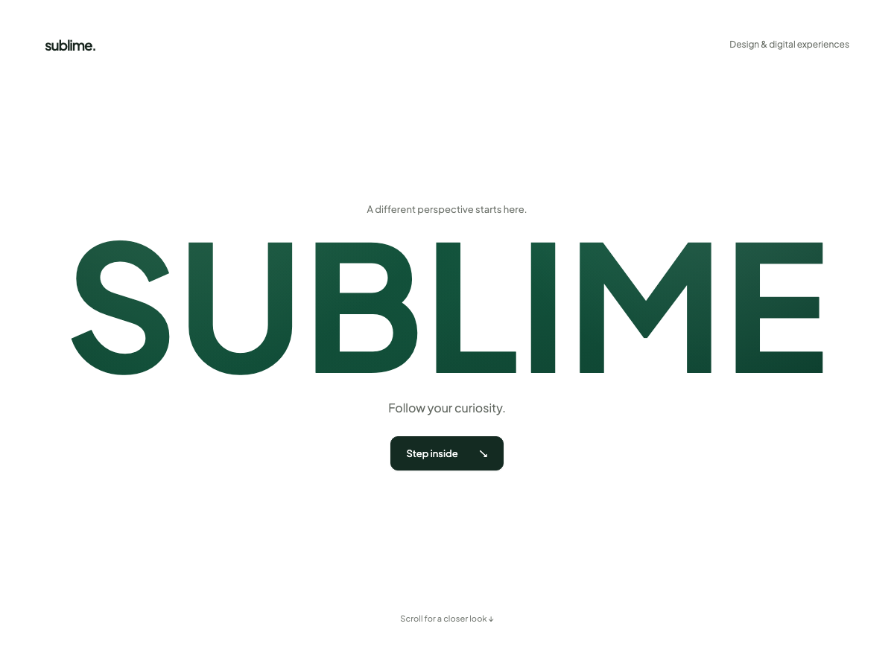

acho que na tela inicial deixar os produtos em algo semelhante a isso aqui sera legal
https://21st.dev/@designali-in/components/bo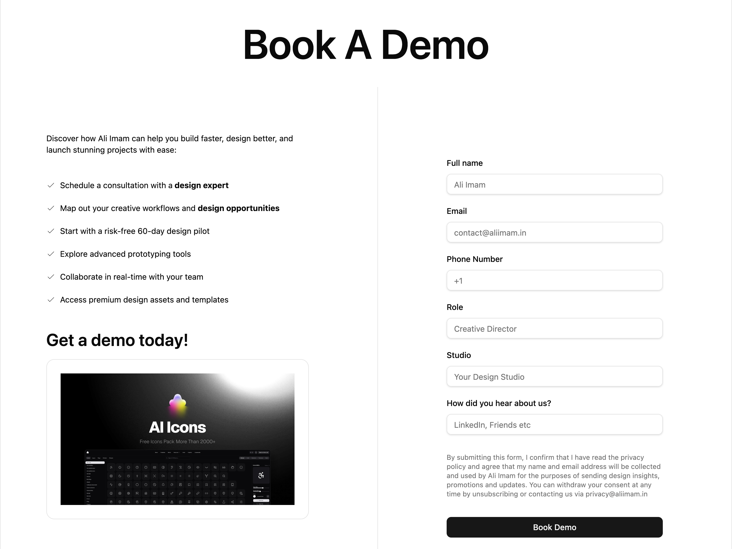ok-a-demo-1

e a tela especifica do produto parevido com isso daqui com botão de adicionar ao carrinho e mais informações
https://21st.dev/@ruixen.ui/components/feature-showcase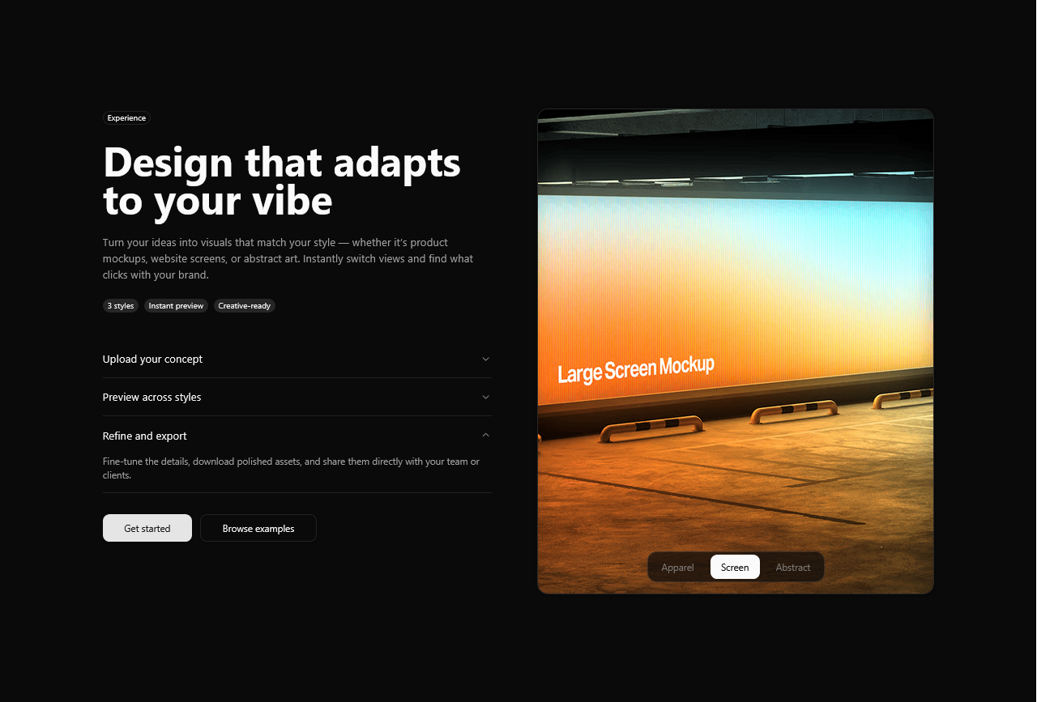

algo assim no rodapé e tela inicial com as marcas que vendemos
https://21st.dev/@ibelick/components/infinite-slider
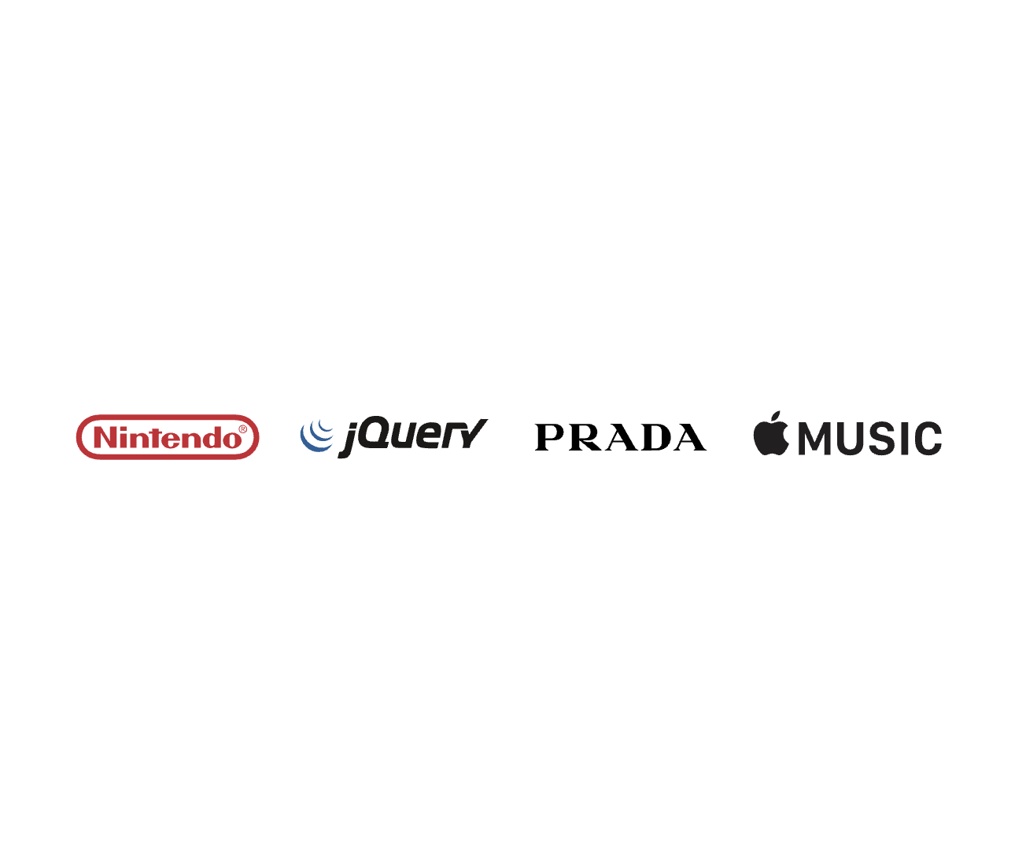

quero os icones da barra assim
https://21st.dev/@lyanchouss/components/dock
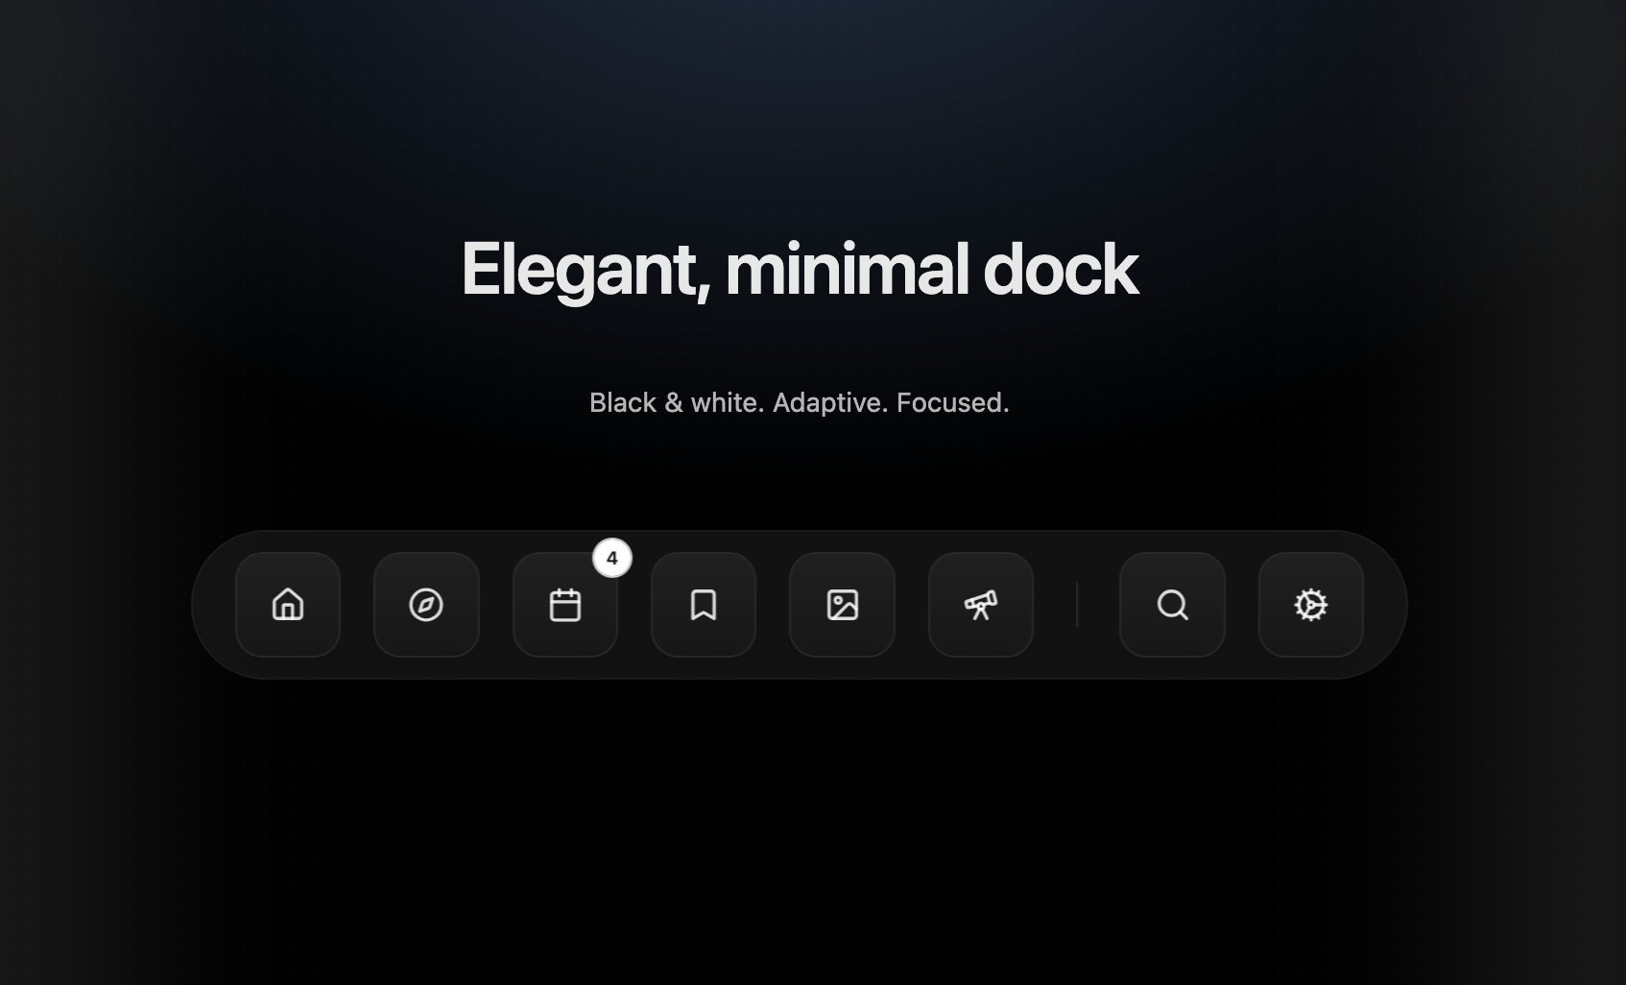
import HeroDock from "@/components/ui/dock";

export default function DemoOne() {
return <HeroDock/>;
}

