FinalExam158

Henrique

May 6, 2019

n <- 30  
coefs_age <- rep(0,1e4)  
coefs_age2 <- rep(0,1e4)  
for (i in 1:1e4) {  
 Age=round(runif(n,min=18,max=70))  
 Age2 <- Age^2  
 HR <- 94-Age*0.5+Age2*0.0035+rnorm(n,sd=10)  
 model <- lm(HR~Age+Age2)  
 coefs_age[i] <- summary(model)$coefficients[2,1]  
 coefs_age2[i] <- summary(model)$coefficients[3,1]  
  
}  
mean(coefs_age)

## [1] -0.4813071

mean(coefs_age2)

## [1] 0.003293108

summary(model)

##   
## Call:  
## lm(formula = HR ~ Age + Age2)  
##   
## Residuals:  
## Min 1Q Median 3Q Max   
## -16.7835 -9.1653 0.2415 8.0607 22.3109   
##   
## Coefficients:  
## Estimate Std. Error t value Pr(>|t|)   
## (Intercept) 78.528993 17.734920 4.428 0.000142 ***  
## Age -0.152304 0.896598 -0.170 0.866380   
## Age2 0.001963 0.010606 0.185 0.854507   
## ---  
## Signif. codes: 0 '***' 0.001 '**' 0.01 '*' 0.05 '.' 0.1 ' ' 1  
##   
## Residual standard error: 11.01 on 27 degrees of freedom  
## Multiple R-squared: 0.00147, Adjusted R-squared: -0.07249   
## F-statistic: 0.01988 on 2 and 27 DF, p-value: 0.9803

a)mean of coefs_age is -0.50 and coefs_age2 is 0.004, its seems right as the summary of one of the instances of the model shows as coef for age being -.53 and for age2 to be -.005 which is pretty close to the mean.

n <- 30  
ageee <- rep(0,1e4)  
HRrr <- rep(0,1e4)  
set.seed(104)  
for (i in 1:1e4) {  
 Age=round(runif(n,min=18,max=70))  
 Age2 <- Age^2  
 HR <- 94-Age*0.5+Age2*0.0035+rnorm(n,sd=10)  
 model <- lm(HR~Age+Age2)  
#ageee[i]<- mean(Age)  
#HRrr[i]<- mean(HR)  
  
}  
plot(Age,HR, xlab='Age', ylab = 'Heart Rate', main = 'Heart Rate vs Age', cex=0.9)

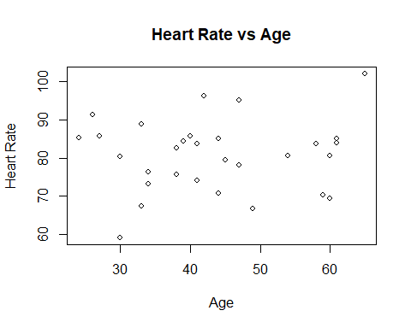 c)

n <- 30  
p1 <- rep(0,1e4)  
p2 <- rep(0,1e4)  
for (i in 1:1e4) {  
 Age=round(runif(n,min=18,max=70))  
 Age2 <- Age^2  
 HR <- 94-Age*0.5+Age2*0.0035+rnorm(n,sd=10)  
 model <- lm(HR~Age+Age2)  
 p1[i] <- summary(model)$coefficients[2,4]  
 p2[i] <- summary(model)$coefficients[3,4]  
}  
sum(p1<0.05)/length(p1)

## [1] 0.0892

sum(p2<0.05)/length(p2)

## [1] 0.065

Power of age is 0.09 and the power of age^2 is 0.06

n <- 30  
p1 <- rep(0,1e4)  
for (i in 1:1e4) {  
 Age=round(runif(n,min=18,max=70))  
 Age2 <- Age^2  
 HR <- 94-Age*0.5+Age*0.0035+rnorm(n,sd=10)  
 model <- lm(HR~Age)  
 p1[i] <- summary(model)$coefficients[2,4]  
}  
sum(p1<0.05)/length(p1)

## [1] 0.9632

summary(model)

##   
## Call:  
## lm(formula = HR ~ Age)  
##   
## Residuals:  
## Min 1Q Median 3Q Max   
## -29.706 -7.511 -1.041 9.088 20.993   
##   
## Coefficients:  
## Estimate Std. Error t value Pr(>|t|)   
## (Intercept) 92.4741 6.4524 14.33 2.03e-14 ***  
## Age -0.4518 0.1373 -3.29 0.00271 **   
## ---  
## Signif. codes: 0 '***' 0.001 '**' 0.01 '*' 0.05 '.' 0.1 ' ' 1  
##   
## Residual standard error: 11.27 on 28 degrees of freedom  
## Multiple R-squared: 0.2788, Adjusted R-squared: 0.253   
## F-statistic: 10.82 on 1 and 28 DF, p-value: 0.00271

It increased the power by a lot which would mean that the relation between HR and age it is not quadratic.

2)a)

h1 <- rgamma(10000, shape = 0.5)  
h2 <- rgamma(10000, shape =0.1)  
h3 <- rgamma(10000, shape =0.05)  
  
hist(h1,breaks=100)

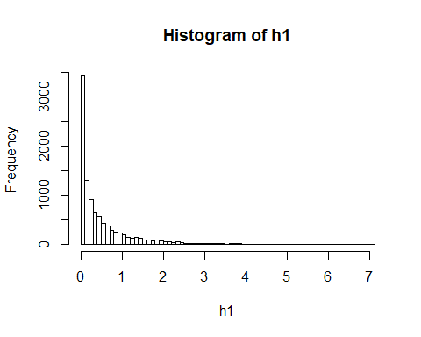

hist(h2,breaks=100)

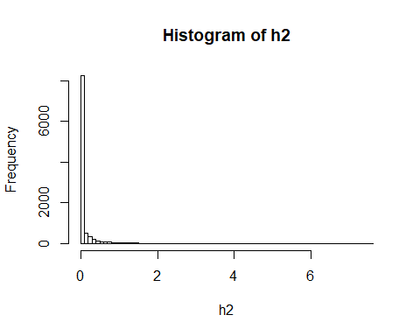

hist(h3,breaks=100)

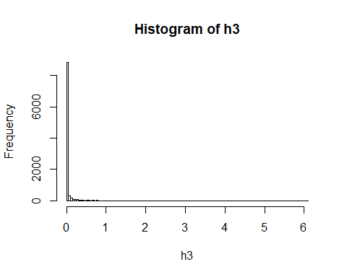 As shape gets smaller the histogram gets more skewed to the right.

tstat <- rep(1e4)  
pvav <- rep(1e4)  
  
for (i in 1:1e4) {  
sim <- rgamma(30, shape = 1)  
sim1 <- rgamma(30, shape = 1)  
  
t <- t.test(sim,sim1)  
tstat[i] <- t$statistic  
pvav[i] <- t$p.value  
}  
hist(tstat)

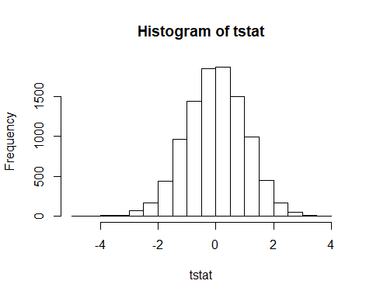

sum(pvav<0.05)/length(pvav)

## [1] 0.046

tstat <- rep(1e4)  
pvav <- rep(1e4)  
  
for (i in 1:1e4) {  
sim <- rgamma(30, shape = 0.5)  
sim1 <- rgamma(30, shape = 0.5)  
  
t <- t.test(sim,sim1)  
tstat[i] <- t$statistic  
pvav[i] <- t$p.value  
}  
hist(tstat)

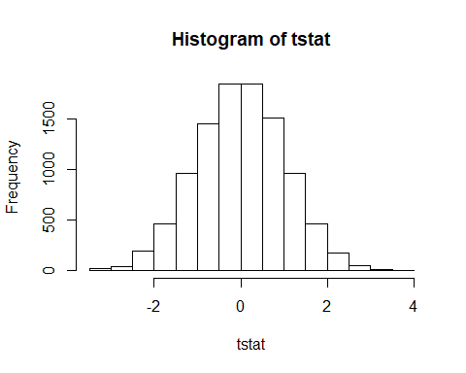

sum(pvav<0.05)/length(pvav)

## [1] 0.0466

tstat <- rep(1e4)  
pvav <- rep(1e4)  
  
for (i in 1:1e4) {  
sim <- rgamma(30, shape = 0.1)  
sim1 <- rgamma(30, shape = 0.1)  
  
t <- t.test(sim,sim1)  
tstat[i] <- t$statistic  
pvav[i] <- t$p.value  
}  
hist(tstat)

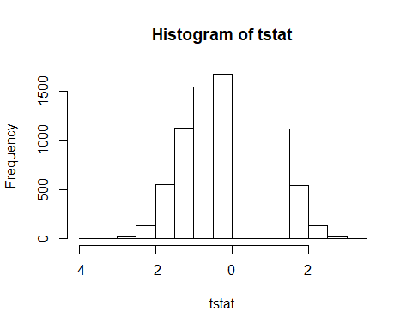

sum(pvav<0.05)/length(pvav)

## [1] 0.0262

the distribution is less normal as the shape decreases, also as the shape gets smaller the proportion of pvalues under 0.05 also gets smaller.

tstat <- rep(1e4)  
pvav <- rep(1e4)  
  
for (i in 1:1e4) {  
sim <- rgamma(10, shape = 1)  
sim1 <- rgamma(10, shape = 1)  
  
t <- t.test(sim,sim1)  
tstat[i] <- t$statistic  
pvav[i] <- t$p.value  
}  
hist(tstat)

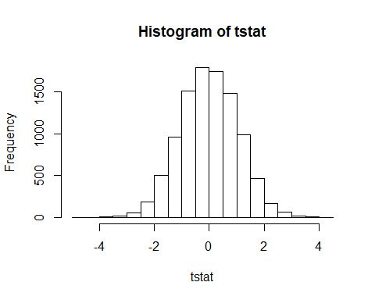

sum(pvav<0.05)/length(pvav)

## [1] 0.0381

tstat <- rep(1e4)  
pvav <- rep(1e4)  
  
for (i in 1:1e4) {  
sim <- rgamma(10, shape = 0.5)  
sim1 <- rgamma(10, shape = 0.5)  
  
t <- t.test(sim,sim1)  
tstat[i] <- t$statistic  
pvav[i] <- t$p.value  
}  
hist(tstat)

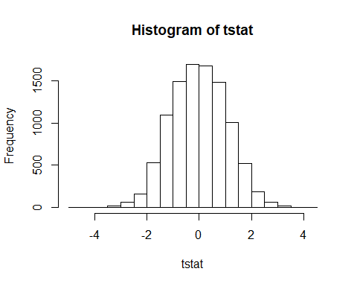

sum(pvav<0.05)/length(pvav)

## [1] 0.032

tstat <- rep(1e4)  
pvav <- rep(1e4)  
  
for (i in 1:1e4) {  
sim <- rgamma(10, shape = 0.1)  
sim1 <- rgamma(10, shape = 0.1)  
  
t <- t.test(sim,sim1)  
tstat[i] <- t$statistic  
pvav[i] <- t$p.value  
}  
hist(tstat)

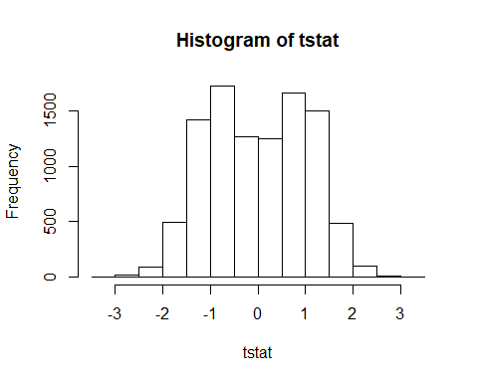

sum(pvav<0.05)/length(pvav)

## [1] 0.0074

yes, as the shape and the n go down the distribution of the mean is less and less normal.

3a)

ferret = read.csv("Ferret_Vaccine.csv", header = TRUE)  
attach(ferret)  
mean(Temperature)

## [1] 101.7395

sd(Temperature)

## [1] 0.9505654

mean(Weight)

## [1] 1145.234

sd(Weight)

## [1] 148.4198

detach(ferret)

Temperature mean = 101.7395 Temperature SD= 0.9505654 Weight mean = 1145.234 Weight SD = 148.4198

attach(ferret)  
  
plot(Day[Ferret.ID==574],Temperature[Ferret.ID==574],type="l",xlab='Day',ylab = 'Temperature', ylim=c(100,105))  
lines(Day[Ferret.ID==546],Temperature[Ferret.ID==546],lty = 2)  
lines(Day[Ferret.ID==548],Temperature[Ferret.ID==548], lty = 3)

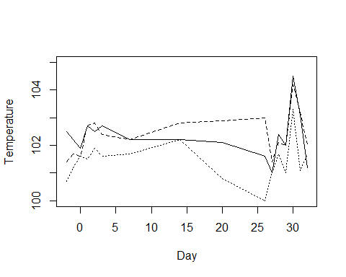

detach(ferret)