HWK3

Henrique

February 15, 2019

question 1.

sample1 <- rnorm(10,0,1)  
sample1

## [1] -1.2591864 0.6174185 0.8214974 0.5903229 0.2399127 -0.6975131  
## [7] 0.5940571 0.1356971 -1.5602417 -1.4896401

mean(sample1)

## [1] -0.2007676

sd(sample1)

## [1] 0.9519454

sample2 <- rnorm(10,100,1)  
sample2

## [1] 99.83935 100.27636 99.33311 100.92943 99.54241 99.56391 99.57379  
## [8] 99.40431 100.92701 100.18182

mean(sample2)

## [1] 99.95715

sd(sample2)

## [1] 0.5982254

sample3 <- rnorm(10,1000,10)  
sample3

## [1] 1005.8991 998.0689 998.1597 996.7504 994.4341 1010.5421 987.0127  
## [8] 990.7123 1013.7642 1014.2990

sd(sample3)

## [1] 9.627158

mean(sample3)

## [1] 1000.964

Question 2

coin <- c("Head","Tail")  
  
  
sample(coin,size = 20, replace=TRUE)

## [1] "Tail" "Tail" "Tail" "Tail" "Head" "Head" "Tail" "Head" "Head" "Tail"  
## [11] "Tail" "Head" "Tail" "Head" "Head" "Tail" "Head" "Tail" "Head" "Tail"

question 3

set.seed(158)  
coin <- c("Head","Tail")  
  
  
sample(coin,size = 20, replace=TRUE)

## [1] "Tail" "Tail" "Tail" "Head" "Head" "Head" "Head" "Tail" "Tail" "Tail"  
## [11] "Head" "Tail" "Tail" "Tail" "Head" "Head" "Head" "Head" "Head" "Tail"

question 4 a/b/c

x <- runif(20,min = -10, max = 10)  
  
b0 = 75  
b1 = 2  
b2 = 0.5  
b3 = 0.1  
  
y=b0 +(b0*x)+(b1*x)+(b2*x*x)+(b3*x*x*x)  
  
plot(x,y)

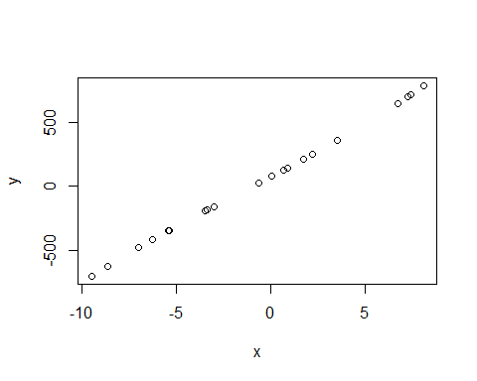

question 4 d

noise <- rnorm(20,0,5)  
plot (x,noise)

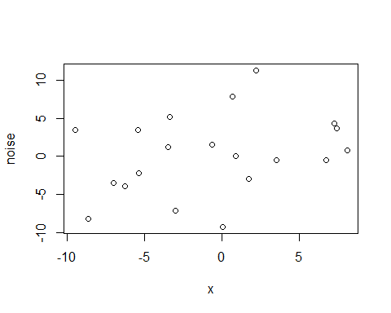 I looks random, and without any correlation between the points.

Question 4 e

noise2 <- rnorm(20,0,50)  
plot (x,noise2)

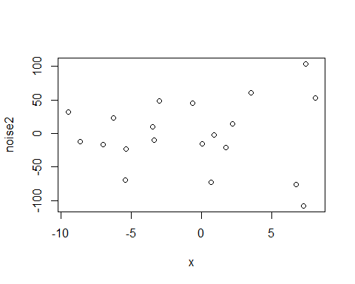 It has a lot more space between the points.

question 4 f

compare <- cbind(y,noise,noise2)  
compare

## y noise noise2  
## [1,] 211.35246 -2.96011023 -20.911398  
## [2,] 79.44783 -9.28444240 -15.146239  
## [3,] -343.47809 3.45398541 -68.946506  
## [4,] 144.23596 0.05072011 -1.748088  
## [5,] -698.66616 3.53530657 31.682086  
## [6,] 783.09960 0.85278845 52.533455  
## [7,] 712.88345 3.65565089 103.785035  
## [8,] 248.33262 11.34069783 14.599314  
## [9,] -157.23576 -7.12835856 48.946299  
## [10,] 125.14277 7.94374182 -72.127491  
## [11,] 23.37933 1.60055217 45.259268  
## [12,] -181.85969 5.18336508 -9.439571  
## [13,] -192.83471 1.18870848 9.486811  
## [14,] 698.36687 4.31340726 -107.735190  
## [15,] -477.66595 -3.50544027 -16.685265  
## [16,] 647.03992 -0.53369841 -76.230805  
## [17,] -412.70205 -3.92198531 23.402754  
## [18,] 356.98836 -0.52666287 60.370180  
## [19,] -342.41325 -2.21178533 -23.245546  
## [20,] -620.18107 -8.21730153 -11.639469

they have no linear relation and are a lot smaller in comparison to the y vaulues.