HWK4

Henrique

March 1, 2019

question 1

attach(iris)  
  
plot(Petal.Width,Petal.Length,col=c("red","blue","green"),pch=c(17,22,10),xlab = "Width of the petal",ylab= "Length of the petal", title(main ="Width vs Length of a petal"))

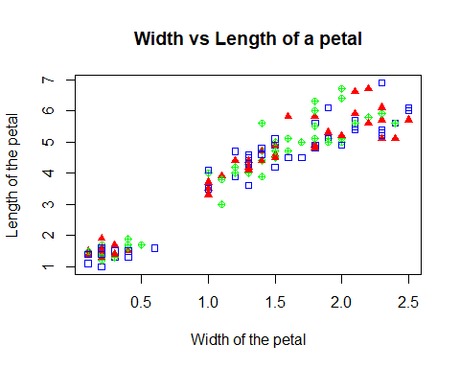

detach(iris)

Question 2

a <- rnorm(10,0,10)  
b <- rnorm(20,40,100)  
c <- rnorm(15,20,50)  
  
boxplot(a,b,c, col = c("gray14","gray23","gray54"), names = c("Mean=0 sd= 10","Mean=40 sd=100","Mean= 20 sd=50"), bty='n')

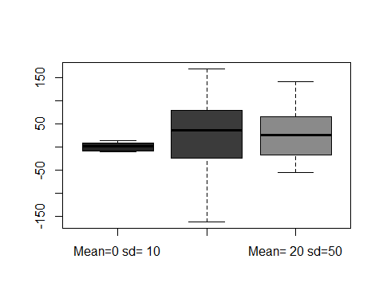

Question 3a)

sample_size <- 30  
sds <- rep(0,10e4)  
for (i in 1:length(sds)){  
 temp_sample <- runif(n=sample_size,min=100, max=300)  
 sds[i] <- sd(temp_sample)  
}  
hist(sds)

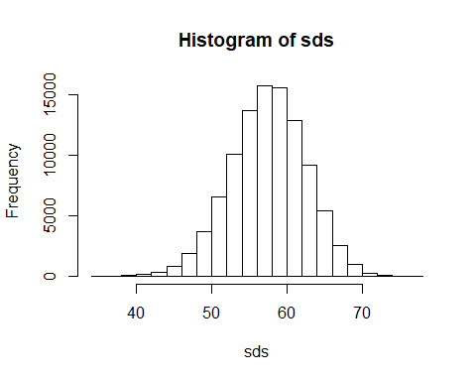

Question 3b)

sample_size <- 50  
sds2 <- rep(0,10e4)  
for (i in 1:length(sds2)){  
 temp_sample <- runif(n=sample_size,min=100, max=300)  
 sds2[i] <- sd(temp_sample)  
}  
hist(sds2)

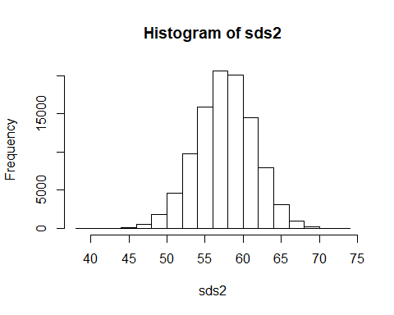 question 3c)

sample_size <- 30  
sds3 <- rep(0,10e4)  
for (i in 1:length(sds3)){  
 temp_sample <- runif(n=sample_size,min=100, max=500)  
 sds3[i] <- sd(temp_sample)  
}  
hist(sds3)

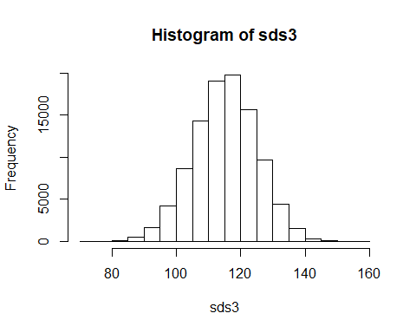

question 3d)

hist(sds,ylim = c(0,30000), xlim = c(0,140))

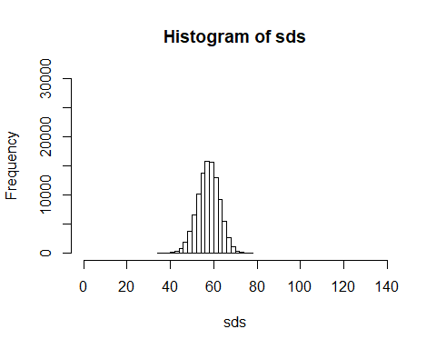

hist(sds2,ylim = c(0,30000),xlim = c(0,140))

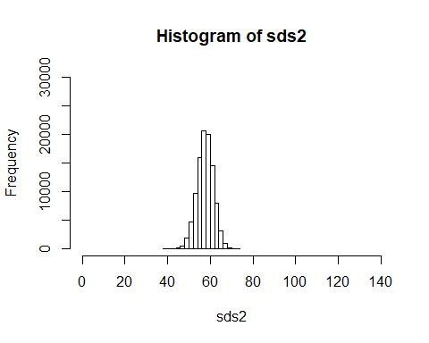

hist(sds3,ylim = c(0,30000),xlim =c(0,140))

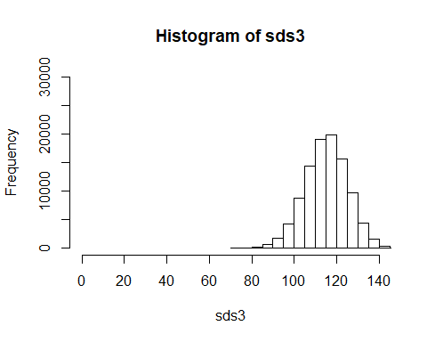 When the sample size is increased it makes the variation of the standard deviation smaller, changin the max value moves the graph of the standard deviation to the right due to the increase in its variation.

Question 4

sample_size <- 30  
lns <- rep(0,30)  
for (i in 1:length(lns)){  
 temp_sample <- rnorm(30,0,10)  
 lns[i] <- log(temp_sample)  
}

## Warning in log(temp_sample): NaNs produced

## Warning in lns[i] <- log(temp_sample): number of items to replace is not a  
## multiple of replacement length

## Warning in log(temp_sample): NaNs produced

## Warning in lns[i] <- log(temp_sample): number of items to replace is not a  
## multiple of replacement length

## Warning in log(temp_sample): NaNs produced

## Warning in lns[i] <- log(temp_sample): number of items to replace is not a  
## multiple of replacement length

## Warning in log(temp_sample): NaNs produced

## Warning in lns[i] <- log(temp_sample): number of items to replace is not a  
## multiple of replacement length

## Warning in log(temp_sample): NaNs produced

## Warning in lns[i] <- log(temp_sample): number of items to replace is not a  
## multiple of replacement length

## Warning in log(temp_sample): NaNs produced

## Warning in lns[i] <- log(temp_sample): number of items to replace is not a  
## multiple of replacement length

## Warning in log(temp_sample): NaNs produced

## Warning in lns[i] <- log(temp_sample): number of items to replace is not a  
## multiple of replacement length

## Warning in log(temp_sample): NaNs produced

## Warning in lns[i] <- log(temp_sample): number of items to replace is not a  
## multiple of replacement length

## Warning in log(temp_sample): NaNs produced

## Warning in lns[i] <- log(temp_sample): number of items to replace is not a  
## multiple of replacement length

## Warning in log(temp_sample): NaNs produced

## Warning in lns[i] <- log(temp_sample): number of items to replace is not a  
## multiple of replacement length

## Warning in log(temp_sample): NaNs produced

## Warning in lns[i] <- log(temp_sample): number of items to replace is not a  
## multiple of replacement length

## Warning in log(temp_sample): NaNs produced

## Warning in lns[i] <- log(temp_sample): number of items to replace is not a  
## multiple of replacement length

## Warning in log(temp_sample): NaNs produced

## Warning in lns[i] <- log(temp_sample): number of items to replace is not a  
## multiple of replacement length

## Warning in log(temp_sample): NaNs produced

## Warning in lns[i] <- log(temp_sample): number of items to replace is not a  
## multiple of replacement length

## Warning in log(temp_sample): NaNs produced

## Warning in lns[i] <- log(temp_sample): number of items to replace is not a  
## multiple of replacement length

## Warning in log(temp_sample): NaNs produced

## Warning in lns[i] <- log(temp_sample): number of items to replace is not a  
## multiple of replacement length

## Warning in log(temp_sample): NaNs produced

## Warning in lns[i] <- log(temp_sample): number of items to replace is not a  
## multiple of replacement length

## Warning in log(temp_sample): NaNs produced

## Warning in lns[i] <- log(temp_sample): number of items to replace is not a  
## multiple of replacement length

## Warning in log(temp_sample): NaNs produced

## Warning in lns[i] <- log(temp_sample): number of items to replace is not a  
## multiple of replacement length

## Warning in log(temp_sample): NaNs produced

## Warning in lns[i] <- log(temp_sample): number of items to replace is not a  
## multiple of replacement length

## Warning in log(temp_sample): NaNs produced

## Warning in lns[i] <- log(temp_sample): number of items to replace is not a  
## multiple of replacement length

## Warning in log(temp_sample): NaNs produced

## Warning in lns[i] <- log(temp_sample): number of items to replace is not a  
## multiple of replacement length

## Warning in log(temp_sample): NaNs produced

## Warning in lns[i] <- log(temp_sample): number of items to replace is not a  
## multiple of replacement length

## Warning in log(temp_sample): NaNs produced

## Warning in lns[i] <- log(temp_sample): number of items to replace is not a  
## multiple of replacement length

## Warning in log(temp_sample): NaNs produced

## Warning in lns[i] <- log(temp_sample): number of items to replace is not a  
## multiple of replacement length

## Warning in log(temp_sample): NaNs produced

## Warning in lns[i] <- log(temp_sample): number of items to replace is not a  
## multiple of replacement length

## Warning in log(temp_sample): NaNs produced

## Warning in lns[i] <- log(temp_sample): number of items to replace is not a  
## multiple of replacement length

## Warning in log(temp_sample): NaNs produced

## Warning in lns[i] <- log(temp_sample): number of items to replace is not a  
## multiple of replacement length

## Warning in log(temp_sample): NaNs produced

## Warning in lns[i] <- log(temp_sample): number of items to replace is not a  
## multiple of replacement length

## Warning in log(temp_sample): NaNs produced

## Warning in lns[i] <- log(temp_sample): number of items to replace is not a  
## multiple of replacement length

hist(lns)

