HWK5

Henrique

April 14, 2019

Question 1a)

jan = read.csv("january_temp.csv", header = TRUE)  
  
attach(jan)  
plot(Lat,Long,xlab= "Latitude",ylab= "Longitude")

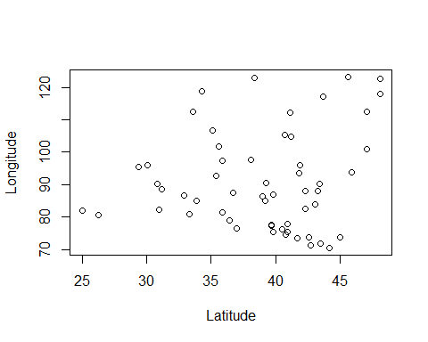

detach(jan)

Yes, it looks scattered as I expected.

Question 1b)

attach(jan)  
estjan <- lm(JanTemp~Lat)  
summary(estjan)

##   
## Call:  
## lm(formula = JanTemp ~ Lat)  
##   
## Residuals:  
## Min 1Q Median 3Q Max   
## -10.6812 -4.5018 -0.2593 2.2489 25.7434   
##   
## Coefficients:  
## Estimate Std. Error t value Pr(>|t|)   
## (Intercept) 108.7277 7.0561 15.41 <2e-16 ***  
## Lat -2.1096 0.1794 -11.76 <2e-16 ***  
## ---  
## Signif. codes: 0 '***' 0.001 '**' 0.01 '*' 0.05 '.' 0.1 ' ' 1  
##   
## Residual standard error: 7.156 on 54 degrees of freedom  
## Multiple R-squared: 0.7192, Adjusted R-squared: 0.714   
## F-statistic: 138.3 on 1 and 54 DF, p-value: < 2.2e-16

plot(JanTemp~Lat)  
  
objects(estjan)

## [1] "assign" "call" "coefficients" "df.residual"   
## [5] "effects" "fitted.values" "model" "qr"   
## [9] "rank" "residuals" "terms" "xlevels"

abline(estjan$coefficients)

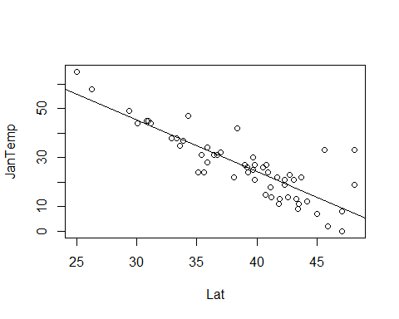

JanTemp=108.73-2.11*Lat  
  
detach(jan)

The R squared statistisc is 0.7192.

Question 1c)

attach(jan)

## The following object is masked _by_ .GlobalEnv:  
##   
## JanTemp

estjan2 <- lm(JanTemp~Long)  
summary(estjan2)

##   
## Call:  
## lm(formula = JanTemp ~ Long)  
##   
## Residuals:  
## Min 1Q Median 3Q Max   
## -16.308 -8.325 -2.608 7.878 28.492   
##   
## Coefficients:  
## Estimate Std. Error t value Pr(>|t|)   
## (Intercept) 36.4893 9.4099 3.878 0.000288 ***  
## Long -0.1098 0.1021 -1.075 0.287085   
## ---  
## Signif. codes: 0 '***' 0.001 '**' 0.01 '*' 0.05 '.' 0.1 ' ' 1  
##   
## Residual standard error: 11.33 on 54 degrees of freedom  
## Multiple R-squared: 0.02096, Adjusted R-squared: 0.002828   
## F-statistic: 1.156 on 1 and 54 DF, p-value: 0.2871

plot(JanTemp~Long)  
  
objects(estjan2)

## [1] "assign" "call" "coefficients" "df.residual"   
## [5] "effects" "fitted.values" "model" "qr"   
## [9] "rank" "residuals" "terms" "xlevels"

abline(estjan2$coefficients)

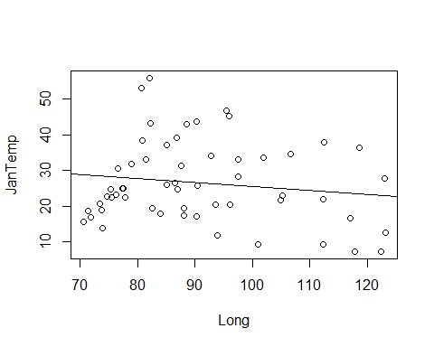

JanTemp2=1.97-2.11*Long  
  
detach(jan)

the R squared statistics is 0.02096.

question 1)d) latitude had a much better prediction, which is shown by its r squared statistic being 1.

Question 1)e)

attach(jan)

## The following object is masked _by_ .GlobalEnv:  
##   
## JanTemp

estjan3 <- lm(JanTemp~Long+Lat)  
summary(estjan3)

## Warning in summary.lm(estjan3): essentially perfect fit: summary may be  
## unreliable

##   
## Call:  
## lm(formula = JanTemp ~ Long + Lat)  
##   
## Residuals:  
## Min 1Q Median 3Q Max   
## -1.665e-14 -4.029e-15 -8.970e-16 3.007e-15 4.334e-14   
##   
## Coefficients:  
## Estimate Std. Error t value Pr(>|t|)   
## (Intercept) 1.087e+02 9.230e-15 1.178e+16 <2e-16 ***  
## Long -1.600e-17 6.999e-17 -2.290e-01 0.82   
## Lat -2.110e+00 1.948e-16 -1.083e+16 <2e-16 ***  
## ---  
## Signif. codes: 0 '***' 0.001 '**' 0.01 '*' 0.05 '.' 0.1 ' ' 1  
##   
## Residual standard error: 7.686e-15 on 53 degrees of freedom  
## Multiple R-squared: 1, Adjusted R-squared: 1   
## F-statistic: 5.995e+31 on 2 and 53 DF, p-value: < 2.2e-16

JanTemp3=108.73-2.11*Lat*Long  
  
detach(jan)

Lat was much better at predicting. lat coefficient changed but long didn’t

question 1)f)

question 1)g)

anova(estjan,estjan2,estjan3)

## Analysis of Variance Table  
##   
## Model 1: JanTemp ~ Lat  
## Model 2: JanTemp ~ Long  
## Model 3: JanTemp ~ Long + Lat  
## Res.Df RSS Df Sum of Sq F Pr(>F)   
## 1 54 2765.1   
## 2 54 6935.2 0 -4170.1   
## 3 53 0.0 1 6935.2 1.1738e+32 < 2.2e-16 ***  
## ---  
## Signif. codes: 0 '***' 0.001 '**' 0.01 '*' 0.05 '.' 0.1 ' ' 1

question 2)

x=rnorm(100,10,10)  
z = t.test(x)  
z$statistic

## t   
## 8.315759

lol <- rep(0,2)  
lol[1]<-z$statistic

t1t <- rep(0,10e4)  
for (i in 1:length(t1t)){  
 x=rnorm(100,10,10)  
 z = t.test(x)  
 t1t[i] <- z$statistic  
}  
  
hist(t1t)

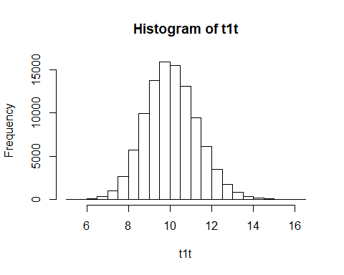

question 3a)

t2t <- rep(0,10000)  
for (i in 1:10000){  
 x<-(rnorm(100,5,1)+rnorm(10,5,5))  
 z = t.test(x)  
 t2t[i] <- (z$statistic)  
   
}  
  
  
hist(t2t)

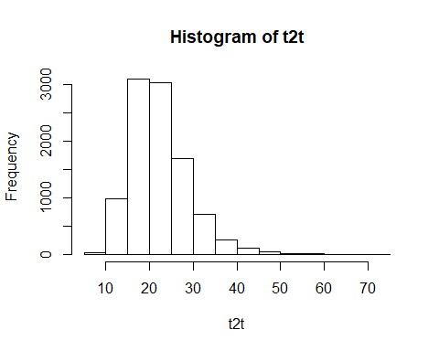

3b)

t2t <- rep(0,10000)  
for (i in 1:10000){  
 x<-(rnorm(100,5,1)+rnorm(10,5,5))  
 z = t.test(x,var.equal = TRUE)  
 t2t[i] <- (z$statistic)  
   
}  
  
  
hist(t2t)

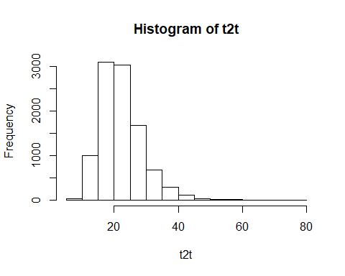

part c looks less skewed to the right when compared to part bv