HW11-315

Henrique

May 1, 2019

require(Sleuth3)

## Loading required package: Sleuth3

## Warning: package 'Sleuth3' was built under R version 3.5.3

require(mosaic)

## Loading required package: mosaic

## Warning: package 'mosaic' was built under R version 3.5.3

## Loading required package: dplyr

## Warning: package 'dplyr' was built under R version 3.5.3

##   
## Attaching package: 'dplyr'

## The following objects are masked from 'package:stats':  
##   
## filter, lag

## The following objects are masked from 'package:base':  
##   
## intersect, setdiff, setequal, union

## Loading required package: lattice

## Loading required package: ggformula

## Warning: package 'ggformula' was built under R version 3.5.3

## Loading required package: ggplot2

## Warning: package 'ggplot2' was built under R version 3.5.3

## Loading required package: ggstance

## Warning: package 'ggstance' was built under R version 3.5.3

##   
## Attaching package: 'ggstance'

## The following objects are masked from 'package:ggplot2':  
##   
## geom_errorbarh, GeomErrorbarh

##   
## New to ggformula? Try the tutorials:   
## learnr::run_tutorial("introduction", package = "ggformula")  
## learnr::run_tutorial("refining", package = "ggformula")

## Loading required package: mosaicData

## Warning: package 'mosaicData' was built under R version 3.5.3

## Loading required package: Matrix

##   
## The 'mosaic' package masks several functions from core packages in order to add   
## additional features. The original behavior of these functions should not be affected by this.  
##   
## Note: If you use the Matrix package, be sure to load it BEFORE loading mosaic.

##   
## Attaching package: 'mosaic'

## The following object is masked from 'package:Matrix':  
##   
## mean

## The following object is masked from 'package:ggplot2':  
##   
## stat

## The following objects are masked from 'package:dplyr':  
##   
## count, do, tally

## The following objects are masked from 'package:stats':  
##   
## binom.test, cor, cor.test, cov, fivenum, IQR, median,  
## prop.test, quantile, sd, t.test, var

## The following objects are masked from 'package:base':  
##   
## max, mean, min, prod, range, sample, sum

head(case0701)

## Velocity Distance  
## 1 170 0.03  
## 2 290 0.03  
## 3 -130 0.21  
## 4 -70 0.26  
## 5 -185 0.28  
## 6 -220 0.28

dim(case0701)

## [1] 24 2

summary(case0701)

## Velocity Distance   
## Min. :-220.0 Min. :0.0300   
## 1st Qu.: 165.0 1st Qu.:0.4075   
## Median : 295.0 Median :0.9000   
## Mean : 373.1 Mean :0.9113   
## 3rd Qu.: 537.5 3rd Qu.:1.1750   
## Max. :1090.0 Max. :2.0000

histogram(~ Velocity, type="density", density=TRUE, nint=10, data=case0701)

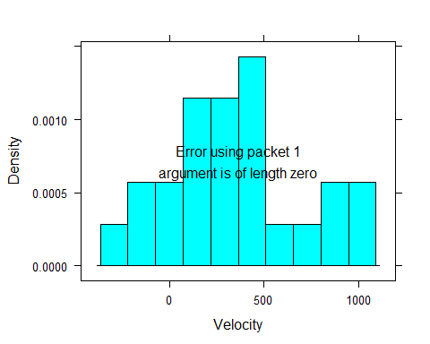

histogram(~ Distance, type="density", density=TRUE, nint=10, data=case0701)

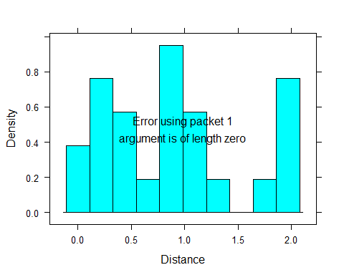 10)

xyplot(Distance ~ Velocity, type=c("p", "r"), data=case0701)

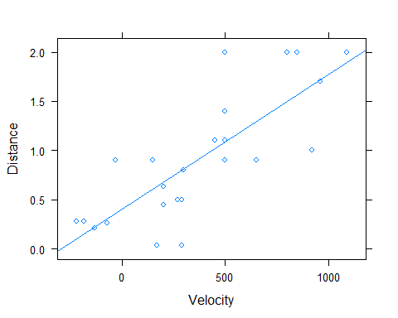

mylm = lm(Distance ~ Velocity, data=case0701)  
summary(mylm)

##   
## Call:  
## lm(formula = Distance ~ Velocity, data = case0701)  
##   
## Residuals:  
## Min 1Q Median 3Q Max   
## -0.76717 -0.23517 -0.01083 0.21081 0.91463   
##   
## Coefficients:  
## Estimate Std. Error t value Pr(>|t|)   
## (Intercept) 0.3991704 0.1186662 3.364 0.0028 **   
## Velocity 0.0013724 0.0002278 6.024 4.61e-06 ***  
## ---  
## Signif. codes: 0 '***' 0.001 '**' 0.01 '*' 0.05 '.' 0.1 ' ' 1  
##   
## Residual standard error: 0.4056 on 22 degrees of freedom  
## Multiple R-squared: 0.6226, Adjusted R-squared: 0.6054   
## F-statistic: 36.29 on 1 and 22 DF, p-value: 4.608e-06

fitted(mylm)

## 1 2 3 4 5 6   
## 0.63247972 0.79716862 0.22075746 0.30310191 0.14527505 0.09724078   
## 7 8 9 10 11 12   
## 0.67365195 0.79716862 0.76972047 0.67365195 0.81089270 0.35799821   
## 13 14 15 16 17 18   
## 1.29123534 0.60503157 1.08537421 1.66178537 1.01675383 1.08537421   
## 19 20 21 22 23 24   
## 1.08537421 1.71668167 1.08537421 1.56571684 1.49709647 1.89509465

resid(mylm)^2

## 1 2 3 4 5   
## 0.3629818132 0.5885476975 0.0001157230 0.0018577749 0.0181508131   
## 6 7 8 9 10   
## 0.0334009315 0.0500201930 0.0883091910 0.0727491337 0.0019054924   
## 11 12 13 14 15   
## 0.0001186509 0.2937659363 0.1530650876 0.0870063750 0.0343635961   
## 16 17 18 19 20   
## 0.4379598745 0.0069299250 0.0002139139 0.0989893905 0.0002782781   
## 21 22 23 24   
## 0.8365403438 0.1886018616 0.2529119654 0.0110051326

sum(resid(mylm)^2)

## [1] 3.619789

sum(resid(mylm)^2)/sum((fitted(mylm)-mean(~Distance, data=case0701))^2)

## [1] 0.6062411

xyplot(Distance ~ Velocity, panel=panel.lmbands, data=case0701)

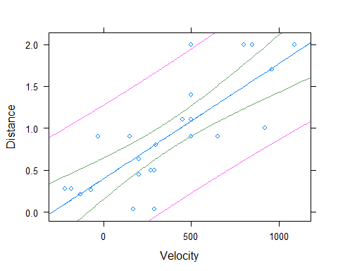 14)

summary(mylm)

##   
## Call:  
## lm(formula = Distance ~ Velocity, data = case0701)  
##   
## Residuals:  
## Min 1Q Median 3Q Max   
## -0.76717 -0.23517 -0.01083 0.21081 0.91463   
##   
## Coefficients:  
## Estimate Std. Error t value Pr(>|t|)   
## (Intercept) 0.3991704 0.1186662 3.364 0.0028 **   
## Velocity 0.0013724 0.0002278 6.024 4.61e-06 ***  
## ---  
## Signif. codes: 0 '***' 0.001 '**' 0.01 '*' 0.05 '.' 0.1 ' ' 1  
##   
## Residual standard error: 0.4056 on 22 degrees of freedom  
## Multiple R-squared: 0.6226, Adjusted R-squared: 0.6054   
## F-statistic: 36.29 on 1 and 22 DF, p-value: 4.608e-06

# linear regression with no intercept  
mylm2 = lm(Distance ~ Velocity-1, data=case0701)  
summary(mylm2)

##   
## Call:  
## lm(formula = Distance ~ Velocity - 1, data = case0701)  
##   
## Residuals:  
## Min 1Q Median 3Q Max   
## -0.76767 -0.06909 0.22948 0.46056 1.03931   
##   
## Coefficients:  
## Estimate Std. Error t value Pr(>|t|)   
## Velocity 0.0019214 0.0001913 10.04 7.05e-10 ***  
## ---  
## Signif. codes: 0 '***' 0.001 '**' 0.01 '*' 0.05 '.' 0.1 ' ' 1  
##   
## Residual standard error: 0.4882 on 23 degrees of freedom  
## Multiple R-squared: 0.8143, Adjusted R-squared: 0.8062   
## F-statistic: 100.9 on 1 and 23 DF, p-value: 7.05e-10

confint(mylm2)

## 2.5 % 97.5 %  
## Velocity 0.001525611 0.002317143