Homework #1

Henrique Magalhaes Rio

8/28/2019

# Question 1

# Question 2

## Part 1 (a)

it comes from cars from the years 1999 to 2008

## Part 2 (b)

the mean on the highway is 23.4 mpg

## Part 3 (c)

there are 103 4 wheel drive vehicles, 106 front wheel drive vehicles and 25 rear wheel drive vehicles.

## Part 4 (d)

The mean for 4 wheel drive cars is 19.17, for front wheel drive 28.16038 and rear wheel drive 21.000.

# Question 3

## Part 1 (a)

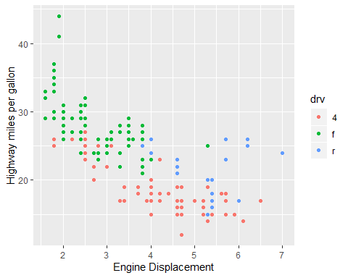

## Part 2 (b)

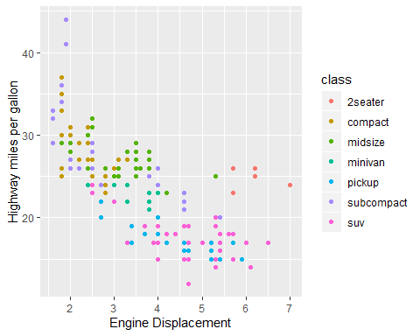

## Part 3 (c)

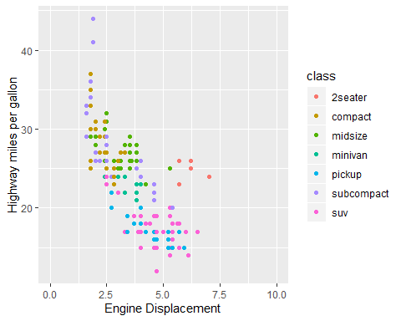

# Question 4

## Part 1 (a)

## `stat_bin()` using `bins = 30`. Pick better value with `binwidth`.

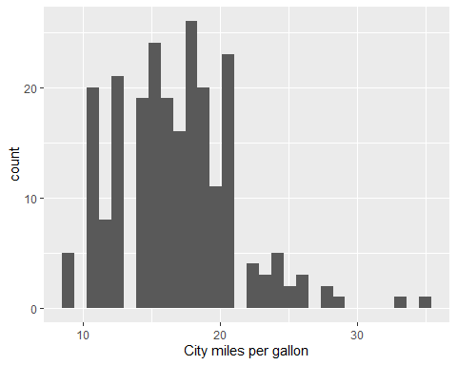

## Part 2 (b)

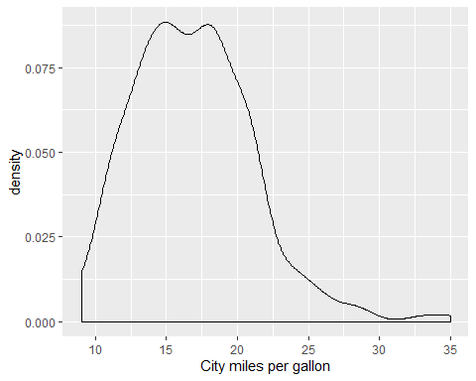

## Part 3 (c)

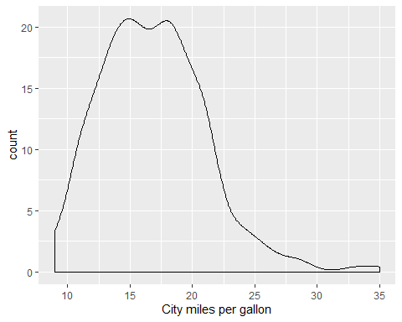 ## Part 4 (d)

## `stat_bin()` using `bins = 30`. Pick better value with `binwidth`.

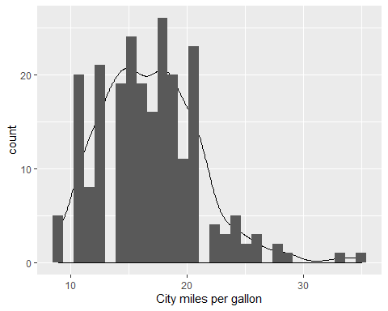

# Question 5

## Part 1 (a)

$E[3X]=15$

## Part 2 (b)

$E[2X+4Y−5]=21$

## Part 3 (c)

$Var(2Y−3)=4$

## Part 4 (d)

$Var[2X+4Y]=20$

# Question 6

$Y_{i}=β_{0}+β_{1}x_{i}$

# Appendix

# Insert packages you need here  
library(knitr)  
library(ggplot2)  
library(dplyr)  
library(tidyverse)  
  
summarize(mpg, mean(hwy))  
  
  
mpg %>%  
 group_by(drv) %>%  
 summarize(n=n()) %>%  
 mutate(freq = n / sum(n))  
  
  
  
  
mpg %>%  
 group_by(drv) %>%  
 summarize(mean_mpg=mean(hwy))  
   
  
ggplot() + geom_point(aes(x=displ,y=hwy, col=drv),data=mpg) + xlab("Engine Displacement") + ylab("Highway miles per gallon")  
ggplot() + geom_point(aes(x=displ,y=hwy, col=class),data=mpg) + xlab("Engine Displacement") + ylab("Highway miles per gallon")  
ggplot() + geom_point(aes(x=displ,y=hwy, col=class),data=mpg) + xlab("Engine Displacement") + ylab("Highway miles per gallon")+xlim(c(0,10))  
ggplot(mpg) + geom_histogram(aes(x=cty))+xlab("City miles per gallon")  
  
ggplot(mpg) + geom_density(aes(x=cty))+xlab("City miles per gallon")  
  
ggplot(mpg) + geom_density(aes(x=cty,y=stat(count)))+xlab("City miles per gallon")  
  
ggplot(mpg) + geom_density(aes(x=cty,y=stat(count)))+geom_histogram(aes(x=cty))+xlab("City miles per gallon")