Homework #10

Henrique Magalhaes Rio

11/14/2019

# Question 1

## Part 1 (a)

$β_{0}=318$ 95%CI= (211,426)

$β_{1}=26$ 95%CI= (5.96,46.02)

$β_{2}=−5.83$ 95%CI= (-10.24,-1.42)

$β_{3}=0.042$ 95%CI= (-1.10,1.19)

## Part 2 (b)

We fail to reject the null hypothesis that there is no relationship between price per square foot and median household income, when adjusting for population density and percent of families living below poverty level. (95%CI= (-1.10,1.19), p-value=0.94)

## Part 3 (c)

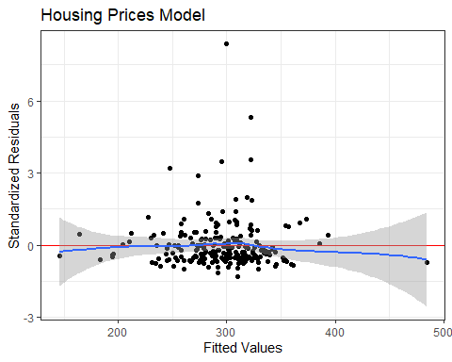

## Part 4 (d)

Yes it violates the constant variance assumption as towards the middle of the graph the points are a lot more spread out than in the corners of the graphs.

# Question 2

## Part 1 (a)

$\hat{Y}=−0.07+0.48x$

## Part 2 (b)

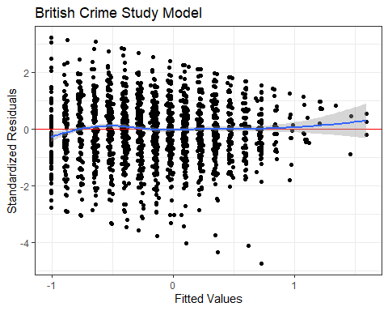

## Part 3 (c)

The plot shows a violation of the non-constant variance assumption, due to is cone shape where at the lower fitted values there is more variance then the higher fitted values.

## Part 4 (d)

$\hat{Y}=−0.1−0.02x$

## Part 5 (e)

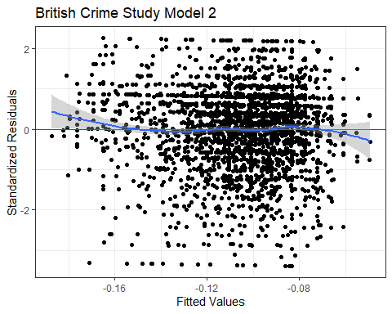

## Part 6 (f)

There are no violations, even though there is a lot of variance it is spread out evenly.

# Question 3

## Part 1 (a)

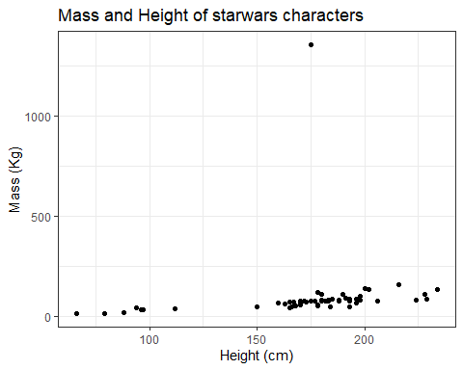

## Part 2 (b)

Ratts Tyerell - height=79 - mass=15 Yoda - height=66 - mass=17

## Part 3 (c)

Jabba Desilijic Tiure - height=175 mass=1358.0

## Part 4 (d)

A one unit difference in height results in a estimated average difference of 0.641 in mass. 95% CI=(-.623,1.91)

## Part 5 (e)

Jabba Desilijic Tiure - DFBETAS=0.264 Ratts Tyerell - DFBETAS = 0.053 Yoda - DFBETAS = 0.034

Yes, Jabba’s has a high influence on the height coefficient.

## Part 6 (f)

Jabba Desilijic Tiure - DFBETAS= 1.525 Ratts Tyerell - DFBETAS = -0.056 Yoda - DFBETAS = -0.035

Yes, Jabba’s has a very high influence on the height coefficient.

# Appendix  
  
  
```r  
# Insert packages you need here  
library(knitr)  
library(ggplot2)  
library(dplyr)  
library(tidyverse)  
library(broom)  
  
hou <-read.csv("housing_prices_CO.csv")  
  
houlm <- lm(price_psf~pop_density+pov+med_hh_income, data= hou)  
tidy(houlm,conf.int = TRUE)  
  
ggplot() + theme_bw()+ geom_point(aes(x=fitted(houlm),y=rstandard(houlm))) + geom_hline(yintercept = 0,col="red") + xlab("Fitted Values") + ylab("Standardized Residuals") + ggtitle("Housing Prices Model") + geom_smooth(aes(x=fitted(houlm),y=rstandard(houlm)),method = "loess")  
  
  
  
bc <-read.csv("british_crime_study.csv")  
  
  
bclm <- lm(conf_police~eff_justice, data = bc)  
  
  
ggplot() + theme_bw()+ geom_point(aes(x=fitted(bclm),y=rstandard(bclm))) + geom_hline(yintercept = 0,col="red") + xlab("Fitted Values") + ylab("Standardized Residuals") + ggtitle("British Crime Study Model") + geom_smooth(aes(x=fitted(bclm),y=rstandard(bclm)),method = "loess")  
  
  
  
bclm2 <- lm(conf_police~worry_pers_crime, data = bc)  
  
  
ggplot() + theme_bw()+ geom_point(aes(x=fitted(bclm2),y=rstandard(bclm2))) + geom_hline(yintercept = 0,col="red") + xlab("Fitted Values") + ylab("Standardized Residuals") + ggtitle("British Crime Study Model 2") + geom_smooth(aes(x=fitted(bclm2),y=rstandard(bclm2)),method = "loess")  
  
  
sw <-read.csv("starwars.csv")  
  
ggplot(sw) + theme_bw()+ geom_point(aes(x=height,y=mass))+ ggtitle("Mass and Height of starwars characters") +xlab("Height (cm)") + ylab("Mass (Kg)")  
  
swlm <- lm(mass~height, data =sw)  
  
round(dfbetas(swlm), 3)