HW1

Henrique Magalhaes Rio

# Question 1

## Part 1 (A)

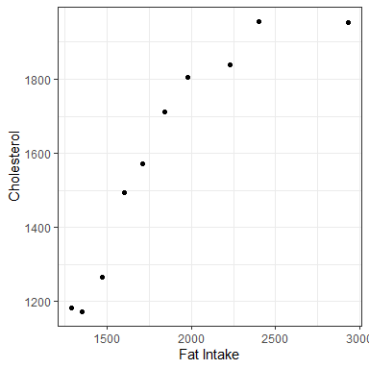

## Part 2 (B)

$\hat{β_{0}}=578.92775$, is the estimated average cholesterol level for an athlete with 0 mg of fat intake.

$\hat{β_{1}}=0.54030$, is the estimated average difference in cholesterol level for a one unit difference in fat intake.

$\hat{σ}=133.4377$, is the estimated standard deviation of the model.

## Part 3 (C)

We reject the null hypothesis that there is no linear relationship between fat intake and cholesterol level. (p-value=0.000236)

# Appendix

library(knitr)  
library(ggplot2)  
library(dplyr)  
library(tidyverse)  
library(broom)  
library(splines)  
library(caret)  
knitr::opts_chunk$set(echo = FALSE, message = FALSE, warning = FALSE, fig.width = 4, fig.height = 4, tidy = TRUE)  
  
chol <- read.csv("cholDat.csv")  
  
ggplot(chol,aes(y=chol,x=fat)) +theme_bw()+ geom_point() +ylab("Cholesterol")+ xlab("Fat Intake")  
cholm <- lm(chol~fat, data=chol)  
  
summary(cholm)