HW2

Henrique Magalhaes Rio

# Question 1

It means even though thought the nominal coverage is 95%, the coverage of pairwise comparisons would be higher then that when adjusted for which means that the confidence interval is more coservative.

# Question 2

## Part 1(A)

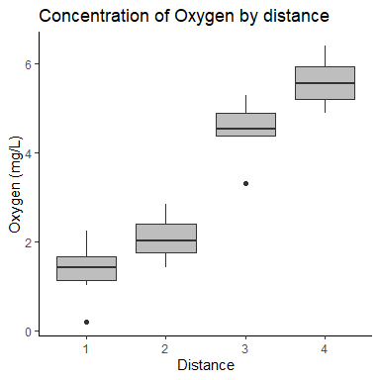

## Part 2 (B)

## Analysis of Variance Table  
##   
## Response: ox$oxy2  
## Df Sum Sq Mean Sq F value Pr(>F)   
## d 3 118.776 39.592 144.05 < 2.2e-16 ***  
## Residuals 36 9.895 0.275   
## ---  
## Signif. codes: 0 '***' 0.001 '**' 0.01 '*' 0.05 '.' 0.1 ' ' 1

## Part 3 (C)

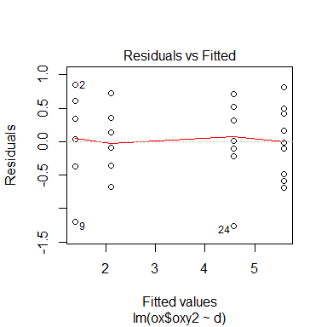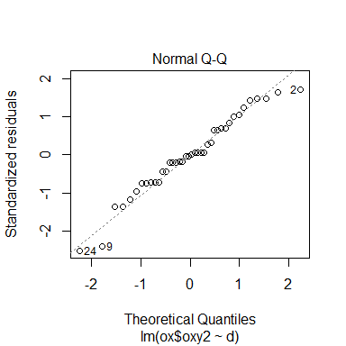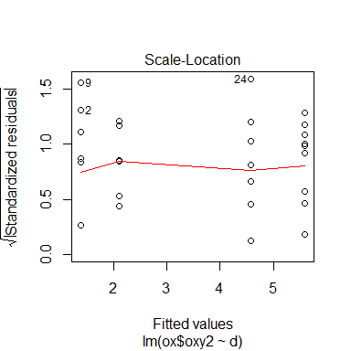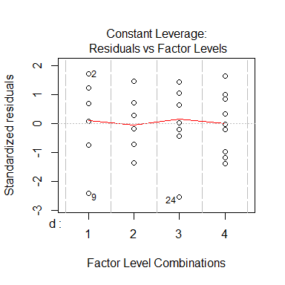

# Question 3

## Part 1 (A)

|  |  |  |  |  |
| --- | --- | --- | --- | --- |
| CPPU | GA3 | Control | ABBA |  |
| 102.70 | 95.57 | 94.15 | 90.72 |  |

## Part 2 (B)

$H_{0}:μ_{i}=μ_{ctrl}$

$H_{a}:μ_{i}≠μ_{ctrl}$

## Part 3 (C)

Tukey’s method compares every mean to every other mean, Dunnet’s method compares every mean to a control mean.

# Question 4

## PArt 1 (A)

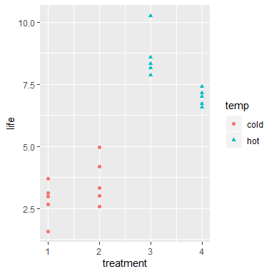

## Part 2 (B)

## Analysis of Variance Table  
##   
## Response: bat2$life  
## Df Sum Sq Mean Sq F value Pr(>F)   
## bat2$trt 3 114.100 38.033 60.269 6.136e-09 ***  
## Residuals 16 10.097 0.631   
## ---  
## Signif. codes: 0 '***' 0.001 '**' 0.01 '*' 0.05 '.' 0.1 ' ' 1

## Part 3 (C)

## contrast estimate SE df t.ratio p.value  
## 1 - 2 -0.802 0.502 16 -1.596 0.4082   
## 1 - 3 -5.828 0.502 16 -11.600 <.0001   
## 1 - 4 -4.164 0.502 16 -8.288 <.0001   
## 2 - 3 -5.026 0.502 16 -10.004 <.0001   
## 2 - 4 -3.362 0.502 16 -6.692 <.0001   
## 3 - 4 1.664 0.502 16 3.312 0.0206   
##   
## P value adjustment: tukey method for comparing a family of 4 estimates

treatments 1-2 do not show evidence of difference (P-value=0.41), however, all the others show evidence of a difference between each other.

## Part 4 (D)

## contrast estimate SE df t.ratio p.value  
## c(-0.5, -0.5, 0.5, 0.5) 4.59 0.355 16 12.934 <.0001

We can conclude the that there is a estimated difference of 4.59 between hot and cold treatments.(P-value<.0001)

## Part 5 (E)

## contrast estimate SE df t.ratio p.value  
## c(0.5, -0.5, -0.5, 0.5) -1.23 0.355 16 -3.471 0.0032

We can conclude the that there is a estimated negative difference of 1.23 between material 1 and material 2.(P-value=0.0032)

## Part 6 (F)

## [1] 0

Yes since the sum is 0.

# Appendix

library(knitr)  
library(ggplot2)  
library(dplyr)  
library(tidyverse)  
library(broom)  
library(splines)  
library(caret)  
library(Matrix)  
library(MASS)  
library(emmeans)  
knitr::opts_chunk$set(echo = FALSE, message = FALSE, warning = FALSE, fig.width = 4,   
 fig.height = 4, tidy = TRUE)  
  
# Q2A  
ox <- read_csv("oxygen.csv")  
  
  
d <- as.factor(ox$distance)  
  
ox = ox %>% mutate(oxy2 = sqrt(ox$oxygen + 0.0375))  
  
  
ggplot(data = ox, aes(x = d, y = oxy2)) + geom_boxplot(fill = "gray") + labs(title = "Concentration of Oxygen by distance ",   
 x = "Distance", y = "Oxygen (mg/L)") + theme_classic()  
  
  
  
  
  
  
lmout <- lm(ox$oxy2 ~ d)  
anova(lmout)  
  
plot(lmout)  
  
# Q4a  
bat <- read.csv("BatteryData.csv")  
  
ggplot(bat, aes(x = treatment, y = life, shape = temp, color = temp)) + geom_point()  
  
  
  
# Q4b  
trt <- as.factor(bat$treatment)  
bat2 <- cbind(bat, trt)  
lmbat <- lm(bat2$life ~ bat2$trt)  
  
anova(lmbat)  
# Q4c  
lmeans <- lsmeans(lmbat, specs = "trt")  
pairs(lmeans)  
  
  
# Q4d  
l1 = c(-1/2, -1/2, +1/2, +1/2)  
  
contrast(lmeans, list(l1))  
# Q4e  
l2 = c(1/2, -1/2, -1/2, +1/2)  
  
contrast(lmeans, list(l2))  
# Q4f  
sum(l1 * l2)