ForecastingArma

# Bitcoin

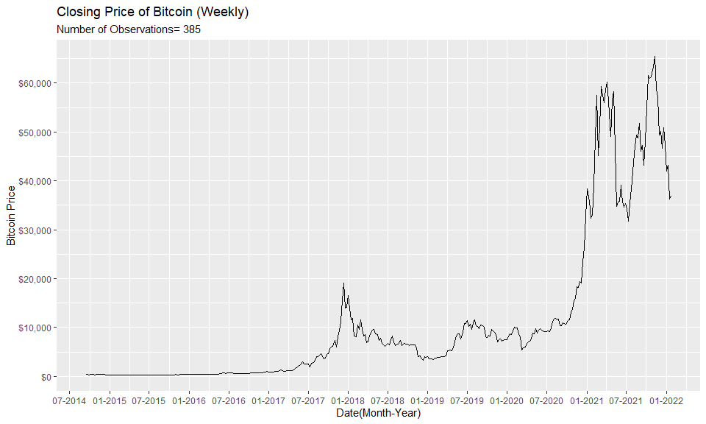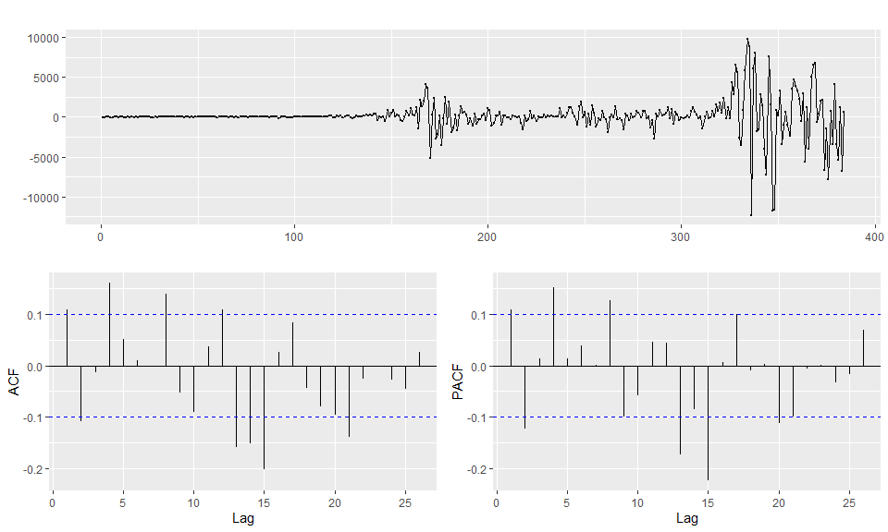

Cut data from 2017-07-2 to 2020-01-01

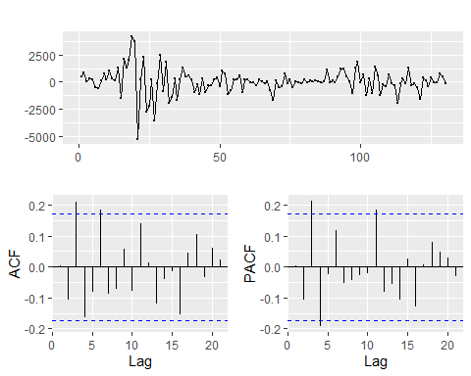

#> Series: btcut$Close   
#> ARIMA(2,1,10)   
#>   
#> Coefficients:  
#> ar1 ar2 ma1 ma2 ma3 ma4 ma5 ma6  
#> -0.7939 -0.7214 0.8948 0.7275 0.2079 -0.0448 -0.0877 -0.0387  
#> s.e. 0.3834 0.3170 0.3756 0.3399 0.1443 0.1560 0.1499 0.1401  
#> ma7 ma8 ma9 ma10  
#> -0.0349 -0.0877 -0.1570 -0.2053  
#> s.e. 0.1724 0.1934 0.1604 0.1120  
#>   
#> sigma^2 = 1217868: log likelihood = -1089.41  
#> AIC=2204.82 AICc=2207.96 BIC=2242.1

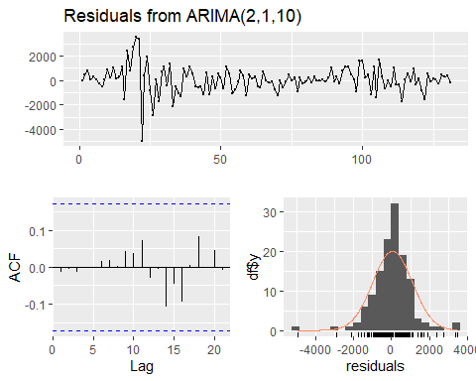

#>   
#> Ljung-Box test  
#>   
#> data: Residuals from ARIMA(2,1,10)  
#> Q* = 3.463, df = 3, p-value = 0.3256  
#>   
#> Model df: 12. Total lags used: 15

#> Series: btcut$Close   
#> ARIMA(2,1,20)   
#>   
#> Coefficients:  
#> ar1 ar2 ma1 ma2 ma3 ma4 ma5 ma6  
#> 0.1633 0.7769 -0.1341 -0.9656 0.2551 -0.0213 -0.2381 0.2065  
#> s.e. 0.1878 0.1812 0.2136 0.2053 0.1415 0.1619 0.1507 0.1320  
#> ma7 ma8 ma9 ma10 ma11 ma12 ma13 ma14  
#> -0.1611 -0.3681 0.1295 0.1080 0.1993 0.125 -0.2295 -0.0861  
#> s.e. 0.1391 0.1421 0.1456 0.1498 0.1464 0.133 0.1449 0.1330  
#> ma15 ma16 ma17 ma18 ma19 ma20  
#> -0.1327 -0.0395 0.1042 0.2658 0.0036 -0.0149  
#> s.e. 0.1501 0.1361 0.1760 0.1580 0.1318 0.1469  
#>   
#> sigma^2 = 1082592: log likelihood = -1082.42  
#> AIC=2210.84 AICc=2221.25 BIC=2276.79

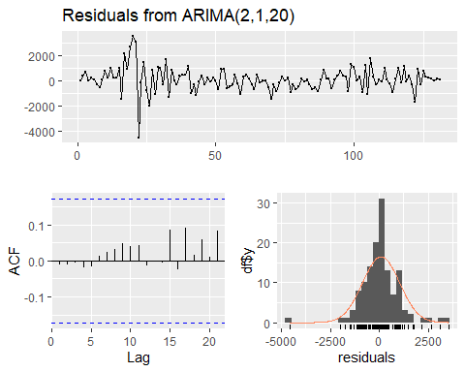

#>   
#> Ljung-Box test  
#>   
#> data: Residuals from ARIMA(2,1,20)  
#> Q* = 7.2838, df = 3, p-value = 0.06338  
#>   
#> Model df: 22. Total lags used: 25

#> Series: btcut$Close   
#> ARIMA(1,1,5)   
#>   
#> Coefficients:  
#> ar1 ma1 ma2 ma3 ma4 ma5  
#> -0.3958 0.4735 -0.0318 0.1071 -0.1018 -0.1893  
#> s.e. 0.2557 0.2506 0.1065 0.0926 0.1226 0.1150  
#>   
#> sigma^2 = 1241195: log likelihood = -1093.57  
#> AIC=2201.15 AICc=2202.06 BIC=2221.22

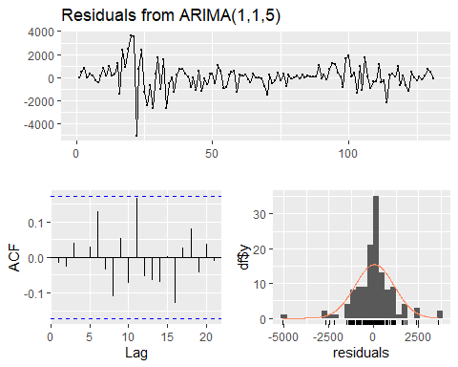

#>   
#> Ljung-Box test  
#>   
#> data: Residuals from ARIMA(1,1,5)  
#> Q* = 5.8198, df = 4, p-value = 0.213  
#>   
#> Model df: 6. Total lags used: 10

#> Series: btcut$Close   
#> ARIMA(2,1,15)   
#>   
#> Coefficients:  
#> ar1 ar2 ma1 ma2 ma3 ma4 ma5 ma6  
#> 1.4119 -0.7555 -1.4744 0.7056 0.3986 -0.5253 0.2640 0.1832  
#> s.e. 0.1340 0.1052 0.1709 0.1980 0.1691 0.1803 0.1791 0.1818  
#> ma7 ma8 ma9 ma10 ma11 ma12 ma13 ma14  
#> -0.4463 0.1276 0.1672 -0.2209 0.2435 -0.3656 0.0168 0.0183  
#> s.e. 0.1822 0.1857 0.1909 0.1731 0.1817 0.2251 0.1587 0.1983  
#> ma15  
#> -0.0923  
#> s.e. 0.1362  
#>   
#> sigma^2 = 1045243: log likelihood = -1082.44  
#> AIC=2200.88 AICc=2207.05 BIC=2252.5

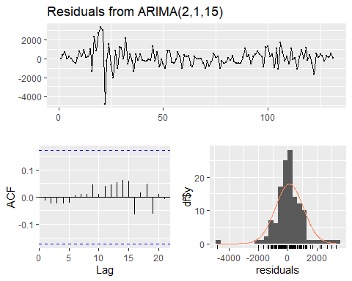

#>   
#> Ljung-Box test  
#>   
#> data: Residuals from ARIMA(2,1,15)  
#> Q* = 4.315, df = 3, p-value = 0.2294  
#>   
#> Model df: 17. Total lags used: 20

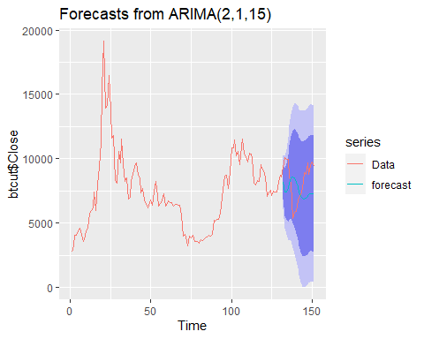

# Ethereum

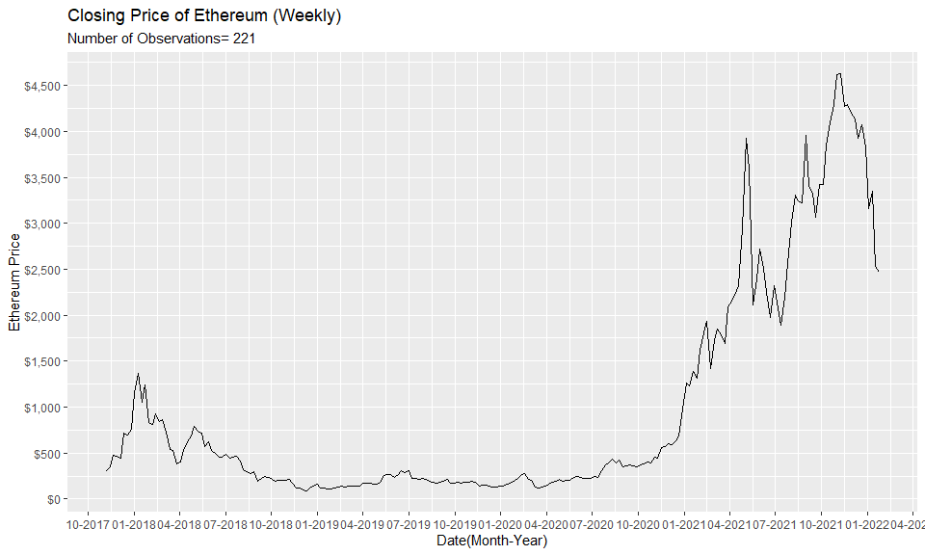

# Etherium

Cut period from 2018-10-15 to 2021-08-30

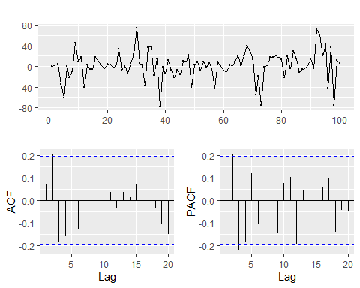

#> Series: ethcut$Close   
#> ARIMA(1,1,0)   
#>   
#> Coefficients:  
#> ar1  
#> 0.0713  
#> s.e. 0.0993  
#>   
#> sigma^2 = 709.8: log likelihood = -469.65  
#> AIC=943.29 AICc=943.42 BIC=948.5

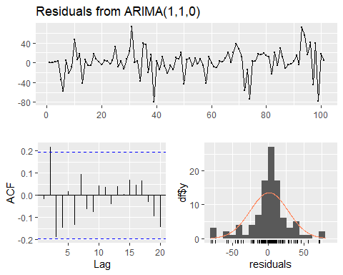

#>   
#> Ljung-Box test  
#>   
#> data: Residuals from ARIMA(1,1,0)  
#> Q* = 15.392, df = 9, p-value = 0.08073  
#>   
#> Model df: 1. Total lags used: 10

#> Series: ethcut$Close   
#> ARIMA(2,1,25)   
#>   
#> Coefficients:  
#> ar1 ar2 ma1 ma2 ma3 ma4 ma5 ma6  
#> -0.4875 -0.9961 0.6041 1.6212 -0.0873 0.194 -0.4726 -0.1854  
#> s.e. 0.0104 0.0051 0.1819 0.3722 0.3034 0.308 0.2893 0.2730  
#> ma7 ma8 ma9 ma10 ma11 ma12 ma13 ma14 ma15  
#> 0.3683 -0.0889 0.1782 -0.3068 -0.1979 0.1141 0.0979 0.2963 0.3586  
#> s.e. 0.2538 0.2480 0.2652 0.2465 0.2589 0.2614 0.2505 0.2313 0.2655  
#> ma16 ma17 ma18 ma19 ma20 ma21 ma22 ma23  
#> 0.3027 0.5769 0.1219 0.0137 -0.4080 -0.4132 -0.6297 -0.5468  
#> s.e. 0.2669 0.2849 0.3074 0.3303 0.2756 0.2365 0.3082 0.3208  
#> ma24 ma25  
#> -0.4254 -0.1932  
#> s.e. 0.2427 0.1540  
#>   
#> sigma^2 = 410: log likelihood = -441.14  
#> AIC=938.27 AICc=961.15 BIC=1011.22

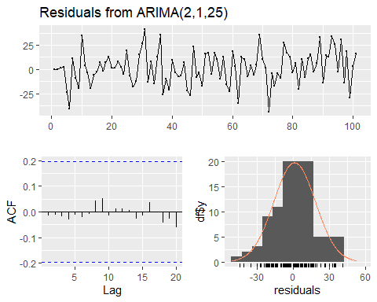

#>   
#> Ljung-Box test  
#>   
#> data: Residuals from ARIMA(2,1,25)  
#> Q* = 4.6275, df = 3, p-value = 0.2012  
#>   
#> Model df: 27. Total lags used: 30

#> Series: ethcut$Close   
#> ARIMA(2,1,20)   
#>   
#> Coefficients:  
#> ar1 ar2 ma1 ma2 ma3 ma4 ma5 ma6  
#> -0.0506 -0.2840 0.1273 0.6835 -0.3925 -0.0466 -0.1044 -0.0556  
#> s.e. 0.2299 0.2871 0.2827 0.4376 0.2819 0.2493 0.1722 0.1744  
#> ma7 ma8 ma9 ma10 ma11 ma12 ma13 ma14 ma15  
#> 0.4796 -0.0103 0.0819 -0.0032 -0.0376 0.1680 0.1071 0.2401 0.4215  
#> s.e. 0.1562 0.2429 0.2337 0.2358 0.1783 0.1894 0.2196 0.2131 0.2638  
#> ma16 ma17 ma18 ma19 ma20  
#> 0.2111 0.3796 -0.0144 -0.2312 -0.417  
#> s.e. 0.1967 0.2470 0.2443 0.2291 0.242  
#>   
#> sigma^2 = 464.6: log likelihood = -448.61  
#> AIC=943.21 AICc=957.74 BIC=1003.13

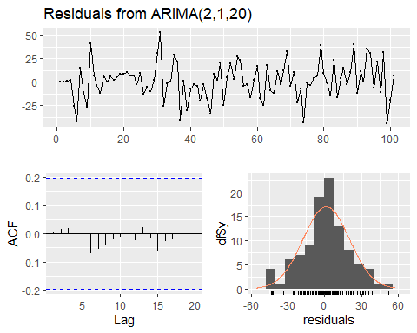

#>   
#> Ljung-Box test  
#>   
#> data: Residuals from ARIMA(2,1,20)  
#> Q* = 5.2626, df = 3, p-value = 0.1535  
#>   
#> Model df: 22. Total lags used: 25

#> Series: ethcut$Close   
#> ARIMA(2,1,15)   
#>   
#> Coefficients:  
#> ar1 ar2 ma1 ma2 ma3 ma4 ma5 ma6  
#> 1.4296 -0.7487 -1.3818 0.9826 -0.7521 0.7387 -0.1841 -0.2437  
#> s.e. 0.2657 0.1503 0.3065 0.2347 0.2292 0.2692 0.2550 0.2537  
#> ma7 ma8 ma9 ma10 ma11 ma12 ma13 ma14 ma15  
#> 0.6756 -0.7826 0.3976 0.0095 0.0847 0.0369 -0.1575 0.3007 0.0072  
#> s.e. 0.2938 0.3767 0.3408 0.3004 0.2676 0.2743 0.2826 0.2255 0.2121  
#>   
#> sigma^2 = 526.9: log likelihood = -451.36  
#> AIC=938.72 AICc=947.17 BIC=985.61

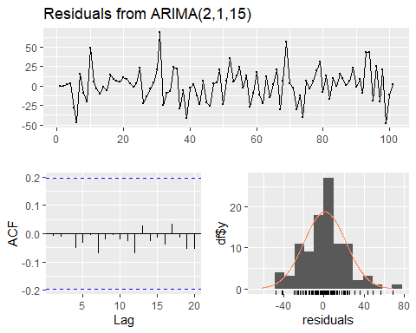

#>   
#> Ljung-Box test  
#>   
#> data: Residuals from ARIMA(2,1,15)  
#> Q* = 3.1736, df = 3, p-value = 0.3656  
#>   
#> Model df: 17. Total lags used: 20

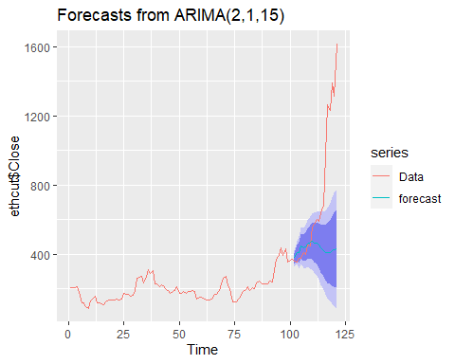

# Monero

2018-10 to 2020-10

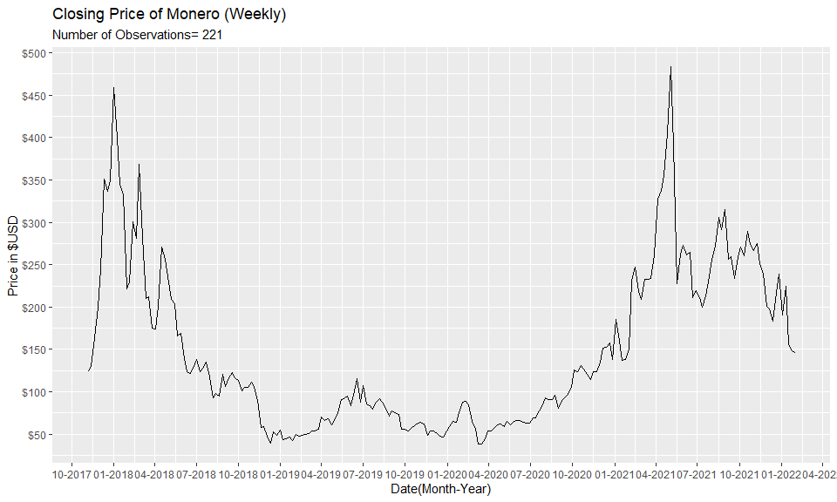

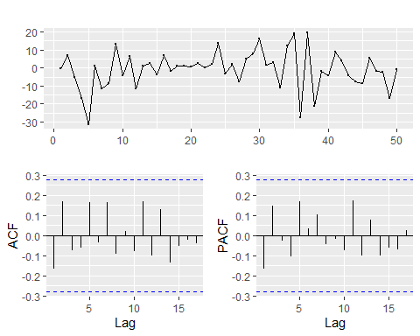

#> Series: xmrcut$Close   
#> ARIMA(1,1,0)   
#>   
#> Coefficients:  
#> ar1  
#> -0.1519  
#> s.e. 0.1383  
#>   
#> sigma^2 = 108.9: log likelihood = -187.71  
#> AIC=379.42 AICc=379.68 BIC=383.24

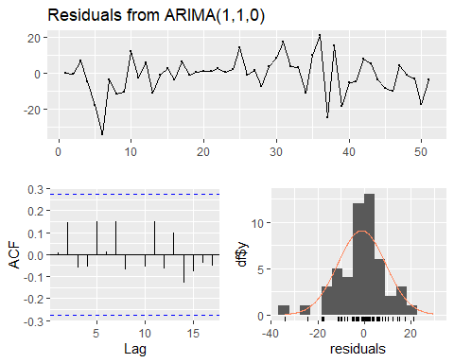

#>   
#> Ljung-Box test  
#>   
#> data: Residuals from ARIMA(1,1,0)  
#> Q* = 4.7918, df = 9, p-value = 0.8521  
#>   
#> Model df: 1. Total lags used: 10

#> Series: xmrcut$Close   
#> ARIMA(2,1,5)   
#>   
#> Coefficients:  
#> ar1 ar2 ma1 ma2 ma3 ma4 ma5  
#> 0.0782 0.6552 -0.1251 -0.6172 0.0442 -0.1290 0.3338  
#> s.e. 0.2513 0.2071 0.2891 0.2333 0.1681 0.1719 0.1675  
#>   
#> sigma^2 = 103.8: log likelihood = -184.42  
#> AIC=384.85 AICc=388.36 BIC=400.14

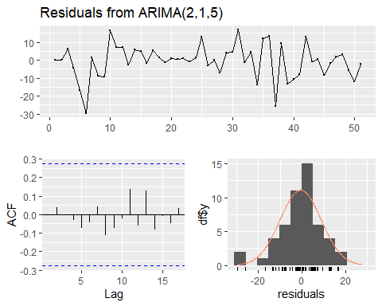

#>   
#> Ljung-Box test  
#>   
#> data: Residuals from ARIMA(2,1,5)  
#> Q* = 1.8718, df = 3, p-value = 0.5994  
#>   
#> Model df: 7. Total lags used: 10

#> Series: xmrcut$Close   
#> ARIMA(2,1,10)   
#>   
#> Coefficients:  
#> ar1 ar2 ma1 ma2 ma3 ma4 ma5 ma6 ma7  
#> 0.2982 0.5035 -0.4449 -0.4779 0.0238 -0.1627 0.3633 0.0166 0.2950  
#> s.e. 0.6338 0.5944 0.6533 0.7092 0.2018 0.2092 0.2795 0.3933 0.3232  
#> ma8 ma9 ma10  
#> -0.1474 -0.2372 -0.2285  
#> s.e. 0.3850 0.3508 0.2096  
#>   
#> sigma^2 = 102.1: log likelihood = -183.47  
#> AIC=392.93 AICc=403.04 BIC=417.79

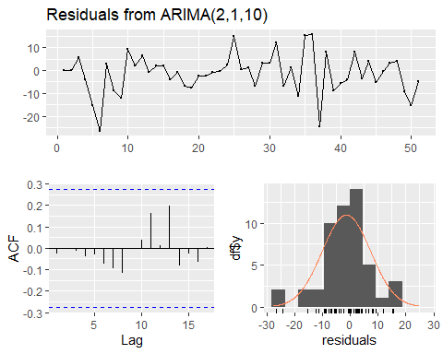

#>   
#> Ljung-Box test  
#>   
#> data: Residuals from ARIMA(2,1,10)  
#> Q* = 7.1669, df = 3, p-value = 0.06676  
#>   
#> Model df: 12. Total lags used: 15

#> Series: xmrcut$Close   
#> ARIMA(2,1,20)   
#>   
#> Coefficients:  
#> ar1 ar2 ma1 ma2 ma3 ma4 ma5 ma6 ma7  
#> -0.6976 -0.2258 0.7270 0.3485 0.1148 -0.1790 0.1296 0.0584 0.1811  
#> s.e. 0.9143 0.5823 1.0267 0.7190 0.4044 0.3669 0.4918 0.4263 0.4065  
#> ma8 ma9 ma10 ma11 ma12 ma13 ma14 ma15  
#> -0.2303 -0.1407 -0.6277 -0.3240 -0.0906 0.2035 0.1870 -0.2007  
#> s.e. 0.4162 0.5020 0.5477 0.9884 0.4547 0.3415 0.3219 0.3707  
#> ma16 ma17 ma18 ma19 ma20  
#> -0.2158 -0.3504 0.1324 -0.3547 -0.3683  
#> s.e. 0.4622 0.4769 0.2792 0.4091 0.3606  
#>   
#> sigma^2 = 88.17: log likelihood = -179.15  
#> AIC=404.3 AICc=446.76 BIC=448.28

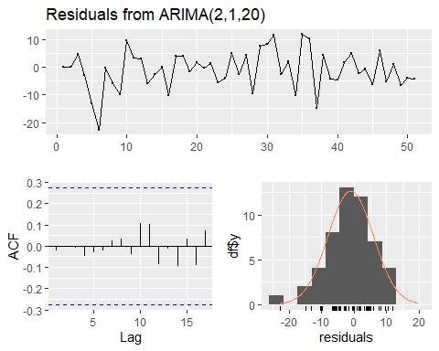

#>   
#> Ljung-Box test  
#>   
#> data: Residuals from ARIMA(2,1,20)  
#> Q* = 9.0214, df = 3, p-value = 0.02901  
#>   
#> Model df: 22. Total lags used: 25

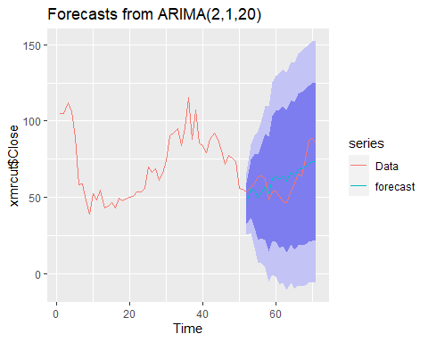

# Litecoin

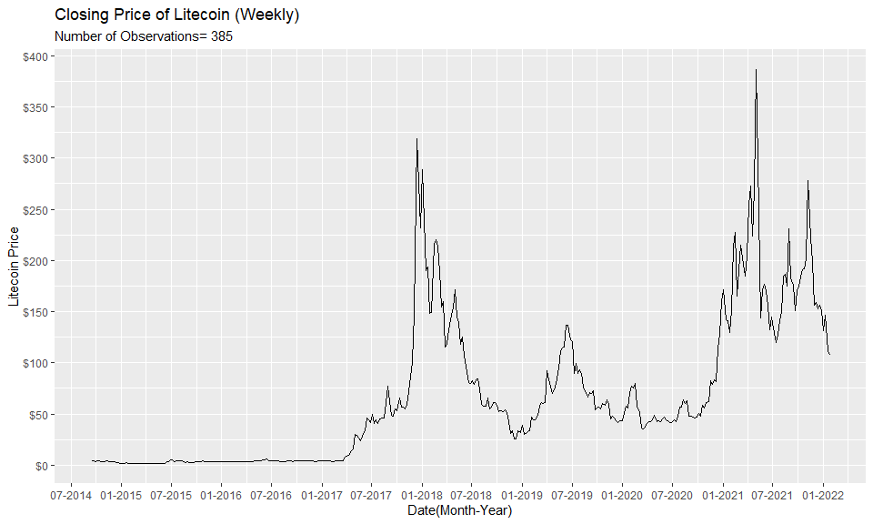

2017-07 to 2021-07

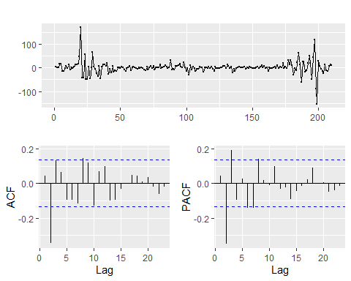

#> Series: ltccut$Close   
#> ARIMA(1,1,10)   
#>   
#> Coefficients:  
#> ar1 ma1 ma2 ma3 ma4 ma5 ma6 ma7  
#> -0.0858 0.2400 -0.3546 0.0417 0.1249 -0.1215 -0.0732 -0.1018  
#> s.e. 0.5008 0.4966 0.1098 0.1892 0.0915 0.1035 0.1009 0.1071  
#> ma8 ma9 ma10  
#> 0.0183 0.1555 -0.0536  
#> s.e. 0.1018 0.0743 0.1243  
#>   
#> sigma^2 = 536.7: log likelihood = -952.71  
#> AIC=1929.43 AICc=1931.01 BIC=1969.59

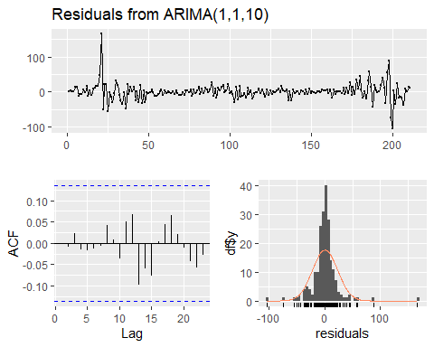

#>   
#> Ljung-Box test  
#>   
#> data: Residuals from ARIMA(1,1,10)  
#> Q* = 5.55, df = 3, p-value = 0.1357  
#>   
#> Model df: 11. Total lags used: 14

#> Series: ltccut$Close   
#> ARIMA(2,1,25)   
#>   
#> Coefficients:  
#> ar1 ar2 ma1 ma2 ma3 ma4 ma5 ma6  
#> 0.7619 -0.1572 -0.6795 -0.3189 0.4747 0.0218 -0.3665 0.0907  
#> s.e. 0.5859 0.4490 0.5829 0.4069 0.2865 0.2832 0.1163 0.2481  
#> ma7 ma8 ma9 ma10 ma11 ma12 ma13 ma14  
#> -0.1075 0.1128 0.1716 -0.2639 0.2331 0.0176 -0.2450 0.0364  
#> s.e. 0.1173 0.1174 0.1262 0.1640 0.1923 0.1639 0.1091 0.1864  
#> ma15 ma16 ma17 ma18 ma19 ma20 ma21 ma22  
#> -0.0541 0.1059 0.0670 -0.0141 -0.0017 -0.0660 0.0123 -0.1352  
#> s.e. 0.1207 0.1273 0.1411 0.1301 0.1312 0.1171 0.1557 0.1327  
#> ma23 ma24 ma25  
#> 0.0235 0.0759 -0.1907  
#> s.e. 0.1074 0.1118 0.1009  
#>   
#> sigma^2 = 474.1: log likelihood = -937.84  
#> AIC=1931.69 AICc=1940.66 BIC=2025.41

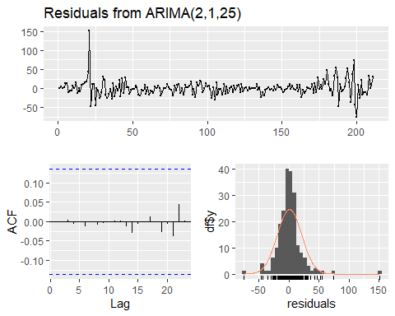

#>   
#> Ljung-Box test  
#>   
#> data: Residuals from ARIMA(2,1,25)  
#> Q* = 2.9957, df = 3, p-value = 0.3923  
#>   
#> Model df: 27. Total lags used: 30

#> Series: ltccut$Close   
#> ARIMA(2,1,5)   
#>   
#> Coefficients:  
#> ar1 ar2 ma1 ma2 ma3 ma4 ma5  
#> 0.3758 -0.1269 -0.2370 -0.3043 0.2846 0.0356 -0.2272  
#> s.e. 0.3673 0.2547 0.3607 0.2284 0.1672 0.1338 0.0819  
#>   
#> sigma^2 = 542: log likelihood = -955.71  
#> AIC=1927.41 AICc=1928.13 BIC=1954.19

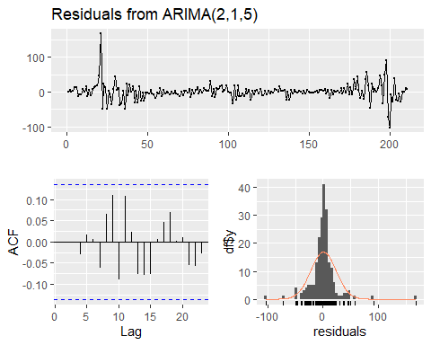

#>   
#> Ljung-Box test  
#>   
#> data: Residuals from ARIMA(2,1,5)  
#> Q* = 6.4385, df = 3, p-value = 0.09212  
#>   
#> Model df: 7. Total lags used: 10

#> Series: ltccut$Close   
#> ARIMA(2,1,15)   
#>   
#> Coefficients:  
#> ar1 ar2 ma1 ma2 ma3 ma4 ma5 ma6  
#> 0.8295 -0.6731 -0.7264 0.2340 0.5636 -0.2126 -0.1955 0.1533  
#> s.e. 0.2878 0.2078 0.2965 0.2124 0.1375 0.1485 0.1160 0.1335  
#> ma7 ma8 ma9 ma10 ma11 ma12 ma13 ma14  
#> -0.1763 0.0644 0.0482 -0.2429 0.3055 -0.0526 -0.2002 0.087  
#> s.e. 0.1106 0.1070 0.1123 0.1270 0.1343 0.1112 0.1142 0.161  
#> ma15  
#> -0.1366  
#> s.e. 0.1668  
#>   
#> sigma^2 = 492.1: log likelihood = -943.42  
#> AIC=1922.83 AICc=1926.41 BIC=1983.08

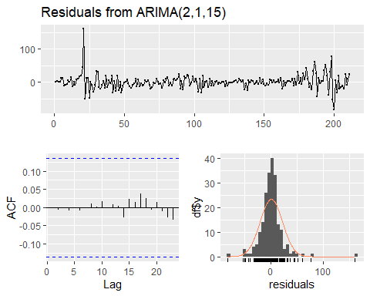

#>   
#> Ljung-Box test  
#>   
#> data: Residuals from ARIMA(2,1,15)  
#> Q* = 1.0553, df = 3, p-value = 0.7879  
#>   
#> Model df: 17. Total lags used: 20

