**Project Auntie**

**Role in group work:**

Ideation, Innovation, service design

**Individual role:**

UI/UX design, defining business model

Read the whole report from: <https://drive.google.com/file/d/0Bwnz7lD4I74iLWk4NDlJZkV5akE/view>

Project was part of Metropolia’s Innovation project -course. In short, the teams were asked to create a concept for Auntie’s mobile service, including visuals, functionality and business model.

Auntie gave us a brief presentation what Auntie is all about, and what it is that they expect from this project. After the presentation me and others asked a bunch of questions, relating to their customers, their brand and image and the psychotherapy packages they provide.

Strict guidelines weren’t set from any side, except the service should accessible on mobile devices.

What is Auntie

Auntie provides low threshold, remote psychotherapy packages for companies (B2B).

The employer pays for the service, while the employees are the end-users.

**Brand / Image**

Fun and laid-back

Tries to separate themselves from the traditional therapy services

**Clients**

B2B

Companies that take care of their employees (brand and image, Best Places to Work)

**End-users**

80% women

30 to 50 years old

Working at offices

Demanding jobs

Have an academic education

**Use of current service**

Remote therapy sessions are accessed mostly from mobile devices

**Revenue model**

Auntie’s therapy packages include five remote therapy sessions, one 45-minute session per week, and three 15-minute follow-up calls.

The cost of one package is 490 € and the price is always the same, regardless of the chosen package.

**Competition**

Mehiläinen and other private healthcare providers that provide psychotherapy

**Possible competition for the online service**

Mind-fulness and mediation apps

(Fabulous, Headspace, Happify)

Issues found from the current service

**Lack of automation and digitalization**

Sending emails is required, when customers are getting started with service

Information from the users is not gathered in one location, but through the therapist or by email

Managing and utilizing gathered information is poor

Suggestion of exercises is done by the therapist, which takes might take excess time

**Lack of privacy**

To enroll for Auntie’s therapy service, employees must ask it usually from HR. This reduces privacy of the employees and makes the threshold higher.

Our online service for Auntie

**Provide platform to support the main service**

It provides a platform to base all the necessary tasks, exercises and processes to carry through a successful remote therapy service.

It also provides a platform where information can be gathered, collected and shared more easily.

(information includes progress of the end users and feeling from the therapy)

This enables faster and easier implementation of the service, makes sending emails back and forth a task of yesterday, and keeps customers and Auntie more organized.

Online service enables user to sign up for Auntie’s therapy packages without any face-

to-face action. This makes the process faster and more manageable, and it could also lower the threshold for employees.

**Organize gathered information and utilize it**

As the information about the end-users can be more easily gathered it should also be utilized as much as possible.

Auntie should use it to improve their therapy services and procedures, companies should use it to improve their work environment and employees, and the end-users (clients) should use it to monitor their progress.

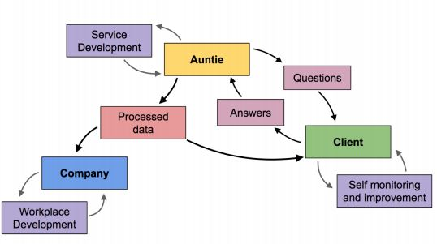

**Offer exercises for 7 areas of happy life**

One part of Auntie’s therapy is based on the idea that person’s life is constructed from seven different areas of life, and these areas should be in balance with one another. If one area is lacking, it should be elevated.

One part of Auntie’s therapy is based on the idea that person’s life is constructed from seven different areas of life; Focus Time, Play Time, Connecting Time, Physical Time, Time In, Down Time and Sleep Time. Together they represent a holistic view of human well-being, and If one area is lacking, it should be elevated.

The exercises in the new online service are based on these *times*.

Online service should suggest exercises for the users based on chosen therapy package and personal preferences.

**Service flow / customer journey**

1. Auntie makes a contract with the company.
2. Identification key is provided to the company, so that Auntie can recognize for whom the employee is working for and grant access to the online service.
3. By using the identification key, every employee of the client company can access the online service, activate their personal account and start using the service.
4. User fills out a start questionnaire in the online service relating general mental state, relationships, hobbies, state of life etc.
5. Employer can advise employee to sign up for a therapy package with an email invitation sent via Auntie’s online service. Employee can also sign up themselves without an invitation. Threshold for the employees to participate is lowered when contacting is done online, with no face-to-face contact.
6. Employee chooses a therapy package suited for himself with the help from Auntie.

1. Based on the chosen package and using the information from the questionnaire, Auntie chooses two Times (segments) from the online service, from which the user should perform tasks and exercises from. This part could be partially automated in the online service.

Business model

**Therapy and online service in the same package**

Online service is going to be provided as a part of Auntie’s existing service and included in the therapy packages with the same price.

**Stay on B2B**

The leading idea of Auntie’s business model, for providing psychotherapy services for businesses is going to be kept the same (B2B).

Our team didn’t see any reasons to expand to the private customer market, as there are more competition and numerous cheaper/free alternatives already available.

We also saw that B2B is a more stable market and that companies would have an interest for providing Auntie’s services to their employees, for preventing sick leaves and enhancing work efficiency.

**Aim for terminable contract**

A potential issue with Auntie’s current business model is the unpredictability of new clients and the revenue stream.

This issue could be addressed by making a terminable contract with a company, for 6 to 24 months with a fixed base price. The value of the contract should be constructed so that every employee is offered a fixed amount of therapy packages to sign up inside the agreed timeline.

Therapy packages taken over the fixed amount would not be included in the price and would be charged separately. These packages could also be provided with a discount.

This solution should ensure the revenue for a longer term and enable Auntie to plan further into the future.

Mockups for the Online service

Visuals references (Character and colors) were provided by Auntie and based on their existing brand.

Start of the journey

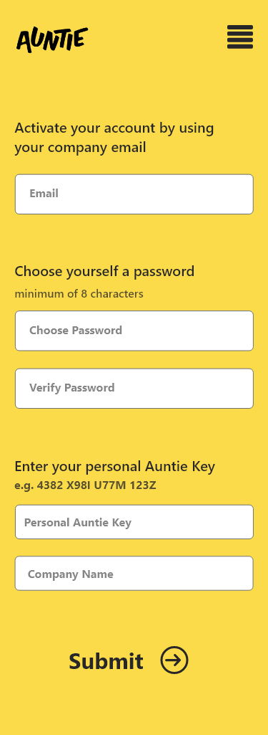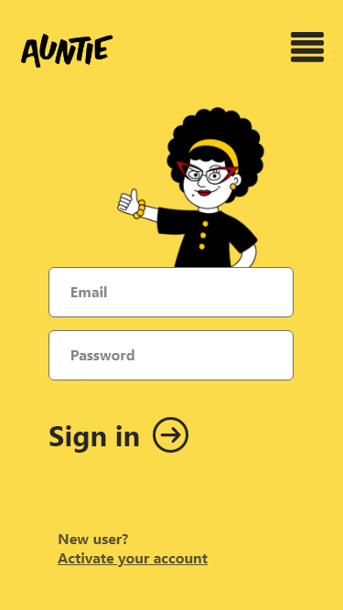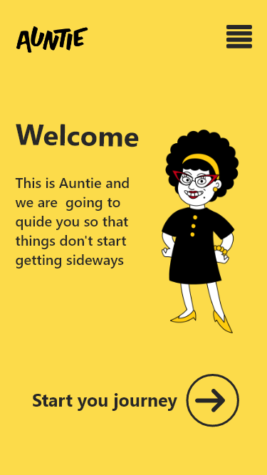

Choose and complete an exercise

