**Project Kohtaamo**

**At two day Kohdataan -hackathon the objective was to design a new social media service for everyone.**

**Role in group work:**

Ideation, Innovation, service design

**Individual role:**

UI/UX design

After forming the groups, our team started mapping out what are the possible pain points in real life situations and in the existing social media services. The event was organized by kehitysvammaliitto and mielenterveysliitto, and purpose was to take everyone into account.

We brought issues from the real world to realize what the problems are.

Finally, we decided to go with one:

*We established the difficulty of forming groups in new environment with unknown people.*

*But, the situation is much easier, when groups are formed for example by a teacher. This takes away the fear of making contact and being rejected.*

*We also established that making friends and meeting new people is much easier when you are joined with similar interests or tasks.*

*New service should also be innovative in some way, and take advantage of current and future technologies such as AI*

With these things established, we continued designing our solution.

On high level, the final product was an online service that:

*Forms groups based on users mutual interest, for example photography.*

*Provides a platform for people to make conversation about their mutual interest and suggest meetings directly for the other members of the group.*

*Provides an AI, called “Aliisa” who can support the group, by giving conversation starters and suggest meetings for the members of the group.*

User flow and design

**Users choose an interest of theirs** or add a new one if the system doesn’t already included it. Interests are initially based on activities, things people can actively do or experience.

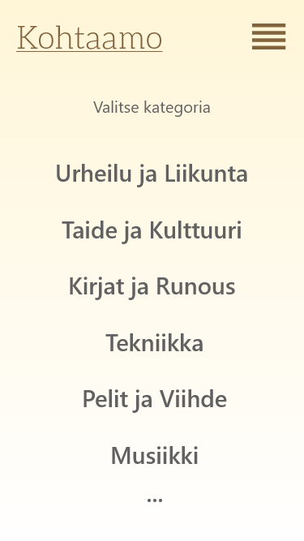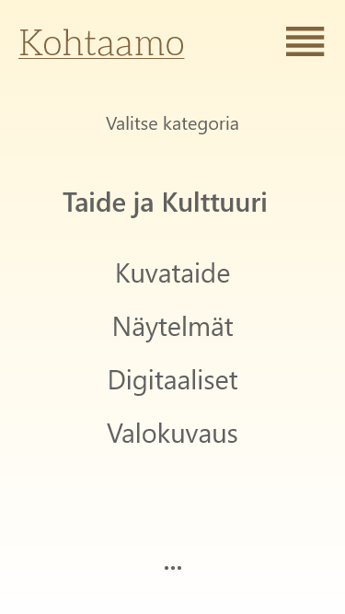

**Groups are then formed based on chosen interests and location.** When service gets more users, grouping would be affected by other characteristics and requests of the user.

**Users are displayed on the system only by their first name**, which makes users “semi-anonymous”. This reduces the risk of bullying and the possibility for someone to follow users from this service to another.

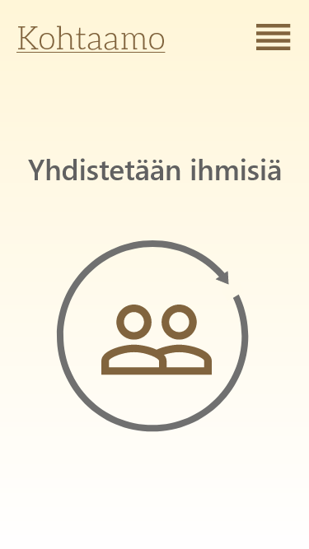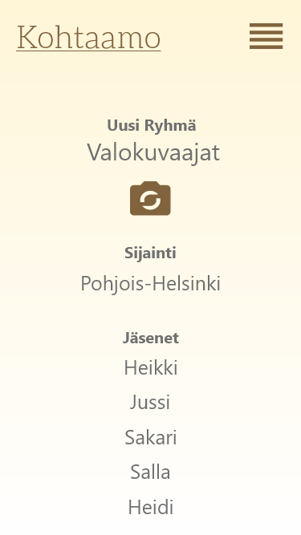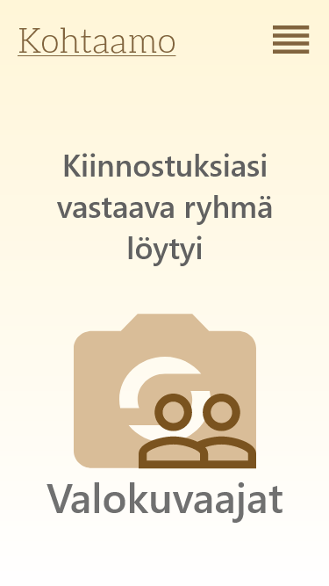

**Members of the group can then have a conversation** inside the group. Risk of bullying and trolling might be reduced when users are closed in one group and direct messages from user to user are not enabled.

**Meetings can be suggested by anyone inside the group, or by the AI** called “Aliisa”.

Point of suggesting users to meet, is that they could meet other people in real life, while their common interest (hobby or other activity) takes away the pressure of contacting and making the initiative.

