ScamShield
Complete Beginner Codebase Guide
How the app works, file by file — and how to present and defend it

Group 2 — Android SMS scam detection project
Rule-based, on-device, offline. No machine learning.
Written against the source code as it stands on 18 September 2026
Every code block is copied from the project files, with real line numbers.
Every screenshot was taken from this build running on an emulator.

Contents
1. ScamShield Overview 8
What the app is, in one sentence 8
The three verdicts 8
What the finished app looks like 9
How to use this guide 9
2. Android Development Basics 11
What Android Studio is 11
What an Android app is made of 11
The eight words you must know 11
3. Understanding the ScamShield Project Structure 13
The Java packages, and why they exist 13
Where each kind of file lives 14
4. How the Application Starts 15
Step 1 — the Application class 15
Step 2 — SplashActivity, the launcher screen 15
Step 3 — OnboardingActivity (first run only) 17
Step 4 — MainActivity, the container for everything else 17
5. AndroidManifest.xml 19
The permissions ScamShield declares 19
Why Android demands permissions at all 19
The components declared 20
The share-sheet entry on MainActivity 21
6. ScamShield User Interface 22
The screens and the files behind them 22
The view types actually used 22
From an ID in XML to a variable in Java 23
Event listeners: how a tap becomes code 23
Two languages and two themes from the same screens 24
7. How Android Receives SMS Messages 26
What a BroadcastReceiver is 26
ScamShield’s receiver, in full 26
8. ScamShield Real-Time SMS Detection 29
What "real-time" means here 29
The switch that makes it real-time 29
The visible service 29
When does detection actually work? 30
Proof it works: a real message on the emulator 30
9. Journey of One SMS Through the Application 32
The same journey in the user’s hands 33
10. Scam Detection Engine 34
What the engine is 34
The 25 rules in the table 35
The 7 combination rules 36
How the rules are run 37
Is this AI? 37
11. Text Processing 39
Step 1 — normalise 39
Step 2 — canonicalise (undo the two evasion tricks) 40
What ScamShield does NOT do 40
12. Classification Logic 42
The four counters 42
From score to verdict 42
Worked example 1 — the prize scam (SCAM, 100) 43
Worked example 2 — a genuine M-PESA receipt (SAFE, 0) 44
Worked example 3 — a shortened link (SUSPICIOUS, 42) 45
13. Activities 47
What an Intent is 47
Fragments: the screens inside MainActivity 48
The lifecycle methods this project actually uses 49
14. BroadcastReceivers 50
Static vs dynamic registration 50
Why a receiver and not a service polling the inbox? 50
The guard that protects the user 50
15. Services 52
What a foreground service is 52
The manager that owns the state 52
16. Models and Helper Classes 54
models/ScamModel.java — one stored scam 54
The helper classes in utils/ 54
17. Database and Data Storage 56
The table 56
The CRUD operations, and who calls them 57
SharedPreferences 58
18. Detection History 59
What a RecyclerView is 59
Filtering by risk 60
What a row can do 61
19. Notifications and User Alerts 62
The two channels 63
20. Dashboard Logic 64
The risk ring is our own code 65
21. Permissions 66
Runtime permissions: asking properly 66
The state machine the switch obeys 67
22. Complete System Architecture 69
ScamShield explained like a story 69
The architecture diagram 69
23. File Connection Diagram 71
What happens if we remove this? 71
24. Data Flow Diagram 73
How the components talk to each other 73
25. Complete Execution Example 75
26. File-by-File Code Walkthrough 78
27. Important Code Explained Line by Line 81
super.onCreate(savedInstanceState); 81
setContentView(R.layout.activity_main); 81
tvScanned = view.findViewById(R.id.tvScanned); 81
ScamDetector.ScamResult result = ScamDetector.detect(pendingMessage, phone); 81
Telephony.Sms.Intents.getMessagesFromIntent(intent) 81
context.getSystemService(Context.CLIPBOARD_SERVICE) 81
PendingIntent.getActivity(context, 0, intent, FLAG_UPDATE_CURRENT | FLAG_IMMUTABLE) 82
new DatabaseHelper(context).addScam(sender, message, result.scamType, receptionTime) 82
Cursor cursor = db.query(TABLE_SCAMS, null, null, null, null, null, COLUMN_ID + " DESC"); 82
@Override 82
private static final int WEAK_SIGNAL_LIMIT = 30; 82
28. Object-Oriented Programming Concepts Used 83
The interface, as written 83
Why not put everything in MainActivity? 84
Java syntax you will be asked about 84
29. Android Concepts Used 86
Synchronous and asynchronous work 86
30. Gradle and Dependencies 88
What Gradle is 88
app/build.gradle, explained 88
The dependencies 89
The other build files 89
31. Error Handling 91
What is handled 91
What is NOT handled — admit these before you are asked 91
32. Privacy and Security 93
The privacy text shown in the app 93
Security of the app’s own surface 93
33. Offline and Online Operation 95
34. Project Limitations 96
35. Possible Future Improvements 98
36. Implemented vs Planned Features 99
Fully implemented — you can demonstrate these 99
Partially implemented — say "partly" when asked 99
Not implemented — never claim these 99
Dead or unused code 100
37. Presentation Claims Verification 101
38. Testing ScamShield 102
The automated tests 102
The measured figures 102
Manual tests you can run in the presentation 103
39. False Positives and False Negatives 105
Why each can happen in this design 105
The families ScamShield currently misses 105
40. Debugging Guide 106
The tools 106
Where to put a log at each stage 106
A debugging checklist for the day of the demo 107
41. Project Demonstration Script 108
Before you walk in 108
Step 1 — Open the app (20 seconds) 108
Step 2 — A safe message first (30 seconds) 108
Step 3 — A scam message (60 seconds) 108
Step 4 — The live SMS: prove it is real-time (60 seconds) 109
Step 5 — History and the database (40 seconds) 109
Step 6 — Reporting (40 seconds) 109
Step 7 — Settings, privacy and the switch (30 seconds) 109
If something goes wrong on the day 110
42. Code Walkthrough Presentation 111
If the lecturer points at this line 112
43. 30-Second Explanation 114
44. 60-Second Explanation 115
45. 3–5 Minute Technical Presentation 116
46. Project Defence Questions and Answers 118
Android questions 118
ScamShield questions 119
Algorithm questions 120
Database questions 121
Security and privacy questions 121
Software engineering questions 122
47. Dangerous Lecturer Questions 123
48. Must Know / Should Know / Advanced 125
MUST KNOW — every member of the group 125
SHOULD KNOW — whoever answers technical questions 125
ADVANCED — for the deepest questions 125
49. File-by-File Cheat Sheet 126
50. Final One-Page Revision Sheet 128
Purpose 128
Architecture in one line 128
Core classes 128
Detection method 128
Preprocessing 128
Database 128
Permissions 128
Key Android concepts 128
Numbers to quote 128
Biggest limitations 129
Three sentences that must never be said 129

1. ScamShield Overview
ScamShield is an Android application written by Group 2. It reads the SMS messages that arrive on a phone, decides whether each one looks like a scam, warns the user when it does, and keeps a local history of everything it flagged.
It does three things, and it is honest about doing only these three:
- Checks messages. Every incoming SMS is scored while real-time protection is on. A message can also be pasted into the app by hand.
- Explains the verdict. The app never says only "this is a scam". It lists the exact reasons, each with the words from the message that triggered it.
- Helps the user report. A flagged message can be reported to TCRA on the short code 15040, or to the user’s mobile operator, through the phone’s own SMS and share apps.

What the app is, in one sentence
ScamShield is a rule-based SMS scam detector: a table of 25 written rules and 7 combination rules gives a message a score out of 100, and two thresholds turn that score into SAFE, SUSPICIOUS or SCAM.
⚠️ Don’t say this
Do not call ScamShield "AI" or "machine learning". There is no model file, no training data used at runtime, and no probabilities in the code. The honest phrase is rule-based (weighted regular-expression) text classification, and it is a perfectly respectable engineering choice — it is the reason the app can explain every verdict.

The three verdicts
Verdict | Score | What the user sees | Stored in the database?
SAFE | 0–29 | Green shield, "No scam indicators were detected." | No
SUSPICIOUS | 30–59 | Amber shield, "This message contains suspicious indicators." | Yes
SCAM | 60–100 | Red shield, "This message is likely a scam!" | Yes

The thresholds are constants in utils/ScamDetector.java, not magic numbers hidden in the logic:
utils/ScamDetector.java — lines 40–42
40 public static final int SUSPICIOUS_THRESHOLD = 30;
41 public static final int SCAM_THRESHOLD = 60;
42 public static final int MAX_SCORE = 100;

What the finished app looks like
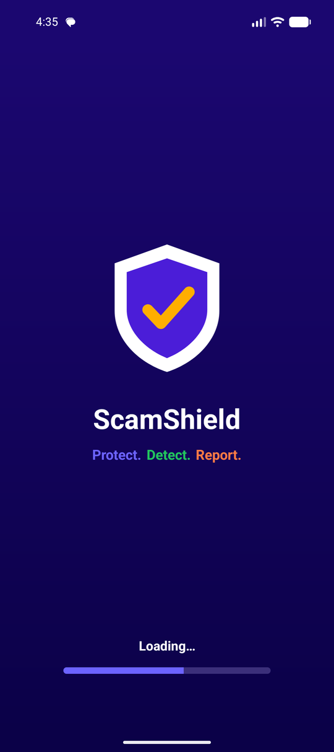  Splash screen (SplashActivity) | 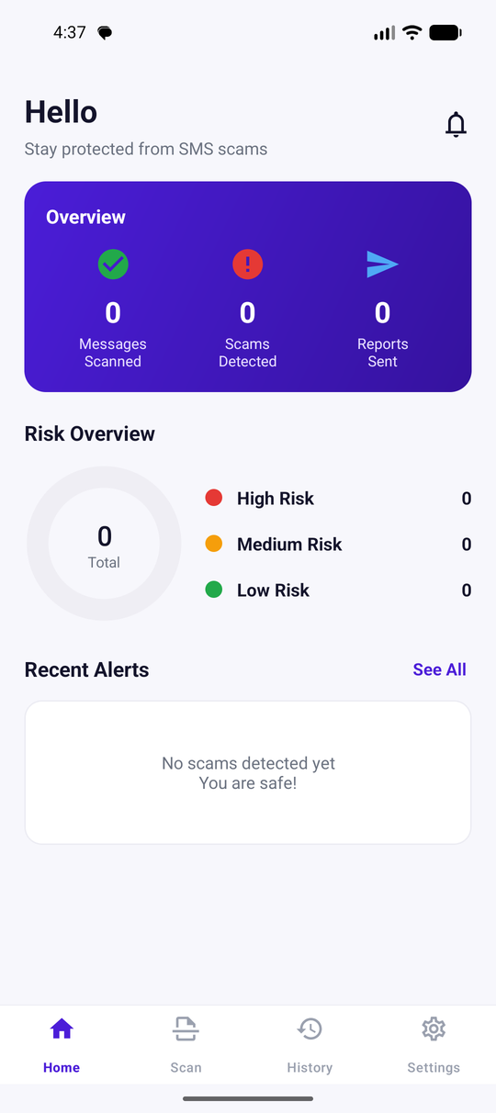  Dashboard on first run (HomeFragment) | 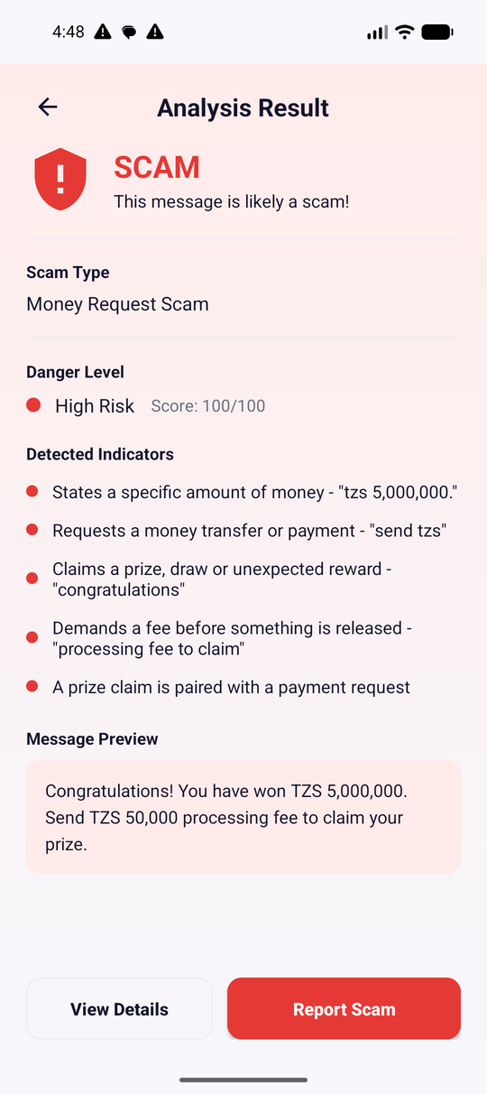  A scam verdict (ScanResultFragment) | 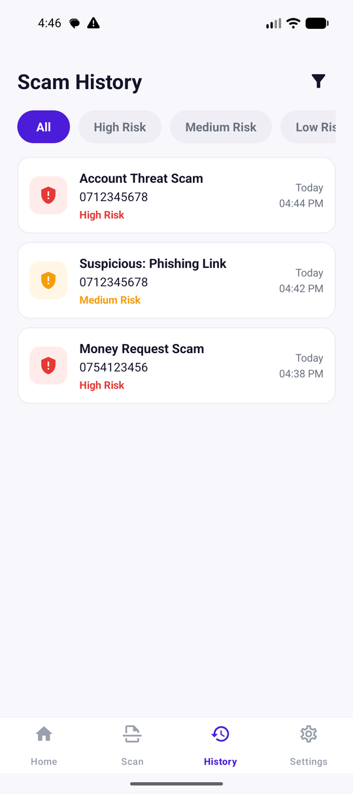  History (HistoryFragment)

Every screenshot in this guide was taken from this codebase running on an Android emulator (Pixel, API 37), and every code block was copied from the project files, with the real file name and line numbers above it.

How to use this guide
- Read sections 1–6 first. They teach only the Android words you need.
- Sections 7–12 are the heart of the project: how an SMS gets in, and how it is judged.
- Sections 13–21 explain each part of the code one by one.
- Sections 22–27 put everything together with diagrams and a full worked example.
- Sections 28–40 cover the engineering topics a panel likes to poke at: OOP, Gradle, errors, privacy, limits and testing.
- Sections 41–50 are pure presentation preparation: demo script, spoken answers, 50+ questions, and a one-page revision sheet.

The four boxes used throughout
🎤 What to say during presentation
A sentence you can say out loud during the presentation. It is written to be technically correct, not to sound impressive.

🧠 What you must understand
The deeper reason behind what you just read — the part a lecturer probes when they ask "but why?".

⚠️ Don’t say this
A statement that would be wrong about this codebase. Saying it invites a question you cannot answer.

📍 Where are we now in the ScamShield flow?
▶ SMS arrives on the phone (Android telephony) ◀ WE ARE HERE
↓
SmsReceiver.onReceive() is called
↓
Sender + text extracted, service messages skipped (WhitelistUtils)
↓
ScamDetector.detect() scores the message
↓
SAFE / SUSPICIOUS / SCAM decided
↓
DatabaseHelper.addScam() + NotificationHelper.showRiskAlert()
↓
Dashboard and History read the database

A green box like the one above appears after the big sections, so you always know which part of the journey the code you just read belongs to.

A note on file paths
Java files live under app/src/main/java/com/group2/scamshield/. To keep the guide readable, that prefix is dropped: receivers/SmsReceiver.java means the full path above plus receivers/SmsReceiver.java. Resource files are written from app/src/main/, for example res/layout/fragment_home.xml.

2. Android Development Basics
This section teaches only what is needed to follow ScamShield. If you have built an Android app before, skip to section 3.

What Android Studio is
Android Studio is the program the group writes the app in. It is an editor, but it also holds the tools that turn source code into an installable app: the Android SDK, the emulator, the debugger and the build system.
Simple explanation: Android Studio is the workshop. Technical explanation: it is an IDE built on IntelliJ that wraps the Android SDK build tools and the Gradle build system, and talks to devices over ADB (Android Debug Bridge).

What an Android app is made of
Part | Everyday analogy | What it really is | In ScamShield
Java | The brain — decisions and actions | Classes compiled to bytecode that runs on the phone’s Android Runtime | 31 .java files
XML | The face — what you see | Declarative resources: layouts, colours, text, menus | 17 layouts, plus colours, strings and themes
AndroidManifest.xml | The ID card handed to Android | Declares components and permissions so the OS knows what exists | 3 activities, 1 receiver, 2 services, 5 permissions
Gradle | The factory foreman | Build system: fetches libraries, compiles, packages the APK | build.gradle files + Gradle 9.6
Android SDK | The parts catalogue | The framework classes (Activity, Intent, SQLite…) the app builds on | compileSdk 34
Resources (res/) | The props cupboard | Images, text and layouts looked up by ID at runtime | 45 drawables, 167 strings × 2 languages

The eight words you must know
Word | What it means | Where you meet it in ScamShield
Activity | One full screen, and the object that owns it | SplashActivity, OnboardingActivity, MainActivity
Fragment | A replaceable section inside an Activity’s screen | HomeFragment, AnalyzeFragment, and 7 more
Intent | A message asking Android to do something or start something | Opening the SMS app to send a report
Context | A handle to the running app: resources, files, system services | Passed to DatabaseHelper, NotificationHelper, everywhere
Bundle | A small labelled box of values passed between screens | ScanArgs builds one for the scan result
BroadcastReceiver | A class Android calls when a system event happens | SmsReceiver — called when an SMS arrives
Service | Code that runs without a screen | ProtectionService — the "protection is on" notification
Lifecycle | The fixed order of callbacks as a screen is created, shown and destroyed | onCreate(), onCreateView(), onResume(), onDestroy()

🧠 What you must understand
Android does not run your app from a main() method. Android calls you. The system creates your Activity and calls onCreate(); the system delivers an SMS broadcast and calls onReceive(). This "don’t call us, we’ll call you" style is why the code is organised as classes with callbacks rather than one long program.

3. Understanding the ScamShield Project Structure
This is the real tree of the project as it stands today. Build outputs (build/), the IDE folder (.idea/) and the local SDK path file are left out because they are generated, not written.
The real project tree
ScamShield/
├─ build.gradle root build file (declares the Android plugin)
├─ settings.gradle project name + where libraries are downloaded from
├─ gradle.properties JVM memory, configuration cache
├─ gradle/
│ ├─ libs.versions.toml version catalogue (Android Gradle Plugin 9.4.0)
│ └─ wrapper/ pins Gradle 9.6.0 so every laptop builds the same way
├─ gradlew / gradlew.bat run the build without installing Gradle
├─ docs/ this guide and other written material
└─ app/
├─ build.gradle the app module: SDK levels, dependencies
└─ src/
├─ main/
│ ├─ AndroidManifest.xml
│ ├─ java/com/group2/scamshield/ 31 Java files (see below)
│ └─ res/
│ ├─ layout/ 17 screen and row layouts
│ ├─ drawable/ 45 icons, shapes and pictures
│ ├─ values/ colours, strings (167), styles, themes
│ ├─ values-sw/ the same 167 strings in Kiswahili
│ ├─ values-night/ dark-theme colours
│ ├─ menu/ bottom_nav_menu.xml (the 4 tabs)
│ ├─ navigation/ nav_graph.xml (the 9 fragment destinations)
│ ├─ mipmap-*/ launcher icons
│ └─ xml/ backup rules
└─ test/
├─ java/… 3 test classes, 28 unit tests
└─ resources/ bongo_scam.csv — 1,508 labelled Tanzanian SMS

The Java packages, and why they exist
Package | Files | Responsibility
(root) com.group2.scamshield | 16 | Everything with a screen: 3 Activities, 9 Fragments, 3 adapters, the Application class
database | 1 | DatabaseHelper — the SQLite table of detected scams
models | 1 | ScamModel — one stored scam as a Java object
receivers | 1 | SmsReceiver — the entry point for incoming SMS
services | 1 | ProtectionService — the visible "protection is on" state
utils | 10 | The engine and shared helpers: ScamDetector, DetectionRule, WhitelistUtils, NotificationHelper, ProtectionManager, AppPrefs, ScanArgs, RiskUi, DateFormats, Nav
views | 1 | RiskDonutView — the hand-drawn risk ring on the dashboard

🧠 What you must understand
The package names are the architecture. utils/ScamDetector.java has no Android imports at all — only java.util and java.util.regex. That is why it can be tested on a laptop in milliseconds by the 28 unit tests, with no emulator. Keeping the detection logic free of Android is the single most important design decision in this project.

Where each kind of file lives
If you are looking for… | Open…
The scam rules and the score | utils/ScamDetector.java
What one rule is | utils/DetectionRule.java
How an SMS gets in | receivers/SmsReceiver.java
The database table | database/DatabaseHelper.java
The dashboard numbers | HomeFragment.java + res/layout/fragment_home.xml
The verdict screen | ScanResultFragment.java + res/layout/fragment_scan_result.xml
Notifications | utils/NotificationHelper.java
Permissions and the on/off switch | utils/ProtectionManager.java + ProfileFragment.java
App registration and permissions | app/src/main/AndroidManifest.xml

4. How the Application Starts
When the user taps the ScamShield icon, this is the exact chain of events. Nothing here is invented — every name comes from the manifest and the three Activity files.
Startup, from icon tap to dashboard
User taps the ScamShield icon
↓
Android reads AndroidManifest.xml and looks for the LAUNCHER activity
↓
ScamShieldApp.onCreate() ← the Application object is created first
↓ (AppPrefs.applyStoredTheme: light or dark)
SplashActivity.onCreate()
↓ setContentView(R.layout.splash_activity)
↓ ObjectAnimator fills the progress bar for 3000 ms
↓ Handler.postDelayed(…, 3000)
↓
AppPrefs.isFirstLaunch(context)?
│
yes │ no
┌────┘ └────┐
▼ ▼
OnboardingActivity MainActivity
• asks for SMS + notification • creates the notification channel
permissions • ProtectionManager.restore()
• 3 intro pages (ViewPager2) • loads nav_graph.xml → HomeFragment
• "Get Started" → MainActivity • user sees the dashboard

Step 1 — the Application class
Before any screen exists, Android creates the class named in the manifest’s android:name attribute:
ScamShieldApp.java — lines 9–14
9 public void onCreate() {
10 super.onCreate();
11 // Apply the saved dark/light choice before the first activity inflates,
12 // otherwise the app would flash the default theme on every cold start.
13 AppPrefs.applyStoredTheme(this);
14 }

Why it exists: the dark/light choice must be applied before the first screen inflates, otherwise the app would flash the wrong theme on every cold start. AppPrefs.applyStoredTheme() calls AppCompatDelegate.setDefaultNightMode().

Step 2 — SplashActivity, the launcher screen
The manifest marks this Activity as the entry point with MAIN / LAUNCHER (section 5). Its onCreate() is short enough to read completely:
SplashActivity.java — lines 21–42
21 protected void onCreate(Bundle savedInstanceState) {
22 super.onCreate(savedInstanceState);
23 setContentView(R.layout.splash_activity);
24
25 // The bar fills over the same span the splash is shown for.
26 ProgressBar progress = findViewById(R.id.progressSplash);
27 progressAnimator = ObjectAnimator.ofInt(progress, "progress", 8, 100);
28 progressAnimator.setDuration(SPLASH_DELAY);
29 progressAnimator.setInterpolator(new LinearInterpolator());
30 progressAnimator.start();
31
32 handler.postDelayed(new Runnable() {
33 @Override
34 public void run() {
35 Intent intent = AppPrefs.isFirstLaunch(SplashActivity.this)
36 ? new Intent(SplashActivity.this, OnboardingActivity.class)
37 : new Intent(SplashActivity.this, MainActivity.class);
38 startActivity(intent);
39 finish();
40 }
41 }, SPLASH_DELAY);
42 }

The lines that matter, one by one
Line | What it does
super.onCreate(savedInstanceState) | Lets the Android AppCompatActivity base class do its own setup first. Skipping this throws an exception.
savedInstanceState | A Bundle Android hands back if this screen was destroyed and recreated (for example on rotation). null on a fresh start.
setContentView(R.layout.splash_activity) | Reads res/layout/splash_activity.xml, builds the real view objects from it, and puts them on the screen. R is the generated class of resource IDs.
findViewById(R.id.progressSplash) | Finds one view inside the layout just inflated, by the ID written in the XML as android:id="@+id/progressSplash".
ObjectAnimator.ofInt(progress, "progress", 8, 100) | Animates the bar from 8 % to 100 % over SPLASH_DELAY (3000 ms), so the wait looks intentional.
handler.postDelayed(runnable, SPLASH_DELAY) | Asks the main thread to run that code 3 seconds later. This is why the splash lasts 3 seconds.

The decision at the end of those 3 seconds is one line, and it is the only place the app asks "is this the first run?":
SplashActivity.java — lines 35–37
35 Intent intent = AppPrefs.isFirstLaunch(SplashActivity.this)
36 ? new Intent(SplashActivity.this, OnboardingActivity.class)
37 : new Intent(SplashActivity.this, MainActivity.class);

🧠 What you must understand
onDestroy() in the same file calls handler.removeCallbacksAndMessages(null). Without it, a user who leaves during the 3 seconds would still get startActivity() fired at a dead screen. This is the kind of small lifecycle detail a lecturer likes to find — and here it is handled.

Step 3 — OnboardingActivity (first run only)
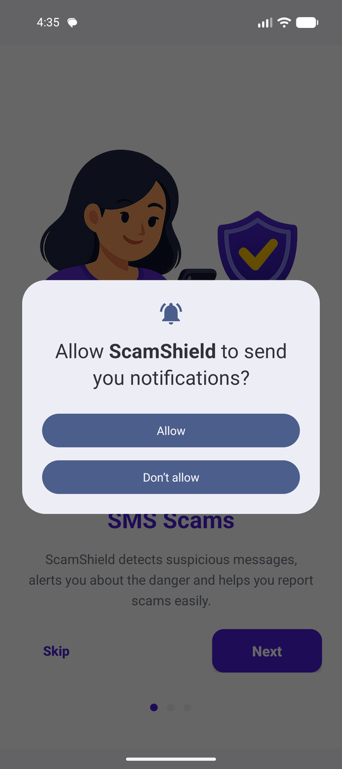  Notification permission | 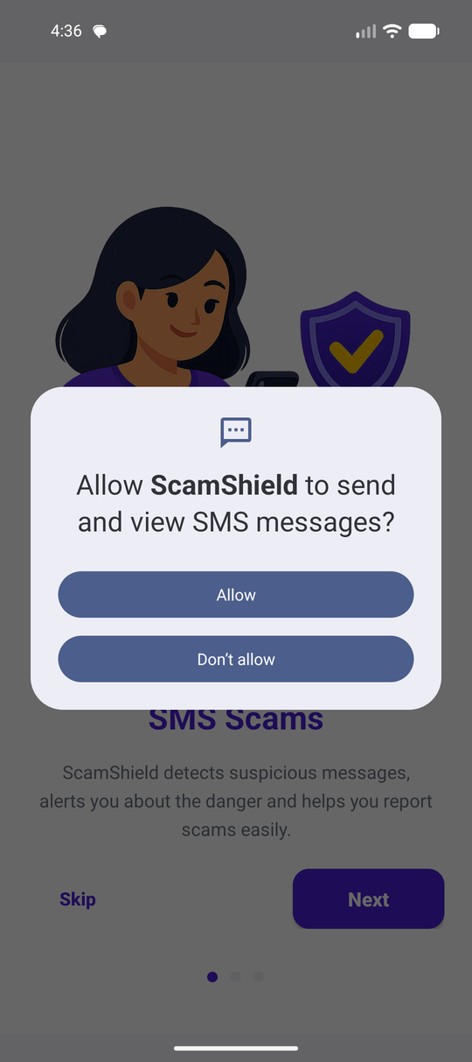  SMS permission | 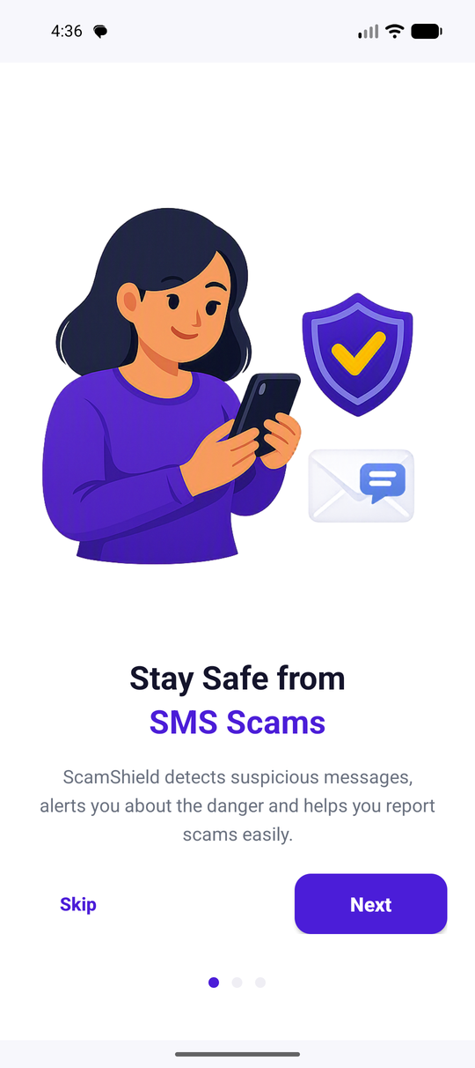  Intro page 1 | 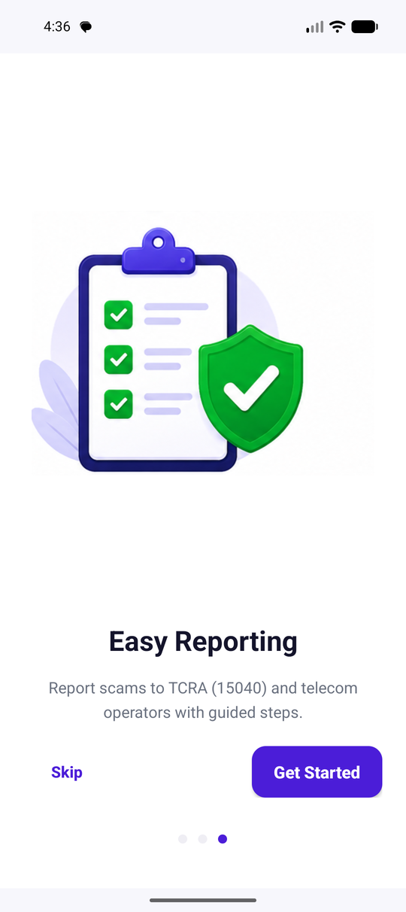  Intro page 3

Two things happen here: Android’s permission dialogs are raised while the intro explains why, and the three pages are shown with a ViewPager2 driven by OnboardingAdapter.
OnboardingActivity.java — lines 35–38
35 if (savedInstanceState == null && !ProtectionManager.hasRequiredPermissions(this)) {
36 ActivityCompat.requestPermissions(this,
37 ProtectionManager.requiredPermissions(), PERMISSION_REQUEST);
38 }

When the user reaches the last page and taps Get Started:
OnboardingActivity.java — lines 85–95
85 private void finishOnboarding() {
86 AppPrefs.setOnboardingDone(this);
87
88 // Granted during the intro: start real-time protection straight away.
89 if (ProtectionManager.hasRequiredPermissions(this)) {
90 ProtectionManager.enable(this);
91 }
92
93 startActivity(new Intent(OnboardingActivity.this, MainActivity.class));
94 finish();
95 }

Step 4 — MainActivity, the container for everything else
MainActivity.java — lines 27–51
27 protected void onCreate(Bundle savedInstanceState) {
28 super.onCreate(savedInstanceState);
29 setContentView(R.layout.activity_main);
30
31 // Create notification channel
32 NotificationHelper.createNotificationChannel(this);
33
34 // Restore protection only when the user previously enabled it and the
35 // required Android permissions are still granted.
36 ProtectionManager.restore(this);
37
38 NavHostFragment navHostFragment = (NavHostFragment) getSupportFragmentManager()
39 .findFragmentById(R.id.nav_host_fragment);
40 final NavController navController = navHostFragment.getNavController();
41
42 bottomNav = findViewById(R.id.bottom_nav);
43 NavigationUI.setupWithNavController(bottomNav, navController);
44
45 navController.addOnDestinationChangedListener((controller, destination, arguments) ->
46 bottomNav.setVisibility(isTabDestination(destination.getId())
47 ? View.VISIBLE
48 : View.GONE));
49
50 routeSharedText(navController, getIntent());
51 }

- NotificationHelper.createNotificationChannel(this) — since Android 8 a notification must belong to a channel, or it never appears.
- ProtectionManager.restore(this) — turns the foreground service back on only if the user had enabled protection and the permissions are still granted.
- NavHostFragment → NavController — the object that swaps fragments in and out of the screen.
- NavigationUI.setupWithNavController(bottomNav, navController) — wires the four tabs to the four destinations whose IDs match the menu items.
- The destination listener hides the bottom bar on every screen that is not Home, History or Settings, so the scan and report pages are full-screen.
📍 Where are we now in the ScamShield flow?
▶ SMS arrives on the phone (Android telephony) ◀ WE ARE HERE
↓
SmsReceiver.onReceive() is called
↓
Sender + text extracted, service messages skipped (WhitelistUtils)
↓
ScamDetector.detect() scores the message
↓
SAFE / SUSPICIOUS / SCAM decided
↓
DatabaseHelper.addScam() + NotificationHelper.showRiskAlert()
↓
Dashboard and History read the database

5. AndroidManifest.xml
The manifest is the app’s registration document. Android reads it before running a single line of your code, to learn what the app contains and what it is allowed to touch. If a component is not in the manifest, it does not exist as far as Android is concerned.

The permissions ScamShield declares
AndroidManifest.xml — lines 5–9
5 <uses-permission android:name="android.permission.RECEIVE_SMS" />
6 <uses-permission android:name="android.permission.VIBRATE" />
7 <uses-permission android:name="android.permission.POST_NOTIFICATIONS" />
8 <uses-permission android:name="android.permission.FOREGROUND_SERVICE" />
9 <uses-permission android:name="android.permission.FOREGROUND_SERVICE_SPECIAL_USE" />

Permission | What it allows | Where it is used | Asked at runtime?
RECEIVE_SMS | Be woken when an SMS arrives, and read that message | receivers/SmsReceiver.java | Yes — dangerous permission
POST_NOTIFICATIONS | Show notifications (required from Android 13) | utils/NotificationHelper.java | Yes — from Android 13
VIBRATE | Vibrate with the scam alert | Alert channel pattern {0, 500, 200, 500} | No — normal permission
FOREGROUND_SERVICE | Run a service the user can see | services/ProtectionService.java | No
FOREGROUND_SERVICE_SPECIAL_USE | The service type required from Android 14 | Declared on the service | No

🧠 What you must understand
There is no `INTERNET` permission and no `READ_SMS` permission in this manifest. That is not an oversight, it is the design: INTERNET is absent because nothing is ever uploaded, and READ_SMS is absent because the app never reads the existing inbox — it only sees messages that arrive while it is installed and protection is on.

Why Android demands permissions at all
An SMS can contain a bank code, a private conversation or a one-time password. If any app could read messages silently, a torch app could harvest your OTPs. So Android puts SMS behind a dangerous permission: it must be declared in the manifest and granted by the user in a dialog at runtime, and the user can take it back at any time in Settings.

The components declared
Declaration | Type | Key attributes | Meaning
.SplashActivity | Activity | exported="true", MAIN + LAUNCHER | The screen the launcher icon starts
.OnboardingActivity | Activity | exported="false" | Only ScamShield can start it
.MainActivity | Activity | exported="true", singleTop, SEND + text/plain | Holds the tabs; also appears in the share sheet of other apps
.receivers.SmsReceiver | BroadcastReceiver | permission="android.permission.BROADCAST_SMS", filter SMS_RECEIVED, priority 1000 | Android calls it when an SMS arrives
.services.ProtectionService | Service | foregroundServiceType="specialUse" | The visible "protection is active" notification
AppLocalesMetadataHolderService | Service (AndroidX) | autoStoreLocales=true | Lets AppCompat remember the English/Kiswahili choice below Android 13

The receiver declaration, exactly as written
AndroidManifest.xml — lines 71–79
71 <!-- SMS Receiver -->
72 <receiver
73 android:name=".receivers.SmsReceiver"
74 android:exported="true"
75 android:permission="android.permission.BROADCAST_SMS">
76 <intent-filter android:priority="1000">
77 <action android:name="android.provider.Telephony.SMS_RECEIVED" />
78 </intent-filter>
79 </receiver>

- android:exported="true" — the receiver accepts a broadcast sent by another process, which is what the Android system itself is.
- android:permission="android.permission.BROADCAST_SMS" — only a sender holding that system permission may deliver to it. A malicious app cannot fake an incoming SMS to ScamShield.
- android:priority="1000" — a hint about the order in which receivers of this ordered broadcast are called.
⚠️ Don’t say this
Do not say "the receiver has priority 1000 so ScamShield gets the SMS before the Messages app and can block it." Since Android 4.4 only the default SMS app receives SMS_DELIVER and can decide what is written to the inbox. ScamShield listens to SMS_RECEIVED, which is a read-only copy: it can warn, but it can never block, delete or hide a message.

The share-sheet entry on MainActivity
AndroidManifest.xml — lines 58–69
58 <!-- Main Activity. Exported so an SMS can be shared into the scan screen. -->
59 <activity
60 android:name=".MainActivity"
61 android:exported="true"
62 android:launchMode="singleTop"
63 android:theme="@style/Theme.ScamShield">
64 <intent-filter>
65 <action android:name="android.intent.action.SEND" />
66 <category android:name="android.intent.category.DEFAULT" />
67 <data android:mimeType="text/plain" />
68 </intent-filter>
69 </activity>

This intent-filter is the reason ScamShield appears when the user taps Share on a message in the Messages app. MainActivity.routeSharedText() picks the text out of the intent and carries it to the scan screen.

6. ScamShield User Interface
Every screen is built the same way: an XML layout describes the views, a Java class inflates it, finds the views by ID and gives them behaviour.
XML describes it, Java drives it
res/layout/fragment_home.xml HomeFragment.java
<TextView android:id="@+id/tvScanned"> ←── tvScanned = view.findViewById(R.id.tvScanned)
<RiskDonutView android:id="@+id/riskDonut"> riskDonut.setCounts(high, medium, low)
<RecyclerView android:id="@+id/recyclerAlerts"> recyclerAlerts.setAdapter(new AlertAdapter(…))

The screens and the files behind them
Screen | Java class | Layout file
Splash | SplashActivity | splash_activity.xml
Intro pages | OnboardingActivity + OnboardingAdapter | onboarding_activity.xml, item_onboarding.xml
Tab container | MainActivity | activity_main.xml, menu/bottom_nav_menu.xml
Dashboard | HomeFragment + AlertAdapter | fragment_home.xml, item_alert.xml
Analyze a message | AnalyzeFragment | fragment_analyze.xml
Verdict | ScanResultFragment | fragment_scan_result.xml, item_indicator.xml
Scam details | ScamDetailsFragment | fragment_scam_details.xml
Report → review → sent | ReportScamFragment, ReviewReportFragment, ReportSentFragment | fragment_report_scam.xml, fragment_review_report.xml, fragment_report_sent.xml
History | HistoryFragment + ScamAdapter | fragment_history.xml, item_scam.xml, item_dialog_option.xml
Settings | ProfileFragment | fragment_profile.xml

The view types actually used
View | What it is | Example in ScamShield
LinearLayout | Stacks children in a row or column | Root of most screens
ConstraintLayout | Positions children relative to each other | Root of activity_main.xml
ScrollView | Makes a tall screen scrollable | Root of fragment_home.xml
TextView | Shows text | tvScanned, every label
EditText | Accepts typed text | etPhone, etMessage on the scan screen
ImageView | Shows an icon or picture | ivVerdict on the result screen
MaterialButton | A styled button | btnAnalyzeNow, btnSend
RecyclerView | A scrolling list that reuses row views | recyclerAlerts, recyclerView in History
BottomNavigationView | The four tabs | bottom_nav in activity_main.xml
SwitchMaterial | An on/off switch | switchProtection in Settings
ViewPager2 | Swipeable pages | The three intro pages
RiskDonutView | Our own class, drawn with Canvas | The risk ring on the dashboard

From an ID in XML to a variable in Java
This is the single most common pattern in the whole app. In res/layout/fragment_analyze.xml:
res/layout/fragment_analyze.xml — lines 96–98
96 android:id="@+id/etMessage"
97 android:layout_width="match_parent"
98 android:layout_height="wrap_content"

and in AnalyzeFragment.java:
AnalyzeFragment.java — lines 41–41
41 etMessage = view.findViewById(R.id.etMessage);

- @+id/etMessage means "create a new ID called etMessage". Android Studio generates a constant R.id.etMessage.
- findViewById(R.id.etMessage) searches the inflated layout for the view carrying that ID and returns it.
- The result is stored in a field so the rest of the class can read what the user typed.

Event listeners: how a tap becomes code
A button does not "call" your method. You register a listener object with the view; when Android detects a tap it calls that object back on the main thread.
AnalyzeFragment.java — lines 51–56
51 view.findViewById(R.id.btnAnalyzeNow).setOnClickListener(new View.OnClickListener() {
52 @Override
53 public void onClick(View v) {
54 analyze(v);
55 }
56 });

Part | Meaning
setOnClickListener(…) | Stores the listener on the view
new View.OnClickListener() { … } | An anonymous class: an object created and defined in one expression
@Override public void onClick(View v) | The one method of that interface; Android calls it on the tap
v | The view that was tapped — used here to find the NavController

Some screens use the shorter lambda form for the same thing, for example in ProfileFragment.java:
ProfileFragment.java — lines 68–68
68 view.findViewById(R.id.rowLanguage).setOnClickListener(v -> showLanguageDialog());

v -> showLanguageDialog() is exactly the anonymous class above, written in one line. Both styles appear in this project; they compile to the same thing.

Two languages and two themes from the same screens
No screen has English text baked into it. Every label is @string/…, so res/values/strings.xml (English) and res/values-sw/strings.xml (Kiswahili) both feed the same layouts, and res/values-night/colors.xml supplies the dark palette. Changing language or theme in Settings re-creates the screens; the XML never changes.
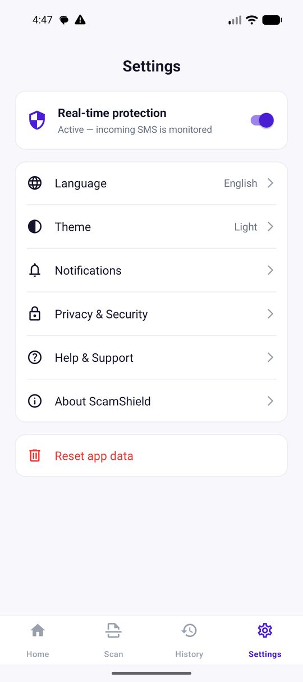  Settings — language, theme and the protection switch | 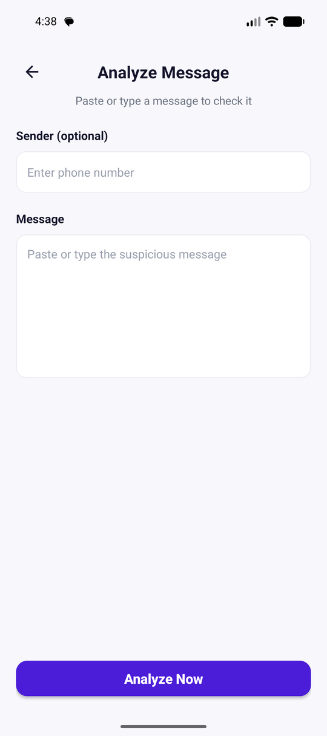  Analyze screen, English | 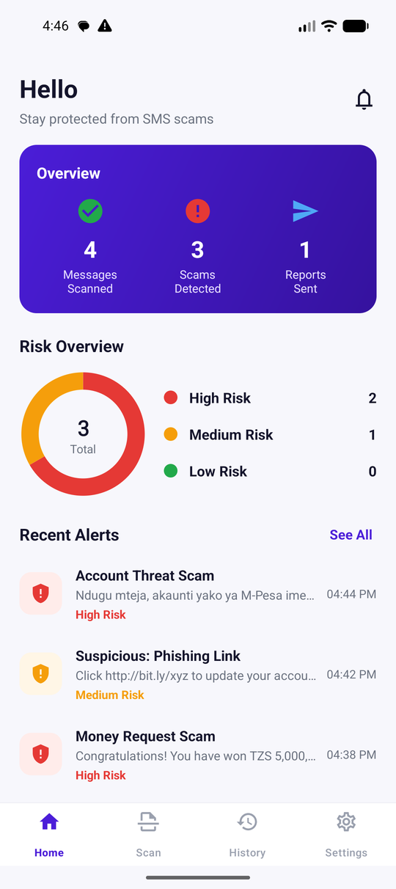  Dashboard after three checks

📍 Where are we now in the ScamShield flow?
SMS arrives on the phone (Android telephony)
↓
SmsReceiver.onReceive() is called
↓
Sender + text extracted, service messages skipped (WhitelistUtils)
↓
ScamDetector.detect() scores the message
↓
SAFE / SUSPICIOUS / SCAM decided
↓
DatabaseHelper.addScam() + NotificationHelper.showRiskAlert()
↓
▶ Dashboard and History read the database ◀ WE ARE HERE

7. How Android Receives SMS Messages
Before ScamShield can judge a message, the message has to reach it. This section starts from the moment someone presses Send on another phone.
From the network to our code
Someone sends an SMS
↓
The mobile network delivers it to the phone’s radio (modem)
↓
Android’s telephony service decodes it into an SmsMessage
↓
Android sends TWO different system broadcasts:
│
├─ SMS_DELIVER → only the DEFAULT SMS app (it writes the inbox)
│
└─ SMS_RECEIVED → every app that declared this filter and holds
RECEIVE_SMS — this is the one ScamShield gets
↓
Android looks in each app’s manifest, finds ScamShield’s SmsReceiver,
starts the app process if it is not running, and calls onReceive()

What a BroadcastReceiver is
Simple explanation: a broadcast is an announcement the system shouts to the whole phone — "battery low", "screen on", "an SMS arrived". A BroadcastReceiver is a class that says "wake me when that announcement happens". It has no screen and lives only for the few milliseconds its method runs.
Technical explanation: a BroadcastReceiver is an Android component whose onReceive(Context, Intent) is invoked by the system on the main thread when an Intent matching its intent-filter is broadcast. A receiver declared in the manifest is a static receiver: it works even when no part of the app is running, because the system can start the process just to deliver the broadcast.
🧠 What you must understand
This is the answer to the hardest question a panel will ask about this project: "If your app is closed, how can it still detect an SMS?" The answer is that the receiver is declared in AndroidManifest.xml, so Android — not ScamShield — keeps the registration. When the broadcast arrives, Android starts the ScamShield process and calls onReceive(). The app is not running in a loop, and it is not checking messages every second.

ScamShield’s receiver, in full
This is the whole class. It is short on purpose: a receiver must finish quickly or Android kills it.
receivers/SmsReceiver.java — lines 19–58
19 public void onReceive(Context context, Intent intent) {
20 if (intent.getAction() == null
21 || !Telephony.Sms.Intents.SMS_RECEIVED_ACTION.equals(intent.getAction())
22 || !ProtectionManager.isActive(context)) {
23 return;
24 }
25
26 String sender = null;
27 String message = null;
28 long receptionTime = System.currentTimeMillis();
29
30 SmsMessage[] messages = Telephony.Sms.Intents.getMessagesFromIntent(intent);
31 if (messages != null) {
32 StringBuilder body = new StringBuilder();
33 for (SmsMessage smsMessage : messages) {
34 if (sender == null) {
35 sender = smsMessage.getDisplayOriginatingAddress();
36 receptionTime = smsMessage.getTimestampMillis();
37 }
38 body.append(smsMessage.getMessageBody());
39 }
40 if (sender != null) {
41 message = body.toString();
42 }
43 }
44
45 if (sender == null || message == null
46 || WhitelistUtils.isServiceMessage(sender, message)) {
47 return;
48 }
49
50 ScamDetector.ScamResult result = ScamDetector.detect(message, sender);
51 AppPrefs.incrementScannedCount(context);
52
53 if (result.shouldAlert()) {
54 new DatabaseHelper(context).addScam(
55 sender, message, result.scamType, receptionTime);
56 NotificationHelper.showRiskAlert(context, sender, result);
57 }
58 }

Line by line
Code | What it does, and why
Context context | A handle to the app. Here it is passed on to the database, the preferences and the notification helper, because a receiver has no this screen of its own.
Intent intent | The delivery itself: the action string plus the raw SMS data ("PDUs") the system attached.
Telephony.Sms.Intents.SMS_RECEIVED_ACTION.equals(…) | Makes sure this really is the SMS broadcast and not something else sent to the class.
ProtectionManager.isActive(context) | The user’s own switch. If protection is off, or a permission was withdrawn, the method returns immediately and nothing is read.
getMessagesFromIntent(intent) | Android turns the raw PDUs into SmsMessage objects. A long SMS arrives as several parts.
body.append(…getMessageBody()) | The parts are joined back into one string, so a 300-character scam is judged as one message.
getDisplayOriginatingAddress() | The sender: a phone number such as 0712345678, or a name such as M-PESA.
getTimestampMillis() | When the network stamped the message — stored later so History shows the true time.
WhitelistUtils.isServiceMessage(…) | Operator and bank traffic is skipped before the detector runs (section 10).
ScamDetector.detect(message, sender) | The decision. One pure Java call, no Android inside.
AppPrefs.incrementScannedCount(context) | The "Messages Scanned" number on the dashboard.
result.shouldAlert() | True for SUSPICIOUS and SCAM. Safe messages are never stored and never notified.

⚠️ Don’t say this
"ScamShield scans all the messages in the inbox." It does not. There is no READ_SMS permission and no query of the SMS content provider anywhere in the code. ScamShield sees a message only at the moment it arrives, or when the user pastes one in by hand.

📍 Where are we now in the ScamShield flow?
SMS arrives on the phone (Android telephony)
↓
▶ SmsReceiver.onReceive() is called ◀ WE ARE HERE
↓
Sender + text extracted, service messages skipped (WhitelistUtils)
↓
ScamDetector.detect() scores the message
↓
SAFE / SUSPICIOUS / SCAM decided
↓
DatabaseHelper.addScam() + NotificationHelper.showRiskAlert()
↓
Dashboard and History read the database

8. ScamShield Real-Time SMS Detection

What "real-time" means here
Real-time in this project means event-driven: the user does not copy a message and press Scan. Android raises an event when the SMS arrives, and the detection runs inside that event, in a few milliseconds.
It is worth saying exactly what is not happening: there is no timer, no polling loop, no background thread scanning the inbox, and no server. Search the project for Thread, Executor or AsyncTask and you will find none.

The switch that makes it real-time
Real-time detection only runs when ProtectionManager.isActive() is true. That is two things at once — the user’s choice, and Android’s permissions:
utils/ProtectionManager.java — lines 48–50
48 public static boolean isActive(Context context) {
49 return isEnabled(context) && hasRequiredPermissions(context);
50 }

utils/ProtectionManager.java — lines 43–45
43 public static boolean isEnabled(Context context) {
44 return AppPrefs.isProtectionEnabled(context);
45 }

- isEnabled() reads the switch the user set in Settings, saved in SharedPreferences by AppPrefs.
- hasRequiredPermissions() re-checks RECEIVE_SMS (and POST_NOTIFICATIONS on Android 13+) every time, because a user can withdraw a permission in system Settings while the app is closed.

The visible service
services/ProtectionService.java is a foreground service: a service that must show a permanent notification. It does not read SMS and it does not detect anything — its job is to make an always-on background state visible and honest to the user.
services/ProtectionService.java — lines 18–31
18 public void onCreate() {
19 super.onCreate();
20 NotificationHelper.createProtectionChannel(this);
21 if (Build.VERSION.SDK_INT >= Build.VERSION_CODES.Q) {
22 startForeground(NOTIFICATION_ID,
23 NotificationHelper.buildProtectionNotification(this),
24 Build.VERSION.SDK_INT >= Build.VERSION_CODES.UPSIDE_DOWN_CAKE
25 ? ServiceInfo.FOREGROUND_SERVICE_TYPE_SPECIAL_USE
26 : 0);
27 } else {
28 startForeground(NOTIFICATION_ID,
29 NotificationHelper.buildProtectionNotification(this));
30 }
31 }


The foreground-service notification from ProtectionService
🧠 What you must understand
Why separate the service from the receiver? Because they answer different needs. The receiver does the work and is started by Android on demand. The service exists so the user is never monitored invisibly: while ScamShield is checking messages, a notification says so. If you remove the service, detection still works — the user simply loses the visible sign.

When does detection actually work?
Situation | Does detection run? | Why
App open on screen | Yes | The receiver is registered in the manifest and the process is alive
App minimised | Yes | The manifest receiver is independent of any screen
App closed (swiped from recents) | Yes | Android restarts the process to deliver the broadcast
Phone locked | Yes | Broadcast delivery does not depend on the lock screen
After a reboot | Yes, for detection | Manifest receivers survive reboot. But the foreground notification only returns when the app is next opened — there is no BOOT_COMPLETED receiver
After "Force stop" in Settings | No | Android puts the app in the stopped state; no broadcasts are delivered until the user opens it again
Protection switch off, or permission denied | No | ProtectionManager.isActive() is false and onReceive() returns immediately

🎤 What to say during presentation
"Detection is event-driven. Our receiver is declared in the manifest, so Android delivers the SMS_RECEIVED broadcast to it even when the app is not running — it will start our process if it has to. The foreground service does not do the detection; it exists so the user can always see that protection is on."

Proof it works: a real message on the emulator
An SMS was sent to the running emulator with adb emu sms send 0712345678 "Ndugu mteja, akaunti yako ya M-Pesa imefungwa. Tuma PIN yako sasa hivi ili kuifungua." — the app was not on screen. The alert below appeared about a second later:
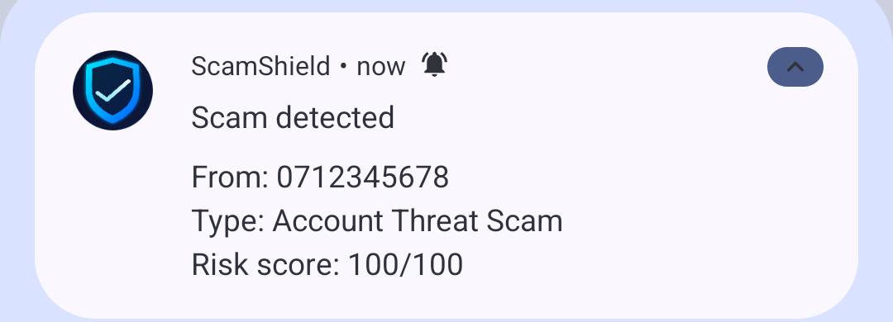
The alert produced by SmsReceiver → ScamDetector → NotificationHelper
The notification text comes straight from the detector: sender 0712345678, type Account Threat Scam, score 100/100. The same message is now the first row in History.
📍 Where are we now in the ScamShield flow?
SMS arrives on the phone (Android telephony)
↓
▶ SmsReceiver.onReceive() is called ◀ WE ARE HERE
↓
Sender + text extracted, service messages skipped (WhitelistUtils)
↓
ScamDetector.detect() scores the message
↓
SAFE / SUSPICIOUS / SCAM decided
↓
DatabaseHelper.addScam() + NotificationHelper.showRiskAlert()
↓
Dashboard and History read the database

9. Journey of One SMS Through the Application
Follow a single message from the network to the screen. The message used here is a real Kiswahili scam shape:
The incoming SMS
Ndugu mteja, akaunti yako ya M-Pesa imefungwa.
Tuma PIN yako sasa hivi ili kuifungua.

The full path, with the real class and method at every step
1. Android telephony SMS arrives, broadcast SMS_RECEIVED
↓
2. SmsReceiver.onReceive() receivers/SmsReceiver.java
↓ guard: is the action right? is protection active?
3. getMessagesFromIntent() sender = "0712345678", body joined from parts
↓
4. WhitelistUtils .isServiceMessage("0712345678", body) → false
↓ (not a 3–5 digit short code, no letters in sender)
5. ScamDetector.detect() utils/ScamDetector.java
│
├─ normalize() lower case, strip accents/invisible characters
├─ canonicalize() undo "p.i.n" / "p1n" style tricks
├─ 25 rules run each against the view of the text it was written for
├─ score strong 65 + weak 27(capped 30) + context 20 → 100
└─ classify 100 ≥ 60 → SCAM, "High Risk", "Account Threat Scam"
↓
6. ScamResult returned classification, score, scamType, indicators[5]
↓
7. AppPrefs.incrementScannedCount() dashboard counter +1
↓
8. DatabaseHelper.addScam() INSERT INTO scams (phone_number, message,
│ scam_type, date_time, is_reported)
↓
9. NotificationHelper.showRiskAlert() "Scam detected — Risk score: 100/100"
↓
10. User taps the notification PendingIntent → MainActivity → dashboard
↓
11. HomeFragment.onResume() re-reads the database, updates tiles + ring

The same journey in the user’s hands
Step 9 — the alert | Step 11 — dashboard updated | The message now in History

🧠 What you must understand
Notice what is not in the journey: no network call, no upload, no model file, no thread. Steps 2–10 all happen on the main thread inside onReceive(), and the whole thing takes a few milliseconds because it is 25 pre-compiled regular expressions over one short string.

📍 Where are we now in the ScamShield flow?
SMS arrives on the phone (Android telephony)
↓
SmsReceiver.onReceive() is called
↓
Sender + text extracted, service messages skipped (WhitelistUtils)
↓
▶ ScamDetector.detect() scores the message ◀ WE ARE HERE
↓
SAFE / SUSPICIOUS / SCAM decided
↓
DatabaseHelper.addScam() + NotificationHelper.showRiskAlert()
↓
Dashboard and History read the database

10. Scam Detection Engine
This is the most important section in the guide. It answers, in code, the question "how does ScamShield decide?".

What the engine is
utils/ScamDetector.java (about 670 lines) holds a table of written rules. Each rule is a DetectionRule object with six things: an identifier, a regular expression, a weight, a plain-English explanation, a category, and which prepared view of the message it reads.
utils/DetectionRule.java — lines 57–68
57 public DetectionRule(String id, String regex, int weight, String explanation,
58 String category, Field field) {
59 this.id = id;
60 // RAW rules read capitalisation, so they must not be folded to one case.
61 this.pattern = Pattern.compile(regex, field == Field.RAW
62 ? Pattern.UNICODE_CASE
63 : Pattern.CASE_INSENSITIVE | Pattern.UNICODE_CASE);
64 this.weight = weight;
65 this.explanation = explanation;
66 this.category = category;
67 this.field = field;
68 }

One real rule from the table — the one that catches a request for a PIN or OTP:
utils/ScamDetector.java — lines 126–140
126 rules.add(rule("R02_CREDENTIAL_REQUEST",
127 // A bank warning you never to share a code uses the same verbs as
128 // the thief asking for it, so negated instructions are excluded.
129 "(?<!\\bdo not )(?<!\\bdon't )(?<!\\bdont )(?<!\\bnever )(?<!\\bcannot )"
130 + "\\b(?:tuma|nitumie|niambie|nipe|weka|ingiza|jaza|thibitisha|hakiki"
131 + "|share|send|enter|provide|confirm|verify|reply\\s+with|jibu\\s+na)\\b"
132 + "[^.!?]{0,45}"
133 + "\\b(?:pin|otp|password|passcode|nenosiri|namba\\s+ya\\s+siri"
134 + "|kitambulisho|cvv|username)\\b"
135 + "|\\b(?:pin|otp|password|nenosiri|namba\\s+ya\\s+siri|cvv)\\b"
136 + "[^.!?]{0,45}"
137 + "\\b(?:tuma|nitumie|niambie|nipe|weka|ingiza|jaza|thibitisha"
138 + "|share|send|enter|confirm)\\b",
139 35, "Asks the recipient to hand over a PIN, OTP or password",
140 CREDENTIAL, DetectionRule.Field.CANONICAL));

- "R02_CREDENTIAL_REQUEST" — the identifier kept in the audit trail (result.matchedRules).
- The regular expression — an action word (tuma, send, share, weka…) within 45 characters of a secret word (pin, otp, nenosiri, cvv…), in either order.
- 35 — the weight added to the score when it fires.
- "Asks the recipient to hand over a PIN, OTP or password" — the sentence the user is shown.
- CREDENTIAL — the category, used to name the verdict ("Credential Theft Scam").
- Field.CANONICAL — read the de-obfuscated view, so p.i.n and p1n are caught too.

The negative look-behinds are not decoration
The same rule starts with (?<!\bdo not )(?<!\bdon’t )(?<!\bnever )…. A real bank writes "never share your PIN" — the same verbs as the thief. Without those exclusions, genuine bank warnings would be flagged as credential theft. There is a unit test for exactly this (bankSecurityAdvice_isNotReadAsACredentialRequest).

The 25 rules in the table
ID | Weight | Fires when the message… | Category
R01_KNOWN_NUMBER | 70 | comes from / points to a number already reported as a scam | Known Scam Number
R08_HEALER_PROMISE | 45 | makes a traditional-healer or supernatural promise | Fake Traditional Healer
R12_BRAND_LOOKALIKE | 35 | uses a look-alike web address built from a trusted brand | Brand Impersonation
R02_CREDENTIAL_REQUEST | 35 | asks for a PIN, OTP or password | Credential Theft
R11_UNSAFE_LINK | 30 | hides a link behind a shortener, raw IP or throwaway domain | Phishing Link
R04_MONEY_REQUEST | 30 | asks for a transfer or payment | Money Request
R18_PAYMENT_REDIRECT | 30 | redirects a payment to a mobile-money number in the text | Money Request
R06_PRIZE | 30 | claims a prize, draw or unexpected reward | Prize / Fake Promotion
R07_ACCOUNT_THREAT | 30 | threatens the account or demands verification | Account Threat
R16_ADVANCE_FEE | 30 | demands a fee before something is released | Money Request
R09_LOAN | 25 | advertises a loan with no checks | Fake Loan
R17_JOB_OFFER | 20 | offers work with no interview or asks money up front | Fake Job Offer
R13_PERSONAL_NUMBER | 15 (weak) | points to a personal mobile number instead of a service line | Suspicious Message
R03_URGENCY | 15 (weak) | pressures the reader to act immediately | Suspicious Message
R19_NAME_TO_EXPECT | 15 (weak) | states the name the transfer should appear to come from | Money Request
R05_LINK | 12 (weak) | contains any web link | Suspicious Message
R14_MONEY_AMOUNT | 12 (weak) | states a specific amount of money | Money Request
R02B_SECRET_MENTION | 12 (weak) | mentions a secret code at all | Credential Theft
R06B_PRIZE_WORD | 12 (weak) | mentions a gift, award or congratulation | Prize / Fake Promotion
R10_INSTITUTION | 10 (weak) | speaks in the name of a bank, operator or authority | Suspicious Message
R20_OFF_CHANNEL | 10 (weak) | moves the conversation to WhatsApp / a call | Suspicious Message
R15_SHOUTING | 8 (weak) | is written in shouted capitals | Suspicious Message
S01_SECURITY_ADVICE | −12 | warns never to share a secret, the way real banks do | Genuine Traffic
S02_TRANSACTION_RECEIPT | −20 | carries the reference numbers of a completed transaction | Genuine Traffic
S03_TRUSTED_SENDER_ID | −20 | arrived on a registered sender ID (M-PESA, NMB…) | Genuine Traffic

Rules whose weight is 15 or less are weak (supporting) signals; rules with a negative weight are suppressors that describe genuine traffic. Both ideas are defined in DetectionRule:
utils/DetectionRule.java — lines 108–111
108 /** True for supporting signals that must not stack into a verdict on their own. */
109 public boolean isWeak() {
110 return weight > 0 && weight <= ScamDetector.WEAK_RULE_WEIGHT;
111 }

utils/DetectionRule.java — lines 113–116
113 /** True for wording that only genuine traffic uses. */
114 public boolean isSuppressor() {
115 return weight < 0;
116 }

The 7 combination rules
Some things are innocent alone and damning together. contextBonuses() adds 20 points (10 for C05) when a pair fires:
ID | Fires when both… | Bonus
C01_PRIZE_PAYMENT | a prize claim + a payment request or advance fee | +20
C02_CREDENTIAL_LINK | a credential request + any link | +20
C03_ACCOUNT_CREDENTIAL | an account threat + a credential request | +20
C04_BRAND_MISMATCH | speaks for an institution + was sent from an ordinary mobile number | +20
C06_REDIRECT_WITH_NAME | a payment redirect + a stated name to expect | +20
C07_GIFT_WITH_MONEY | a gift/award word + a sum of money (only when no explicit win wording) | +20
C05_URGENT_LINK | a deadline + a link to follow | +10

The first one, in the real code:
utils/ScamDetector.java — lines 400–403
400 if (matchedIds.contains("R06_PRIZE")
401 && containsAny(matchedIds, "R04_MONEY_REQUEST", "R16_ADVANCE_FEE")) {
402 bonus += addContext(matchedIds, indicators, categoryScores, "C01_PRIZE_PAYMENT",
403 CONTEXT_WEIGHT, "A prize claim is paired with a payment request", PRIZE);

How the rules are run
utils/ScamDetector.java — lines 330–348
330 for (DetectionRule rule : RULES) {
331 String evidence = rule.match(input);
332 if (evidence == null) {
333 continue;
334 }
335 matchedIds.add(rule.getId());
336 indicators.add(describe(rule.getExplanation(), evidence));
337
338 if (rule.isSuppressor()) {
339 suppression += -rule.getWeight();
340 continue;
341 }
342 if (rule.isWeak()) {
343 weakScore += rule.getWeight();
344 } else {
345 strongScore += rule.getWeight();
346 }
347 addCategoryScore(categoryScores, rule.getCategory(), rule.getWeight());
348 }

Every rule is asked for the text that fired it, not just true/false. DetectionRule.match() returns that text (trimmed to 44 characters), and it becomes the quoted evidence the user reads on the verdict screen.
utils/DetectionRule.java — lines 76–91
76 public String match(Input input) {
77 switch (field) {
78 case RAW:
79 return firstMatch(input.raw);
80 case SENDER:
81 return firstMatch(input.sender);
82 case MESSAGE:
83 return firstMatch(input.message);
84 case SENDER_OR_MESSAGE:
85 String senderHit = firstMatch(input.sender);
86 return senderHit != null ? senderHit : firstMatch(input.message);
87 case CANONICAL:
88 default:
89 return firstMatch(input.canonical);
90 }
91 }

🧠 What you must understand
Patterns are compiled once, in the static block that builds the table, when the class is first used. Scanning a message never compiles a regular expression, which is why detection is fast enough to run inside onReceive() on the main thread.

Is this AI?
No, and the honest answer is a strength, not a weakness. Say it like this:
🎤 What to say during presentation
"ScamShield uses a deterministic rule-based classifier: 25 weighted regular-expression rules plus 7 co-occurrence rules, bounded to a score out of 100 and cut by two fixed thresholds. We chose it over a machine-learning model because the app must justify every verdict to the user — and because we can measure and explain it. There are no learned parameters and no model file in the repository."

📍 Where are we now in the ScamShield flow?
SMS arrives on the phone (Android telephony)
↓
SmsReceiver.onReceive() is called
↓
Sender + text extracted, service messages skipped (WhitelistUtils)
↓
▶ ScamDetector.detect() scores the message ◀ WE ARE HERE
↓
SAFE / SUSPICIOUS / SCAM decided
↓
DatabaseHelper.addScam() + NotificationHelper.showRiskAlert()
↓
Dashboard and History read the database

11. Text Processing
Before any rule runs, the message is prepared. ScamShield builds four views of the same SMS, and each rule declares which view it reads.
View (DetectionRule.Field) | What it contains | Why it exists
RAW | The message exactly as it arrived | Only R15_SHOUTING uses it — capitals must survive
MESSAGE | Normalised: lower case, accents and invisible characters removed, spacing collapsed | Links, digits and punctuation keep their shape for structural rules
CANONICAL | Normalised plus de-obfuscated | Wording rules: catches p.i.n, p1n, t u m a
SENDER | The normalised sender only | S03_TRUSTED_SENDER_ID, half of R01_KNOWN_NUMBER

Step 1 — normalise
utils/ScamDetector.java — lines 521–523
521 public static String normalize(String value) {
522 return collapseSpacing(fold(value));
523 }

utils/ScamDetector.java — lines 526–540
526 private static String fold(String value) {
527 if (value == null) {
528 return "";
529 }
530 return Normalizer.normalize(value, Normalizer.Form.NFKD)
531 // Accents and zero-width or bidirectional marks hide keywords.
532 .replaceAll("[\\p{Mn}\\p{Cf}]", "")
533 .toLowerCase(Locale.ROOT)
534 .replace('\u2018', '\'')
535 .replace('\u2019', '\'')
536 .replace('\u201c', '"')
537 .replace('\u201d', '"')
538 .replace('\u2013', '-')
539 .replace('\u2014', '-');
540 }

- Normalizer.normalize(value, Form.NFKD) splits characters such as Ó into O + an accent mark.
- replaceAll("[\\p{Mn}\\p{Cf}]", "") then deletes those marks and invisible formatting characters. Scammers paste zero-width spaces inside words (P\u200bIN) precisely to break keyword matching.
- toLowerCase(Locale.ROOT) so one spelling of a rule covers every case.
- Smart quotes and long dashes become plain ASCII, so don’t and don't are the same text.

Step 2 — canonicalise (undo the two evasion tricks)
utils/ScamDetector.java — lines 565–571
565 private static String canonicalize(String text) {
566 if (text == null || text.isEmpty()) {
567 return "";
568 }
569 String spaced = fold(text).replaceAll("[\\t\\r\\n\\u00a0]+", " ");
570 return collapseSpacing(foldLookalikes(joinSpacedRuns(foldLookalikes(spaced))));
571 }

Trick | What the scammer writes | After canonicalise
Characters that look like letters | p1n, 0TP, m0ney | pin, otp, money
Separators pushed between letters | p.i.n, t u m a, o-t-p | pin, tuma, otp
Both at once | p 1 n | pin

The order matters and the code says why: folding runs before and after the separators are removed, because p 1 n needs the join first while 0tp needs the fold first.
This was verified on the real app, not just in theory. Typing Tuma p.1.n yako sasa into the scan screen produces SUSPICIOUS, score 47, with the indicator Asks the recipient to hand over a PIN, OTP or password — "tuma pin": the rule matched tuma pin although those letters never appear together in the message.

What ScamShield does NOT do
- No tokenisation. The rules are regular expressions over the whole string, not over a list of words.
- No stop-word removal. Words like "the" and "ya" are left in place; they cost nothing.
- No stemming or lemmatisation. Word endings are handled inside the patterns themselves (expires?, mkopo|mikopo).
- No punctuation removal. Punctuation is load-bearing here: [^.!?]{0,45} keeps a rule inside one sentence.
- No feature vectors, no bag of words, no embeddings. Nothing is converted into numbers except the final score.
⚠️ Don’t say this
"We tokenise the message and remove stop words before classifying." That would describe a different design. In this codebase the only preprocessing is normalize() and canonicalize(), both shown above.

📍 Where are we now in the ScamShield flow?
SMS arrives on the phone (Android telephony)
↓
SmsReceiver.onReceive() is called
↓
Sender + text extracted, service messages skipped (WhitelistUtils)
↓
▶ ScamDetector.detect() scores the message ◀ WE ARE HERE
↓
SAFE / SUSPICIOUS / SCAM decided
↓
DatabaseHelper.addScam() + NotificationHelper.showRiskAlert()
↓
Dashboard and History read the database

12. Classification Logic
Preparation and rules produce numbers. This section turns those numbers into SAFE, SUSPICIOUS or SCAM — with the arithmetic written out.

The four counters
Counter | Filled from | Rule
strongScore | rules with weight > 15 | added in full
weakScore | rules with weight 1–15 | added, then capped at 30 (WEAK_SIGNAL_LIMIT)
suppression | rules with negative weight | subtracted, but see the rule below
context bonuses | the 7 combination rules | added to strongScore

utils/ScamDetector.java — lines 350–363
350 // A pile of supporting signals is not a verdict: cap what they may add.
351 weakScore = Math.min(weakScore, WEAK_SIGNAL_LIMIT);
352
353 strongScore += contextBonuses(matchedIds, normalizedSender, indicators, categoryScores);
354
355 // Genuine wording can cancel supporting noise, but a direct request for
356 // money or credentials still stands on its own.
357 int appliedSuppression = strongScore > 0
358 ? Math.min(suppression, weakScore)
359 : suppression;
360
361 int score = Math.max(0, Math.min(MAX_SCORE,
362 strongScore + weakScore - appliedSuppression));
363

Two design decisions worth defending
- The weak cap. Ten mild signals must not add up to a conviction. Whatever the weak rules sum to, they contribute at most 30 — exactly the SUSPICIOUS threshold, never SCAM on their own. The unit test weakSignalsAlone_cannotReachScam locks this in.
- Limited suppression. If a strong rule fired, genuine-sounding wording can only cancel the weak noise (min(suppression, weakScore)), never the strong evidence. Otherwise a scammer would simply paste "we will never ask for your PIN" at the bottom of the message to erase their own score. The test copiedSecurityAdvice_cannotHideARealRequest proves it.

From score to verdict
utils/ScamDetector.java — lines 364–375
364 String classification;
365 String dangerLevel;
366 if (score >= SCAM_THRESHOLD) {
367 classification = SCAM;
368 dangerLevel = "High Risk";
369 } else if (score >= SUSPICIOUS_THRESHOLD) {
370 classification = SUSPICIOUS;
371 dangerLevel = "Medium Risk";
372 } else {
373 classification = SAFE;
374 dangerLevel = "Low Risk";
375 }

utils/ScamDetector.java — lines 377–385
377 String category = strongestCategory(categoryScores);
378 String displayType;
379 if (SAFE.equals(classification)) {
380 displayType = "Safe Message";
381 } else if (SUSPICIOUS.equals(classification)) {
382 displayType = "Suspicious: " + category;
383 } else {
384 displayType = category + (category.endsWith("Scam") ? "" : " Scam");
385 }

The name shown to the user is the heaviest specific category, not the first rule that fired. Generic and genuine categories are skipped when choosing:
utils/ScamDetector.java — lines 505–518
505 private static String strongestCategory(Map<String, Integer> scores) {
506 String strongest = GENERAL;
507 int highest = -1;
508 for (Map.Entry<String, Integer> entry : scores.entrySet()) {
509 if (GENERAL.equals(entry.getKey()) || GENUINE.equals(entry.getKey())) {
510 continue;
511 }
512 if (entry.getValue() > highest) {
513 highest = entry.getValue();
514 strongest = entry.getKey();
515 }
516 }
517 return strongest;
518 }

Worked example 1 — the prize scam (SCAM, 100)
Message
Congratulations! You have won TZS 5,000,000.
Send TZS 50,000 processing fee to claim your prize.

sender: 0754123456

Fired | Kind | Weight | Running total
R06_PRIZE — claims a prize | strong | +30 | strong 30
R04_MONEY_REQUEST — asks for a transfer | strong | +30 | strong 60
R16_ADVANCE_FEE — fee before release | strong | +30 | strong 90
R14_MONEY_AMOUNT — a specific sum | weak | +12 | weak 12 (cap 30)
C01_PRIZE_PAYMENT — prize and payment | context | +20 | strong 110
Total |  | 110 + 12 = 122 → bounded to 100 | SCAM — High Risk

Category scores: Money Request 12 + 30 + 30 = 72, Prize 30 + 20 = 50 → the heaviest is Money Request, so the type shown is "Money Request Scam". This is exactly what the app printed:
The verdict screen for the message above | 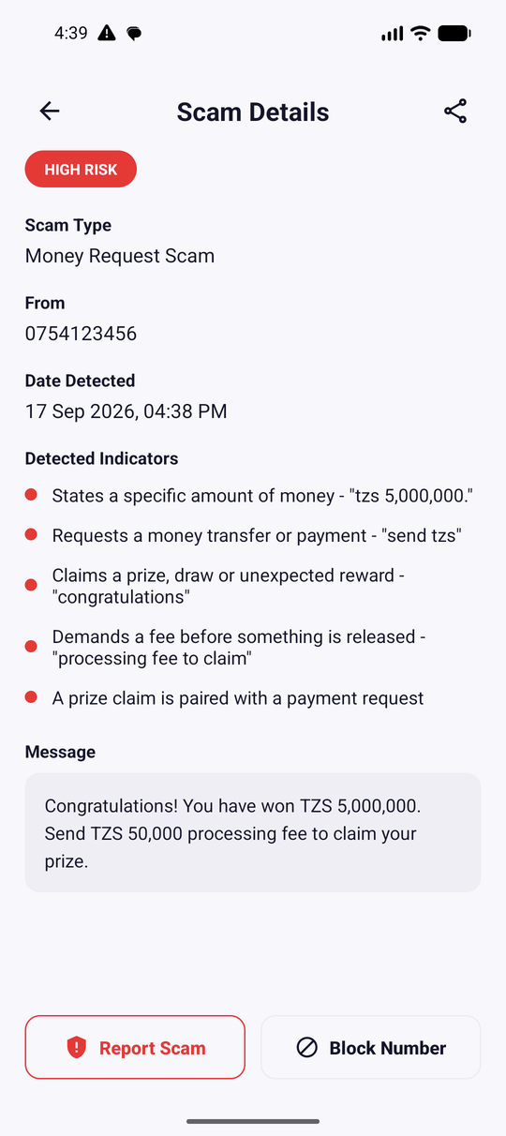  The same evidence on the details screen

Worked example 2 — a genuine M-PESA receipt (SAFE, 0)
Message
Umepokea Tsh 20,000 kutoka JOHN. Salio lako ni Tsh 45,000.
Muamala namba QWE123.

sender: M-PESA

Fired | Kind | Weight | Effect
R14_MONEY_AMOUNT | weak | +12 | weak 12
S02_TRANSACTION_RECEIPT | suppressor | −20 | suppression 20
S03_TRUSTED_SENDER_ID | suppressor | −20 | suppression 40
Total |  | no strong rule → full suppression: 12 − 40 = −28 → 0 | SAFE — Low Risk

Worked example 3 — a shortened link (SUSPICIOUS, 42)
Message
Click http://bit.ly/xyz to update your account now

sender: 0712345678

R11_UNSAFE_LINK (strong, 30) + R05_LINK (weak, 12) = 42. That is above 30 but below 60, so the verdict is SUSPICIOUS — the app warns without accusing:
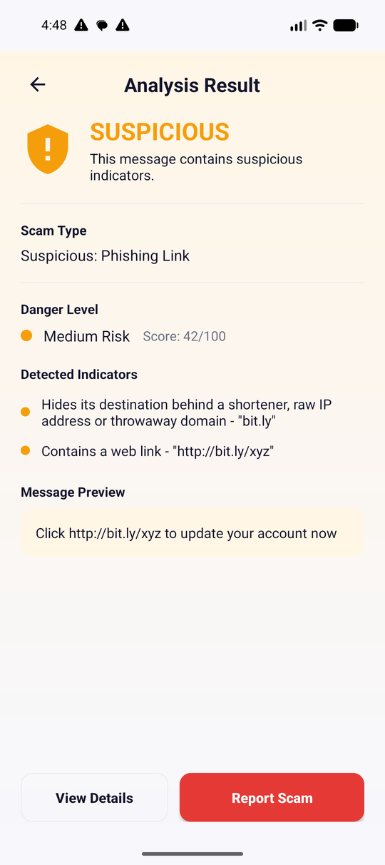  SUSPICIOUS — score 42/100 | 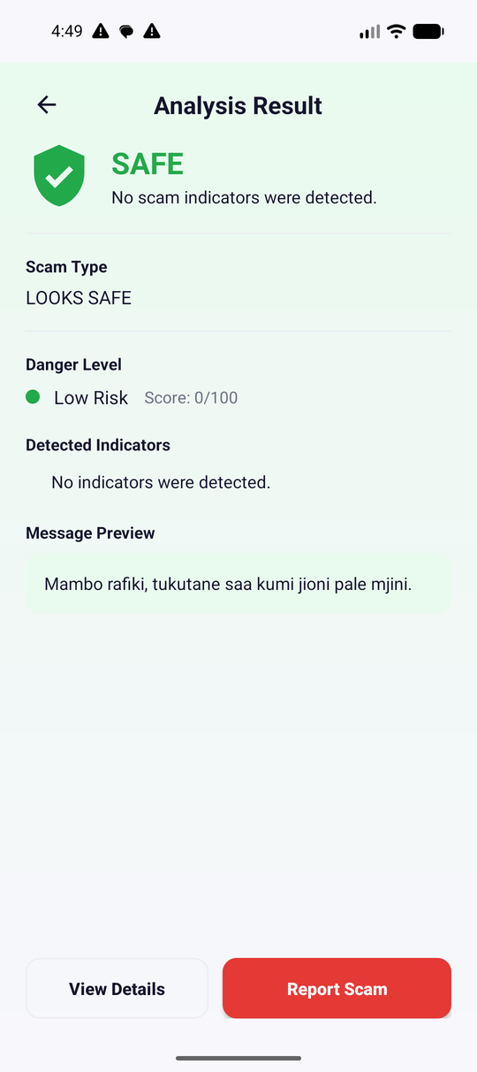  SAFE — an ordinary Kiswahili message, 0/100

🧠 What you must understand
The score is not a probability and not a confidence. It is a bounded sum of weights the group chose by hand. Calling it "87 % sure" in the presentation would be wrong; call it "a risk score out of 100, above our scam threshold of 60".

📍 Where are we now in the ScamShield flow?
SMS arrives on the phone (Android telephony)
↓
SmsReceiver.onReceive() is called
↓
Sender + text extracted, service messages skipped (WhitelistUtils)
↓
ScamDetector.detect() scores the message
↓
▶ SAFE / SUSPICIOUS / SCAM decided ◀ WE ARE HERE
↓
DatabaseHelper.addScam() + NotificationHelper.showRiskAlert()
↓
Dashboard and History read the database

13. Activities
ScamShield has three Activities. Everything else the user sees is a Fragment inside MainActivity.
Activity | Layout | What it is for | Started by
SplashActivity | splash_activity.xml | Brand screen for 3 seconds, then decides where to go | Android (launcher icon)
OnboardingActivity | onboarding_activity.xml | Three intro pages + the permission requests, first run only | SplashActivity
MainActivity | activity_main.xml | Holds the bottom tabs and every Fragment | SplashActivity, OnboardingActivity, notifications, the share sheet

What an Intent is
Simple explanation: an Intent is a note that says what you want to happen. You hand it to Android and Android finds who can do it. Technical explanation: an Intent is a messaging object describing an operation — either explicit (naming the exact class to start) or implicit (naming an action and data, letting the system choose an app).
Kind | Example in ScamShield | File
Explicit | new Intent(SplashActivity.this, MainActivity.class) | SplashActivity.java
Explicit | new Intent(context, ProtectionService.class) | utils/ProtectionManager.java
Implicit | new Intent(Intent.ACTION_SENDTO, Uri.parse("smsto:15040")) | ReviewReportFragment.java
Implicit | new Intent(Intent.ACTION_DIAL) with tel: | HistoryFragment.java
Implicit | new Intent(Intent.ACTION_SEND).setType("text/plain") | ScamDetailsFragment.java
Incoming | ACTION_SEND received from another app | MainActivity.routeSharedText()

The incoming one is worth reading, because it is how a message shared from the Messages app reaches the scan screen:
MainActivity.java — lines 69–85
69 private void routeSharedText(NavController navController, Intent intent) {
70 if (intent == null || !Intent.ACTION_SEND.equals(intent.getAction())) {
71 return;
72 }
73
74 String shared = intent.getStringExtra(Intent.EXTRA_TEXT);
75 if (TextUtils.isEmpty(shared)) {
76 return;
77 }
78
79 Bundle args = new Bundle();
80 args.putString(AnalyzeFragment.ARG_SHARED_TEXT, shared);
81 navController.navigate(R.id.analyzeFragment, args, Nav.tabs());
82
83 // Consumed: a configuration change must not re-open the same message.
84 intent.removeExtra(Intent.EXTRA_TEXT);
85 }

🧠 What you must understand
intent.removeExtra(Intent.EXTRA_TEXT) at the end is deliberate. An Intent is kept by the Activity, so after a screen rotation the same shared message would be delivered a second time and the user would be dropped back into the scan screen. Consuming the extra prevents that.

Fragments: the screens inside MainActivity
Activity = the screen frame. Fragment = a replaceable section inside it. ScamShield keeps one Activity and swaps nine Fragments, so the bottom bar never flickers and the back stack stays in one place.
Fragment | Role
HomeFragment | Dashboard: counters, risk ring, three newest alerts
AnalyzeFragment | The sender + message form and the Analyze Now button
ScanResultFragment | The verdict, the evidence, and the two next actions
ScamDetailsFragment | Everything stored about one scam, plus share and block
ReportScamFragment | Choose TCRA or the operator, add notes
ReviewReportFragment | Last check, then hand the report to the SMS or share app
ReportSentFragment | Confirmation, Done and View History
HistoryFragment | The stored list with risk filters and row actions
ProfileFragment | Settings: protection switch, language, theme, privacy, reset

The navigation graph
The nine destinations are declared in res/navigation/nav_graph.xml, and each has an ID that Java navigates to:
res/navigation/nav_graph.xml — lines 7–16
7 <!-- Tabs -->
8 <fragment
9 android:id="@+id/homeFragment"
10 android:name="com.group2.scamshield.HomeFragment"
11 android:label="Home" />
12
13 <fragment
14 android:id="@+id/analyzeFragment"
15 android:name="com.group2.scamshield.AnalyzeFragment"
16 android:label="Analyze" />

Four of those IDs are repeated in res/menu/bottom_nav_menu.xml. Because the IDs match, one line in MainActivity wires the tabs to the destinations:
MainActivity.java — lines 43–43
43 NavigationUI.setupWithNavController(bottomNav, navController);

Passing data between Fragments
Fragments do not call each other’s methods. They pass a Bundle, and utils/ScanArgs.java is the one place that builds and reads it:
utils/ScanArgs.java — lines 50–59
50 public static Bundle of(ScamModel scam, String danger, ArrayList<String> indicators,
51 String classification, int score) {
52 Bundle args = new Bundle();
53 args.putSerializable(SCAM, scam);
54 args.putString(DANGER, danger);
55 args.putStringArrayList(INDICATORS, indicators);
56 args.putString(CLASSIFICATION, classification);
57 args.putInt(SCORE, score);
58 return args;
59 }

One Bundle travels the whole report flow
AnalyzeFragment ScanArgs.of(scam, danger, indicators, classification, score)
↓ navigate(R.id.scanResultFragment, args)
ScanResultFragment reads the same Bundle
↓ navigate(R.id.reportScamFragment, args)
ReportScamFragment ScanArgs.withReport(args, channel, notes)
↓ navigate(R.id.reviewReportFragment, next)
ReviewReportFragment sends, then navigate(R.id.reportSentFragment, args)

The lifecycle methods this project actually uses
Callback | When Android calls it | Used in ScamShield for
onCreate() | Activity created | Layout, channels, protection restore, navigation
onCreateView() | Fragment needs its view | Inflate the layout, find views, attach listeners
onResume() | Screen becomes interactive | Re-reading the database — HomeFragment, HistoryFragment, ProfileFragment
onNewIntent() | A new Intent arrives at a singleTop Activity | A second shared message while MainActivity is open
onDestroy() | Screen is going away | SplashActivity cancels its pending navigation

🧠 What you must understand
Why is the data reloaded in onResume() rather than onCreate()? Because a Fragment’s view survives while the user visits another screen. If the dashboard only read the database once, a scam detected while the user was in Settings would never appear. onResume() runs every time the screen comes back to the front.

14. BroadcastReceivers
There is exactly one receiver: receivers/SmsReceiver.java, explained line by line in section 7. This section covers what a panel usually asks about it.

Static vs dynamic registration
 | Static (manifest) | Dynamic (registerReceiver)
Declared in | AndroidManifest.xml | Java code at runtime
Works when the app is closed | Yes — Android starts the process | No — dies with the component
Used by ScamShield | Yes, this one | Not used anywhere in the project

Why a receiver and not a service polling the inbox?
- Correctness: Android already knows the exact moment a message arrives. Polling would be later and never as accurate.
- Battery: a loop that wakes the CPU every few seconds drains the battery; a receiver costs nothing until an SMS arrives.
- Permissions: polling the inbox would need READ_SMS, a far more invasive permission than RECEIVE_SMS.
- Platform rules: modern Android kills background loops. Event delivery is the supported way.
🎤 What to say during presentation
"We use a manifest-declared BroadcastReceiver because SMS delivery is an event, not a state to poll. Android wakes our process only when a message actually arrives, which is both accurate and battery-friendly, and it means we only need RECEIVE_SMS rather than READ_SMS."

The guard that protects the user
receivers/SmsReceiver.java — lines 20–25
20 if (intent.getAction() == null
21 || !Telephony.Sms.Intents.SMS_RECEIVED_ACTION.equals(intent.getAction())
22 || !ProtectionManager.isActive(context)) {
23 return;
24 }
25

Three checks in one if: the action must be the SMS broadcast, and protection must be active — which itself means "the user switched it on and the permissions are still granted". If any of these fails, onReceive() returns before a single character of the message is read.
📍 Where are we now in the ScamShield flow?
SMS arrives on the phone (Android telephony)
↓
▶ SmsReceiver.onReceive() is called ◀ WE ARE HERE
↓
Sender + text extracted, service messages skipped (WhitelistUtils)
↓
ScamDetector.detect() scores the message
↓
SAFE / SUSPICIOUS / SCAM decided
↓
DatabaseHelper.addScam() + NotificationHelper.showRiskAlert()
↓
Dashboard and History read the database

15. Services
services/ProtectionService.java is the only service ScamShield writes (the second <service> in the manifest belongs to AndroidX and stores the language choice).

What a foreground service is
Simple explanation: a service is code with no screen. A foreground service is one that must show a permanent notification, so the user always knows it is running. Technical explanation: startForeground() moves the service into a state the system will not silently kill, at the cost of a mandatory ongoing notification; from Android 14 the service must also declare a foregroundServiceType, here specialUse.
services/ProtectionService.java — lines 34–40
34 public int onStartCommand(Intent intent, int flags, int startId) {
35 if (!ProtectionManager.isActive(this)) {
36 stopSelf();
37 return START_NOT_STICKY;
38 }
39 return START_STICKY;
40 }

- START_STICKY asks Android to recreate the service if it is killed for memory.
- If protection was turned off while the service was starting, it stops itself instead — the manager and the service can never disagree.
- onBind() returns null: nothing binds to this service; it is a state holder, not an API.

The manager that owns the state
utils/ProtectionManager.java is the single source of truth. No fragment ever starts the service itself.
utils/ProtectionManager.java — lines 52–60
52 public static void enable(Context context) {
53 if (!hasRequiredPermissions(context)) {
54 disable(context);
55 return;
56 }
57 AppPrefs.setProtectionEnabled(context, true);
58 ContextCompat.startForegroundService(context.getApplicationContext(),
59 new Intent(context, ProtectionService.class));
60 }

utils/ProtectionManager.java — lines 69–76
69 public static void restore(Context context) {
70 if (isActive(context)) {
71 ContextCompat.startForegroundService(context.getApplicationContext(),
72 new Intent(context, ProtectionService.class));
73 } else if (isEnabled(context)) {
74 disable(context);
75 }
76 }

Who talks to ProtectionManager
ProfileFragment switch ON ──▶ ProtectionManager.enable()
├─ AppPrefs.setProtectionEnabled(true)
└─ startForegroundService(ProtectionService)
└─ ongoing notification appears
MainActivity.onCreate() ──▶ ProtectionManager.restore()
├─ active? → start the service again
└─ enabled but permission gone → disable()
SmsReceiver.onReceive() ──▶ ProtectionManager.isActive() (the gate)

⚠️ Don’t say this
"The service listens for incoming messages." It does not. ProtectionService contains no SMS code at all — look at the file. The receiver does the listening; the service only makes the state visible and keeps the app from being treated as fully idle.

16. Models and Helper Classes

models/ScamModel.java — one stored scam
models/ScamModel.java — lines 14–21
14 public ScamModel(int id, String phoneNumber, String message, String scamType, String dateTime, boolean isReported) {
15 this.id = id;
16 this.phoneNumber = phoneNumber;
17 this.message = message;
18 this.scamType = scamType;
19 this.dateTime = dateTime;
20 this.isReported = isReported;
21 }

- Six fields, all private final: nothing can change a row object after it is built.
- Only getters — the class is a value object, not a place for logic.
- implements Serializable so the whole object can be put into a Bundle with putSerializable() and travel between fragments.

The helper classes in utils/
Class | Responsibility | Why it is separate
ScamDetector | The rule table, the score, the verdict | Pure Java — testable without Android
DetectionRule | One rule: pattern, weight, explanation, category, field | Lets rules be data, not code branches
WhitelistUtils | Recognise operator/bank traffic before detection | Keeps that policy out of the receiver
NotificationHelper | Channels, the alert, the ongoing notification, opening settings | Two callers need identical notifications
ProtectionManager | Permissions + on/off state + the service | One truth for four callers
AppPrefs | SharedPreferences: theme, first launch, scan count, protection flag | No screen should touch preference keys directly
ScanArgs | Build and read the Bundle for the scan/report flow | Five fragments would otherwise duplicate key names
RiskUi | Risk bucket → colour, background, label, headline | Dashboard, history, verdict and report can never drift apart
DateFormats | Write the stored stamp, and "Today / 17 Sep 2026, 04:38 PM" | One date format in one file
Nav | Shared NavOptions for tab switching and after sending a report | Prevents a growing back stack

RiskUi — one mapping for the whole app
utils/RiskUi.java — lines 28–44
28 public static String bucket(String value) {
29 if (value == null) {
30 return LOW;
31 }
32 String v = value.toLowerCase(Locale.ROOT);
33 if (v.startsWith("high")) {
34 return HIGH;
35 }
36 if (v.startsWith("medium")) {
37 return MEDIUM;
38 }
39 if (v.startsWith("low")) {
40 return LOW;
41 }
42 // Not a level - treat it as a scam type and let the detector classify it.
43 return ScamDetector.riskLevelFor(value);
44 }

HomeFragment, ScamAdapter, AlertAdapter, ScanResultFragment, ScamDetailsFragment, ReportScamFragment and ReviewReportFragment all paint risk through this class, so "High Risk" is the same red everywhere and in both themes.

ScanArgs.ofStored() — why the reasons are never stale
utils/ScanArgs.java — lines 40–48
40 public static Bundle ofStored(ScamModel scam) {
41 if (scam == null) {
42 return of(null, null, new ArrayList<String>(), ScamDetector.SAFE, 0);
43 }
44 ScamDetector.ScamResult result =
45 ScamDetector.detect(scam.getMessage(), scam.getPhoneNumber());
46 return of(scam, result.dangerLevel, new ArrayList<>(result.indicators),
47 result.classification, result.score);
48 }

🧠 What you must understand
The database stores what a message was, not why. When the user opens an old row, the detector runs again over the saved text and rebuilds the reasons. If the group edits a rule tomorrow, old rows explain themselves with today’s rules instead of showing a stale stored column. The detector has no learned state and no I/O, so re-running it is cheap and gives exactly the same answer.

17. Database and Data Storage
ScamShield stores data in two places, both on the phone only.
Store | Technology | What goes in it | File
Scam history | SQLite via SQLiteOpenHelper | One row per flagged message | database/DatabaseHelper.java
Small settings | SharedPreferences | Theme, first launch, scan count, protection on/off | utils/AppPrefs.java

There is no Room, no server, no cloud database and no file storage in this project.

The table
database/DatabaseHelper.java — lines 30–38
30 private static final String CREATE_TABLE_SCAMS =
31 "CREATE TABLE " + TABLE_SCAMS + "("
32 + COLUMN_ID + " INTEGER PRIMARY KEY AUTOINCREMENT,"
33 + COLUMN_PHONE + " TEXT,"
34 + COLUMN_MESSAGE + " TEXT,"
35 + COLUMN_SCAM_TYPE + " TEXT,"
36 + COLUMN_DATE_TIME + " TEXT,"
37 + COLUMN_IS_REPORTED + " INTEGER DEFAULT 0"
38 + ")";

Column | Type | Holds | Example
id | INTEGER PK AUTOINCREMENT | Row number given by SQLite | 7
phone_number | TEXT | Sender, or - when the user typed no sender | 0712345678
message | TEXT | The full message text | "Ndugu mteja, akaunti…"
scam_type | TEXT | The detector’s display type | "Account Threat Scam"
date_time | TEXT | yyyy-MM-dd HH:mm:ss, written by DateFormats.stamp() | 2026-09-17 16:44:10
is_reported | INTEGER (0/1) | Set to 1 when the user sends a report | 0

🧠 What you must understand
What is not stored is as important as what is: the score, the classification and the indicators are absent by design (see ScanArgs.ofStored() in section 16), and safe messages are never written at all — SmsReceiver and AnalyzeFragment only insert when result.shouldAlert() is true. The database is a scam log, not a copy of the user’s inbox.

The CRUD operations, and who calls them
Method | SQL | Called by
addScam(phone, message, type, timestamp) | INSERT | SmsReceiver, AnalyzeFragment
getAllScams() | SELECT … ORDER BY id DESC | HomeFragment, HistoryFragment
markAsReported(id) | UPDATE … SET is_reported = 1 | ReviewReportFragment, HistoryFragment
deleteScam(id) | DELETE … WHERE id = ? | HistoryFragment
deleteAllScams() | DELETE (all rows) | HistoryFragment (Clear All), ProfileFragment (Reset)
getReportedCount() | SELECT COUNT(*) WHERE is_reported = 1 | HomeFragment ("Reports Sent")

INSERT, as written
database/DatabaseHelper.java — lines 58–69
58 public long addScam(String phoneNumber, String message, String scamType,
59 long timestampMillis) {
60 SQLiteDatabase db = this.getWritableDatabase();
61 ContentValues values = new ContentValues();
62 values.put(COLUMN_PHONE, phoneNumber);
63 values.put(COLUMN_MESSAGE, message);
64 values.put(COLUMN_SCAM_TYPE, scamType);
65 values.put(COLUMN_DATE_TIME, DateFormats.stamp(timestampMillis));
66 values.put(COLUMN_IS_REPORTED, 0);
67
68 return db.insert(TABLE_SCAMS, null, values);
69 }

- ContentValues is a labelled bag of column → value; db.insert() builds the SQL from it, so nothing is concatenated into a query string.
- The return value is the new row id, or -1 on failure. AnalyzeFragment uses it so the verdict screen knows which row it is looking at.

SELECT, and the cursor
database/DatabaseHelper.java — lines 72–92
72 public List<ScamModel> getAllScams() {
73 List<ScamModel> scamList = new ArrayList<>();
74 SQLiteDatabase db = this.getReadableDatabase();
75
76 Cursor cursor = db.query(TABLE_SCAMS, null, null, null, null, null, COLUMN_ID + " DESC");
77
78 if (cursor.moveToFirst()) {
79 do {
80 int id = cursor.getInt(cursor.getColumnIndexOrThrow(COLUMN_ID));
81 String phone = cursor.getString(cursor.getColumnIndexOrThrow(COLUMN_PHONE));
82 String message = cursor.getString(cursor.getColumnIndexOrThrow(COLUMN_MESSAGE));
83 String scamType = cursor.getString(cursor.getColumnIndexOrThrow(COLUMN_SCAM_TYPE));
84 String dateTime = cursor.getString(cursor.getColumnIndexOrThrow(COLUMN_DATE_TIME));
85 boolean isReported = cursor.getInt(cursor.getColumnIndexOrThrow(COLUMN_IS_REPORTED)) == 1;
86
87 scamList.add(new ScamModel(id, phone, message, scamType, dateTime, isReported));
88 } while (cursor.moveToNext());
89 }
90 cursor.close();
91 return scamList;
92 }

Term | Meaning
Cursor | A pointer into the result set, one row at a time — not a copy of the table
moveToFirst() / moveToNext() | Step through the rows; both return false when there are none left
getColumnIndexOrThrow("phone_number") | Find which column position holds that name, failing loudly if the schema changed
cursor.close() | Frees the cursor. Leaking cursors is a classic Android bug
ORDER BY id DESC | Newest first — which is why History and Recent Alerts read top-down

⚠️ Don’t say this
"We use SQL injection protection with prepared statements everywhere." Be precise: insert(), update() and delete() take ContentValues and ? placeholders (new String[]{String.valueOf(id)}), which is parameterised and safe. The two COUNT(*) queries are rawQuery with a fixed string and no user input. That is accurate; the sweeping claim is not.

SharedPreferences
utils/AppPrefs.java — lines 62–64
62 public static void incrementScannedCount(Context context) {
63 prefs(context).edit().putInt(KEY_SCANNED, getScannedCount(context) + 1).apply();
64 }

SharedPreferences is a small key–value file (ScamShieldPrefs.xml) for values too small to deserve a table. apply() writes in the background; commit() would block the caller.

18. Detection History
From a detection to a row on screen
Detection happens SmsReceiver / AnalyzeFragment
↓
DatabaseHelper.addScam() one row inserted
↓
User opens History HistoryFragment.onResume()
↓
dbHelper.getAllScams() List<ScamModel>, newest first
↓
filter by chip activeFilter vs ScamDetector.riskLevelFor(type)
↓
new ScamAdapter(list) the bridge
↓
recyclerView.setAdapter() rows drawn from item_scam.xml

What a RecyclerView is
Simple explanation: a list that only builds as many rows as fit on the screen, then reuses them as you scroll — like a bus with 10 seats serving 500 passengers. Technical explanation: RecyclerView delegates to an Adapter that creates ViewHolder objects (onCreateViewHolder) and fills them with data (onBindViewHolder), recycling holders as items scroll off screen.
Part | Class in ScamShield | Job
Data | List<ScamModel> | Rows read from SQLite
Adapter | ScamAdapter, AlertAdapter | Turn one ScamModel into one filled row
ViewHolder | ScamAdapter.ViewHolder | Holds the found views so findViewById is not repeated while scrolling
Row layout | item_scam.xml, item_alert.xml | What one row looks like
List view | recyclerView, recyclerAlerts | The scrolling container

ScamAdapter.java — lines 45–72
45 public void onBindViewHolder(@NonNull ViewHolder holder, int position) {
46 final ScamModel scam = scamList.get(position);
47
48 holder.tvScamType.setText(scam.getScamType());
49 holder.tvPhone.setText(scam.getPhoneNumber());
50 holder.tvDate.setText(DateFormats.dayLabel(context, scam.getDateTime()));
51 holder.tvTime.setText(DateFormats.timeLabel(scam.getDateTime()));
52
53 // Same mapping as the dashboard, so a type such as "Fake Traditional
54 // Healer Scam" is never shown as low risk here.
55 String risk = ScamDetector.riskLevelFor(scam.getScamType());
56 int riskColor = ContextCompat.getColor(context, RiskUi.color(risk));
57
58 holder.tvRiskLabel.setText(RiskUi.label(risk));
59 holder.tvRiskLabel.setTextColor(riskColor);
60 holder.tileRisk.setBackgroundTintList(ColorStateList.valueOf(
61 ContextCompat.getColor(context, RiskUi.background(risk))));
62 ImageViewCompat.setImageTintList(holder.ivRisk, ColorStateList.valueOf(riskColor));
63
64 holder.itemView.setOnClickListener(new View.OnClickListener() {
65 @Override
66 public void onClick(View v) {
67 if (listener != null) {
68 listener.onScamClick(scam);
69 }
70 }
71 });
72 }

🧠 What you must understand
Two adapters exist because the two lists show different things from the same object: History shows the sender and the date, the dashboard shows the message text and only the time. They share ScamAdapter.OnScamClickListener, so a tap is handled the same way in both.

Filtering by risk
HistoryFragment.java — lines 133–166
133 private void loadScamHistory() {
134 if (dbHelper == null) {
135 return;
136 }
137
138 List<ScamModel> scamList = new ArrayList<>();
139 for (ScamModel scam : dbHelper.getAllScams()) {
140 if (activeFilter == null
141 || activeFilter.equals(ScamDetector.riskLevelFor(scam.getScamType()))) {
142 scamList.add(scam);
143 }
144 }
145
146 if (scamList.isEmpty()) {
147 recyclerView.setVisibility(View.GONE);
148 tvEmpty.setVisibility(View.VISIBLE);
149 tvEmpty.setText(activeFilter == null
150 ? R.string.history_empty
151 : R.string.history_empty_filter);
152 return;
153 }
154
155 recyclerView.setVisibility(View.VISIBLE);
156 tvEmpty.setVisibility(View.GONE);
157
158 ScamAdapter adapter = new ScamAdapter(getActivity(), scamList,
159 new ScamAdapter.OnScamClickListener() {
160 @Override
161 public void onScamClick(ScamModel scam) {
162 showScamOptionsDialog(scam);
163 }
164 });
165 recyclerView.setAdapter(adapter);
166 }

The filter compares the chip the user selected with ScamDetector.riskLevelFor(scam.getScamType()) — the same mapping the dashboard uses, so a row can never be "High" in one screen and "Medium" in another.

What a row can do
History with risk filter chips | 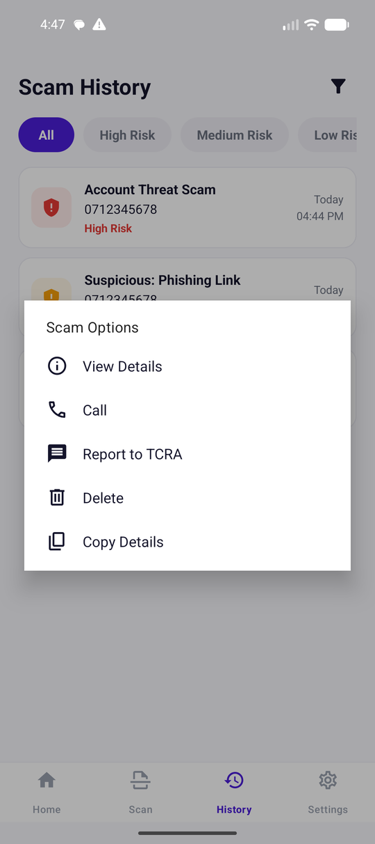  The five row actions

Action | What happens | Code
View Details | Opens ScamDetailsFragment with re-computed reasons | ScanArgs.ofStored(scam)
Call | Opens the dialer with the number (does not dial) | Intent.ACTION_DIAL
Report to TCRA | Opens the SMS app to 15040 and marks the row reported | ACTION_SENDTO + markAsReported()
Delete | Confirms, then deletes the row | dbHelper.deleteScam(id)
Copy Details | Copies phone, type, message, date and status | ClipboardManager

19. Notifications and User Alerts
How an alert is built
ScamDetector says SUSPICIOUS or SCAM
↓
NotificationHelper.showRiskAlert(context, sender, result)
↓
createNotificationChannel() channel "scamshield_alerts", IMPORTANCE_HIGH
↓
NotificationCompat.Builder title, text, BigTextStyle, vibration
↓
PendingIntent → MainActivity what happens when the user taps it
↓
NotificationManager.notify(id) Android draws it

utils/NotificationHelper.java — lines 66–91
66 public static void showRiskAlert(Context context, String phoneNumber,
67 ScamDetector.ScamResult result) {
68 createNotificationChannel(context);
69 String title = ScamDetector.SCAM.equals(result.classification)
70 ? context.getString(R.string.notif_scam_title)
71 : context.getString(R.string.notif_suspicious_title);
72 String text = context.getString(R.string.notif_risk_text,
73 phoneNumber, result.scamType, result.score);
74
75 NotificationCompat.Builder builder = new NotificationCompat.Builder(
76 context, ALERT_CHANNEL_ID)
77 .setSmallIcon(android.R.drawable.ic_dialog_alert)
78 .setContentTitle(title)
79 .setContentText(text)
80 .setStyle(new NotificationCompat.BigTextStyle().bigText(text))
81 .setContentIntent(openAppIntent(context))
82 .setPriority(NotificationCompat.PRIORITY_HIGH)
83 .setAutoCancel(true)
84 .setVibrate(new long[]{0, 500, 200, 500});
85
86 NotificationManager manager =
87 (NotificationManager) context.getSystemService(Context.NOTIFICATION_SERVICE);
88 if (manager != null) {
89 manager.notify((int) System.currentTimeMillis(), builder.build());
90 }
91 }

Piece | What it is for
Channel | Since Android 8 every notification belongs to a channel; the user can silence a channel instead of the whole app. ScamShield has two: alerts (high importance) and protection (low, silent).
NotificationCompat.Builder | The AndroidX builder that produces a notification that works on old and new Android versions.
setStyle(BigTextStyle) | Lets the three lines (sender, type, score) expand instead of being cut off.
PendingIntent | A "permission slip": Android launches MainActivity on the app’s behalf when the notification is tapped. FLAG_IMMUTABLE means the system may not rewrite it — required from Android 12.
setAutoCancel(true) | The alert disappears once tapped.
notify((int) System.currentTimeMillis(), …) | A different ID each time, so a second scam does not overwrite the first alert.

The two channels
utils/NotificationHelper.java — lines 24–37
24 public static void createNotificationChannel(Context context) {
25 if (Build.VERSION.SDK_INT < Build.VERSION_CODES.O) return;
26
27 NotificationChannel channel = new NotificationChannel(
28 ALERT_CHANNEL_ID,
29 context.getString(R.string.notif_channel_name),
30 NotificationManager.IMPORTANCE_HIGH);
31 channel.setDescription(context.getString(R.string.notif_channel_desc));
32 channel.enableVibration(true);
33 channel.setVibrationPattern(new long[]{0, 500, 200, 500});
34
35 NotificationManager manager = context.getSystemService(NotificationManager.class);
36 if (manager != null) manager.createNotificationChannel(channel);
37 }

The alert channel: high importance, vibration, tap opens the app
The protection channel: low importance, ongoing, cannot be swiped away
🧠 What you must understand
A weakness worth admitting before a lecturer finds it: showRiskAlert() does not check whether POST_NOTIFICATIONS was granted. On Android 13+ with the permission denied, the detection still runs and the row is still stored, but the user sees nothing until they open the app. ProtectionManager prevents this in the normal flow by refusing to enable protection without the permission — but a message analysed by hand can still be silent.

20. Dashboard Logic
The dashboard after three manual checks and one real SMS

Every number on this screen is computed in one method, HomeFragment.loadStats(), which runs in onResume():
HomeFragment.java — lines 74–102
74 private void loadStats() {
75 List<ScamModel> scams = dbHelper.getAllScams();
76 int total = scams.size();
77
78 // Clean messages are not stored, so the scan counter is kept in prefs;
79 // it can only ever be behind the database, never ahead of it.
80 tvScanned.setText(String.valueOf(Math.max(AppPrefs.getScannedCount(requireContext()), total)));
81 tvDetected.setText(String.valueOf(total));
82 tvReportsSent.setText(String.valueOf(dbHelper.getReportedCount()));
83
84 int high = 0, medium = 0, low = 0;
85 for (ScamModel scam : scams) {
86 String risk = ScamDetector.riskLevelFor(scam.getScamType());
87 if (RiskUi.HIGH.equals(risk)) {
88 high++;
89 } else if (RiskUi.MEDIUM.equals(risk)) {
90 medium++;
91 } else {
92 low++;
93 }
94 }
95
96 tvHighRisk.setText(String.valueOf(high));
97 tvMediumRisk.setText(String.valueOf(medium));
98 tvLowRisk.setText(String.valueOf(low));
99 riskDonut.setCounts(high, medium, low);
100
101 showAlerts(scams);
102 }

What the user sees | Where the number comes from
Messages Scanned | max(AppPrefs.getScannedCount(), rows in the database) — the preference counts safe messages too, which are never stored
Scams Detected | dbHelper.getAllScams().size() — every stored row
Reports Sent | dbHelper.getReportedCount() — rows with is_reported = 1
High / Medium / Low | Counted in the loop above with ScamDetector.riskLevelFor(scam.getScamType())
The ring | riskDonut.setCounts(high, medium, low) — views/RiskDonutView draws three arcs with Canvas
Recent Alerts | The first MAX_ALERTS = 3 rows, shown by AlertAdapter
"No scams detected yet" | Shown by showAlerts() when the list is empty

🧠 What you must understand
Two honest details about this screen. First, Math.max exists because the scan counter lives in preferences and the rows live in SQLite: if a user clears history, the counter must not drop below the number of rows. Second, the Low Risk tile is normally 0 — safe messages are never stored, so only Medium and High rows exist. Do not present "Low Risk: 0" as proof that no harmless messages arrived.

The risk ring is our own code
views/RiskDonutView.java — lines 61–67
61 public void setCounts(int high, int medium, int low) {
62 this.high = Math.max(0, high);
63 this.medium = Math.max(0, medium);
64 this.low = Math.max(0, low);
65 this.totalText = String.valueOf(this.high + this.medium + this.low);
66 invalidate();
67 }

RiskDonutView extends View and overrides onDraw(), drawing one arc per bucket with Canvas.drawArc() and the app’s own colours, so it follows the light and dark palettes. No chart library is used — that is one less dependency in the APK.

21. Permissions
Permission | Level | Why ScamShield needs it | If the user says no
RECEIVE_SMS | Dangerous — runtime dialog | To be woken with the message when an SMS arrives | Real-time detection cannot run; the switch stays off. Manual paste still works
POST_NOTIFICATIONS | Dangerous (Android 13+) | To show the scam alert and the protection notification | Protection will not enable; detections are stored silently
VIBRATE | Normal — granted at install | The alert vibration pattern | n/a
FOREGROUND_SERVICE | Normal | To run the visible protection service | n/a
FOREGROUND_SERVICE_SPECIAL_USE | Normal (Android 14+) | The declared type for that service | n/a

Runtime permissions: asking properly
Since Android 6, a dangerous permission must be requested while the app is running, and the user can refuse or withdraw it later. ScamShield asks in two places, and both ask for the same list from one method:
utils/ProtectionManager.java — lines 18–26
18 public static String[] requiredPermissions() {
19 if (Build.VERSION.SDK_INT >= Build.VERSION_CODES.TIRAMISU) {
20 return new String[]{
21 Manifest.permission.RECEIVE_SMS,
22 Manifest.permission.POST_NOTIFICATIONS
23 };
24 }
25 return new String[]{Manifest.permission.RECEIVE_SMS};
26 }

During onboarding
OnboardingActivity.java — lines 36–37
36 ActivityCompat.requestPermissions(this,
37 ProtectionManager.requiredPermissions(), PERMISSION_REQUEST);

From the Settings switch (the modern API)
ProfileFragment.java — lines 34–47
34 private final ActivityResultLauncher<String[]> protectionPermissionLauncher =
35 registerForActivityResult(new ActivityResultContracts.RequestMultiplePermissions(), result -> {
36 if (getContext() == null) return;
37 if (ProtectionManager.hasRequiredPermissions(requireContext())) {
38 ProtectionManager.enable(requireContext());
39 Toast.makeText(getActivity(), R.string.protection_enabled_toast,
40 Toast.LENGTH_SHORT).show();
41 } else {
42 ProtectionManager.disable(requireContext());
43 Toast.makeText(getActivity(), R.string.protection_permission_denied,
44 Toast.LENGTH_LONG).show();
45 }
46 updateProtectionState();
47 });

- registerForActivityResult(…) is the current AndroidX way: it registers a callback before the screen is shown and hands back the result, without the old onRequestPermissionsResult request codes.
- The callback does not trust the dialog result on its own — it re-asks ProtectionManager.hasRequiredPermissions() before enabling anything.
- If anything was refused, protection is explicitly disabled and the user is told, instead of the app pretending to be on.

The state machine the switch obeys
ProfileFragment.java — lines 108–125
108 private void updateProtectionState() {
109 if (ProtectionManager.isEnabled(requireContext())
110 && !ProtectionManager.hasRequiredPermissions(requireContext())) {
111 ProtectionManager.disable(requireContext());
112 }
113 boolean active = ProtectionManager.isActive(requireContext());
114 updatingProtectionSwitch = true;
115 switchProtection.setChecked(active);
116 updatingProtectionSwitch = false;
117
118 if (active) {
119 tvProtectionStatus.setText(R.string.protection_active);
120 } else if (!ProtectionManager.hasRequiredPermissions(requireContext())) {
121 tvProtectionStatus.setText(R.string.protection_needs_permission);
122 } else {
123 tvProtectionStatus.setText(R.string.protection_inactive);
124 }
125 }

State | Switch | Status text
Enabled + permissions granted | On | "Active — incoming SMS is monitored"
Permissions missing | Off | "Off — SMS and notification permissions required"
Permissions fine, user switched off | Off | "Off — incoming SMS is not monitored"

🎤 What to say during presentation
"Permissions are checked, never remembered. Every time the Settings screen appears, and every time an SMS arrives, the app re-asks Android whether it still holds RECEIVE_SMS. If the user withdrew it in system settings while we were closed, protection turns itself off rather than claiming to be on."

📍 Where are we now in the ScamShield flow?
SMS arrives on the phone (Android telephony)
↓
SmsReceiver.onReceive() is called
↓
Sender + text extracted, service messages skipped (WhitelistUtils)
↓
ScamDetector.detect() scores the message
↓
SAFE / SUSPICIOUS / SCAM decided
↓
▶ DatabaseHelper.addScam() + NotificationHelper.showRiskAlert() ◀ WE ARE HERE
↓
Dashboard and History read the database

22. Complete System Architecture

ScamShield explained like a story
Imagine the phone’s message inbox is a building, and ScamShield is the security team.
- The postman is Android. Only the postman touches the post; nobody in the building runs outside to look for letters. When a letter arrives, the postman rings a bell.
- `SmsReceiver` is the guard who answers the bell. He does not sit awake all night — he is woken by the bell, reads the letter and the sender, and that is all.
- Before reading further, the guard checks a short list: `WhitelistUtils`, the list of official senders. A letter from the bank’s own counter (a 3–5 digit short code) is waved through.
- `ScamDetector` is the inspector. He has a written manual of 25 signs — asks for a PIN, promises a prize, demands a fee, hides a link — each worth a number of points, plus 7 pairs that are worse together. He totals the points, out of 100.
- Two lines on the inspector’s wall decide the verdict: 60 and above is a scam, 30 to 59 is suspicious, below 30 is fine.
- If the letter is bad, two things happen: `NotificationHelper` rings the alarm the resident can see, and `DatabaseHelper` writes it in the logbook.
- The logbook is what the resident reads later on the dashboard and the History screen — and the inspector can always re-read a page and explain again why he flagged it.
- Finally, the resident can ask the security team to write a complaint letter to TCRA. The team drafts it, but the resident posts it themselves.
That last detail is true of the real app: ScamShield prepares the report and hands it to the phone’s SMS app, where the user presses Send.

The architecture diagram
ScamShield, top to bottom
ANDROID OPERATING SYSTEM
│
┌──────────────────────┼────────────────────────┐
│ SMS_RECEIVED broadcast │ user taps the icon / a tab │
▼ ▼ │
┌────────────────┐ ┌────────────────────────┐ │
│ SmsReceiver │ │ SplashActivity │ │
│ (manifest- │ │ └─ OnboardingActivity │ │
│ declared) │ │ └─ MainActivity │ │
└───────┬────────┘ │ └─ 9 Fragments │ │
│ └────────────┬──────────────┘ │
│ ProtectionManager.isActive()? │
│ │ AnalyzeFragment (manual paste) │
▼ ▼ │
┌────────────────┐ ┌────────────────────────┐ │
│ WhitelistUtils │ │ ScamDetector │ │
│ service traffic │─────▶│ normalize + canonicalize│ │
│ skipped │ │ 25 rules + 7 combos │ │
└────────────────┘ │ score 0–100 │ │
└───────────┬────────────┘ │
│ ScamResult │
┌───────────────┼───────────────┐ │
▼ ▼ ▼ │
SAFE SUSPICIOUS SCAM │
(nothing) └──────┬───────┘ │
▼ │
┌──────────────────┴─────────────────┐ │
▼ ▼ │
┌─────────────────┐ ┌──────────────────┐ │
│ DatabaseHelper │ │ NotificationHelper│ │
│ SQLite "scams" │ │ alert + ongoing │ │
└────────┬────────┘ └──────────────────┘ │
│ │
└─▶ HomeFragment / HistoryFragment ───────────┘
(dashboard, list, details, report flow)

🧠 What you must understand
The diagram has two entrances and one engine. An SMS can enter automatically through SmsReceiver, or by hand through AnalyzeFragment — but both call the same ScamDetector.detect(), so a message gets the same verdict either way. A panel loves this question: "is the manual check the same code as the automatic one?" The answer is yes, and you can point at the single call site in each file.

23. File Connection Diagram
Which file opens which
AndroidManifest.xml
├─ .SplashActivity ─────────────────▶ splash_activity.xml
│ └─ AppPrefs.isFirstLaunch()
│ ├─▶ OnboardingActivity ──▶ OnboardingAdapter ─▶ item_onboarding.xml
│ └─▶ MainActivity ────────▶ activity_main.xml + bottom_nav_menu.xml
│ └─ nav_graph.xml
│ ├─ HomeFragment ──▶ fragment_home.xml
│ │ ├─ AlertAdapter ─▶ item_alert.xml
│ │ ├─ RiskDonutView
│ │ └─ DatabaseHelper
│ ├─ AnalyzeFragment ─▶ fragment_analyze.xml
│ │ └─ ScamDetector ─▶ ScanArgs ─▶ ScanResultFragment
│ ├─ HistoryFragment ─▶ ScamAdapter ─▶ item_scam.xml
│ ├─ ScamDetailsFragment ─▶ item_indicator.xml
│ ├─ ReportScamFragment ─▶ ReviewReportFragment ─▶ ReportSentFragment
│ └─ ProfileFragment ─▶ ProtectionManager ─▶ ProtectionService
│
└─ .receivers.SmsReceiver
├─▶ ProtectionManager.isActive() ─▶ AppPrefs
├─▶ WhitelistUtils.isServiceMessage()
├─▶ ScamDetector.detect() ─▶ DetectionRule (×25 rules)
│ └─ ScamResult
├─▶ DatabaseHelper.addScam() ─▶ ScamModel
└─▶ NotificationHelper.showRiskAlert() ─▶ MainActivity (PendingIntent)

What happens if we remove this?
This table proves you understand the architecture rather than just the file names.
Remove… | What stops working | What still works
receivers/SmsReceiver.java | All real-time detection. Nothing reacts to an incoming SMS | Manual checking, history, reporting — the whole app minus automation
utils/ScamDetector.java | Everything. Messages could be received but never judged; the app cannot compile | —
utils/DetectionRule.java | The rule table cannot be built; detector cannot compile | —
database/DatabaseHelper.java | History, the dashboard counts and the risk ring. Reports lose their subject | Detection and the alert notification
utils/NotificationHelper.java | The user gets no warning while the app is closed | Detection, storage, history — silently
services/ProtectionService.java | The visible "protection is active" notification | Detection itself — the receiver is independent
utils/ProtectionManager.java | The on/off switch and the permission gate; onReceive would run unconditionally | Detection, but with no user control — unacceptable
utils/WhitelistUtils.java | Operator and bank traffic would reach the detector (suppressor rules still catch most of it) | Everything else
utils/ScanArgs.java | The scan → details → report chain loses its data | Real-time detection and storage
utils/RiskUi.java | Colours and labels for risk across four screens | Detection and storage
views/RiskDonutView.java | The ring on the dashboard | The three numbers beside it

24. Data Flow Diagram
Where the data goes — and where it stops
Scammer’s phone User typing in the app
│ │
▼ ▼
SMS over the mobile network EditText etPhone / etMessage
│ │
▼ │
Android telephony │
│ Intent (PDUs) │
▼ │
SmsReceiver.onReceive() │
│ String sender, String message │
└───────────────┬───────────────────┘
▼
ScamDetector.detect(message, sender)
│ ScamResult {classification, score,
│ scamType, dangerLevel,
│ indicators[], matchedRules[]}
┌───────────────┼───────────────┐
▼ ▼ ▼
SharedPreferences SQLite row Notification
messagesScanned++ (if alerting) (if alerting)
│ │
└─────┬───────┘
▼
HomeFragment tiles + RiskDonutView + HistoryFragment list
│
▼ ScanArgs Bundle (re-runs the detector for stored rows)
ScamDetailsFragment → ReportScamFragment → ReviewReportFragment
│
▼ Intent with the report text
The phone’s SMS app (15040) or the share sheet — the USER presses send

🧠 What you must understand
Follow every arrow to its end: they all stop inside the phone. The only arrow that leaves the device is the last one, and it is an SMS the user sends themselves from their own SMS app, containing the sender number and the scam type — not the message body.

How the components talk to each other
From | To | How | Evidence in code
Android OS | SmsReceiver | Broadcast Intent | intent-filter for SMS_RECEIVED
SmsReceiver | ScamDetector | Direct static method call | ScamDetector.detect(message, sender)
ScamDetector | caller | Return value (ScamResult) | return new ScamResult(…)
SmsReceiver | DatabaseHelper | Method call → SQL INSERT | new DatabaseHelper(context).addScam(…)
SmsReceiver | NotificationHelper | Method call → NotificationManager | showRiskAlert(context, sender, result)
Notification | MainActivity | PendingIntent | openAppIntent(context)
Fragment | Fragment | Bundle through the NavController | ScanArgs.of(…) / navigate(id, args)
ProfileFragment | ProtectionService | Via ProtectionManager → startForegroundService | ProtectionManager.enable(context)
App | SMS app | Implicit Intent ACTION_SENDTO | Uri.parse("smsto:" + TCRA_SHORTCODE)
Other apps | MainActivity | Implicit Intent ACTION_SEND | routeSharedText()

25. Complete Execution Example
One message, ten steps, with the real class, method and result at each step. This exact message was sent to the emulator while preparing this guide.
The message
URGENT! Your bank account will be blocked.
Verify now at http://example-scam-link.com

from: 0754123456

Step 1 — Android receives the SMS
The modem decodes it; the telephony service broadcasts android.provider.Telephony.SMS_RECEIVED with the raw PDUs attached.

Step 2 — which ScamShield component activates
receivers/SmsReceiver.java. Android matches the broadcast against the intent-filter in the manifest and calls onReceive(Context, Intent) on the main thread, starting the app process first if needed.

Step 3 — the guard clause
ProtectionManager.isActive(context) → AppPrefs.isProtectionEnabled() is true and RECEIVE_SMS + POST_NOTIFICATIONS are granted → continue.

Step 4 — extracting the text
Telephony.Sms.Intents.getMessagesFromIntent(intent) returns one SmsMessage. getDisplayOriginatingAddress() → "0754123456"; getMessageBody() → the two lines above; getTimestampMillis() → the network time used for the row.

Step 5 — the whitelist
WhitelistUtils.isServiceMessage("0754123456", body) → false: the sender is 10 digits (not a 3–5 digit short code) and contains no letters, so it cannot be an operator sender ID. Detection proceeds.

Step 6 — preparation
View | Content
RAW | URGENT! Your bank account will be blocked. Verify now at http://example-scam-link.com
MESSAGE (normalised) | urgent! your bank account will be blocked. verify now at http://example-scam-link.com
CANONICAL | the same here — this message uses no character tricks
SENDER | 0754123456

Step 7 — which rules fire
Rule | Evidence it reports | Kind | Weight
R07_ACCOUNT_THREAT | "account will be blocked" | strong | +30
R03_URGENCY | "urgent" | weak | +15
R05_LINK | "http://example-scam-link.com" | weak | +12
R10_INSTITUTION | "bank" | weak | +10
C04_BRAND_MISMATCH | speaks for an institution, sent from a personal number | context | +20
C05_URGENT_LINK | a deadline paired with a link | context | +10

Step 8 — the arithmetic
Score computation
strong = 30 (R07)
weak = 15 + 12 + 10 = 37 → capped at WEAK_SIGNAL_LIMIT = 30
context = 20 (C04) + 10 (C05) = 30 → added to strong → strong = 60
suppression = 0 (no S-rule fired)
score = min(100, 60 + 30 - 0) = 90

Step 9 — the verdict
90 ≥ SCAM_THRESHOLD (60) → classification SCAM, danger level High Risk. Category scores: Account Threat 30, Brand Impersonation 20, generic signals ignored when naming → display type "Account Threat Scam".

Step 10 — what the user sees
- AppPrefs.incrementScannedCount() — "Messages Scanned" +1.
- DatabaseHelper.addScam("0754123456", body, "Account Threat Scam", timestamp) — one new row.
- NotificationHelper.showRiskAlert(…) — heads-up alert: Scam detected — From: 0754123456, Type: Account Threat Scam, Risk score: 90/100.
- Opening the app shows the row in Recent Alerts and History; tapping it re-runs the detector and lists the six reasons above.
🧠 What you must understand
Every number in this trace came from running the real code, not from reading it. You can reproduce it in seconds during the presentation with the emulator: adb emu sms send 0754123456 "URGENT! Your bank account will be blocked. Verify now at http://example-scam-link.com"

📍 Where are we now in the ScamShield flow?
SMS arrives on the phone (Android telephony)
↓
SmsReceiver.onReceive() is called
↓
Sender + text extracted, service messages skipped (WhitelistUtils)
↓
ScamDetector.detect() scores the message
↓
SAFE / SUSPICIOUS / SCAM decided
↓
▶ DatabaseHelper.addScam() + NotificationHelper.showRiskAlert() ◀ WE ARE HERE
↓
Dashboard and History read the database

26. File-by-File Code Walkthrough
A one-line summary of every file, in the order they run. Use this as the map while reading the code.
File | Responsibility | Called by | Calls / uses
ScamShieldApp.java | Applies the saved theme before any screen | Android (app start) | AppPrefs
SplashActivity.java | Brand screen, then routes first-run vs normal | Android (launcher) | AppPrefs, OnboardingActivity, MainActivity
OnboardingActivity.java | Intro pages + permission requests; enables protection at the end | SplashActivity | OnboardingAdapter, ProtectionManager, AppPrefs
OnboardingAdapter.java | Supplies the three intro pages to ViewPager2 | OnboardingActivity | item_onboarding.xml
MainActivity.java | Hosts tabs + fragments; receives shared SMS | Android, notifications, share sheet | NavController, NotificationHelper, ProtectionManager, Nav
HomeFragment.java | Dashboard numbers, ring, recent alerts | NavController | DatabaseHelper, AppPrefs, ScamDetector, RiskUi, AlertAdapter, ScanArgs
AnalyzeFragment.java | Manual check: form → detector → verdict | NavController | ScamDetector, DatabaseHelper, NotificationHelper, ScanArgs, DateFormats
ScanResultFragment.java | Shows the verdict and the evidence | NavController | ScanArgs, RiskUi, ScamDetector (constants)
ScamDetailsFragment.java | Full record of one scam; share and block | NavController | ScanArgs, RiskUi, DateFormats, TelecomManager
ReportScamFragment.java | Choose channel, add notes | NavController | ScanArgs, RiskUi
ReviewReportFragment.java | Final check, hands the report to the SMS/share app | NavController | DatabaseHelper, ScanArgs, Nav, DateFormats
ReportSentFragment.java | Confirmation screen | NavController | Nav, ScanArgs
HistoryFragment.java | Stored list, filters, row actions | NavController | DatabaseHelper, ScamAdapter, ScamDetector, RiskUi, DateFormats
ProfileFragment.java | Settings: protection, language, theme, reset | NavController | ProtectionManager, AppPrefs, DatabaseHelper, NotificationHelper
ScamAdapter.java | One history row per ScamModel | HistoryFragment | item_scam.xml, RiskUi, DateFormats, ScamDetector
AlertAdapter.java | One dashboard alert row | HomeFragment | item_alert.xml, RiskUi, DateFormats, ScamDetector
receivers/SmsReceiver.java | Entry point for incoming SMS | Android OS | ProtectionManager, WhitelistUtils, ScamDetector, DatabaseHelper, NotificationHelper, AppPrefs
services/ProtectionService.java | Visible "protection is on" state | ProtectionManager | NotificationHelper
database/DatabaseHelper.java | The scams table and its six operations | 4 fragments + the receiver | SQLite, ScamModel, DateFormats
models/ScamModel.java | One stored scam as an object | Everything that shows a row | —
utils/ScamDetector.java | The engine: rules, score, verdict | SmsReceiver, AnalyzeFragment, ScanArgs, adapters | DetectionRule, java.util.regex
utils/DetectionRule.java | One rule and the four views of a message | ScamDetector | java.util.regex
utils/WhitelistUtils.java | Skip operator/bank traffic | SmsReceiver | —
utils/NotificationHelper.java | Channels, alerts, ongoing notification, settings | MainActivity, SmsReceiver, AnalyzeFragment, ProtectionService, HomeFragment, ProfileFragment | NotificationManager, PendingIntent
utils/ProtectionManager.java | Permissions + protection state + service | SmsReceiver, MainActivity, ProfileFragment, OnboardingActivity | AppPrefs, ProtectionService, ContextCompat
utils/AppPrefs.java | SharedPreferences for small state | 5 classes | AppCompatDelegate
utils/ScanArgs.java | The Bundle of the scan/report flow | 6 fragments | ScamDetector, RiskUi, ScamModel
utils/RiskUi.java | Risk → colour, label, headline | 7 classes | ScamDetector, R.color, R.string
utils/DateFormats.java | Stored stamp and human dates | DatabaseHelper, adapters, 3 fragments | SimpleDateFormat
utils/Nav.java | Shared navigation options | 5 fragments/activities | NavOptions
views/RiskDonutView.java | The risk ring, drawn by hand | fragment_home.xml | Canvas, Paint

27. Important Code Explained Line by Line
If a lecturer points at a line and asks "what does this do?", these are the lines they are most likely to choose.

super.onCreate(savedInstanceState);
Calls the parent class’s version of the method first. AppCompatActivity needs to restore its own state before your code runs; omitting this throws SuperNotCalledException. savedInstanceState is the Bundle Android saved if this screen was destroyed and recreated — it is null on a fresh start.

setContentView(R.layout.activity_main);
Reads the XML layout, creates the real view objects ("inflates" it) and attaches the tree to the Activity’s window. R is a class generated at build time holding an integer for every resource, so R.layout.activity_main is just a number the framework looks up.

tvScanned = view.findViewById(R.id.tvScanned);
Searches the inflated tree for the view whose android:id is tvScanned and returns it. Since Java 8 in AGP there is no cast: the method is generic and infers TextView from the variable. Doing this once in onCreateView() and keeping the field is why scrolling stays smooth.

ScamDetector.ScamResult result = ScamDetector.detect(pendingMessage, phone);
Fragment of the line | Meaning
ScamDetector.ScamResult | The type of the returned object — a static nested class declared inside ScamDetector
result | The local variable holding it
ScamDetector.detect(…) | A static call: no detector object is created, because the rules are shared and stateless
(message, phone) | The two inputs; the sender matters because two rules read it

Telephony.Sms.Intents.getMessagesFromIntent(intent)
An Android framework helper that pulls the raw PDU byte arrays out of the broadcast Intent and rebuilds them into SmsMessage objects. A message longer than 160 characters arrives as several parts, which is why the code loops and appends the bodies.

context.getSystemService(Context.CLIPBOARD_SERVICE)
Asks Android for one of its system managers. The returned object must be cast to the right type (ClipboardManager). ScamShield uses the same pattern for NotificationManager and TelecomManager.

PendingIntent.getActivity(context, 0, intent, FLAG_UPDATE_CURRENT | FLAG_IMMUTABLE)
Creates a token that lets another process (the notification system) start our Activity later, with our permissions. FLAG_IMMUTABLE forbids the receiver of the token from changing the Intent inside it — mandatory from Android 12 for security.

new DatabaseHelper(context).addScam(sender, message, result.scamType, receptionTime)
Creates the SQLite helper (which opens or creates the database on first use) and inserts one row. The helper is created where it is needed rather than kept in a field, because a BroadcastReceiver object is discarded as soon as onReceive() returns.

Cursor cursor = db.query(TABLE_SCAMS, null, null, null, null, null, COLUMN_ID + " DESC");
null for the columns means "all columns"; the three nulls after it are the WHERE clause, its arguments and GROUP BY; the last argument is ORDER BY. Reading it aloud: select everything from `scams`, newest id first.

@Override
An annotation telling the compiler "this method replaces one from the parent class or interface". If the signature is wrong — a typo such as onCreat — the build fails instead of silently never being called.

private static final int WEAK_SIGNAL_LIMIT = 30;
Keyword | Meaning here
private | Only this class can see it (this one is public — the tests read it)
static | Belongs to the class, not to an object; there is one copy
final | Cannot be reassigned — a constant
int | A whole number

28. Object-Oriented Programming Concepts Used
Every OOP idea in the syllabus appears somewhere in ScamShield. Use these examples rather than textbook ones.
Concept | Where it lives in ScamShield
Class | DetectionRule — a blueprint for one rule
Object | Each of the 25 entries in the RULES list is a DetectionRule object
Constructor | new DetectionRule(id, regex, weight, explanation, category, field) — compiles the pattern once
Field / instance variable | private final Pattern pattern; inside DetectionRule
Method | match(Input input) returns the text that fired the rule
Parameter / return value | detect(String message, String sender) → ScamResult
Encapsulation | The pattern and weight fields are private; callers can only ask isWeak(), getWeight(), match()
Inheritance | MainActivity extends AppCompatActivity, SmsReceiver extends BroadcastReceiver, DatabaseHelper extends SQLiteOpenHelper, RiskDonutView extends View
Method overriding | onCreate(), onReceive(), onDraw(), onBindViewHolder() — all marked @Override
Interface | ScamAdapter.OnScamClickListener — declared by the adapter, implemented by the fragments
Anonymous class | new View.OnClickListener() { … } in most fragments
Lambda | v -> showLanguageDialog() in ProfileFragment
Static nested class | ScamDetector.ScamResult, DetectionRule.Input, ScamAdapter.ViewHolder
Enum | DetectionRule.Field — RAW, MESSAGE, CANONICAL, SENDER, SENDER_OR_MESSAGE
Utility class | ScamDetector, RiskUi, AppPrefs, Nav — final classes with a private constructor and static methods
Immutability | ScamModel has only final fields; ScamResult wraps its lists in Collections.unmodifiableList
Polymorphism | The loop for (DetectionRule rule : RULES) rule.match(input) treats 25 different rules identically

The interface, as written
ScamAdapter.java — lines 27–29
27 public interface OnScamClickListener {
28 void onScamClick(ScamModel scam);
29 }

HistoryFragment implements it to open the options dialog; HomeFragment implements it to open the details screen. The adapter does not know or care which — that is the point of an interface.

Why not put everything in MainActivity?
This question is asked in almost every defence. The answers, with proof from this project:
Reason | Proof in ScamShield
Separation of concerns | ScamDetector decides, DatabaseHelper stores, fragments display. Each file has one job
Testability | The detector has no Android imports, so 28 unit tests run on a laptop in seconds. Logic inside an Activity could only be tested on a device
Reuse | ScamDetector.detect() is called from the receiver, the manual screen and ScanArgs. One copy, three callers
Consistency | RiskUi means the four screens that paint risk cannot disagree; ProtectionManager means the four callers of protection cannot disagree
Maintainability | Adding a rule means adding one rules.add(…) line — no screen changes
Debuggability | A wrong verdict is a detector bug; a missing row is a database bug. The blame is narrow
Lifecycle safety | A BroadcastReceiver lives milliseconds. If detection lived in an Activity, an SMS arriving while the app was closed could not be judged

Java syntax you will be asked about
Syntax | What it means | Real example
new | Create an object | new DatabaseHelper(context)
this | The current object | ProtectionManager.restore(this) inside an Activity
super | The parent class | super.onCreate(savedInstanceState)
extends | Inherit from a class | class MainActivity extends AppCompatActivity
implements | Promise to provide an interface’s methods | class ScamModel implements Serializable
null | "No object" | if (scam == null) return;
boolean | true / false | boolean isReported
int | Whole number | int score
String | Text | String scamType
List<String> / ArrayList<> | An ordered collection; <String> is the generic type it holds | List<String> indicators = new ArrayList<>();
try / catch | Run code that may fail, and handle the failure | catch (ActivityNotFoundException e) around every external Intent
switch | Choose among fixed values | switch (bucket(risk)) in RiskUi
?: | A compact if/else that produces a value | isRisky ? ScanArgs.risk(args) : RiskUi.LOW
static block | Runs once when the class is first loaded | The static { } that builds the 25-rule table

29. Android Concepts Used
Concept | Where ScamShield uses it
Activity lifecycle | onCreate, onResume, onNewIntent, onDestroy
Fragment lifecycle | onCreateView, onResume
Navigation Component | nav_graph.xml, NavController, NavigationUI, NavOptions
Intents (explicit + implicit) | Starting activities, dialling, SMS, sharing
PendingIntent | Notification taps
BroadcastReceiver | SmsReceiver
Foreground Service | ProtectionService
Runtime permissions | ActivityCompat.requestPermissions, registerForActivityResult
SQLite + SQLiteOpenHelper | DatabaseHelper
SharedPreferences | AppPrefs
RecyclerView + Adapter + ViewHolder | History and Recent Alerts
ViewPager2 | The three onboarding pages
Notification channels | NotificationHelper
Custom View + Canvas | RiskDonutView
Resource qualifiers | values-sw (Kiswahili), values-night (dark theme)
Per-app language (AndroidX) | AppCompatDelegate.setApplicationLocales
Material Components | Buttons, switch, bottom navigation, dialogs
ClipboardManager, TelecomManager | Copy details, open blocked numbers

Synchronous and asynchronous work
Everything in ScamShield is synchronous and runs on the main thread. There is no Thread, Executor, AsyncTask, coroutine or WorkManager anywhere in the project. That is a deliberate scale decision, and you should be ready to defend it and to name its limit.
Operation | Where it runs | Why it is acceptable here | When it would stop being acceptable
ScamDetector.detect() | Main thread (inside onReceive or a click) | 25 pre-compiled regexes over one SMS — sub-millisecond | If rules grew into thousands, or an ML model were loaded
getAllScams() | Main thread, in onResume() | Tens of rows on a phone; the query is indexed by primary key | With thousands of rows the list would stutter — use a background thread or Room + LiveData
addScam() | Main thread inside onReceive() | One INSERT, and the receiver must finish quickly anyway | If the work grew, goAsync() or WorkManager would be required
SharedPreferences.apply() | Main thread call, disk write in background | That is what apply() is for | commit() would block the UI

🧠 What you must understand
Android gives a receiver roughly 10 seconds before it is killed. ScamShield’s onReceive() does a handful of regex matches and one INSERT, so it finishes in a few milliseconds — but if you ever add network calls or heavy work there, you must call goAsync() or hand the job to WorkManager. Saying this in the defence shows you know the limit of your own design.

30. Gradle and Dependencies

What Gradle is
Simple explanation: Gradle is the factory that turns the source files into an installable app. Technical explanation: Gradle is the build system; the Android Gradle Plugin adds the Android tasks (compiling resources, generating R, dexing, packaging and signing the APK). The Gradle wrapper (gradlew) pins the exact version — here Gradle 9.6.0 — so every group member builds identically.

app/build.gradle, explained
app/build.gradle — lines 5–27
5 android {
6 namespace 'com.group2.scamshield'
7 compileSdk 34
8
9 defaultConfig {
10 applicationId "com.group2.scamshield"
11 minSdk 24
12 targetSdk 34
13 versionCode 1
14 versionName "1.0"
15 }
16
17 buildTypes {
18 release {
19 minifyEnabled false
20 proguardFiles getDefaultProguardFile('proguard-android-optimize.txt'), 'proguard-rules.pro'
21 }
22 }
23 compileOptions {
24 sourceCompatibility JavaVersion.VERSION_11
25 targetCompatibility JavaVersion.VERSION_11
26 }
27 }

Setting | Value | What it means
namespace | com.group2.scamshield | The package the R class and BuildConfig are generated into
applicationId | com.group2.scamshield | The identity of the app on the device and on Play — two apps may never share it
compileSdk | 34 | The API level the code is compiled against (which framework classes are visible)
minSdk | 24 | The oldest Android the app installs on — Android 7.0 Nougat
targetSdk | 34 | The Android version the app declares it was tested against; controls which behaviour changes apply
versionCode | 1 | Internal build number, must increase with every release
versionName | "1.0" | The version shown to people
minifyEnabled false | release | R8 shrinking is off, so class names in the APK stay readable
sourceCompatibility / targetCompatibility | Java 11 | The Java language level used to compile

The dependencies
app/build.gradle — lines 29–40
29 dependencies {
30 implementation 'androidx.appcompat:appcompat:1.6.1'
31 implementation 'com.google.android.material:material:1.9.0'
32 implementation 'androidx.constraintlayout:constraintlayout:2.1.4'
33 implementation 'androidx.navigation:navigation-fragment:2.7.5'
34 implementation 'androidx.navigation:navigation-ui:2.7.5'
35
36 // Onboarding pages
37 implementation 'androidx.viewpager2:viewpager2:1.0.0'
38
39 testImplementation 'junit:junit:4.13.2'
40 }

Dependency | What it gives ScamShield
androidx.appcompat:appcompat:1.6.1 | AppCompatActivity, dark-mode support, per-app language
com.google.android.material:material:1.9.0 | Material buttons, SwitchMaterial, BottomNavigationView, dialogs — and RecyclerView transitively
androidx.constraintlayout:constraintlayout:2.1.4 | The layout used by activity_main.xml and the splash screen
androidx.navigation:navigation-fragment:2.7.5 | NavHostFragment, NavController — fragment navigation
androidx.navigation:navigation-ui:2.7.5 | NavigationUI, which binds the bottom bar to the graph
androidx.viewpager2:viewpager2:1.0.0 | The swipeable onboarding pages
junit:junit:4.13.2 (test only) | The 28 unit tests — not shipped in the APK

🧠 What you must understand
Notice what is absent: no TensorFlow Lite, no Room, no Retrofit or OkHttp, no Firebase, no analytics SDK. Seven libraries in total, one of them test-only. That is why the APK is small, why nothing phones home, and why the whole detection path can be read in an afternoon.

The other build files
File | Purpose
settings.gradle | Names the project, includes the :app module, declares where libraries are downloaded from
build.gradle (root) | Declares the Android Gradle Plugin for all modules
gradle/libs.versions.toml | The version catalogue — holds the AGP version (9.4.0) in one place
gradle/wrapper/gradle-wrapper.properties | Pins Gradle 9.6.0
gradle.properties | JVM memory for the build and the Gradle configuration cache
app/src/main/keepRules/rules.keep | Where R8 keep rules would go if shrinking were enabled

31. Error Handling
Be honest here: some failures are handled well, and some are not handled at all. Knowing which is which is what a panel is testing.

What is handled
Failure | How ScamShield handles it | Where
No SMS app / dialer installed | try/catch (ActivityNotFoundException) → a toast instead of a crash | HistoryFragment, ReviewReportFragment
No blocked-numbers screen | catch (ActivityNotFoundException | SecurityException) → toast | ScamDetailsFragment.openBlockedNumbers()
Empty message on the scan screen | setError("Add a message first") on the field, nothing is analysed | AnalyzeFragment.analyze()
null or empty message text | normalize()/canonicalize() return ""; no rule fires; verdict SAFE | ScamDetector — covered by nullMessage_doesNotCrashAndIsSafe
Permission withdrawn while closed | isActive() is false → receiver returns; Settings switch flips itself off | ProtectionManager, ProfileFragment
A malformed SMS broadcast | getMessagesFromIntent() returning null, or a null sender, exits early | SmsReceiver
Insert failure | addScam() returns -1; the verdict screen simply has no row id | AnalyzeFragment
Screen destroyed during the splash delay | handler.removeCallbacksAndMessages(null) in onDestroy() | SplashActivity
Unparseable stored date | DateFormats.parse() returns null and the raw text is shown | utils/DateFormats.java
A shared Intent without text | TextUtils.isEmpty(shared) → ignored | MainActivity.routeSharedText()

What is NOT handled — admit these before you are asked
- No `try/catch` around SQLite. getWritableDatabase() or an INSERT that fails (disk full, corrupt database) throws SQLiteException and crashes the app. A production version would wrap these.
- Cursors are not closed with try/finally. If an exception is thrown mid-loop in getAllScams(), cursor.close() is skipped and the cursor leaks.
- No notification-permission check before notify() — on Android 13+ with the permission denied the alert is silently dropped (section 19).
- No logging at all. There is not a single Log.d() in the project, so a failure in the field leaves no trace (section 40 shows exactly where to add them).
- Database work runs on the main thread, including inside onReceive(). It is fast today; it is not a pattern that scales.
- "Report Sent" is optimistic. The app shows the confirmation screen and marks the row reported as soon as the SMS app opens — it cannot know whether the user actually pressed Send.
🎤 What to say during presentation
"We handle the failures a user will actually hit — a missing SMS app, an empty message, a withdrawn permission, a malformed broadcast. We do not yet wrap the SQLite calls, and we have no logging, so a database failure would crash rather than degrade. Both are on the list of things we would fix before releasing this."

32. Privacy and Security
SMS is the most sensitive stream on a phone: one-time passwords, bank balances, private conversations. An app that reads it must be able to say exactly what it does with the text. ScamShield can — and the answers below are all provable from the code.
Question | Answer | Proof
Does the app read message content? | Yes, at the moment a message arrives | SmsReceiver.onReceive()
Does it read the existing inbox? | No | No READ_SMS permission; no query of the SMS provider anywhere
Does anything leave the phone? | No — the app has no network code | No INTERNET permission in the manifest; no HTTP library in build.gradle
Where does analysis happen? | Entirely on the device, in Java | ScamDetector — pure java.util.regex
Is internet needed? | No. The app works in flight mode | Same as above
Is message text stored? | Only for messages judged SUSPICIOUS or SCAM | if (result.shouldAlert()) before addScam()
Are safe messages stored? | No | Same if — nothing happens on the SAFE path
Can the user delete it? | Yes: one row, all rows, or Settings → Reset app data | deleteScam(), deleteAllScams(), AppPrefs.reset()
Does the app block or delete SMS? | No — it cannot | It listens to SMS_RECEIVED, not SMS_DELIVER; it is not the default SMS app

The privacy text shown in the app
Settings → Privacy & Security shows the string privacy_message: "Messages are checked on this phone only. Nothing is uploaded: the history lives in a local database and is cleared when you delete it." The first two claims are exactly right. The third needs one honest footnote:
🧠 What you must understand
AndroidManifest.xml sets android:allowBackup="true", and res/xml/backup_rules.xml and data_extraction_rules.xml are still the empty templates Android Studio generated. With the default rules, Android’s own Auto Backup may copy the app’s database and preferences to the user’s Google Drive backup. ScamShield itself uploads nothing — but the platform might, and a sharp examiner may ask. The one-line fix is to exclude the database in those rules, or set allowBackup="false".

Security of the app’s own surface
- SmsReceiver is protected by android:permission="android.permission.BROADCAST_SMS", so another app cannot fake an incoming SMS to it.
- OnboardingActivity is exported="false" — it cannot be launched from outside the app.
- MainActivity is exported on purpose, and only accepts ACTION_SEND with text/plain. The text is treated as data to analyse, never executed.
- Database writes use ContentValues and ? placeholders, so message text is never concatenated into SQL.
- PendingIntents are created with FLAG_IMMUTABLE, so the notification system cannot alter what they launch.
⚠️ Don’t say this
"The database is encrypted" — it is not. It is a plain SQLite file in the app’s private storage, which Android protects from other apps but not from a rooted device or a full backup. Say "stored in app-private storage", not "encrypted".

33. Offline and Online Operation
Everything happens on the device
SMS arrives
↓
Local processing normalize() + canonicalize() ← on device
↓
Local rule table 25 rules + 7 combinations ← on device
↓
Classification SAFE / SUSPICIOUS / SCAM ← on device
↓
Local storage SQLite on the phone ← on device
↓
Local notification ← on device

(the only thing that can leave the phone is a report SMS
that the USER sends from their own Messages app)

ScamShield is a fully offline application. No INTERNET permission, no HTTP client, no API key, no server. Detection works in flight mode, on a phone with no data bundle, in an area with no coverage — which matters for the users this project targets.
Advantage of offline | Cost of offline
Works with no data bundle or coverage | Rules cannot be updated without shipping a new APK
Message text never travels — strongest possible privacy | No shared intelligence between users
Instant: no round trip, no latency | The known-scam-number list (R01) is frozen at three numbers
Nothing to breach on a server; no hosting cost | No central dashboard for researchers or TCRA

34. Project Limitations
Being first to name a weakness turns it from an attack into evidence that you understand your own system. These are real, and each one has a matching improvement in section 35.
# | Limitation | Why it exists in this design
1 | New scam wording gets through. The rules describe scams the group has seen; a family of scams nobody wrote a rule for scores 0 | Hand-written rules cannot generalise the way a trained model can
2 | Measured recall is 0.674 on the held-out corpus — roughly a third of labelled scams were not flagged | 25 rules over very varied wording
3 | Letter-for-letter obfuscation is not undone. canonicalize() fixes p1n and p.i.n but not Xorry… nina xhida (x for s) | The fold table covers digits and separators only
4 | Spoofed alphanumeric senders can bypass detection entirely. If the sender contains letters and the text contains a service word such as namba (which contains "mb"), WhitelistUtils skips the message before the detector runs | The keyword list is matched with contains() on substrings
5 | The whitelist trusts any 3–5 digit short code, and short codes can be spoofed by an attacker with network access | A deliberate trade to keep genuine bank and operator traffic quiet
6 | No blocking. ScamShield warns after the message is already in the inbox; it cannot delete or block it | Only the default SMS app receives SMS_DELIVER
7 | Reporting is not confirmed. The app marks a row "reported" when the SMS app opens, not when the SMS is sent | The app cannot see what the user does in another app
8 | No `BOOT_COMPLETED` receiver. After a reboot detection still works, but the "protection is active" notification only returns when the app is opened | Nothing re-starts the service at boot
9 | Aggressive OEM battery managers (Xiaomi, Oppo, Tecno, Infinix…) may stop background delivery on some devices | Manufacturer behaviour outside the app’s control
10 | Force stop kills detection until the user opens the app again | Android’s stopped-state rule for all apps
11 | Everything runs on the main thread, including SQLite reads in onResume() | Acceptable at tens of rows; not at thousands
12 | No SQLite error handling and no logging | Discussed in section 31
13 | The corpus figure is optimistic. The rules were revised after measuring against bongo_scam.csv, and the file holds 1,377 distinct bodies in 1,508 rows, so near-duplicates inflate the result | No grouped cross-validation was run
14 | Kiswahili and English only. Sheng and heavy code-mixing are only partly covered | Patterns were written for the two languages

🎤 What to say during presentation
"Our biggest limitation is recall: on a held-out corpus of 1,508 Tanzanian messages we catch about 67 % of labelled scams, with no false alarms. And that figure is generous, because we revised rules after seeing that corpus. We would rather miss a scam than accuse a genuine bank message, so we tuned for precision — but a missed scam is still a real cost."

35. Possible Future Improvements
Improvement | Fixes limitation | What it would take
Community rule updates fetched from a server | 1, 2 | An INTERNET permission, a signed rules file, and a privacy decision — rules would travel, never messages
Letter-substitution folding (x→s, ii→i, sheng forms) | 3 | Extend letterFor() and the canonical pass; add tests from the missed rows
Tighten WhitelistUtils: exact keyword matching on word boundaries, and a real sender-ID allow-list | 4, 5 | Replace contains() with a word-boundary regex; keep a list of genuine sender IDs
Become the default SMS app (or add a warning overlay) | 6 | Implement the four components Android requires of an SMS app — a large change, and it makes the app responsible for the inbox
Confirm the report was actually sent | 7 | Use SmsManager with a sent PendingIntent and the SEND_SMS permission, instead of handing off to the SMS app
BOOT_COMPLETED receiver to restore the protection notification | 8 | One receiver, one permission (RECEIVE_BOOT_COMPLETED), a few lines
Move database work off the main thread (Room + LiveData, or an executor) | 11 | Replace DatabaseHelper with Room DAOs; the table shape stays the same
Wrap SQLite calls and add Log statements | 12 | try/catch + a small logging policy (never log message bodies)
Grouped cross-validation before quoting accuracy | 13 | Group near-duplicate bodies, evaluate per group, report the honest interval
A "was this right?" button on the verdict screen | 1, 2, 13 | Store the user’s correction locally; it becomes labelled data for the next version
Statistical classifier trained on the corpus, used beside the rules | 1, 2 | A Naive Bayes or logistic model exported for on-device use — but keep the rules for the explanation, or the app loses the thing that makes it trustworthy

36. Implemented vs Planned Features

Fully implemented — you can demonstrate these
- Real-time checking of incoming SMS while protection is on (SmsReceiver).
- Manual checking of a pasted or typed message (AnalyzeFragment).
- Receiving a message shared from another app (MainActivity.routeSharedText).
- Three-way classification with a 0–100 score and a named scam type (ScamDetector).
- Plain-language reasons, each quoting the text that triggered it (indicators).
- High-priority notification for SUSPICIOUS and SCAM (NotificationHelper).
- Visible ongoing "protection is active" notification (ProtectionService).
- Local history with risk filters, delete, clear-all, copy and call (HistoryFragment).
- Dashboard counters, risk ring and recent alerts (HomeFragment, RiskDonutView).
- Report flow to TCRA 15040 or to an operator via the share sheet.
- Opening Android’s blocked-numbers screen for a scam number.
- English and Kiswahili, light and dark theme, and a full reset.

Partially implemented — say "partly" when asked
Feature | What works | What does not
Reporting | The report is composed and the SMS app opens at 15040 | The app cannot confirm the user pressed Send, yet the row is marked reported and the screen says "Report Sent!"
Blocking a number | The app opens Android’s blocked-numbers screen | ScamShield does not block anything itself; the user completes it
Protection after reboot | Detection still works — the manifest receiver survives | The ongoing notification only comes back when the app is next opened
Notifications on Android 13+ | Shown when the permission is granted | No check before notify(); if denied, alerts are silently dropped
The "Low Risk" dashboard tile | The tile and the ring arc exist | It is normally 0, because safe messages are never stored

Not implemented — never claim these
- No OCR / screenshot reading. The option was removed from the Analyze screen because it was never implemented.
- No machine learning, no model file, no training at runtime.
- No blocking, deleting or silencing of messages.
- No reading of the existing inbox (no READ_SMS).
- No internet, no account, no cloud sync, no server-side reporting API.
- No call or WhatsApp scanning — SMS only.
- No automatic rule updates.

Dead or unused code
The project was cleaned before this guide was written, and the build tool agrees it is clean: Android Lint reports 0 unused resources and 0 errors, and there are no unused imports or unreachable methods. Removed in that pass were the screenshot/OCR option, the floating scan button, three unused database queries, unused model setters, a redundant whitelist number list, 24 unused icons, 26 unused strings and 4 unused colours, plus the two template example tests.
🎤 What to say during presentation
"There is no dead code in the project. We removed the unimplemented screenshot option rather than leaving a button that shows an error, and Android Lint reports zero unused resources."

37. Presentation Claims Verification
Before the defence, check every sentence in your slides against this table.
Claim | True? | Evidence
ScamShield detects incoming SMS automatically | Yes — while protection is on | SmsReceiver.onReceive() + manifest intent-filter
It classifies messages as safe / suspicious / scam | Yes | ScamDetector.detect(), thresholds 30 and 60
It explains why a message was flagged | Yes | result.indicators, shown by ScanResultFragment.addIndicators()
It stores a detection history | Yes | DatabaseHelper.addScam(), table scams
It works offline | Yes | No INTERNET permission; no network library
It works when the app is closed | Yes | Manifest-declared receiver; Android starts the process
It works after a reboot | Yes for detection | Receiver survives; the ongoing notification does not return until the app is opened
It uses machine learning / AI | No | No model, no training, no probabilities — 25 regex rules and weights
It uses a weighted scoring system | Yes | strongScore, weakScore, WEAK_SIGNAL_LIMIT, context bonuses
It blocks scam messages | No | Listens to SMS_RECEIVED; only the default SMS app can affect the inbox
It reports scams to TCRA | Partly | It composes the SMS to 15040; the user presses Send
It reads all messages in the inbox | No | No READ_SMS; only messages that arrive live, or are pasted
It never uploads message text | Yes, the app does not | No network code. (Android Auto Backup may copy the database — section 32)
It supports Kiswahili | Yes | res/values-sw/strings.xml, 167 strings; rules match Kiswahili wording directly
Accuracy is 78 % / recall 67 % | Measured, with caveats | BongoCorpusTest on 1,508 rows — read section 38 before quoting it

38. Testing ScamShield

The automated tests
The project has 28 unit tests in three classes, all pure JVM tests (no emulator needed). Run them with gradlew :app:testDebugUnitTest, or right-click the test folder in Android Studio.
Test class | Tests | What it proves
ScamDetectorTest | 24 | Rule behaviour: thresholds, the weak cap, suppression, obfuscation folding, every rule having a unique id and an explanation
ScamDetectorCorpusTest | 2 | A 20-scam / 20-genuine corpus written alongside the rules — a regression guard, scoring 1.000 by construction
BongoCorpusTest | 2 | The 1,508-message corpus collected separately — the honest measurement

A test that documents the scoring
app/src/test/java/com/group2/scamshield/ScamDetectorTest.java — lines 89–99
89 public void prizeWithPayment_isScamAndScoresAsDocumented() {
90 // 30 prize + 30 payment request + 20 combination, plus 12 amount and 12
91 // gift wording as supporting signals, which carries the total past the
92 // ceiling: a message this explicit scores the maximum.
93 ScamDetector.ScamResult result = ScamDetector.detect(
94 "Hongera umeshinda zawadi. Lipa shilingi 5000 sasa.", "PROMO");
95
96 assertEquals(ScamDetector.SCAM, result.classification);
97 assertEquals(ScamDetector.MAX_SCORE, result.score);
98 assertTrue(hasRule(result, "C01_PRIZE_PAYMENT"));
99 }

A test that protects the design
app/src/test/java/com/group2/scamshield/ScamDetectorTest.java — lines 121–130
121 public void weakSignalsAlone_cannotReachScam() {
122 // Link, amount, personal number, urgency and a brand name: five
123 // supporting signals worth 64 raw, capped so they can only warn.
124 ScamDetector.ScamResult result = ScamDetector.detect(
125 "OFA MPYA LEO! Bofya www.duka.co.tz, bei ni Tsh 20,000, "
126 + "piga 0715222333 haraka, huduma ya Vodacom.", "DUKA");
127
128 assertTrue(result.score < ScamDetector.SCAM_THRESHOLD);
129 assertEquals(ScamDetector.SUSPICIOUS, result.classification);
130 }

The measured figures
BongoCorpusTest prints its own report when it runs. These are the current numbers, copied from the test output:
Output of BongoCorpusTest
bongo corpus: 1508 rows (1000 scam, 508 genuine), no sender
TP=674 FP=0 TN=508 FN=326
precision=1.000 recall=0.674 f1=0.805 accuracy=0.784
reached SCAM threshold: 458 of 1000

Measure | Value | In plain words
Precision | 1.000 | Of the messages ScamShield flagged, none was a genuine one. Zero false alarms in this corpus
Recall | 0.674 | It flagged 674 of the 1,000 labelled scams; 326 were missed
F1 | 0.805 | The balance between the two
Accuracy | 0.784 | Correct verdicts over all 1,508 rows
Confusion matrix | TP 674, FP 0, TN 508, FN 326 | True/false positives and negatives

🧠 What you must understand
Four caveats you must state whenever you quote these numbers, all documented in app/src/test/resources/README.md: (1) the corpus has no sender column, so three sender-dependent rules sit idle and real recall on a phone should be better; (2) the labels are the collector’s, not a security analyst’s; (3) 1,508 rows contain only 1,377 distinct bodies, so near-duplicates weight the result; (4) the rules were revised after first measuring against this corpus (recall rose from 0.384 to 0.674), so it is no longer a truly held-out set. Quoting 67 % without caveat (4) would be dishonest.

Manual tests you can run in the presentation
Type the message… | What the app really returns | Why
Hello, what time are we meeting today? | SAFE, 0/100 | No rule fires
Mambo rafiki, tukutane saa kumi jioni pale mjini. | SAFE, 0/100 | Ordinary Kiswahili conversation
Click http://bit.ly/xyz to update your account now | SUSPICIOUS, 42/100 — Phishing Link | R11 (30) + R05 (12)
Tuma p.1.n yako sasa | SUSPICIOUS, 47/100 — Credential Theft | Canonicalisation turns p.1.n into pin
Congratulations! You have won TZS 5,000,000. Send TZS 50,000 processing fee to claim your prize. | SCAM, 100/100 — Money Request Scam | Three strong rules + C01
Ndugu mteja, akaunti yako ya M-Pesa imefungwa. Tuma PIN yako sasa hivi ili kuifungua. | SCAM, 100/100 — Account Threat Scam | R02 + R07 + C03
Habari, tuma pesa kwa namba hii 0754123456 haraka, jina litakuja Juma. | SCAM, 100/100 — Money Request Scam | R18 + R19 + C06 — the wrong-number scam
Your account requires verification. Click this link. | SAFE, 0/100 — a miss | R07 needs a threat word such as "blocked" or "verify"; "requires verification" does not match

⚠️ Don’t say this
Do not demonstrate the last row by accident. It is a genuine false negative and it is better to show it deliberately, as proof that you tested honestly, than to have a lecturer find it for you.

39. False Positives and False Negatives
The two kinds of mistake
FALSE POSITIVE FALSE NEGATIVE
a genuine message a real scam
↓ ↓
ScamShield says SCAM ScamShield says SAFE
↓ ↓
the user distrusts a real bank the user trusts a thief
↓ ↓
they stop believing the app they may lose money

Why each can happen in this design
Mistake | Cause in ScamShield | What limits it
False positive | A genuine message uses scam vocabulary — a bank asking you to verify, a promotion mentioning a prize | The three suppressor rules (S01–S03), the weak-signal cap of 30, and a SCAM threshold of 60. Measured FP = 0 on 508 genuine messages
False negative | The wording is not in any rule (new scam family), or uses letter substitution, or the sender bypasses via the whitelist | Nothing today — this is the honest weak point: 326 of 1,000

The families ScamShield currently misses
BongoCorpusTest prints ten sample misses each run. They fall into four groups, all named in the corpus README:
- Occult / Freemason recruitment — 666 KARIBU FREEMASON UTIMIZE NDOTO…. R08_HEALER_PROMISE covers traditional healers but not this vocabulary.
- Healer adverts written without "ya" — MZEE X WA TIBA ASILI. MALI. PETE. The rule requires tiba ya asili.
- Letter-for-letter obfuscation — Xorry nipo xafari nina xhida… unixaidie sh elfu 9. The canonicaliser folds digits and separators, not x for s.
- Landlord / new-number impersonation — mimi mwenye nyumba wako, hii namba yangu mpya… with no money verb close enough to fire R04.
🎤 What to say during presentation
"Our false-positive rate on 508 genuine messages was zero, and that was a deliberate trade: the suppressor rules and the cap on weak signals mean a pile of mild hints can never convict. The price is recall — we miss scam families nobody has written a rule for yet, and we can name them: occult recruitment, healer adverts without the exact phrase, x-for-s obfuscation, and landlord impersonation."

40. Debugging Guide

The tools
Tool | What it is for | How
Logcat | The live log from the device | Android Studio → Logcat, filter by package:com.group2.scamshield
Log.d(TAG, msg) | Your own debug message | import android.util.Log; then Log.d("ScamShield", "…")
Log.e(TAG, msg, e) | An error, with the exception | Use it in catch blocks
Breakpoints | Pause and inspect variables | Click the gutter, then Run → Debug
Emulator SMS | Send a test SMS with no second phone | adb emu sms send 0712345678 "message", or the emulator’s ... → Phone → SMS panel
Unit tests | Check detection logic without a device | gradlew :app:testDebugUnitTest
Device File Explorer | Inspect the SQLite file directly | View → Tool Windows → Device Explorer → /data/data/com.group2.scamshield/databases/

🧠 What you must understand
The project currently contains no `Log` statements at all. That is clean for release but unhelpful when something goes wrong in a demo. The five places below are where you would add them — and note the rule: never log the message body, only its length and the verdict, or your debug log becomes a copy of the user’s private SMS.

Where to put a log at each stage
Stage to verify | File and place | Suggested line
Did the SMS reach us? | SmsReceiver.onReceive(), first line | Log.d(TAG, "onReceive action=" + intent.getAction());
Was protection on? | After the guard if | Log.d(TAG, "active=" + ProtectionManager.isActive(context));
Was the text extracted? | After the message loop | Log.d(TAG, "sender=" + sender + " len=" + message.length());
Did the whitelist skip it? | Before the early return | Log.d(TAG, "skipped as service message");
What did the detector decide? | After detect() | Log.d(TAG, result.classification + " " + result.score + " " + result.matchedRules);
Was it stored and notified? | Inside if (result.shouldAlert()) | Log.d(TAG, "stored rowId=" + rowId);

A debugging checklist for the day of the demo
- Is protection on? Settings must read "Active — incoming SMS is monitored". If it says permissions are required, grant them.
- Is the emulator the right one? adb devices should list exactly one device, and it must be the one Android Studio deployed to.
- Did the broadcast arrive? With Logcat open, send adb emu sms send 0712345678 "Tuma pin yako sasa". No log line means the broadcast never reached the app — check the manifest receiver and the permission.
- Did the detector run? If the receiver logged but no verdict appeared, the message was probably skipped by WhitelistUtils — try a sender that is a full 10-digit number.
- Was there no notification? Check POST_NOTIFICATIONS in App info → Permissions, and that the ScamShield Alerts channel is not silenced.
- Is the row missing from History? Only SUSPICIOUS and SCAM are stored. Check the verdict first — SAFE is never written.
- Nothing at all? Reopen the app: a "Force stop" from Settings keeps the receiver dormant until the app is launched again.
📍 Where are we now in the ScamShield flow?
SMS arrives on the phone (Android telephony)
↓
SmsReceiver.onReceive() is called
↓
Sender + text extracted, service messages skipped (WhitelistUtils)
↓
▶ ScamDetector.detect() scores the message ◀ WE ARE HERE
↓
SAFE / SUSPICIOUS / SCAM decided
↓
DatabaseHelper.addScam() + NotificationHelper.showRiskAlert()
↓
Dashboard and History read the database

41. Project Demonstration Script
Rehearse this exactly. Every step uses a feature that exists; nothing here needs luck.

Before you walk in
- Install the current build on the phone or emulator and open it once — an app that has been force-stopped does not receive broadcasts.
- Open Settings in the app: the switch must read "Active — incoming SMS is monitored".
- Clear the history (History → funnel → Clear All History) so the dashboard starts at zero and the numbers you create are visibly yours.
- Have the three demo messages ready to paste, and a second phone (or adb emu sms send) for the live SMS.
- Put the phone on a stand or share the emulator screen. Turn the ringer up so the alert is audible.

Step 1 — Open the app (20 seconds)
🎤 What to say during presentation
"This is the ScamShield dashboard. Everything on it comes from a local SQLite database on this phone: how many messages we have checked, how many were scams, how many were reported, and the split by risk level. It is empty because we cleared the history before starting."

Step 2 — A safe message first (30 seconds)
Scan tab → type Mambo rafiki, tukutane saa kumi jioni pale mjini. → Analyze Now.
🎤 What to say during presentation
"An ordinary Kiswahili message. The verdict is SAFE with a score of zero out of a hundred, and the app tells us plainly that no indicators were found. Notice that nothing was saved — safe messages are never written to the database, because we do not want a copy of the user’s private conversations."

Step 3 — A scam message (60 seconds)
Back → sender 0754123456, message Congratulations! You have won TZS 5,000,000. Send TZS 50,000 processing fee to claim your prize. → Analyze Now.
🎤 What to say during presentation
"Now the verdict is SCAM, one hundred out of a hundred, and the type is Money Request Scam. The important part is underneath: five reasons, each quoting the words that triggered it — it claims a prize, it asks for a transfer, it demands a fee before releasing the prize, it names a specific amount, and the last one is a combination rule: a prize claim paired with a payment request. That is the pairing that makes it conclusive rather than merely suspicious."

Step 4 — The live SMS: prove it is real-time (60 seconds)
Press Home so ScamShield is not on screen. Send from the second phone, or run adb emu sms send 0712345678 "Ndugu mteja, akaunti yako ya M-Pesa imefungwa. Tuma PIN yako sasa hivi ili kuifungua."
🎤 What to say during presentation
"The app is not open. Android delivered the SMS_RECEIVED broadcast to our BroadcastReceiver, which is declared in the manifest, so Android starts our process to hand it over. The receiver extracted the sender and the text, ran the detector, stored the result and raised this notification — Account Threat Scam, one hundred out of a hundred. This is what we mean by real-time: it is event-driven, we are not polling anything."

Step 5 — History and the database (40 seconds)
Tap the notification → the dashboard now shows the counts → History tab → filter High Risk → tap a row → View Details.
🎤 What to say during presentation
"Every flagged message is one row in the scams table: sender, text, type, date and whether it was reported. The reasons are not stored — when you open a row we run the detector again over the saved text, so the explanation always matches the current rules instead of a stale copy."

Step 6 — Reporting (40 seconds)
From the details screen → Report Scam → keep TCRA → add a note → Continue to Review → Send Report.
🎤 What to say during presentation
"We compose the report and hand it to the phone’s own SMS app, addressed to TCRA on 15040. The user presses send — we deliberately do not send SMS silently on their behalf, and we do not ask for the SEND_SMS permission."

⚠️ Don’t say this
Do not say "the report has been submitted to TCRA". Until the user presses Send in the Messages app, nothing has been sent — and the app cannot tell. If a panelist notices the "Report Sent!" screen, agree with them: it is a known weakness, listed in section 36.

Step 7 — Settings, privacy and the switch (30 seconds)
Settings → show the protection switch, the language and theme options, then Privacy & Security.
🎤 What to say during presentation
"Protection can be switched off at any time, and the switch re-checks the Android permission every time this screen appears — if the user withdrew SMS access while we were closed, the app turns itself off instead of claiming to be protecting them. The app is fully offline: there is no INTERNET permission in our manifest at all."

If something goes wrong on the day
Symptom | Most likely cause | Recovery in front of the panel
No notification for the live SMS | Protection off, or notification permission denied | Open Settings in the app, show the status line, grant and repeat — it demonstrates the permission gate
Nothing happens at all | The app was force-stopped | Open the app once, explain Android’s stopped state, resend
The verdict is lower than expected | You mistyped the message | Show the indicator list — it names exactly which rules fired
The emulator SMS panel is unavailable | — | Use the Analyze screen instead and say you are showing the same detector through the manual path

42. Code Walkthrough Presentation
If the lecturer says "show us the code", open the files in this order. Two to four lines each is enough — do not scroll aimlessly.
# | File | What to point at | One sentence to say
1 | AndroidManifest.xml | The <receiver> block and the permissions | "This is where Android learns our receiver exists; this is why it can wake us for an SMS."
2 | SplashActivity.java | AppPrefs.isFirstLaunch() branch | "The launcher screen decides between onboarding and the main screen."
3 | receivers/SmsReceiver.java | onReceive() — the guard, the extraction, the three calls at the end | "Twelve lines of real work: check the guard, extract, detect, store, notify."
4 | utils/ScamDetector.java | The static rule table, then detect() | "The rules are data, not if-statements. Every rule carries its own weight and its own explanation."
5 | utils/DetectionRule.java | match() and isWeak() | "A rule returns the text that fired it, which is what the user sees on screen."
6 | utils/ScamDetector.java | The scoring block and the thresholds | "Strong plus capped weak plus combinations, minus suppression, bounded to 100."
7 | database/DatabaseHelper.java | CREATE_TABLE_SCAMS and addScam() | "One table, six columns, parameterised inserts."
8 | utils/NotificationHelper.java | showRiskAlert() | "Channel, builder, PendingIntent — the alert the user actually sees."
9 | HomeFragment.java | loadStats() | "Every number on the dashboard is computed here, in onResume."
10 | ScamDetectorTest.java | prizeWithPayment_isScamAndScoresAsDocumented() | "The scoring is not a claim in a slide; it is asserted in a test that runs in seconds."

If the lecturer points at this line
Line | What to say
@Override | "It tells the compiler this method replaces one from the parent class, so a typo fails the build instead of silently doing nothing."
super.onCreate(savedInstanceState); | "It lets AppCompatActivity restore its own state first; leaving it out throws SuperNotCalledException."
setContentView(R.layout.activity_main); | "It inflates that XML into real view objects and attaches them to the window."
Intent intent | "The message Android delivered; for an SMS it carries the raw PDUs we decode."
context.getSystemService(…) | "How you ask Android for a system manager — notifications, clipboard or telecom."
new Intent(Intent.ACTION_SENDTO, Uri.parse("smsto:15040")) | "An implicit intent: we describe the job and Android picks the SMS app; we never send the SMS ourselves."
PendingIntent.getActivity(… FLAG_IMMUTABLE) | "A token that lets the notification system start our activity with our permissions, and immutable means it cannot be rewritten."
Cursor cursor = db.query(…) | "A pointer into the result rows; we step through it and close it when we are done."
manager.notify((int) System.currentTimeMillis(), builder.build()) | "A unique id per alert so a second scam does not replace the first."
Pattern.compile(regex, CASE_INSENSITIVE | UNICODE_CASE) | "Each rule compiles its pattern once when the table is built, so scanning never compiles a regex."
Collections.unmodifiableList(…) | "The result hands out read-only lists, so a screen cannot change the evidence it was given."
if (result.shouldAlert()) | "True for SUSPICIOUS and SCAM — this single check is why safe messages are never stored or notified."

43. 30-Second Explanation
🎤 What to say during presentation
"ScamShield is an Android app that checks SMS messages for scams on the phone itself. When a message arrives, Android hands it to our BroadcastReceiver, which passes the text to a rule-based detector: twenty-five weighted rules, plus seven combination rules, produce a risk score out of a hundred. Above sixty it is a scam, thirty to sixty is suspicious. The user gets a notification that lists the exact reasons, the message is stored locally so they can review it, and they can report it to TCRA on 15040. Everything runs offline — the app has no internet permission at all."

44. 60-Second Explanation
🎤 What to say during presentation
"ScamShield protects people from SMS fraud, which in Tanzania usually means fake prizes, fake M-Pesa messages and requests for a PIN or a transfer.
When an SMS arrives, Android broadcasts it and calls onReceive() in our SmsReceiver, which is declared in the manifest — so it works even when the app is closed. The receiver checks that the user has protection switched on and the permission granted, extracts the sender and the text, and skips known operator and bank short codes.
The text then goes to ScamDetector. It normalises the message — lower case, accents and invisible characters removed — and builds a canonical view that undoes tricks like writing p-dot-i-dot-n or p-one-n. Then twenty-five regular-expression rules run. Strong rules like "asks for your PIN" add their full weight; weak supporting signals are capped at thirty so noise alone can never convict; wording that only genuine traffic uses subtracts; and seven combination rules add points when two signals appear together, like a prize claim paired with a payment request.
The score is bounded at a hundred and compared with two thresholds: sixty for scam, thirty for suspicious. If it is either, we store the row in SQLite and raise a notification. The user sees the verdict, the score, and a list of plain-language reasons, each quoting the words that triggered it — then they can report it to TCRA through their own SMS app.
We measured it on a corpus of one thousand five hundred Tanzanian messages: precision one point zero, recall zero point six seven."

45. 3–5 Minute Technical Presentation

1. The problem
"SMS fraud is the most common fraud reaching ordinary Tanzanians: fake prize draws, fake M-Pesa reversals, fake loans, fake healers, and messages that simply ask for a PIN. The messages arrive on every phone, including feature-phone-grade Android devices with no data bundle, and the victim has seconds to decide."

2. Our solution
"ScamShield reads each SMS as it arrives, scores it against a written rule table, and warns the user with reasons they can check themselves. It runs entirely on the phone, offline, and it can explain every verdict — which matters, because a warning nobody trusts is a warning nobody obeys."

3. Android architecture
"One Application class, three Activities and nine Fragments under a Navigation graph, one manifest-declared BroadcastReceiver, one foreground Service, a SQLite database through SQLiteOpenHelper, and a utils package that holds the detector. The detector has no Android imports, so it is unit-tested on the JVM."

4. SMS reception
"Android broadcasts SMS_RECEIVED; our receiver is registered in the manifest with the BROADCAST_SMS permission, so only the system can deliver to it. Android starts our process if it is not running. onReceive() checks the protection gate, joins multipart messages, and passes the text on."

5. The detection algorithm
"Rule-based weighted classification. Normalisation and canonicalisation first; then 25 compiled regular-expression rules, each with an id, a weight, a category and a plain-English explanation; then seven co-occurrence rules. Strong weights count in full, weak signals are capped at 30, suppressor rules subtract, and a strong hit cannot be erased by copied security advice."

6. Classification
"Score bounded to 0–100. Sixty and above is SCAM, thirty to fifty-nine is SUSPICIOUS, below thirty is SAFE. The scam type shown is the heaviest specific category — Money Request, Credential Theft, Account Threat, and so on."

7. Alerts
"Two notification channels: a high-importance alert channel with vibration, and a low-importance channel for the ongoing ‘protection is active’ notification, so the user is never monitored invisibly."

8. Data storage
"One SQLite table, scams, six columns. Only flagged messages are stored; safe messages are never written. The reasons are not stored — we re-run the detector when a row is opened, so explanations can never go stale."

9. Limitations
"Recall of 0.674 on our held-out corpus, and that number is generous because we revised rules after seeing it. We cannot block messages, only warn. We cannot confirm a report was actually sent. Letter-substitution obfuscation still gets through, and a spoofed alphanumeric sender can bypass the whitelist."

10. Future work
"Signed rule updates over the network — rules travelling out, never messages. Extending canonicalisation to letter substitution. Tightening the whitelist to word boundaries. Moving database work off the main thread with Room. And a ‘was this right?’ button, which would give us labelled data to improve the rules honestly."

46. Project Defence Questions and Answers
Fifty-four questions, grouped. Each has a short answer for the moment, a deeper answer if they push, and the file that proves it.

Android questions
# | Question | Simple answer | Deeper answer + evidence
1 | What is an Activity? | One screen of the app. | A component with its own lifecycle and window, declared in the manifest. We have three: SplashActivity, OnboardingActivity, MainActivity.
2 | What is a Fragment? | A replaceable section inside a screen. | It has its own lifecycle but lives inside an Activity’s view. Our nine fragments are swapped by the Navigation component inside MainActivity.
3 | What is a BroadcastReceiver? | A class Android calls when a system event happens. | A component whose onReceive() runs on the main thread when a matching Intent is broadcast; a manifest-declared one works even when the app is not running — receivers/SmsReceiver.java.
4 | Why use a BroadcastReceiver for SMS? | Because arrival is an event, not something to check for. | Polling would need READ_SMS, waste battery and still be late. Android delivers SMS_RECEIVED the moment the message lands.
5 | What is an Intent? | A request to Android to do or start something. | Explicit intents name a class (new Intent(this, MainActivity.class)); implicit ones name an action and let the system choose the app (ACTION_SENDTO with smsto:15040).
6 | What is AndroidManifest.xml? | The app’s registration document. | It declares components, permissions and intent filters. Android reads it before running any code — an undeclared receiver simply never fires.
7 | Why are permissions required? | SMS is private, so the user must agree. | RECEIVE_SMS is a dangerous permission: declared in the manifest, granted in a runtime dialog, and revocable at any time — which is why we re-check it on every message.
8 | What happens in onCreate()? | The screen is set up once. | In MainActivity: create the notification channel, restore protection, get the NavController, bind the bottom bar, handle a shared message.
9 | What is a Context? | A handle to the running app. | It gives access to resources, files, databases and system services. A receiver has no screen, so it is handed a Context to pass on.
10 | What is a Bundle? | A small labelled box of values. | Used to pass the scam, its score and its reasons between fragments — built and read in one place, utils/ScanArgs.java.
11 | What is the difference between a Service and a BroadcastReceiver? | A service runs on; a receiver is a one-off call. | Our ProtectionService is a foreground service that exists to show state; SmsReceiver lives only for the milliseconds of onReceive().
12 | What is a PendingIntent? | A permission slip letting another app start ours. | Created in NotificationHelper.openAppIntent() with FLAG_IMMUTABLE, so the notification system can launch MainActivity without being able to alter the intent.

ScamShield questions
# | Question | Simple answer | Deeper answer + evidence
13 | How does ScamShield detect a scam? | 25 written rules give points; 60+ out of 100 is a scam. | ScamDetector.detect() runs compiled regexes over prepared views of the text, adds strong weights, caps weak ones at 30, adds combination bonuses, subtracts suppressors, bounds to 100.
14 | What makes it real-time? | It reacts to the arrival event itself. | Manifest-declared receiver → Android delivers the broadcast → detection runs in milliseconds. No timer, no polling loop, no thread.
15 | What happens immediately after reception? | We check the protection gate, then extract sender and text. | ProtectionManager.isActive() then Telephony.Sms.Intents.getMessagesFromIntent(), joining multipart bodies.
16 | How do you distinguish suspicious from scam? | Two thresholds: 30 and 60. | SUSPICIOUS_THRESHOLD = 30, SCAM_THRESHOLD = 60 in ScamDetector. Weak signals are capped at exactly 30 so they can warn but never convict.
17 | Can it work without internet? | Yes, completely. | There is no INTERNET permission and no network library in build.gradle. All processing is local Java.
18 | What happens when the app is closed? | Detection still works. | The receiver is registered in the manifest, so Android starts our process to deliver the broadcast. Only a Force stop suspends that.
19 | Does it work after rebooting the phone? | Detection yes; the ongoing notification comes back when the app is opened. | Manifest receivers survive reboot. We have no BOOT_COMPLETED receiver, so ProtectionService restarts on the next MainActivity.onCreate() via ProtectionManager.restore().
20 | Can it block or delete a scam message? | No — it warns. | Only the default SMS app receives SMS_DELIVER and controls the inbox. We listen to SMS_RECEIVED, a read-only copy.
21 | What does the user see when a scam arrives? | A notification with the sender, type and score. | NotificationHelper.showRiskAlert() on a high-importance channel with vibration; tapping it opens the app through a PendingIntent.
22 | Why is there also a manual scan screen? | For messages already in the inbox, or shared from another app. | AnalyzeFragment calls exactly the same ScamDetector.detect(), so a manual check and an automatic one give the same verdict.
23 | How is a message reported? | The app composes an SMS to TCRA 15040 and opens the SMS app. | ReviewReportFragment.send() uses ACTION_SENDTO. We never request SEND_SMS — the user presses send.
24 | Does it support Kiswahili? | Yes, interface and rules. | res/values-sw/strings.xml for the UI; the rule patterns match Kiswahili wording directly (tuma pesa, umeshinda, akaunti imefungwa).

Algorithm questions
# | Question | Simple answer | Deeper answer + evidence
25 | What algorithm does the system use? | A weighted rule-based classifier. | Deterministic regex rules with signed weights, a cap on weak signals, co-occurrence bonuses and two fixed thresholds. No learned parameters anywhere.
26 | Why that technique and not machine learning? | Because it can explain every verdict. | Explainability was the requirement: the user sees the reason and the words that fired it. A small model would also need labelled Tanzanian data we do not reliably have.
27 | Is your detector AI? | No — it is rule-based. | Nothing is trained, nothing is inferred; there is no model file in the repository. Calling it AI would be false.
28 | How is text prepared for the rules? | Lower case, accents and invisible characters stripped, obfuscation undone. | normalize() then canonicalize() in ScamDetector, producing four views: RAW, MESSAGE, CANONICAL, SENDER.
29 | How do you handle "p.i.n" or "p1n"? | We fold them back to "pin" before matching. | foldLookalikes() maps digits and symbols to letters; joinSpacedRuns() removes inserted separators; both run before and after each other.
30 | What is "confidence" in your app? | We do not use that word — we show a score. | The score is a bounded sum of hand-chosen weights, not a probability. Calling it confidence would imply a statistical model.
31 | How do you reduce false positives? | Three suppressor rules, a weak-signal cap, and a high scam threshold. | S01–S03 subtract for genuine wording; weak rules together add at most 30; measured false positives on 508 genuine messages: zero.
32 | How can two differently-worded scams both be caught? | Rules describe behaviour, not exact sentences. | Each pattern covers many synonyms in two languages (tuma|nitumie|send|transfer), and combinations catch the shape rather than the words.
33 | Where exactly is the scam decision made? | In ScamDetector.detect(). | The comparison of the bounded score against SCAM_THRESHOLD / SUSPICIOUS_THRESHOLD — one place, called by both the receiver and the manual screen.
34 | Could someone game your rules? | Yes, and we can say how. | Letter substitution (xorry for sorry) is not folded yet, and a spoofed alphanumeric sender can bypass WhitelistUtils. Both are in our limitations with planned fixes.

Database questions
# | Question | Simple answer | Deeper answer + evidence
35 | Why do you need a database? | So flagged messages survive closing the app. | SQLite via SQLiteOpenHelper gives durable local storage for the history, the dashboard counts and the report flow.
36 | What tables exist? | One: scams. | Columns id, phone_number, message, scam_type, date_time, is_reported — see CREATE_TABLE_SCAMS in DatabaseHelper.
37 | Why SQLite and not Room? | It is small, built in and enough for one table. | Room would add compile-time checking, LiveData and background threading — exactly what we list as future work if the data grew.
38 | How is history retrieved? | getAllScams() returns the rows newest first. | db.query(… ORDER BY id DESC), each row becomes a ScamModel, then ScamAdapter binds it to item_scam.xml in a RecyclerView.
39 | Do you store safe messages? | No. | if (result.shouldAlert()) guards every insert, in both SmsReceiver and AnalyzeFragment. SAFE means nothing is written.
40 | Why are the reasons not stored? | So old rows explain themselves with today’s rules. | ScanArgs.ofStored() re-runs the detector over the saved text. The detector is deterministic with no I/O, so the result is identical and cheap.

Security and privacy questions
# | Question | Simple answer | Deeper answer + evidence
41 | Does ScamShield read private messages? | It reads messages as they arrive, on the phone only. | Content is processed in memory by ScamDetector; only flagged messages are written, to app-private storage.
42 | Does message text leave the phone? | No. | No INTERNET permission, no HTTP library. The only outbound item is a report SMS the user sends, containing the sender number and scam type.
43 | Why does Android require RECEIVE_SMS? | Because SMS carries codes and private conversations. | It is classified dangerous, so it needs a runtime grant and can be withdrawn — our isActive() check re-reads it each time.
44 | What happens if the permission is denied? | Real-time detection cannot start; manual checking still works. | ProtectionManager.enable() refuses and calls disable(); the Settings screen shows "Off — SMS and notification permissions required".
45 | Is the database encrypted? | No — it is in app-private storage. | Android isolates app data by UID, but a rooted device or a backup could read it. SQLCipher would be the fix if we needed encryption.
46 | Could another app fake an SMS to your receiver? | No. | The receiver requires android:permission="android.permission.BROADCAST_SMS", which only the system holds.

Software engineering questions
# | Question | Simple answer | Deeper answer + evidence
47 | What architecture does the app use? | Layered: UI, logic, data, with Android components at the edges. | Fragments and Activities for UI; utils for logic; database and AppPrefs for data; receiver and service as the Android entry points. Not MVVM — there are no ViewModels, and we should say so plainly.
48 | Why separate classes instead of one big Activity? | Separation of concerns, testability and reuse. | The detector is used by three callers and tested without Android; RiskUi keeps four screens consistent; a rule change touches one file.
49 | What is modularity here? | Each file has one job and a small public surface. | DetectionRule exposes match(), isWeak(), getWeight() — nothing else. Rules are data, so the table grows without changing logic.
50 | What is maintainability here? | Adding a rule is one line. | rules.add(rule("R21_…", regex, weight, explanation, category, field)); plus a test. No screen or database change is needed.
51 | How did you test it? | 28 unit tests plus a 1,508-message corpus. | ScamDetectorTest (24), ScamDetectorCorpusTest (2), BongoCorpusTest (2) — all JVM tests run by gradlew :app:testDebugUnitTest.
52 | What would you change for one million users? | Move work off the main thread, add updatable rules, add telemetry with consent. | Room + background queries, paging in History, a signed rules file fetched over the network, and opt-in anonymous statistics — never message content.
53 | What was the hardest part? | Not flagging genuine bank messages. | Real banks use the same verbs as thieves, so R02 carries negative look-behinds for "never share" and we added three suppressor rules — with tests to prove a scammer cannot exploit them.
54 | What would you do differently? | Freeze the evaluation corpus before tuning. | We revised rules after measuring against bongo_scam.csv, so that figure is optimistic; a proper held-out split with grouped cross-validation would have been more honest.

47. Dangerous Lecturer Questions
These are the questions that expose a team that memorised slides. Each answer below is short, true, and points at a file.
Question | The answer that survives
"If your application is closed, how can it still detect an SMS?" | Because the receiver is registered in AndroidManifest.xml, not in code. Android keeps that registration and starts our process to deliver SMS_RECEIVED. The only exception is after a Force stop, when Android suspends broadcasts to the app until the user opens it again.
"Why does Android call your code instead of your app checking for messages?" | Because delivery is an OS event. Polling would need READ_SMS, drain the battery and still be late. Event delivery is both cheaper and more accurate — and modern Android kills background loops anyway.
"What exactly happens between onReceive() and the notification?" | Guard check ProtectionManager.isActive() → getMessagesFromIntent() joins multipart parts → WhitelistUtils.isServiceMessage() → ScamDetector.detect() normalises, canonicalises, runs 25 rules, scores and classifies → AppPrefs.incrementScannedCount() → DatabaseHelper.addScam() → NotificationHelper.showRiskAlert(). Six method calls, all in one file.
"If two scam messages use different words, how can one algorithm catch both?" | The rules describe behaviour, not sentences: a transfer verb near a money word, a threat near an account word. Each pattern lists synonyms in Kiswahili and English, and combination rules score the shape. Where that fails — new families, letter substitution — we miss, and section 39 names exactly which families.
"Where exactly is the scam decision made in your source code?" | In utils/ScamDetector.java, in detect(), at the comparison of the bounded score with SCAM_THRESHOLD. Everything else displays or stores that decision.
"If I delete the BroadcastReceiver, what stops working?" | All real-time detection. Manual checking, history, the dashboard and reporting keep working, because they do not depend on it. That is the test of whether our layers are really separate.
"If I delete the detection class, what happens?" | The project does not compile — the receiver, the manual screen, the adapters and ScanArgs all call it. It is the one component nothing can work around, which is why it has 28 tests.
"Why not put everything inside MainActivity?" | Because an SMS can arrive when no Activity exists. Detection had to live outside the UI, and once it is outside we can unit-test it on the JVM in seconds. Section 28 has the full list of reasons.
"Is your detector truly AI, or is it rule-based?" | Rule-based, deliberately. No model, no training, no probabilities. We chose it because the app must justify each verdict to the user, and because we can test and measure every rule.
"What happens when SMS permission is denied?" | ProtectionManager.hasRequiredPermissions() returns false, enable() refuses and calls disable(), the Settings line reads "Off — SMS and notification permissions required", and onReceive() returns immediately even if a broadcast arrives. The manual scan screen still works.
"Your history shows a scam, but where is the score stored?" | It is not stored. We keep sender, text, type, date and reported-flag; when a row is opened we re-run the detector over the saved text so the score and the reasons match the current rules.
"You claim 78 % accuracy — on what data, and was it held out?" | On bongo_scam.csv, 1,508 labelled Tanzanian messages, no sender column. Precision 1.000, recall 0.674. And it was not strictly held out: we revised rules after first measuring, which raised recall from 0.384. The honest statement is that this is an optimistic estimate.
"Show me a message your app gets wrong." | Your account requires verification. Click this link. scores 0 and is reported SAFE, because R07 needs a stronger threat word. We know it, it is in our limitations, and the fix is a wider pattern plus a test.

48. Must Know / Should Know / Advanced

MUST KNOW — every member of the group
- What the app does, in one sentence, without the word "AI".
- The path of an SMS: Android → SmsReceiver → ScamDetector → database + notification → dashboard.
- The three verdicts and the two thresholds: 30 and 60.
- Why a BroadcastReceiver, and why it works when the app is closed.
- Which permissions the app uses and why (RECEIVE_SMS, POST_NOTIFICATIONS).
- That everything is offline and nothing is uploaded.
- That the app warns but cannot block a message.
- Where the history is stored: one SQLite table called scams.
- The name of the detection file: utils/ScamDetector.java.

SHOULD KNOW — whoever answers technical questions
- The scoring arithmetic: strong + capped weak + combinations − suppression, bounded to 100.
- Why weak signals are capped at 30, and why suppression cannot erase a strong hit.
- What normalize() and canonicalize() do, with the p.1.n example.
- The four views a rule can read: RAW, MESSAGE, CANONICAL, SENDER.
- How the fragments pass data: one Bundle built by ScanArgs.
- Why the reasons are re-computed rather than stored.
- The measured figures and all four caveats.
- What ProtectionManager guarantees, and how the switch re-checks permissions.
- The difference between the receiver (does the work) and the service (shows the state).

ADVANCED — for the deepest questions
- Why patterns are compiled once in a static block, and what that costs at class-load time.
- Why onReceive() must finish quickly, and what goAsync() would be for.
- Why SMS_RECEIVED cannot block a message and SMS_DELIVER could.
- How FLAG_IMMUTABLE protects a PendingIntent.
- The WhitelistUtils bypass: an alphanumeric sender plus a substring such as "mb" in "namba".
- Why allowBackup="true" with the default rules may let Android back up the database.
- Why the corpus figure is optimistic, and what grouped cross-validation would change.
- What Room, LiveData and paging would fix if the history grew large.

49. File-by-File Cheat Sheet
One line per file. Read this on the way to the presentation.
File | In one line | Key member
ScamShieldApp | Applies the saved theme before the first screen | onCreate()
SplashActivity | 3-second brand screen, then onboarding or main | isFirstLaunch branch
OnboardingActivity | Intro pages; asks for permissions; enables protection | finishOnboarding()
OnboardingAdapter | Feeds the three pages to ViewPager2 | onBindViewHolder()
MainActivity | Tabs + fragments; catches shared messages | routeSharedText()
HomeFragment | Dashboard numbers, ring, recent alerts | loadStats()
AnalyzeFragment | Manual check: form → detector → verdict | analyze()
ScanResultFragment | Verdict, score, reasons, next actions | addIndicators()
ScamDetailsFragment | Full record; share; open blocked numbers | confirmBlock()
ReportScamFragment | Choose TCRA or operator, add notes | selectChannel()
ReviewReportFragment | Final check; hands the SMS to the phone | send()
ReportSentFragment | Confirmation screen | onCreateView()
HistoryFragment | Stored list, filters, row actions | loadScamHistory()
ProfileFragment | Protection switch, language, theme, reset | updateProtectionState()
ScamAdapter / AlertAdapter | Turn a ScamModel into a row | onBindViewHolder()
SmsReceiver | Entry point for incoming SMS | onReceive()
ProtectionService | Visible "protection is active" state | onCreate() → startForeground()
DatabaseHelper | The scams table and its six operations | addScam(), getAllScams()
ScamModel | One stored scam, immutable | getters
ScamDetector | The engine: rules, score, verdict | detect()
DetectionRule | One rule + the four views of a message | match()
WhitelistUtils | Skip operator and bank traffic | isServiceMessage()
NotificationHelper | Channels, alerts, ongoing notification | showRiskAlert()
ProtectionManager | Permissions + state + service | isActive()
AppPrefs | Theme, first launch, scan count, protection flag | incrementScannedCount()
ScanArgs | The Bundle for the scan/report flow | ofStored()
RiskUi | Risk → colour, label, headline | bucket()
DateFormats | Stored stamp and human dates | stamp(), full()
Nav | Shared navigation options | tabs()
RiskDonutView | The risk ring, drawn with Canvas | onDraw()

50. Final One-Page Revision Sheet
Read this ten minutes before you present.

Purpose
An offline Android app that checks SMS for scams on the phone, warns the user with reasons, keeps a local history, and helps report to TCRA 15040.

Architecture in one line
SmsReceiver (or AnalyzeFragment) → ScamDetector → DatabaseHelper + NotificationHelper → HomeFragment / HistoryFragment.

Core classes
ScamDetector (rules + score) · DetectionRule (one rule) · SmsReceiver (entry) · DatabaseHelper (SQLite) · NotificationHelper (alerts) · ProtectionManager (permissions + switch).

Detection method
Rule-based weighted regex classification. 25 rules + 7 combinations. Strong weights in full; weak signals capped at 30; suppressor rules subtract; bounded 0–100. SCAM ≥ 60, SUSPICIOUS ≥ 30, else SAFE.

Preprocessing
normalize() — lower case, strip accents and invisible characters, collapse spacing. canonicalize() — fold look-alike characters and remove inserted separators (p.1.n → pin). No tokenising, no stop words, no stemming.

Database
scamshield.db, one table scams: id, phone_number, message, scam_type, date_time, is_reported. Only flagged messages are stored; reasons are re-computed, never stored.

Permissions
RECEIVE_SMS (dangerous, runtime) · POST_NOTIFICATIONS (Android 13+) · VIBRATE · FOREGROUND_SERVICE (+ SPECIAL_USE). No `INTERNET`, no `READ_SMS`.

Key Android concepts
Manifest-declared BroadcastReceiver · foreground Service · Activity/Fragment lifecycle · Navigation component · explicit and implicit Intents · PendingIntent · notification channels · SQLiteOpenHelper · SharedPreferences · RecyclerView + Adapter + ViewHolder · custom View with Canvas.

Numbers to quote
31 Java files · 17 layouts · 25 rules + 7 combinations · 28 unit tests · corpus of 1,508 messages · precision 1.000, recall 0.674, F1 0.805, accuracy 0.784 — always with the caveat that the rules were revised after seeing that corpus.

Biggest limitations
Misses new scam families (recall 0.674) · cannot block messages · cannot confirm a report was sent · letter-substitution obfuscation not folded · spoofed alphanumeric senders can bypass the whitelist · no logging or SQLite error handling · main-thread database work.

Three sentences that must never be said
- "ScamShield uses AI / machine learning." — It is rule-based.
- "ScamShield blocks scam messages." — It warns; only the default SMS app could block.
- "The report was sent to TCRA." — The SMS app was opened; the user presses send.
🎤 What to say during presentation
"ScamShield checks every SMS as it arrives, on the phone, with no internet. Twenty-five weighted rules give a score out of a hundred; above sixty we call it a scam, and we show the user exactly which rules fired and which words triggered them. Flagged messages are stored locally so they can be reviewed and reported to TCRA. We measured it on one thousand five hundred real Tanzanian messages: no false alarms, and about two thirds of the scams caught."

