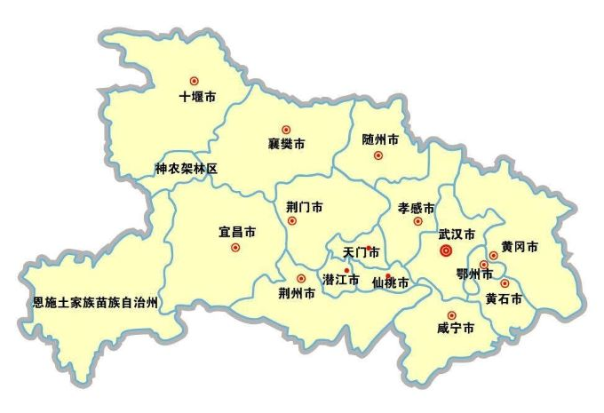

C

G

I

K

D

H

L

M

F

J

E

B

A