Web Design Fundamentals

Dining – book table

Project: Project Dining

Student: Jessica Henry

Email: Jessica.henry@mail.itsligo.ie



<https://henry-jessica.github.io/Dining/index.html>

Initial proposal sketched

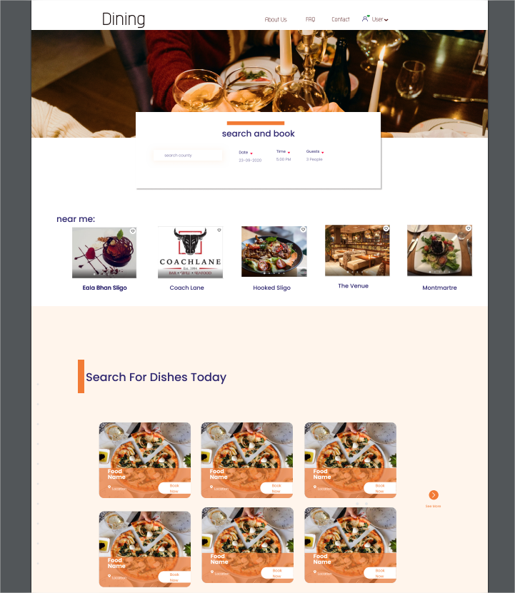the initial prototype was divided into 3 main colours of the site plus 2 auxiliary colours. Some things have changed since the development of the site started. Firstly, the initial photo contains alcoholic drinks, so it was decided that it will be changed by a rustic restaurant table.

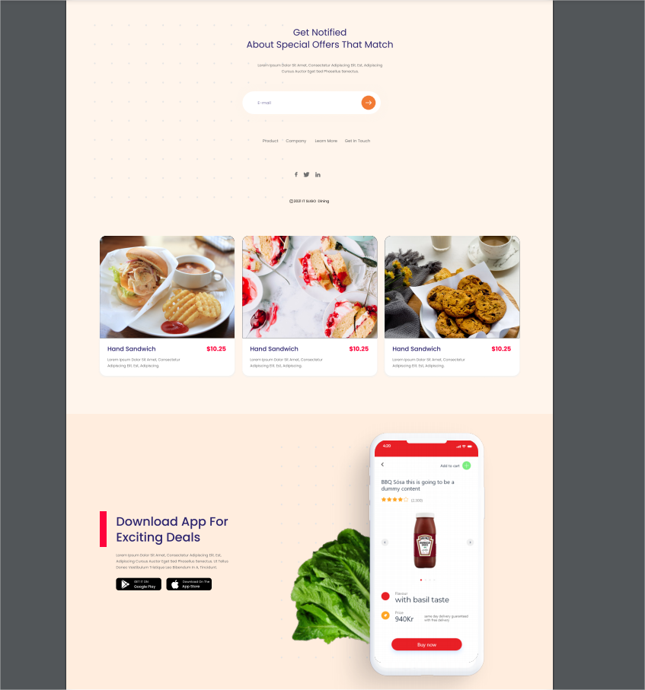

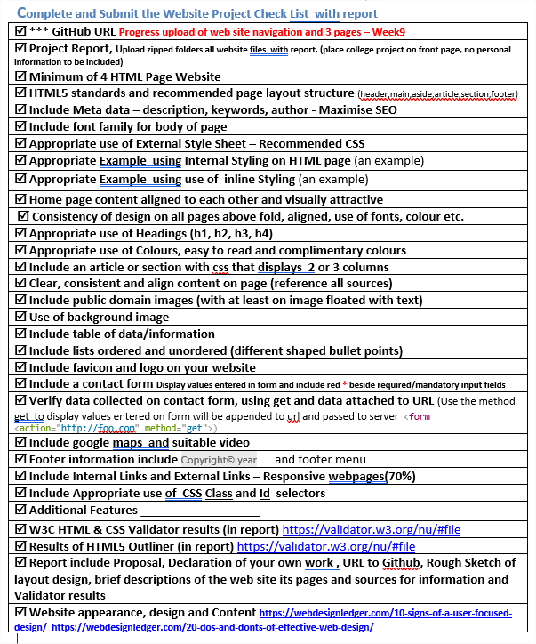

Was created a folder called Project – Index, About, FAQ and Contact tambem foi criado tres pastas, um para imagen – img , style css – style e uma com documentacoes de prototipagem.

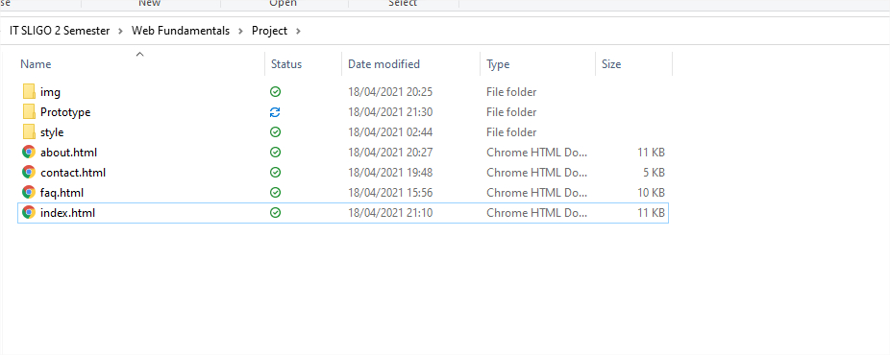

**All pages contain:**

* HTML5 standards and page layout structure
* Meta data – description, keywords and author
* Include font family for body of page
* Appropriate use of External Style Sheet – Recommended CSS
* Appropriate Example using Internal Styling on HTML page (an example)
* Appropriate use of Headings (h1, h2, h3, h4)
* <secton>
* Background image
* Favicon and logo
* Footer information include Copyright© year and footer menu
* CSS class and Id -properly used.
* Favicon Logo
* Images
* Standard colour for all pages
* H1, H2, H3, H4 - Respecting the order of priority

**Index Contains**

* Internal Styling
* Inline Styling
* Contact Form
* Verify Data collect using using <http://foo.com> method “get”.

**About Contains**

* Google maps
* Youtube Video
* List ordered and unordered
* Aside
* 4 Columns – section
* External Link
* Internal Link
* Article
* Reference all sources

**FAQ Contains**

* List ordered and unordered
* Table and data information
* External Link
* Internal Link

**Contact Contains**

* Contact Form
* Verify Data collect using using <http://foo.com> method “get”.

**pIndex Details**

The index page has some important elements to characterize a search company. On the first page, a form was created where the user enters the information, and the County field and the Seated field are mandatory to be. The body is divided into the following sections header, nav, main section 80% of header, nav, footer and 75% my main, sections, lists.

* Head has keywords: “Dining, restaurant, book restaurants, download dining app, special offers, wonderful dishes".

All keywords are in the index. Also, in the index, external responsive pages were redirected to optimize the SEO.

MAIN CONTENT

The main content will display images organized on the first screen, a block with images of typical gourmet restaurant dishes, 75% of the browser.

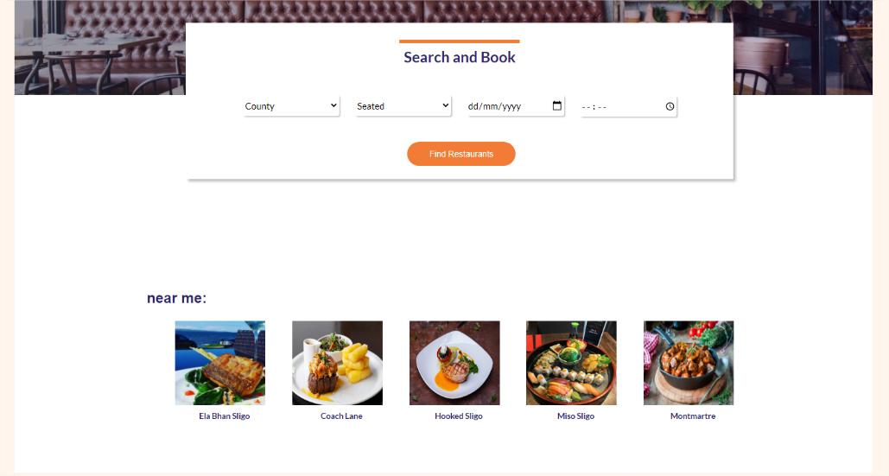Background image is inside the main. this decision was made, because it was visually cleaner with the background image following the same size as the rest of the site.

it was necessary to create a container to better organize the user's search form.

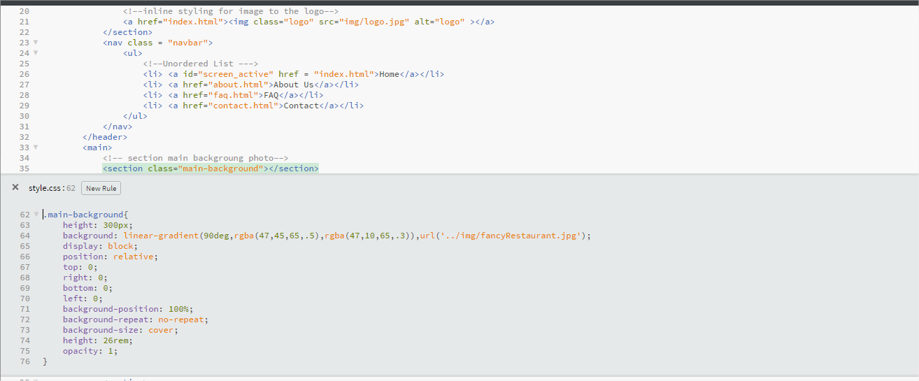

Class = rectangle is just a detail, wee orange thing in the container, just aesthetics in the form to be close to the initial prototype. Relative position to keep the container on top of the background image.

< Footer>

The footer and header have a Nav that informs the user of the screen that he is currently on.

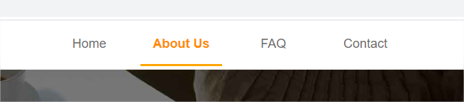Header:

Footer

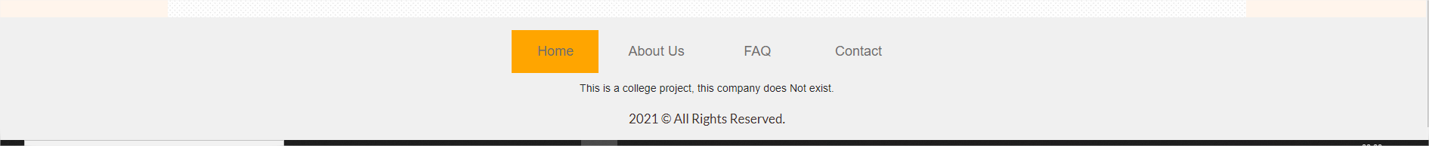

About

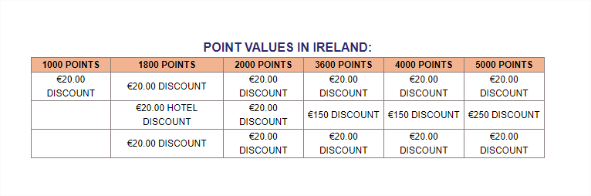The about screen has 2 lists, one sorted where it is listed as Trending Articles and the other list is just below. The two lists are inside a <aside> sidebar. The text content containing the company's information was distributed within an article. The texts have external links to responsive and quality pages. In the middle of the page, an image containing a button was inserted, the button has a mouse effect: hover. Still on the about screen, a youtube video was inserted containing information about food promotions

FAQ

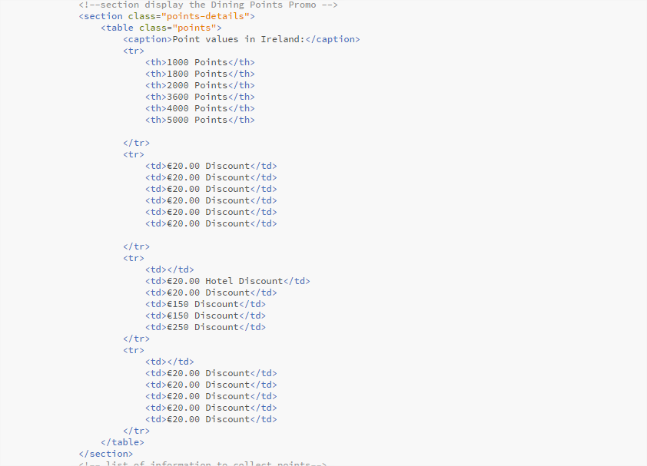

Contact

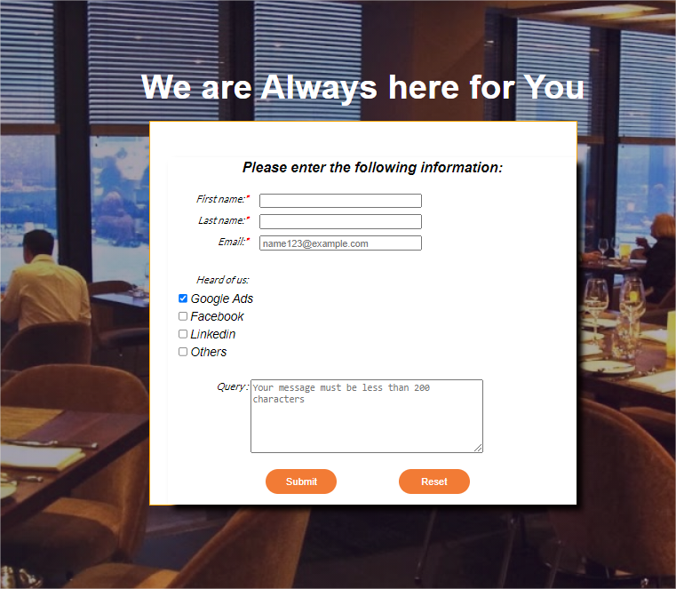

* Contact Form
* Verify Data collect using using <http://foo.com> method “get”.

Conclusion

It was the first time that I built something from scratch, and I am happy to see a quick result. Some commands can see the code taking shape.

I use two screens to develop and during the work I realized that depending on the screen I am developing some attributes need to be resized. When I learn more about fluidity, I intend to make this entire site fluid.

Validation

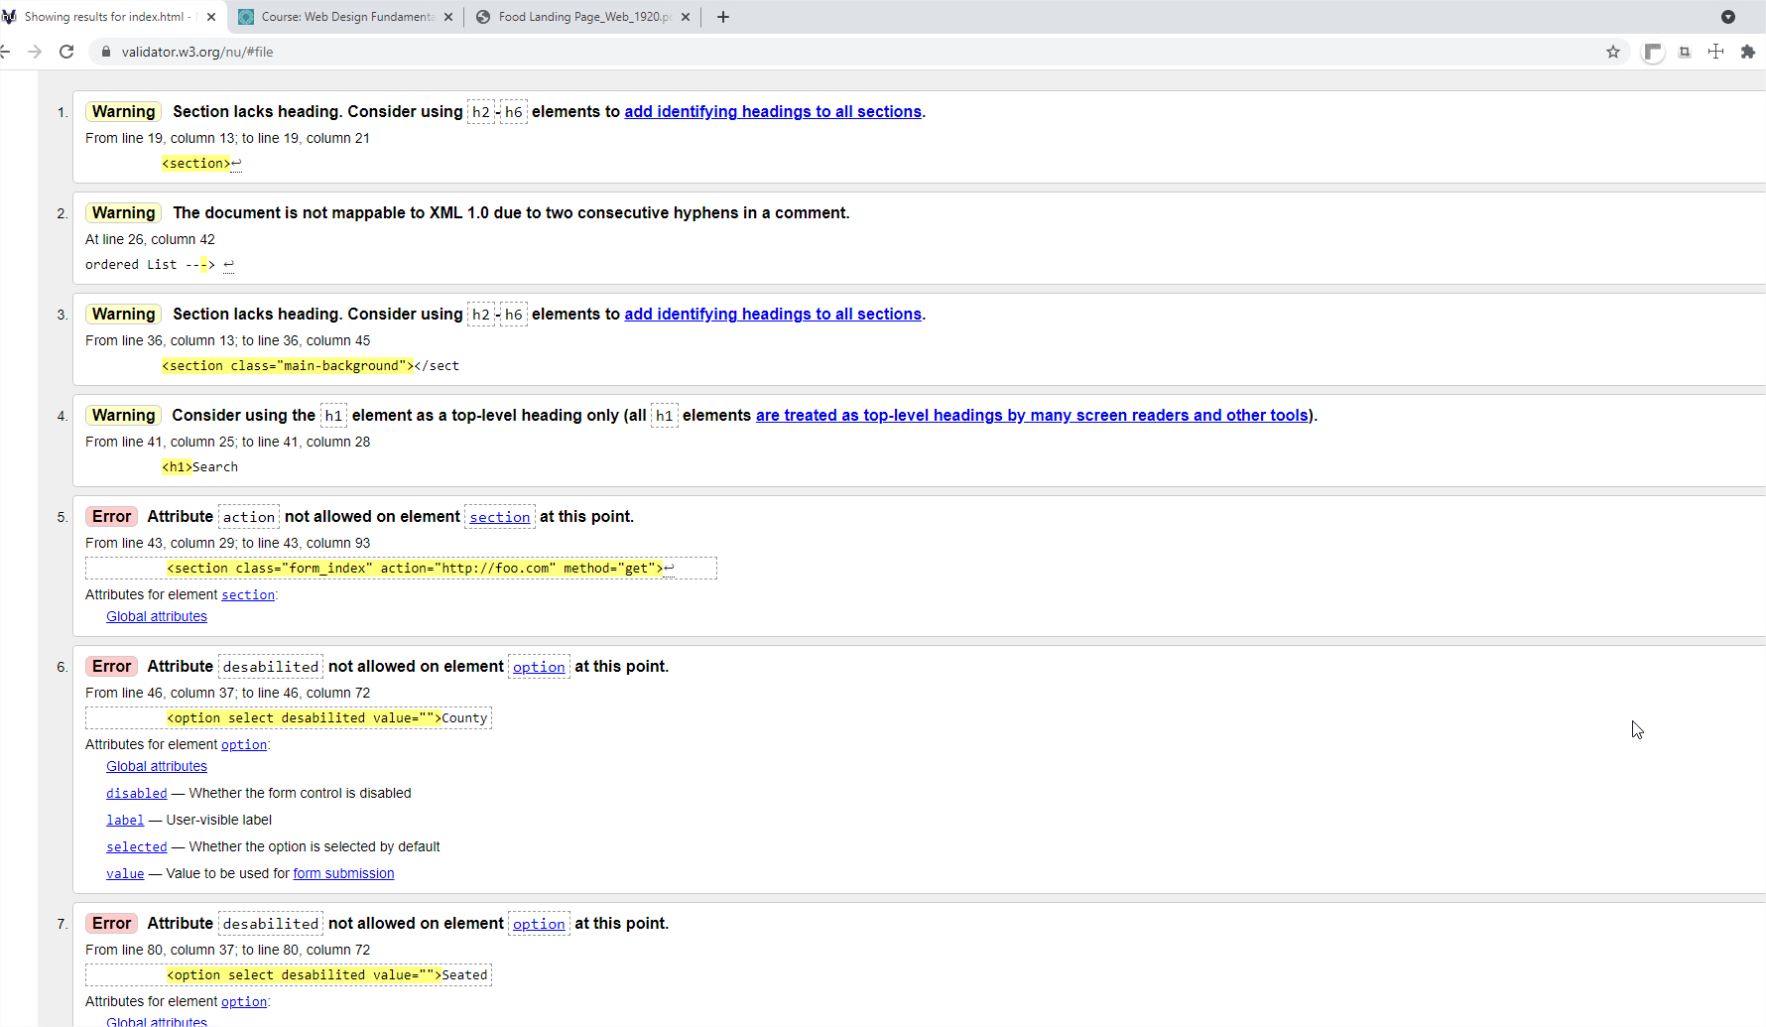Index

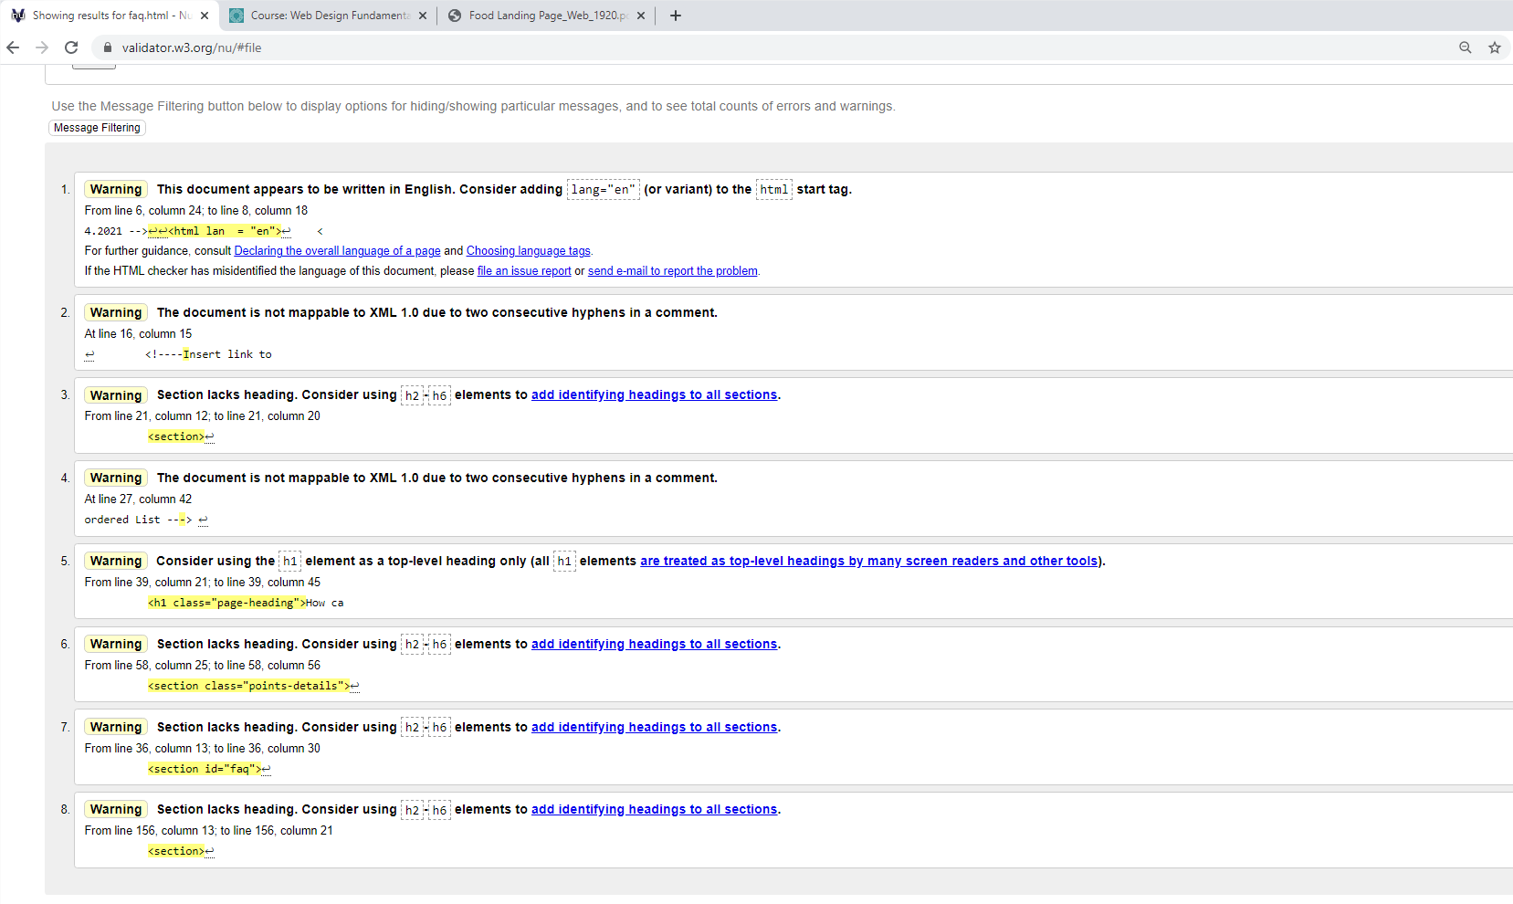FAQ

Contact

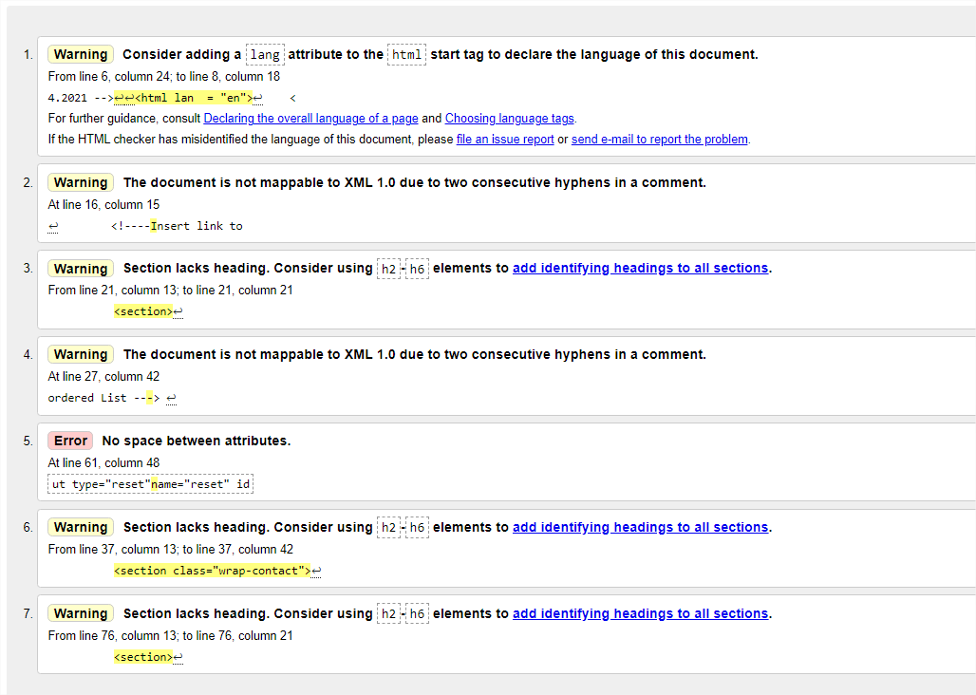

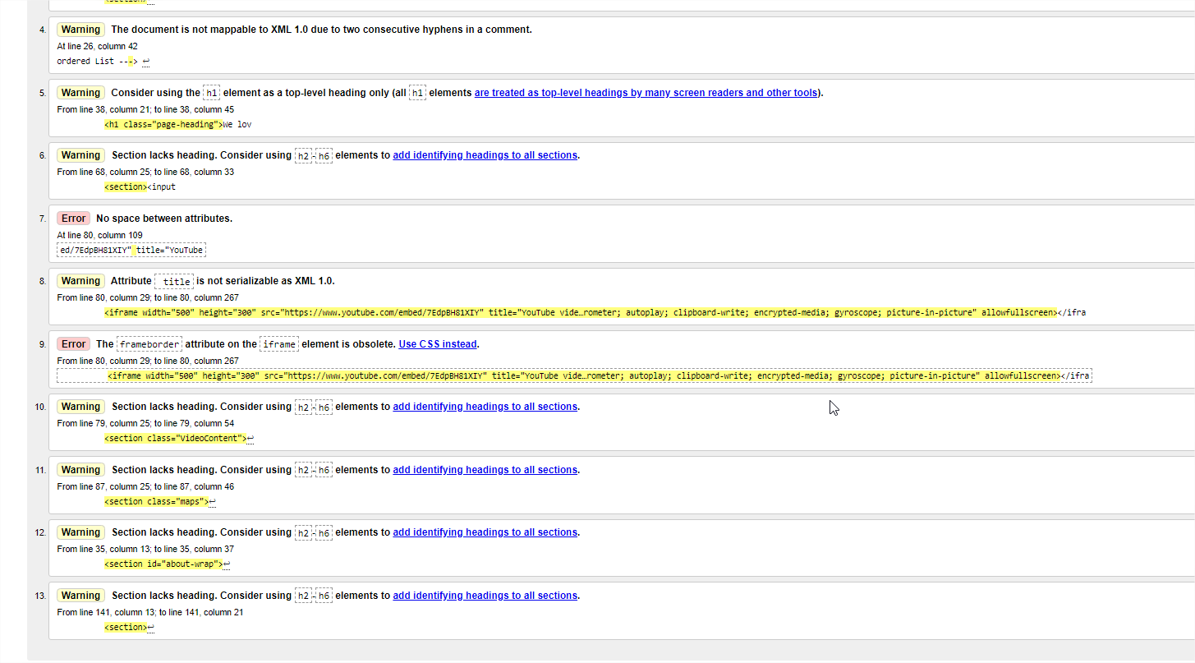About

Declaration

I the undersigned declare that the project material, which I now submit, is my own work. This material or project has not previously been submitted for any other assignment. Any assistance received by way of borrowing from previous work, or the work of others has been cited and acknowledged within the work. I make this declaration in the knowledge that a breach of the rules pertaining to project submission may carry serious consequences. We are aware that the project will not be accepted unless this form has been handed in along with the project.

Website Topic: Restaurant Research and Book table

Student name: Jessica Henry

Student number: S00214115

Date:18/04/2021