Лабораторная работа №3 вариант 16

**Задание 1**

1. Заполнение таблиц
2. Вставка записи в таблицу командой INSER

INSERT INTO Cities (ID_City,City_name,Day_rate,Night_rate,Length) values((10,Mordor,0.15,0.12,0),

(10,Mordor,0.14,0.11,5),

(10,Mordor,0.13,0.10,10),

(10,Mordor,0.12,0.09,15),

(10,Mordor,0.12,0.09,15),

(10,Mordor,0.11,0.08,30),

(10,Mordor,0.10,0.07,60),

(11,Riften,0.20,0.19,0),

(11,Riften,0.18,0.17,10),

(11,Riften,0.16,0.15,20),

(11,Riften,0.14,0.13,40),

(11,Riften,0.12,0.11,60),

(12,Tolren,0.05,0.04,00029);

1. Файлы приложены к отчету
2. Через графический интерфейс 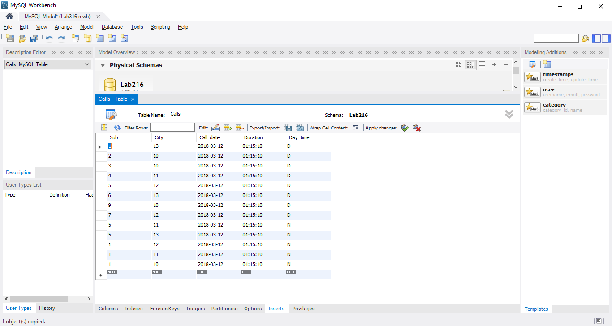
3. Изменение записи в таблице (UPDATE)

UPDATE Calls SET Day_time = ‘N’

UPDATE drivers SET Sub_name = ‘Pixoft’, City = ‘Vilnus’ WHERE ID_Sub = 3;

UPDATE Cities SET Day_rate=0.05, Night_rate=0.04 WHERE Lenght=60;

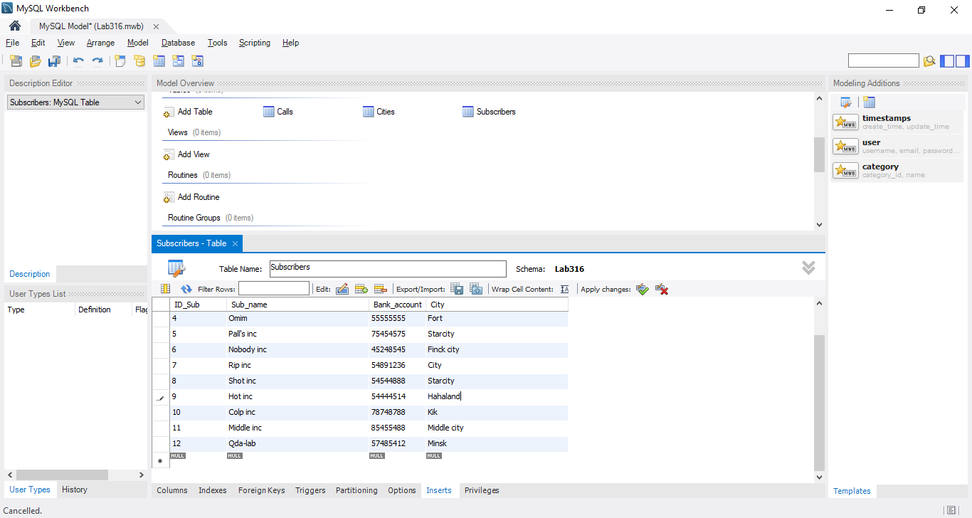

1. Изменение записи в таблице (REPLACE)

UPDATE Subscribers SET City = REPLACE(City, ' ', '');

1. Удаление записи

DELETE FROM Subscribers WHERE ID_Sub=11;

DELETE FROM Cities WHERE Day_rate>0.99;

DELETE FROM Calls;

TRUNCATE TABLE Subscribers;

**Задание 2**

SELECT City_name AS 'Name', (Day_rate*9) AS 'Nine min of talk' FROM Cities WHERE Length=0;

SELECT City_name AS 'Name', Nigth_rate AS 'Rate', Length

FROM Cities

Where Night_rate<0.08;

SELECT City_name AS 'Name', Nigth_rate AS 'Rate', Length

FROM Cities

Where Night_rate<0.10

LIMIT 5;

SELECT * FROM Subscribers

GROUP BY Sub_name;

SELECT City_name, AVG(Day_rate) AS 'Rate'

FROM Cities

GROUP BY Day_rate

HAVING AVG(Day_rate)<0.50;

SELECT DISTINCT City_Name AS 'City' FROM Cities

UNION

SELECT DISTINCT City AS 'City' FROM Subscribers WHERE Citi IS NOT NULL;