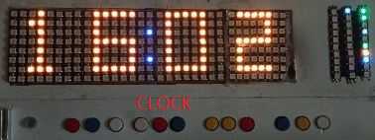
⏰ Ouma Ria Smart Clock
Screen & Web Interface Guide
A visual guide to the current user interface
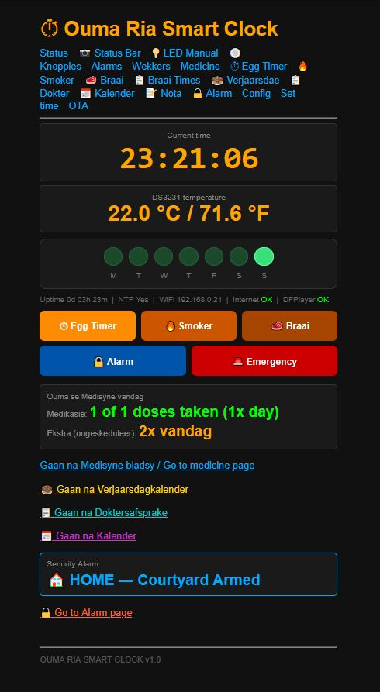

Designed and built by Henry Vermaak, Koster, South Africa
Dedicated to Ouma Ria

Prepared from the current live interface — every screenshot in this guide was taken directly from the running clock.

How to use this booklet
This booklet documents the current Ouma Ria Smart Clock web interface, screen by screen. Each page shows one screen at a readable size, with a short bilingual description. It is meant as a visual reference for the owner, builder, tester, and any future maintainer.
Important: every screenshot here was taken directly from the live interface. This booklet does not change the firmware, and does not describe any function that is not visible on the screens shown.
System & Controls
01 Status — Home Screen
02 LED Manual
03 Status Bar — Security & System States
04 Status Bar — Internet & Wi-Fi Indicators
05 Knoppies — Button Manual
06 Knoppies — Special Button Functions
06b Sw1 — The Six Display Screens
Alarms & Reminders
07 Alarm — Alarm 1
08 Wekkers — Wekker 1
09 Wekkers — Wekker 2
10 Wekkers — Wekker 3
Medicine
11 Medicine — Medicine Schedule
12 Medicine — Dose / LED View
13 Medicine — Additional Schedule Settings
Kitchen, Smoker & Braai
14 Egg Timer — Kombuis Tydhouer
15 Smoker Uptimer — Rooker Optyd
16 Braai Timer — Braai Tydhouer
17 Braai Times Reference
18 Braai / Recipe Reference
19 Braai / Recipe Details
Calendar & Personal Information
20 Verjaarsdae — Birthdays
21 Verjaarsdae — Birthday List
22 Verjaarsdag Reminder / Status
23 Doktersafsprake — Doctor Appointments
24 Kalender — Calendar
25 Nota — Notebook / Notes
Security & Configuration
26 Sekuriteitsalarm — Security Alarm
27 Sekuriteitsalarm — Alarm Status / Pause
28 Config — Main Settings
29 Config — Continued
Time & Software Update
30 Set Time — Stel Tyd
31 OTA — Software Update

EGG TIMER
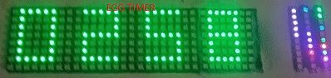

01 — Status — Home Screen

Tyd, temperatuur en vinnige skakels na die belangrikste funksies. / Time, temperature and quick links to the main functions.

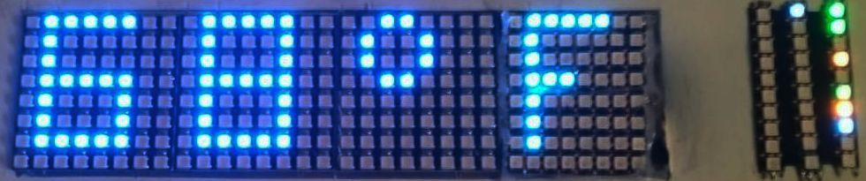
The main display, showing the current temperature. / Die hoofskerm, wat die huidige temperatuur wys.

02 — LED Manual
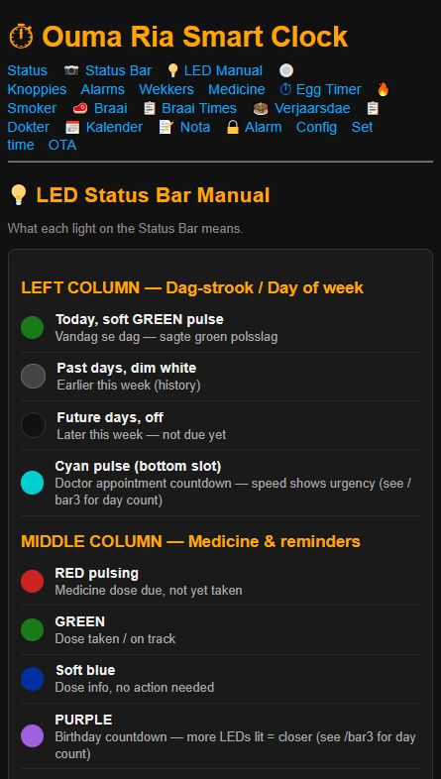
Handleiding vir die status- en LED-aanduidings. / Guide to the status and LED indicators.

03 — Status Bar — Security & System States
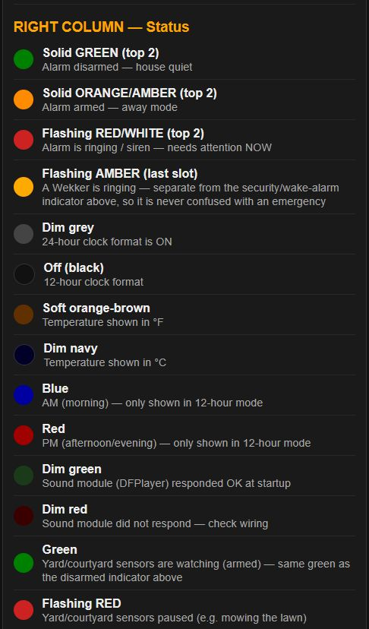
Verduideliking van die belangrikste alarm- en stelselstatusse. / Explanation of key alarm and system states.

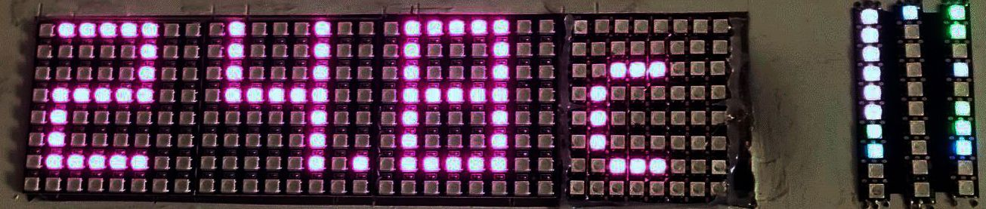
The main display, showing the current temperature. / Die hoofskerm, wat die huidige temperatuur wys.

04 — Status Bar — Internet & Wi-Fi Indicators
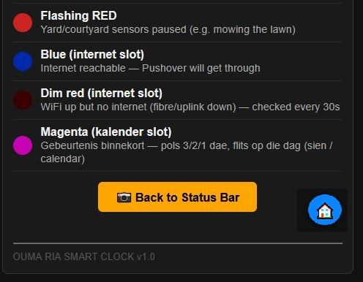
Kleurkode vir Wi-Fi en Internet-status. / Colour guide for Wi-Fi and Internet status.

05 — Knoppies — Button Manual
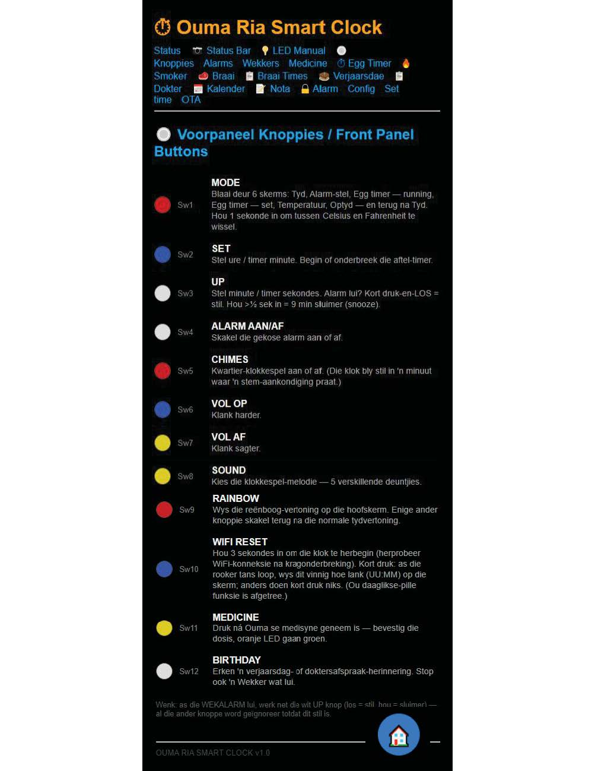
Die voorpaneel se knoppies en hul funksies. / Front-panel buttons and their functions.

06 — Knoppies — Special Button Functions
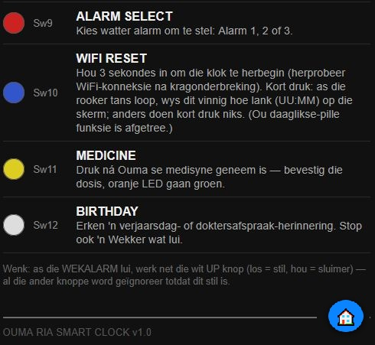
Alarm-keuse, Wi-Fi-herstel, medisyne-bevestiging, verjaardag-herinnering en die reënboog-vertoning funksies. / Alarm selection, Wi-Fi recovery, medicine confirmation, birthday reminder — and the Rainbow display — functions.
Updated: Sw9 now shows the Rainbow display (see the photo below) rather than the retired “Alarm Select” function.

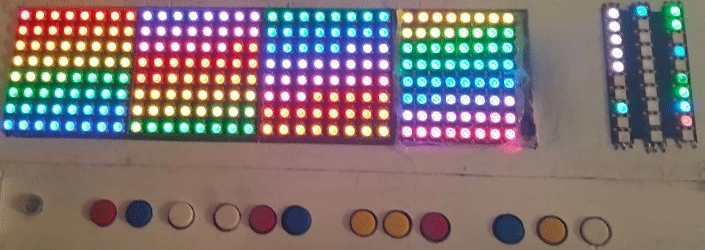
Sw9 — Rainbow display, shown on the main screen. Any other button returns to the normal time display. / Sw9 — reënboog-vertoning op die hoofskerm. Enige ander knoppie skakel terug na die normale tydvertoning.

06b — Sw1 — The Six Display Screens
MODE (Sw1) cycles through six screens, one short press at a time, then wraps back around to the start — like a rotary switch with six positions. Holding it down for one second, on any position, does something different: it toggles the temperature display between Celsius and Fahrenheit.
Pos | Screen | Skerm (AF) | What you see | Colour
0 | Time | Tyd | HH:MM, the everyday clock face. | Amber
1 | Alarm set | Alarm-stel | Set the hour and minute for the main wake alarm. | Cyan
2 | Egg timer — running | Egg Timer (loop) | Live countdown while the egg timer is active. | Green
3 | Egg timer — set | Egg Timer (stel) | Set minutes and seconds before starting the timer. | Orange
4 | Temperature | Temperatuur | Current room temperature, °C or °F. | Magenta
5 | Uptime | Optyd | Days and hours since the clock last restarted. | Blue
After position 5, the next short press returns to position 0 — back to the normal clock. / Ná posisie 5 gaan die volgende kort druk terug na posisie 0 — terug na die normale tyd.

07 — Alarm — Alarm 1
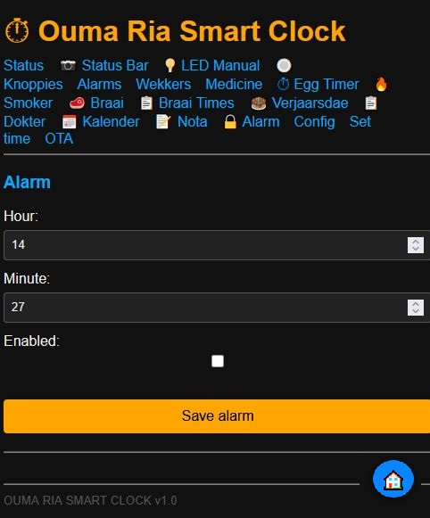
Die eenvoudige alarm-instelling. / Simple alarm setting.

08 — Wekkers — Wekker 1
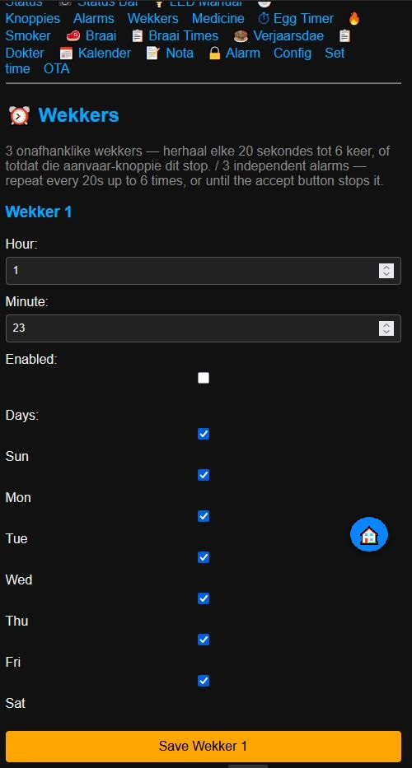
Wekker 1 met tyd en weekdae. / Alarm 1 with time and selectable weekdays.

09 — Wekkers — Wekker 2
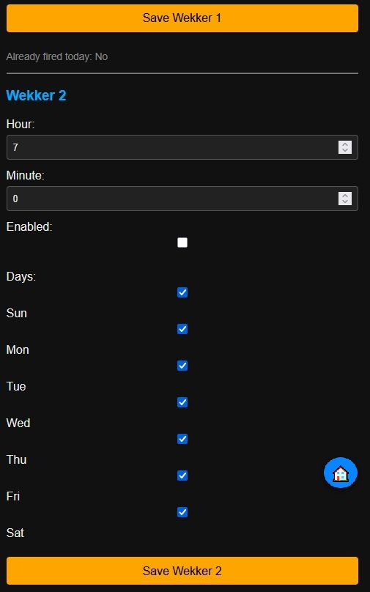
Wekker 2. / Alarm 2.

10 — Wekkers — Wekker 3
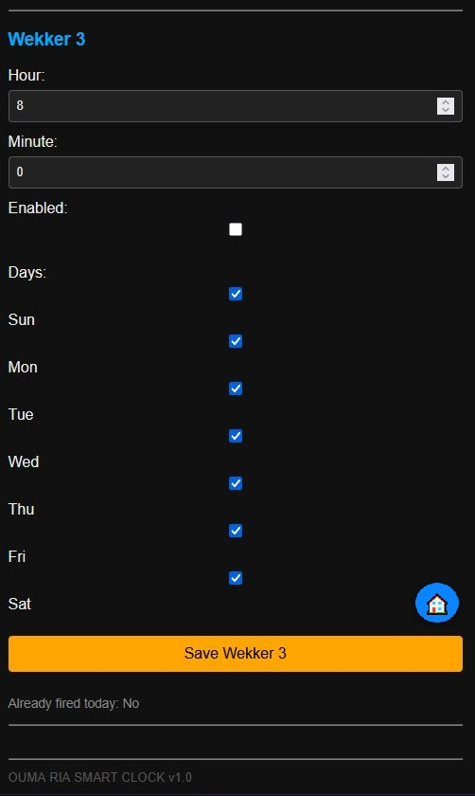
Wekker 3. / Alarm 3.

11 — Medicine — Medicine Schedule
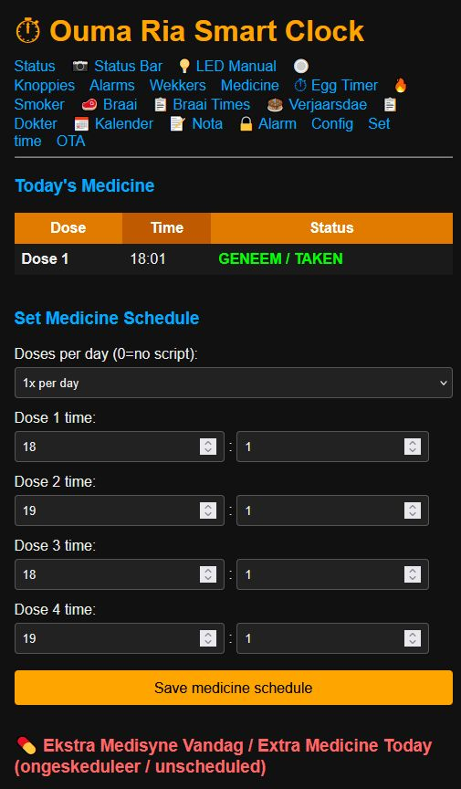
Medisyne-skedule en dosisbeheer. / Medicine schedule and dose control.

12 — Medicine — Dose / LED View
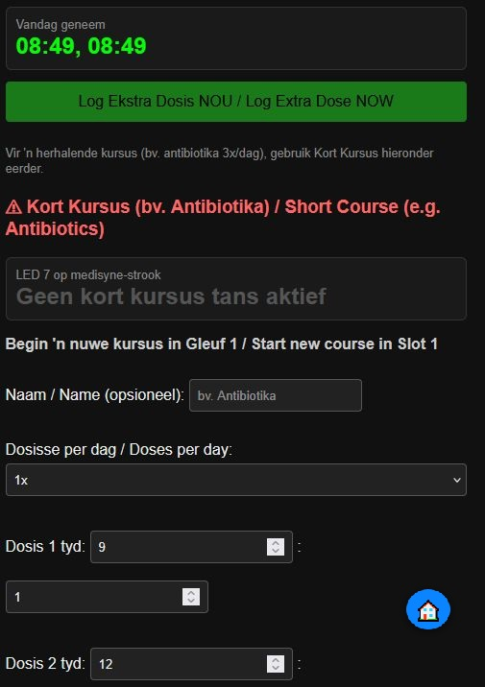
Dosis- en LED-terugvoer vir medisyne, insluitend die ekstra-dosis log en die Kort Kursus-skeduleerder. / Dose and LED feedback for medicine, including the extra-dose log and the Kort Kursus short-course scheduler.

13 — Medicine — Additional Schedule Settings
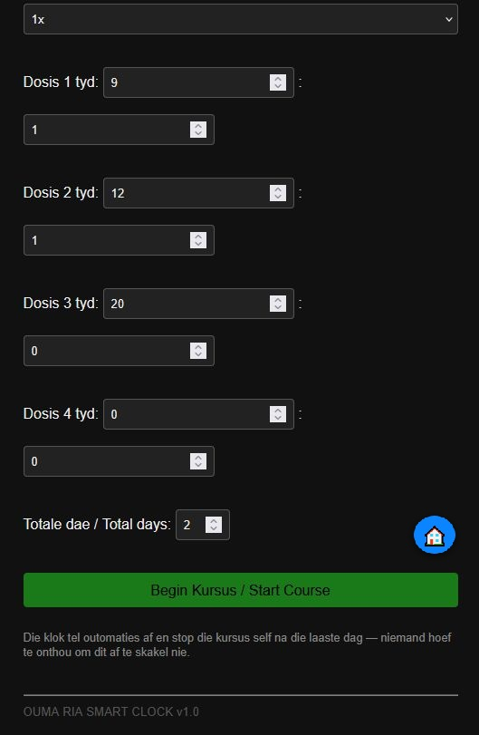
Bykomende medisyne-instellings en bevestigings. / Additional medicine settings and confirmations.

14 — Egg Timer — Kombuis Tydhouer
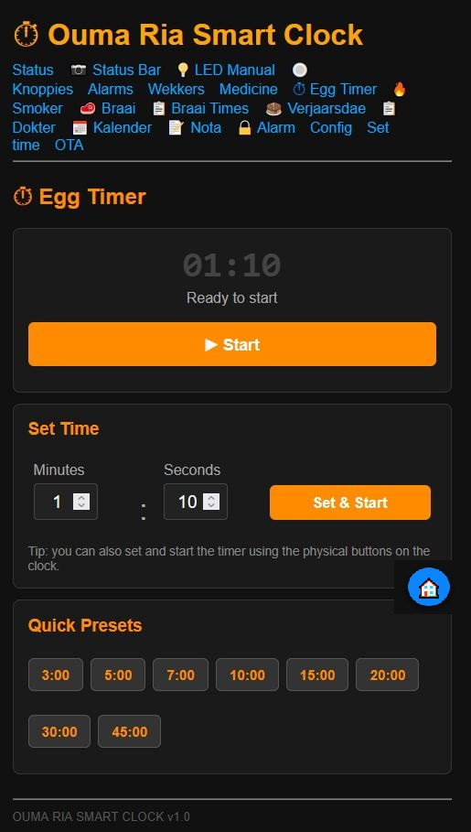
Vinnige aftelklok met gunsteling-tye. / Quick countdown timer with favourite presets.

15 — Smoker Uptimer — Rooker Optyd
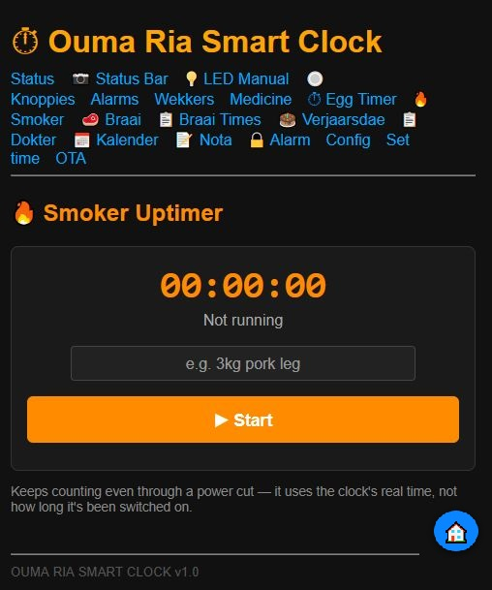
Hou tred met hoe lank die rooker aan is — tel steeds tydens kragonderbreking, en 'n kort druk op die WiFi Herstel-knoppie wys die looptyd op die hoofskerm. / Tracks how long the smoker has been running — keeps counting even through a power cut, and a short tap of the WiFi Reset button shows the running time on the main display.

16 — Braai Timer — Braai Tydhouer
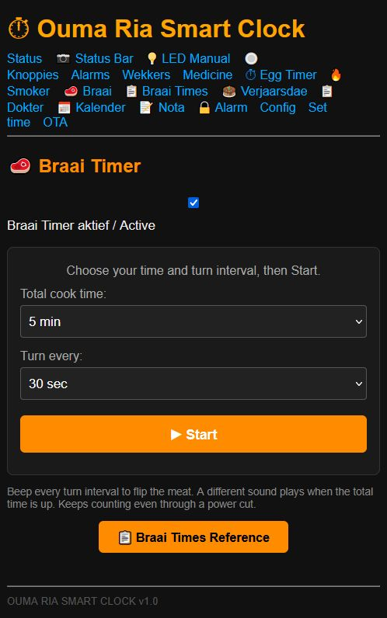
Herinner jou wanneer om die vleis te draai. / Reminds you when to turn the meat.

17 — Braai Times Reference
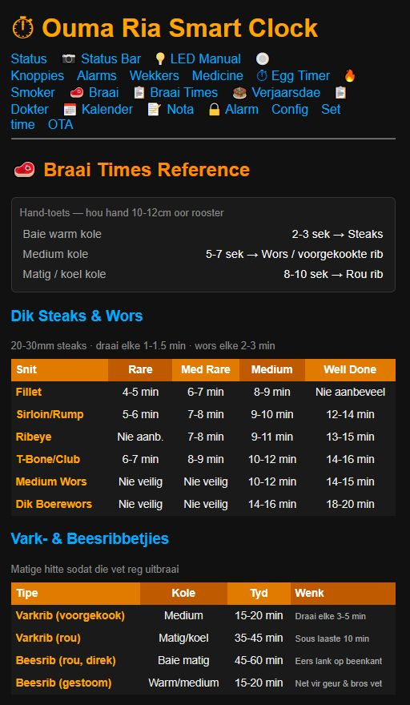
Verwysingstye vir verskillende vleissnitte. / Reference times for different cuts of meat.

18 — Braai / Recipe Reference
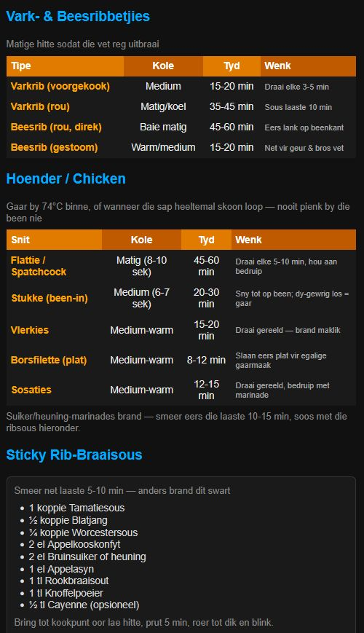
Braai- en resepverwysings. / Braai and recipe reference information.

19 — Braai / Recipe Details
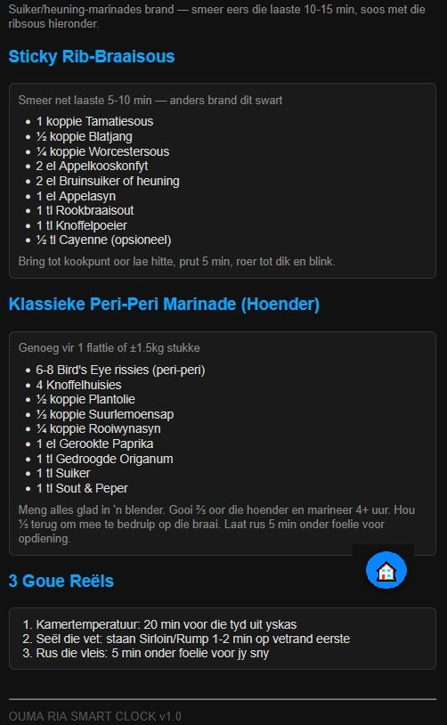
Bykomende resep- en braai-inligting. / Additional recipe and braai information.

20 — Verjaarsdae — Birthdays
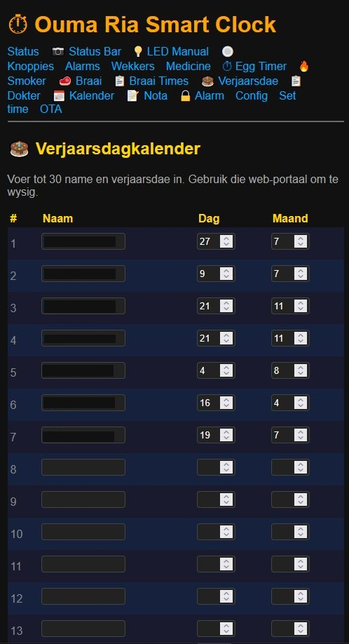
Verjaarsdagkalender met gestoorde verjaarsdae. / Birthday calendar with stored birthdays.

21 — Verjaarsdae — Birthday List
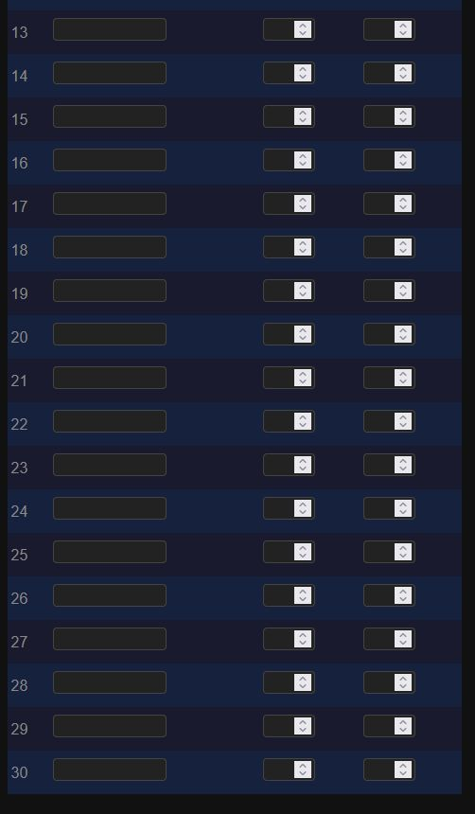
Lys van verjaarsdae en herinnerings. / Birthday list and reminders.

22 — Verjaarsdag Reminder / Status
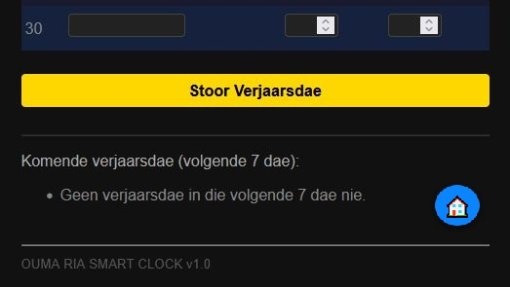
Vertoon wanneer daar geen verjaarsdag in die volgende sewe dae is nie. / Shows when there is no birthday in the next seven days.

23 — Doktersafsprake — Doctor Appointments
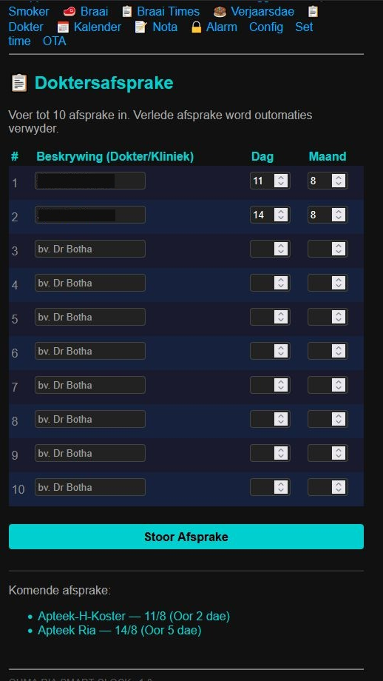
Gestoorde doktersafsprake en opvolg-inligting. / Stored doctor appointments and follow-up information.

24 — Kalender — Calendar
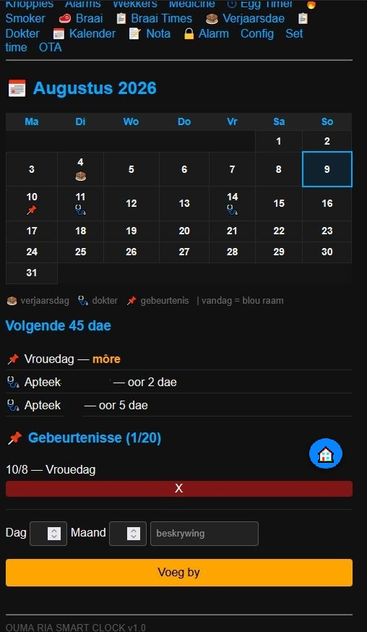
Maandkalender met gebeurtenisse, met alles wat in die volgende 45 dae kom. / Monthly calendar with events, showing everything coming up in the next 45 days.

25 — Nota — Notebook / Notes
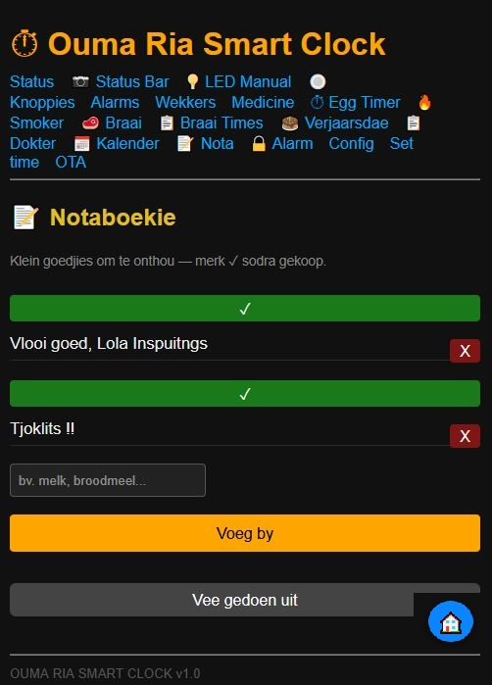
Persoonlike notas en kort herinneringe. / Personal notes and short reminders.

26 — Sekuriteitsalarm — Security Alarm
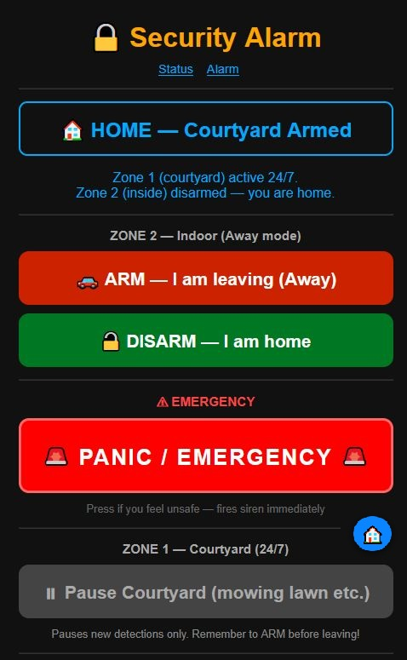
Wapen, ontwapen of aktiveer PANIEK / NOOD. / Arm, disarm, or activate PANIC / EMERGENCY.

27 — Sekuriteitsalarm — Alarm Status / Pause
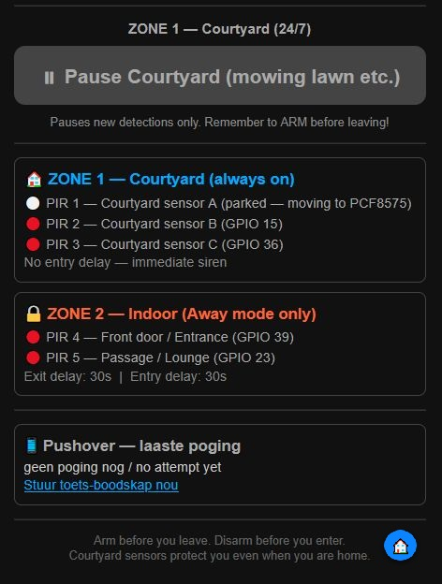
Alarmstatus, sones en tydelike onderbreking. Sone 1 (werf) dek PIR-sensors 1 tot 3; Sone 2 (binnenshuis) dek sensors 4 en 5. / Alarm status, zones, and temporary pause. Zone 1 (courtyard) covers PIR sensors 1 through 3; Zone 2 (indoor) covers sensors 4 and 5.

28 — Config — Main Settings
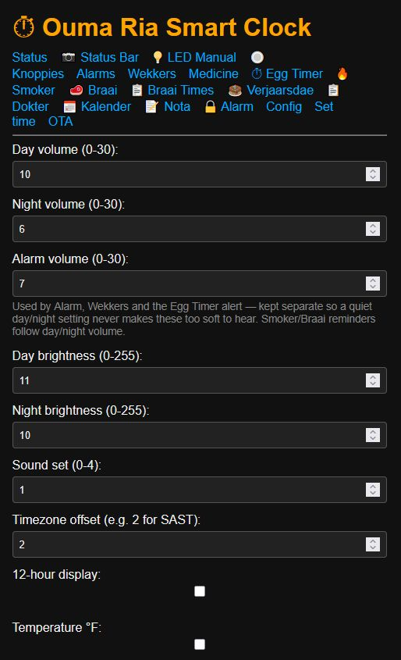
Volume, helderheid, tydsone en ander hoofinstellings. Alarm-volume word gedeel deur die Wekker-alarm, Wekkers, die Egg Timer-waarskuwing, Verjaarsdae en Doktersafsprake — apart gehou van die dag/nag-volume sodat 'n sagte instelling dit nooit te sag maak om te hoor nie. / Volume, brightness, timezone, and other main settings. Alarm Volume is shared by the wake Alarm, Wekkers, the Egg Timer alert, Birthdays, and Doctor Appointments — kept separate from the day/night volume so a quiet setting never makes these too soft to hear. Everyday medicine and the Smoker/Braai reminders follow ordinary day/night volume.
Updated: this list now also includes Birthdays and Doctor Appointments, which were later switched to Alarm Volume for consistency.

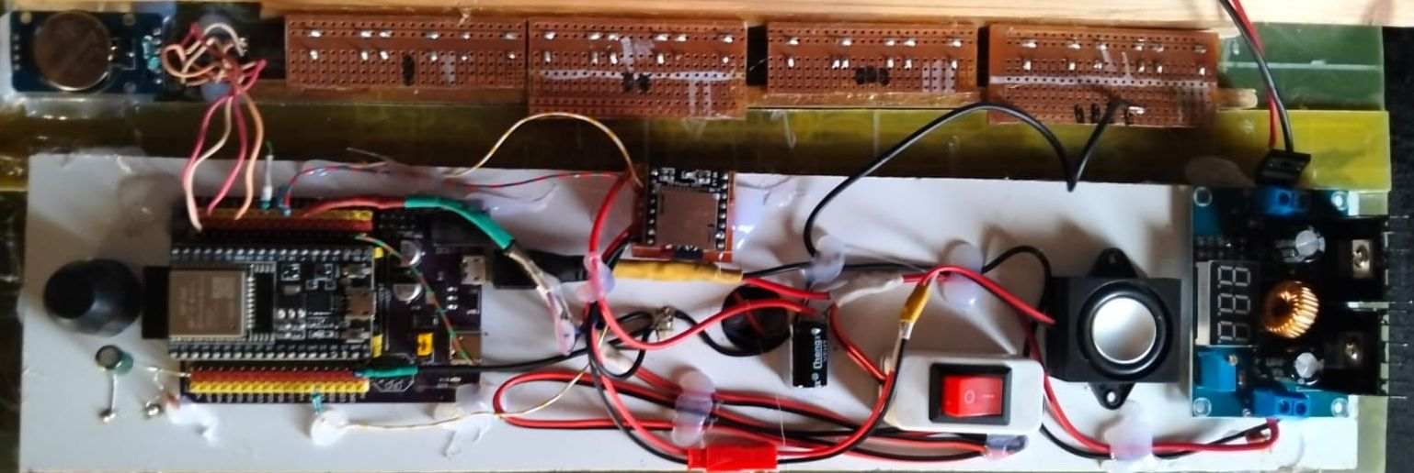
Inside the enclosure — the ESP32 expansion board and wiring. / Binne die behuising — die ESP32-uitbreidingsbord en bedrading.

29 — Config — Continued
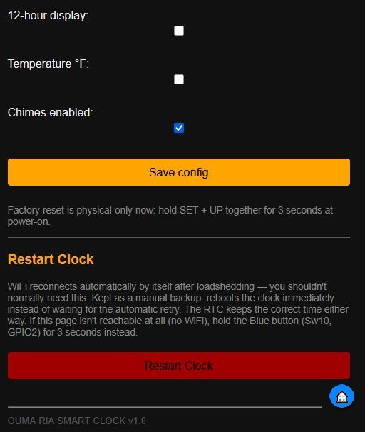
Bykomende konfigurasie en die Restart Clock-funksie. / Additional configuration and the Restart Clock function.

30 — Set Time — Stel Tyd
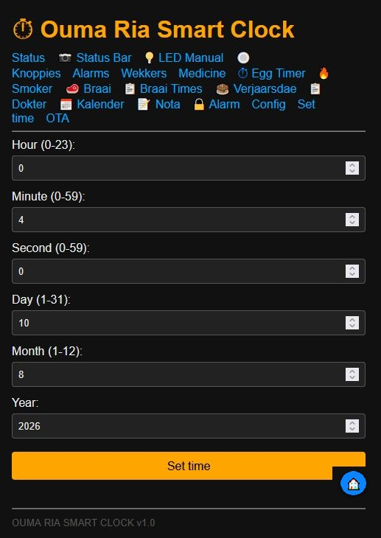
Stel die klok se tyd en datum handmatig. / Set the clock's time and date manually.

31 — OTA — Software Update
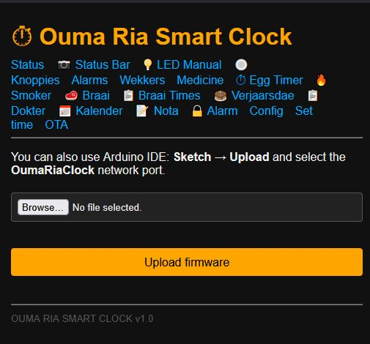
Upload new firmware from the web page. / Laai nuwe firmware vanaf die webblad op.

