OUMA RIA SMART CLOCK
Technical Reference
A companion volume to the main project book
Designed and built by Henry Vermaak
South Africa

About This Document
The main project book tells the story of the Ouma Ria Smart Clock — why it exists, how it grew, and the lessons learned along the way. This document is different on purpose.
It is a reference, not a story. Each section answers one practical question a builder is likely to have at the workbench: what does this block of the circuit do, what will break the system if I miss it, and where do I look up an exact value.
Read the book once, front to back. Come back to this document again and again while you build.

Contents:
- Part 1 — Hardware Walkthrough
- Part 2 — Critical Warnings
- Part 3 — Reference Tables
- Part 4 — Suggested Enclosure

Part 1 — Hardware Walkthrough
This section walks through the system block by block, following the wiring diagram from the power input to the front panel. Each block explains what it does and why it is specified the way it is — not just a parts list, but the reasoning behind each choice.

1.1 Power Supply
A 12V 10A desktop switch-mode power supply is the primary source. 10A is comfortably more than the system needs under normal operation, but LED matrices can draw meaningfully more current at full brightness with many pixels lit simultaneously — the headroom avoids the supply ever being pushed to its limit.
A 12V sealed lead-acid battery sits in parallel with the main supply through a dual Schottky diode arrangement (20A rated), so the battery automatically takes over during a power interruption with no switching delay and no software involvement. This is what allows the clock to keep correct time and continue any active timer straight through loadshedding.

1.2 Buck Converter
The 12V rail is stepped down to a regulated 5.0V by an adjustable buck converter rated at 8A. This feeds the ESP32 board, the DFPlayer, and both LED chains. The digital display on the converter itself makes it straightforward to confirm the output voltage is trimmed correctly before connecting anything downstream — always verify 5.0V here before connecting the ESP32 for the first time.

1.3 ESP32 Board
An ESP32-WROOM-32 module mounted on an expansion board with screw terminals and clearly labelled GPIO breakouts. Using an expansion board rather than a bare devkit makes the wiring far easier to inspect and service later — every connection is a labelled screw terminal, not a bare header pin.
GPIO0, GPIO1 and GPIO3 are never wired to any peripheral. Full reasoning is in Part 2.

1.4 Display System
The main display is four WS2812B 8×8 panels wired in series (256 pixels total), driven from a single GPIO as one continuous data chain. A separate 30-LED WS2812B strip (arranged 3 rows of 10) forms the status bar, driven from its own GPIO independently of the main display — this keeps status information visible even while the main display is showing something else entirely, such as the egg timer or a rainbow idle animation.

1.5 Audio System
A DFPlayer Mini communicates with the ESP32 over UART (two GPIOs, one in each direction) and plays MP3 files from a microSD card through a small speaker. It operates independently of the ESP32's own processing, so a voice announcement or chime does not compete with the main loop for CPU time.
Clone DFPlayer modules are common and generally work correctly, but some clones require audio files to be numbered sequentially with no gaps — worth confirming before recording a full set of announcements.

1.6 Sensors
A DS3231 real-time clock provides accurate timekeeping (better than ±2ppm) with a coin-cell battery backup of its own, independent of the main 12V battery — the clock keeps correct time even if the whole system is unplugged for an extended period. A BH1750 ambient light sensor drives automatic day/night brightness. Both share the same I²C bus (two wires) alongside the RTC.
Up to five AM312 PIR motion sensors provide security coverage, split into two zones with different behaviour — see Part 4 of the main book for the reasoning, and the pin table in Part 3 of this document for exact wiring.

1.7 Front Panel
Twelve 12mm tactile push-buttons provide the full user interface. All are wired the same simple way — one side to a GPIO, other side to ground — with two exceptions: the two input-only GPIOs (34 and 35) have no internal pull-up resistor at all and require an external 10kΩ pull-up to 3.3V each. Missing either of these two resistors specifically will make that one button behave erratically.

1.8 Alarm / Siren Output
External alarm devices are switched through an IRLZ44N logic-level MOSFET, driven directly from a single GPIO. A 10kΩ resistor in series with the gate limits inrush current; a second 10kΩ resistor from gate to ground holds the MOSFET firmly off during boot. A 1N4007 diode across the siren terminals protects the MOSFET from inductive kickback. All three of these small components matter — see Part 2.

Part 2 — Critical Warnings
These are the mistakes most likely to cause a confusing first boot, or worse, damaged hardware. Read this section before wiring anything.

⚠ GPIO0, GPIO1, GPIO3 — never for peripherals
GPIO0 is the boot-strapping pin — a sensor idling LOW here can prevent the board from booting at all. GPIO1 carries the boot log at every reset. GPIO3 is driven by the on-board USB-serial chip whenever the board is powered through its USB socket — loading a peripheral onto it caused real, hard-to-diagnose notification failures during development. Treat all three as reserved for USB/serial only.

⚠ Siren MOSFET gate pulldown is not optional
Without the 10kΩ pulldown resistor from the MOSFET gate to ground, the gate can float high momentarily at power-on — the siren will chirp before the firmware has even started running. This is one of the easiest wiring steps to skip and one of the most startling to discover by accident.

⚠ GPIO34 and GPIO35 need external pull-ups
These two GPIOs are input-only on the ESP32 and have no internal pull-up resistor available in software. Each needs its own external 10kΩ resistor to 3.3V, or the corresponding button will read unpredictably.

⚠ Partition scheme must be “Minimal SPIFFS”
In the Arduino IDE, Tools → Partition Scheme must be set to a scheme with two OTA app slots (“Minimal SPIFFS” works). A “Huge APP” scheme removes the second slot and silently disables over-the-air updates entirely — the symptom is OTA uploads simply failing with no obvious cause.

⚠ 1N4007 diode orientation
The flyback diode across the siren/speaker terminals must have its cathode (banded end) toward the positive supply rail. Reversed, it provides no protection at all while looking correctly installed at a glance.

⚠ A fault that survives replacing every obvious part may not be where it appears to be
During this build, one front-panel button misbehaved intermittently in a way that survived replacing the switch, the wire, and even the ESP32 itself. The eventual cause was a small amount of stray resistance on the expansion board's connector for that one pin — a manufacturing defect, not a design fault. If a problem survives every obvious replacement, measure the actual board connections before assuming the design itself is wrong.

⚠ SD card file numbers are not sequential — do not renumber 1, 2, 3…
The DFPlayer expects specific numbers with deliberate gaps between them (see 3.6), not a simple running count. Files copied on as 0001.mp3, 0002.mp3, 0003.mp3… in whatever order they happen to be in will not match what the firmware actually calls, and several reminders will play the wrong sound — or nothing at all. Always copy files onto the card under the exact track numbers in the table in 3.6, not the order you happen to have them in.

Part 3 — Reference Tables
Look up a fact fast. These tables are not meant to be read start to finish.

3.1 Complete Pin Connection Table
GPIO | Connect to | Notes
13 | Matrix DATA IN | Main 16×32 display (four 8×8 panels in series)
4 | BAR3 strip DATA IN | 30-LED status chain (3 rows of 10)
21 | SDA | DS3231 RTC + BH1750 (shared I²C bus)
22 | SCL | DS3231 RTC + BH1750 (shared I²C bus)
16 | DFPlayer TX → ESP RX | 1kΩ resistor on DFPlayer RX side
17 | DFPlayer RX ← ESP TX | 1kΩ resistor in series here
5 | Siren MOSFET gate | 10kΩ series + 10kΩ pulldown to GND — see Part 2
19 | Button — MODE (red)
26 | Button — SET (blue)
27 | Button — UP (white)
14 | Button — ALARM ON/OFF (white)
12 | Button — CHIMES (red) | LOW at boot is safe
32 | Button — VOL UP (blue)
33 | Button — VOL DOWN (yellow)
34 | Button — SOUND (yellow) | External 10kΩ pull-up to 3.3V required (input-only pin)
35 | Button — ALARM SELECT (red) | External 10kΩ pull-up to 3.3V required (input-only pin)
2 | Button — WIFI RESET (blue) | Hold 3s: WiFi/network reset. Short tap: Smoker quick-peek (when running)
18 | Button — MEDICINE (yellow)
25 | Button — BIRTHDAY (white)
15 | PIR Courtyard B | AM312 direct, 3.3V power
36 | PIR Courtyard C | Input-only, no internal pull
39 | PIR Front Door (Zone 2) | Input-only, no internal pull
23 | PIR Passage (Zone 2)
0 | — | DO NOT USE — boot strap pin
1 | — | DO NOT USE — USB serial TX
3 | — | DO NOT USE — USB serial RX / CH340

3.2 Power Rails Summary
Rail | Voltage | Feeds
Buck converter out | 5.0V, 8A | ESP32 board, DFPlayer, all LEDs
12V PSU | 12V | Siren speakers (via IRLZ44N MOSFETs on GPIO5)
Battery backup | 12V | Keeps 12V rail alive during loadshedding
ESP32 3.3V out | 3.3V | DS3231, BH1750, AM312 PIR sensors, button pull-ups

3.3 NVS Storage Namespaces
All persistent settings are stored in the ESP32's non-volatile storage (NVS), organised into separate namespaces so different subsystems never collide — even though they all share one Preferences object in code. Everything here survives a reboot, a power cut, and an OTA firmware update.
Namespace | Stores
clock | General settings — volume, brightness, timezone, main wake alarm, chime state
pill | Legacy daily-pills subsystem (retained for compatibility, disabled by default)
med | Chronic medicine schedule, both Kort Kursus course slots, ad-hoc extra-dose log
wekker | All three independent Wekker alarms — time, days, enabled state
bday | Birthday calendar entries
docappt | Doctor appointment entries
events | General Kalender events
notepad | Shopping / reminder notes

3.4 Key Configurable Values
Constant | Default | Meaning
MED_MAX_DOSES | 4 | Maximum chronic medicine doses per day
COURSE_SLOTS | 2 | Number of independent Kort Kursus short-course slots
COURSE_MAX_DOSES | 4 | Maximum doses per day, per course slot
ADHOC_MAX_LOG | 6 | Maximum unscheduled extra-dose log entries per day
MED_PO_LEAD_MIN | 5 | Minutes before a dose that the Pushover pre-warning fires
BDAY_MAX | 30 | Maximum birthday entries
DOC_MAX | 10 | Maximum doctor appointment entries
EVT_MAX | 20 | Maximum general Kalender events
NOTE_MAX | 20 | Maximum notepad entries
NUM_ALARM_SLOTS | 3 | Number of independent Wekker alarms
WEKKER_REPEAT_MS | 20,000 | Milliseconds between Wekker repeat rings
WEKKER_MAX_REPEATS | 6 | Maximum Wekker rings before giving up unacknowledged
SNOOZE_MINUTES | 9 | Minutes added when the wake alarm is snoozed
SMOKE_PEEK_MS | 5,000 | Milliseconds the Smoker quick-peek display stays on screen
BUTTON_SETTLE_MS | 2,000 | Settle window after boot before button hold-logic is trusted

3.5 Web Server Routes
Every page and action the web interface exposes. Useful when writing an automation script against the clock, or when diagnosing which page a given button on the site actually calls.
Route | Purpose
/ | Home status page
/config, /set | Settings, manual time set
/alarm, /alarms, /alarm_save | Security system page; wake-alarm setup
/alarm/arm, /alarm/disarm, /alarm/dismiss, /alarm/panic, /alarm/z1on, /alarm/z1off | Security actions
/medicine, /med_save, /med_confirm | Chronic medicine schedule
/course_start, /course_confirm, /course_stop | Kort Kursus short-course actions
/adhoc_log | Log an unscheduled extra dose
/pills, /pill_active, /pill_alarm, /pill_confirm | Legacy daily-pills subsystem
/wekkers, /wekkers_save | Wekker alarms
/birthdays, /bday_save | Birthday calendar
/docappts, /doc_save | Doctor appointments
/calendar, /evt_add, /evt_del | General Kalender events
/notepad, /note_add, /note_tog, /note_del, /note_clear | Shopping / reminder notes
/egg, /egg_start, /egg_pause, /egg_resume, /egg_stop, /egg_set | Egg timer
/smoker, /smoker_start, /smoker_pause, /smoker_resume, /smoker_stop | Smoker uptimer
/braai, /braai_start, /braai_pause, /braai_resume, /braai_stop, /braai_enable | Braai timer
/braaitimes | Braai times reference guide
/bar3, /bar3data | Live status-bar phone mirror
/buttons, /ledmanual | On-device button and LED reference pages
/potest | Pushover self-test
/ota, /ota_upload | Over-the-air firmware update
/restart | Manual restart

3.6 SD Card / Audio Track Layout
The DFPlayer Mini plays files by number, not by name — files must be copied onto a freshly formatted microSD card as 0001.mp3, 0002.mp3, and so on, matching the track numbers below exactly. The numbering is deliberately sparse, not sequential — it leaves room for five full chime sets without renumbering everything each time one is added or changed. Do not renumber files 1, 2, 3… in whatever order you happen to have them; see the warning in Part 2.
Track | Content
1 | Wake alarm sound
2 | Egg-timer / general alert sound
10–13 | Chime Set 0 — quarter past, half past, quarter to, full hour
14 | Short confirm “ding” — used by most front-panel buttons
20–23 | Chime Set 1 — same four positions
30–33 | Chime Set 2
40–43 | Chime Set 3
50–53 | Chime Set 4
61 | “Pille geneem!” — daily pill confirmation (legacy subsystem)
62 | “Medisyne tyd Ouma!” — medicine dose reminder
63 | Birthday song
64 | “Doktersafspraak vandag!” — doctor appointment reminder
Within each chime set, the four positions are always in the same order: quarter past, half past, quarter to, full hour — for example Set 1 is tracks 20, 21, 22, 23 in that order. Record your own MP3s and number them to match if you want different wording, a different language, or different chime melodies — the firmware does not care what the audio actually says, only which number it is filed under.
Testing a card without waiting for a scheduled event: connect the ESP32 over USB, open the Arduino IDE's Serial Monitor, and type any track number followed by Enter — for example 62 to hear the medicine reminder, or 10 to hear Chime Set 0's quarter-past chime. This plays the track through the exact same code path the clock uses for real reminders, so it is a genuine like-for-like test, not a separate diagnostic mode.

3.7 SD Card Preparation Checklist
A step-by-step copy order, formatted for printing and ticking off by hand. All 27 files, lowest track number to highest — the order matters, not just the filenames (see the note on clone modules below).
✓ | Order | Save as | Content
☐ | 1 | 0001.mp3 | Wake alarm sound
☐ | 2 | 0002.mp3 | Egg-timer / general alert sound
☐ | 3 | 0010.mp3 | Chime Set 0 — quarter past (:15)
☐ | 4 | 0011.mp3 | Chime Set 0 — half past (:30)
☐ | 5 | 0012.mp3 | Chime Set 0 — quarter to (:45)
☐ | 6 | 0013.mp3 | Chime Set 0 — full hour (:00)
☐ | 7 | 0014.mp3 | Short confirm “ding”
☐ | 8 | 0020.mp3 | Chime Set 1 — quarter past (:15)
☐ | 9 | 0021.mp3 | Chime Set 1 — half past (:30)
☐ | 10 | 0022.mp3 | Chime Set 1 — quarter to (:45)
☐ | 11 | 0023.mp3 | Chime Set 1 — full hour (:00)
☐ | 12 | 0030.mp3 | Chime Set 2 — quarter past (:15)
☐ | 13 | 0031.mp3 | Chime Set 2 — half past (:30)
☐ | 14 | 0032.mp3 | Chime Set 2 — quarter to (:45)
☐ | 15 | 0033.mp3 | Chime Set 2 — full hour (:00)
☐ | 16 | 0040.mp3 | Chime Set 3 — quarter past (:15)
☐ | 17 | 0041.mp3 | Chime Set 3 — half past (:30)
☐ | 18 | 0042.mp3 | Chime Set 3 — quarter to (:45)
☐ | 19 | 0043.mp3 | Chime Set 3 — full hour (:00)
☐ | 20 | 0050.mp3 | Chime Set 4 — quarter past (:15)
☐ | 21 | 0051.mp3 | Chime Set 4 — half past (:30)
☐ | 22 | 0052.mp3 | Chime Set 4 — quarter to (:45)
☐ | 23 | 0053.mp3 | Chime Set 4 — full hour (:00)
☐ | 24 | 0061.mp3 | “Pille geneem!” (legacy daily-pills subsystem)
☐ | 25 | 0062.mp3 | “Medisyne tyd Ouma!” — medicine dose reminder
☐ | 26 | 0063.mp3 | Birthday song
☐ | 27 | 0064.mp3 | “Doktersafspraak vandag!” — doctor appointment reminder

3.8 Card Formatting & Handling
- Format the card as FAT32 (not exFAT) — the DFPlayer Mini cannot read exFAT at all. A Class 10 card, 32GB or smaller, gives the most reliable playback.
- Start from a freshly formatted, empty card each time. Copy all 27 files in one pass, in the order in the checklist above.
- If even one file needs replacing later — a re-recorded chime, a fixed typo in a voice line — reformat the whole card and copy all 27 files again from scratch, rather than deleting and replacing just the one file. Some DFPlayer modules resolve tracks partly by their physical write position on the card, not purely by the number in the filename; deleting and re-copying a single file can leave the card in a state where that track (or others near it) plays intermittently or incorrectly, even though the filename itself is correct.

If a clone module refuses to recognise any file numbered above the low single digits, or plays consistently wrong tracks regardless of copy order, it may be one of the modules documented in the main book (Chapter 16) that only works with strictly sequential 0001, 0002, 0003… numbering and no gaps at all. That is a genuine hardware limitation on some clone chips, not a sign anything here was done wrong — a genuine DFPlayer Mini is the more reliable choice if this happens.
Free sources for chime melodies and sound-effect files, if recording your own voice lines is not practical: freesound.org and pixabay.com/sound-effects both offer royalty-free audio that can be downloaded and renumbered to match the table above.

Part 4 — Suggested Enclosure
This section documents the author's own enclosure design as a reference, not a finished, tested product. The design has not been fabricated as a complete case at the time of writing — the author does not own a 3D printer and built the working prototype in a simpler enclosure while refining this design. It is included because the layout and construction approach are sound and worth sharing, adapted to whatever fabrication method is available to you.

4.1 Construction Approach
The front faceplate is black 932 acrylic (“plexiglass”) — dark enough to hide the LED matrix hardware when unlit, while still transmitting light cleanly when the display is on. A 10mm steel plate forms the structural base the faceplate mounts to, giving the case real rigidity without relying on the acrylic itself for strength.
This combination — a rigid structural base with a thin cosmetic/functional faceplate — is a reasonable approach regardless of what the base is made from. Plywood, sheet aluminium, or 3D-printed panels would all serve the same structural role if steel and a full workshop are not available.

4.2 Front Panel Layout
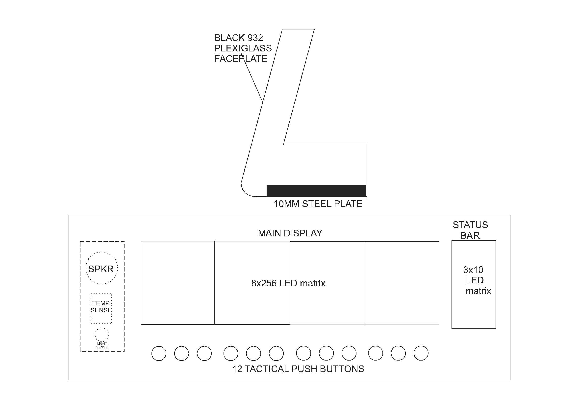
Front panel layout — author's design. Dimensions and cutout positions are illustrative; adapt to the exact components on hand.
The layout places the 256-pixel main display centrally, with the 30-LED status bar to its right — matching the physical arrangement described in Part 1. The speaker, ambient light sensor, and a temperature-sensing point sit to the left, kept clear of the display's electrical noise. All twelve front-panel buttons run along the bottom edge, within comfortable reach.

4.3 The Working Prototype
The clock has been running in day-to-day use in a simpler enclosure while this design was refined — the same electronics, the same firmware, the same front-panel layout, in a plainer case.
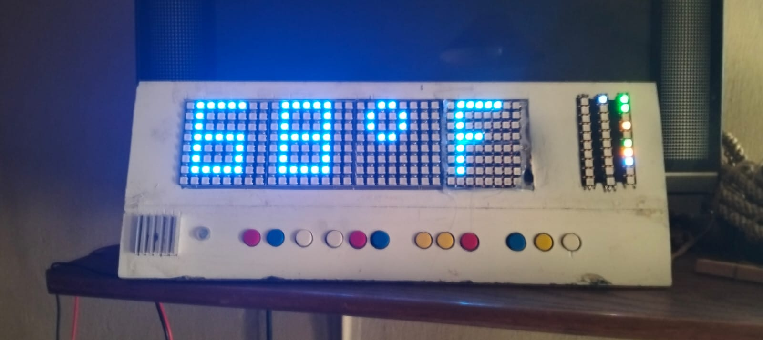
The working prototype in everyday use.

4.4 Component Reference
For anyone sourcing parts, a visual reference of the key modules used in this build:
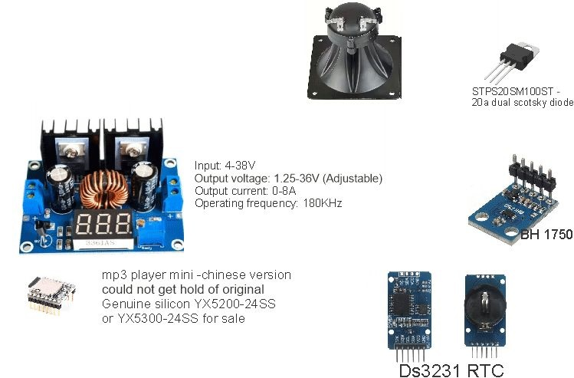
Buck converter, piezo horn, Schottky diode, BH1750 light sensor, DFPlayer Mini, and DS3231 RTC.
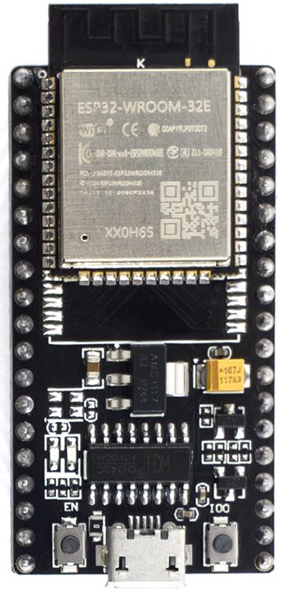
ESP32-WROOM-32E module.
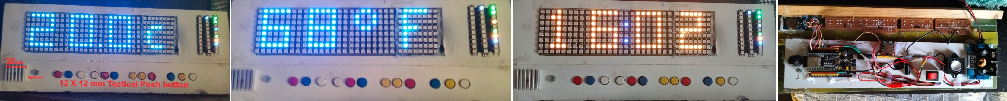
The main display across its different colour modes, and the internal wiring on the working prototype.

