OUMA RIA SMART CLOCK
A Simple Guide to Using Your Clock
Designed and built by Henry Vermaak
South Africa

Welcome
This clock was built with a lot of love, to help make everyday life a little easier.
It tells the time, but it also remembers things for you — your medicine, birthdays, doctor visits, and small daily reminders — so you do not have to carry it all in your head.
This guide will show you, step by step, how everything works. Nothing here is complicated. Take your time, and feel free to read it a little at a time.

♡ If you ever forget how something works, just come back to this page. There is no such thing as a silly question.

Your Clock at a Glance
Here is your clock, doing what it does every day — showing the time clearly, with its row of little coloured buttons underneath.
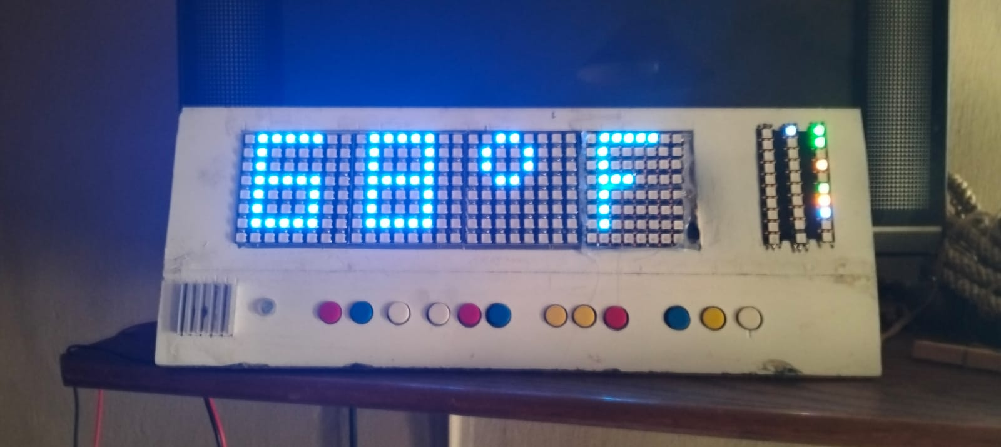
Your clock, showing the time.
Along the bottom of the clock are twelve small buttons. Each one has its own colour and its own job. You do not need to remember all of them at once — the ones you will use every day are covered in this guide, and there is a full list near the end for whenever you need to check.
On the right-hand side of the display is a small strip of coloured lights. These lights quietly tell you things at a glance — for example, whether your medicine has been taken today, or whether a birthday is coming up soon. You will learn what each colour means as you go through this guide.

Telling the Time
Most of the time, your clock simply shows the current time in large, clear numbers.
The red MODE button lets you look at a few other things too — pressing it moves you along to the next screen, and pressing it again and again brings you back to the normal clock.
The other screens you can look at are:
- The temperature in the room
- How many days the clock has been running without needing to be switched off
Do not worry about these extra screens — the clock always comes back to showing the normal time on its own after a little while, even if you do not press anything.

♡ If you hold the red MODE button down for a couple of seconds, the clock will switch between Celsius and Fahrenheit for the temperature. If this ever happens by accident, just hold it again to switch back.

Your Morning Alarm
Your clock has one main alarm, for waking up in the morning.

When the Alarm Rings
A gentle sound plays. To stop it:
- A quick press of the white UP button switches it off for the day.
- Holding the white UP button down for a moment instead gives you a little more time to sleep — the alarm will come back a short while later.

Turning the Alarm On or Off
The white ALARM ON/OFF button switches your morning alarm on or off completely, if there is ever a day you do not need it.

Your Other Alarms — “Wekkers”
Besides your main morning alarm, your clock can also remind you of up to three other things during the day — these are called Wekkers.
A Wekker might be set to remind you to check on something at a certain time, or as a second alarm for someone else in the house. Each one can be set for different days of the week, so one might ring only on weekdays, while another rings every day.
When a Wekker rings, it will keep gently reminding you every twenty seconds or so, until you press the white BIRTHDAY button to say you have heard it.

♡ A Wekker sounds a little different from your main morning alarm, so you can always tell the two apart.

Taking Your Medicine
This is one of the most important things your clock does.

Your Daily Medicine
If you take medicine every day, your clock can remind you at the right times — up to four times a day.
When it is time, the clock will speak to you gently and one of the lights on the right-hand strip will glow to remind you.
Once you have taken your medicine, press the yellow MEDICINE button. The light will change to show it has been taken, and the clock will not remind you again until the next dose is due.

A Short Course of Medicine
Sometimes a doctor prescribes medicine for just a few days — like antibiotics. Your clock can remind you about this too, completely separately from your everyday medicine.
Once the last day is finished, the clock stops reminding you all by itself. You do not need to remember to switch anything off.
Your clock can even keep track of two different short courses of medicine at the same time, if you ever need to.

An Extra Dose, Just for Today
If you ever need to take something extra, just once, that is not part of your normal schedule — like a headache tablet — there is a simple button on the medicine screen on the web page that lets you note it down, with no need to set up anything special.

♡ If a family member is not at home, the clock can also send a gentle message to their phone as a backup, so your medicine is never missed.

Birthdays
Your clock can remember birthdays for you — family, friends, anyone you like.
A few days before someone's birthday, a small light will begin to glow gently on the right-hand strip, getting a little brighter as the day gets closer.
On the morning of the birthday itself, your clock will play a little birthday tune for you at 08:40.
Press the white BIRTHDAY button any time to acknowledge it.

Doctor Visits
Just like birthdays, your clock can remind you of doctor's appointments.
The evening before an appointment, your clock will remind you out loud, so you have time to prepare. It will remind you again on the morning of the appointment itself.
If a family member is not at home, they will also get a message on their phone the evening before — doctor's appointments matter, so this reminder is sent a little more reliably than most.

Shopping List and Notes
Your clock also keeps a simple notebook — handy for a shopping list, or anything small you want to remember.
You can add notes, tick them off once done, and clear away the ticked ones — all from the web page on your phone or computer. It remembers everything, even if the clock is switched off and on again.

Kitchen Timers
Your clock is also a handy helper in the kitchen.

Egg Timer
A simple countdown timer, with a clear alert when the time is up — and if someone is outside when it finishes, a message is sent to their phone too, so nothing gets forgotten.

Braai Timer
Tells you when it is time to turn the meat, and lets you know once the whole cooking time is done. There is even a built-in guide on the web page for how long to cook different cuts of meat.

Smoker Timer
Smoking meat can take many hours. This timer quietly keeps track of how long it has been going — even through a power cut — and reminds you every thirty minutes to check the coals or wood.
If you are inside the house and want a quick answer to “how long has the smoker been going?”, a short tap of the blue WIFI RESET button will flash the running time on the main display for a few seconds.

Keeping Safe
Your clock also includes a security alarm, to help keep your home safe.
This is managed from the web page on your phone or computer, where you can:
- Arm the alarm when you leave the house
- Disarm it when you come home
- Press a Panic button if you ever feel unsafe, which sounds the alarm immediately
Part of the alarm system — covering your courtyard — stays switched on all the time, even while you are home, for extra peace of mind.

♡ If the alarm ever goes off by accident, simply disarm it from the web page. There is nothing to be worried about.

Getting Messages on Your Phone
For the more important reminders — medicine, doctor's visits, security — your clock can also send a gentle message to a phone, using a free app called Pushover.
This means that even if nobody is standing near the clock at the right moment, the reminder still gets through.
A family member can help set this up once, and after that, it simply works quietly in the background.

Quick Button Guide
A simple reference for all twelve buttons, whenever you need a reminder.

Colour | Button | What it does
Red | MODE | Look at other screens (temperature, uptime)
Blue | SET | Adjust settings
White | UP | Stop or snooze the morning alarm
White | ALARM ON/OFF | Switch the morning alarm on or off
Red | CHIMES | Switch the hourly chime on or off
Blue | VOLUME UP | Make the clock louder
Yellow | VOLUME DOWN | Make the clock quieter
Yellow | SOUND | Change the chime tune
Blue | WIFI RESET | Hold: restart the clock. Quick tap: check smoker time
Yellow | MEDICINE | Confirm you have taken your medicine
White | BIRTHDAY | Acknowledge a birthday, doctor visit, or Wekker

If Something Doesn't Seem Right
Now and then, something small might look a little unusual. Here is what to do — nothing here is anything to worry about.

The time looks wrong
This usually corrects itself within a few minutes, once the clock connects to the internet again. If it does not, ask a family member to check it for you.

The screen seems too bright or too dim
The clock adjusts its own brightness depending on the light in the room. Give it a moment — it usually settles on its own.

A button doesn't seem to do anything
Every button gives a small confirming beep when pressed. If you hear the beep but nothing seems to happen, that button simply may not have a job to do at that particular moment — try again a little later.

Something still doesn't feel right
There is no need to try and fix anything yourself. Simply ask a family member for help — that is exactly what this clock, and this guide, are here for.

♡ You cannot break this clock by pressing the wrong button. Every part of it was built to be gentle and forgiving — explore it without worry.

A Final Word
This clock was not built to be clever for its own sake. It was built so that one more small thing in your day is taken care of, quietly and reliably.
We hope it brings a little more ease, and a little more peace of mind, to your everyday life.

With love,
Henry Vermaak

