硬體測試:

stepper motor: 17hs1910

stepper motor driver: A4988

遠距通訊: HC-12

GPS: GY-NEO6MV2

計畫表:

1. 熟習Arduino

2. 測試GPS

3. 測試stepper motor

4. 連接兩塊版的

Arduino:

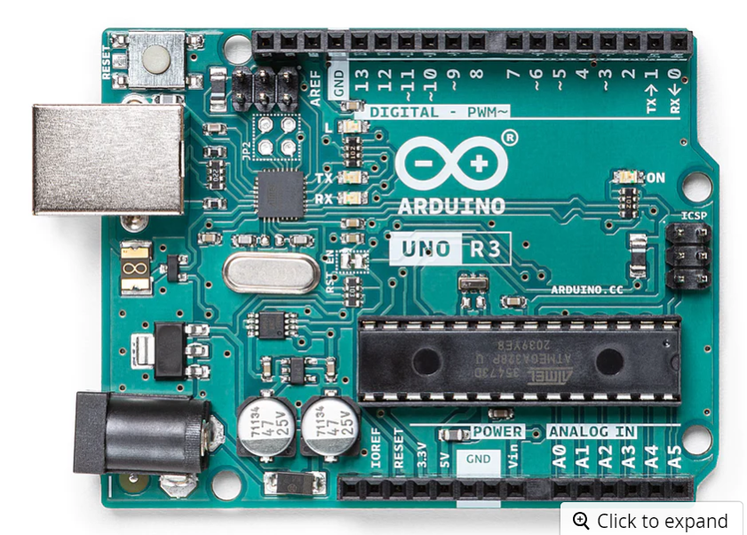

語法: <https://medium.com/jeasee%E9%9A%A8%E7%AD%86/arduino-%E5%9F%BA%E6%9C%AC%E8%AA%9E%E6%B3%95-a6a580e1650b>

Gps: <https://www.hwlibre.com/zh-TW/gps-arduino/>

Hc-12: <https://www.allaboutcircuits.com/projects/understanding-and-implementing-the-hc-12-wireless-transceiver-module/>

Stepper motor driver: <https://chenfuguo.gitbooks.io/arduino/content/Shields/a4988Controller.html>

樹梅派

Gps: <https://www.xarg.org/2016/06/neo6mv2-gps-module-with-raspberry-pi/> (不必要，應該是在arduino手持裝置上)

HC-12: <https://www.doctormonk.com/2022/09/simple-long-range-radio-from-raspberry.html>

Stepper motor: <https://how2electronics.com/control-stepper-motor-with-a4988-raspberry-pi-pico/>

GPS位置計算

Bearing: 指A點到B點與true north之間角度(就是我要計算的攝影機要轉幾度)

<https://www.lifewire.com/what-is-bearing-in-gps-1683320>

atan(x,y): x到y與x軸的夾角

目前台灣磁偏角 -5.06’

From: <https://www.magnetic-declination.com/Taiwan/Taipei/2654816.html#google_vignette>

GPS經緯度單位(degree。、min’、sec’’): 1degree=60min; 1min=60sec

2446.21577 12057.45911

2446.21560 12057.45807

24\*46.21577’ = 24.770262833333

24\*46.21560’ = 24.77026

00.00000283333