- main.js引入store
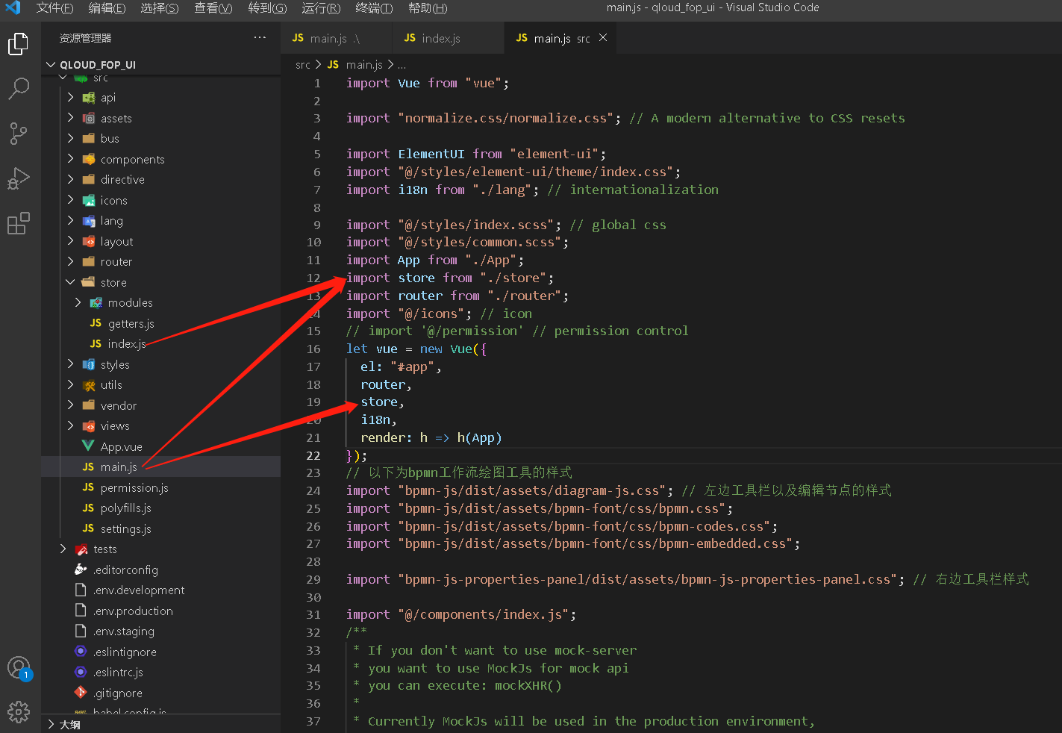
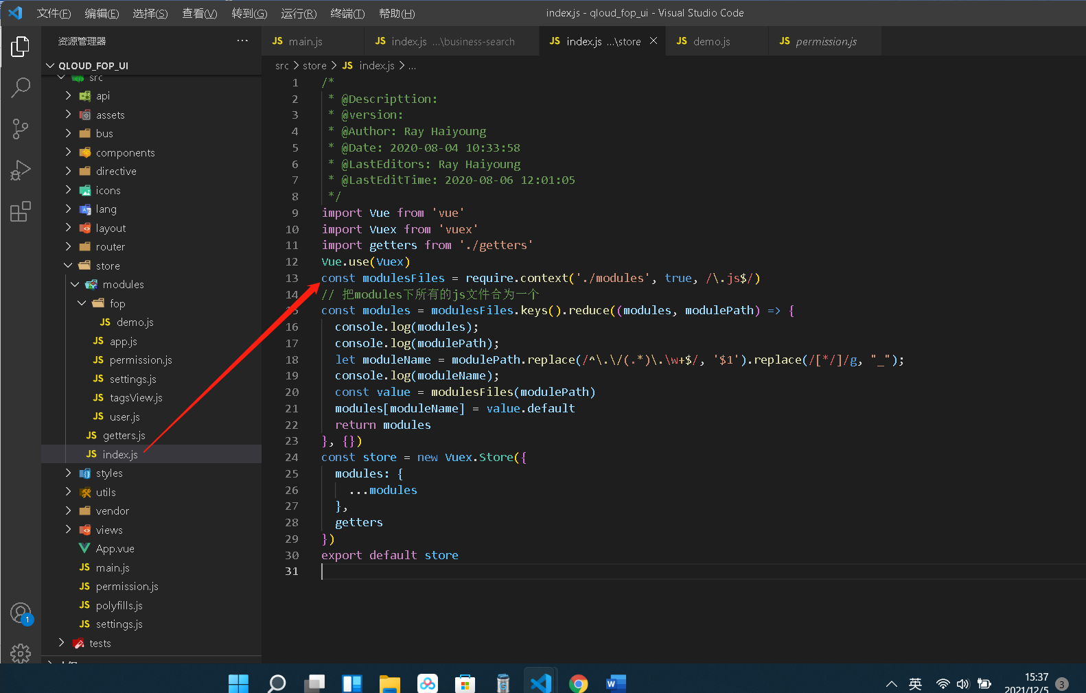
/*
* @Descripttion:
* @version:
* @Author: Ray Haiyoung
* @Date: 2020-08-04 10:33:58
* @LastEditors: Ray Haiyoung
* @LastEditTime: 2020-08-06 12:01:05
*/
import Vue from 'vue'
import Vuex from 'vuex'
import getters from './getters'
Vue.use(Vuex)
const modulesFiles = require.context('./modules', true, /\.js$/)
// 把modules下所有的js文件合为一个
const modules = modulesFiles.keys().reduce((modules, modulePath) => {
console.log(modules);
console.log(modulePath);
let moduleName = modulePath.replace(/^\.\/(.*)\.\w+$/, '$1').replace(/[*/]/g, "_");
console.log(moduleName);
const value = modulesFiles(modulePath)
modules[moduleName] = value.default
return modules
}, {})
const store = new Vuex.Store({
modules: {
...modules
},
getters
})
export default store
- 每个modules下js
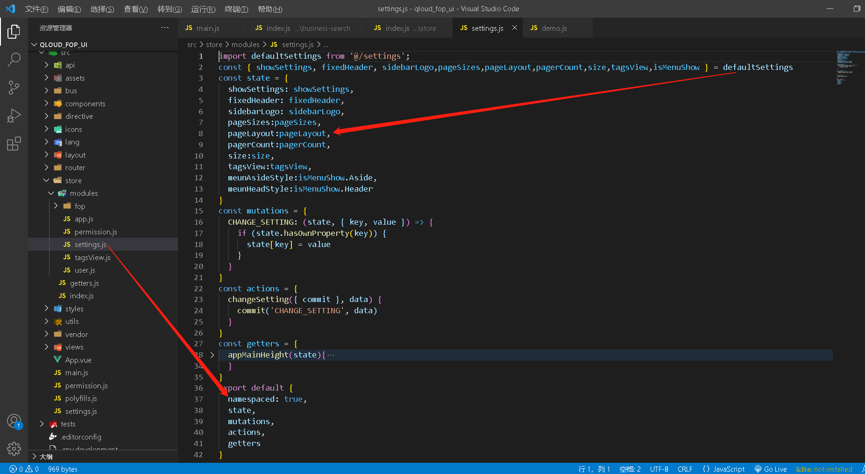
export default
必须有namespaced: true,的配置

