- main.js引入路由
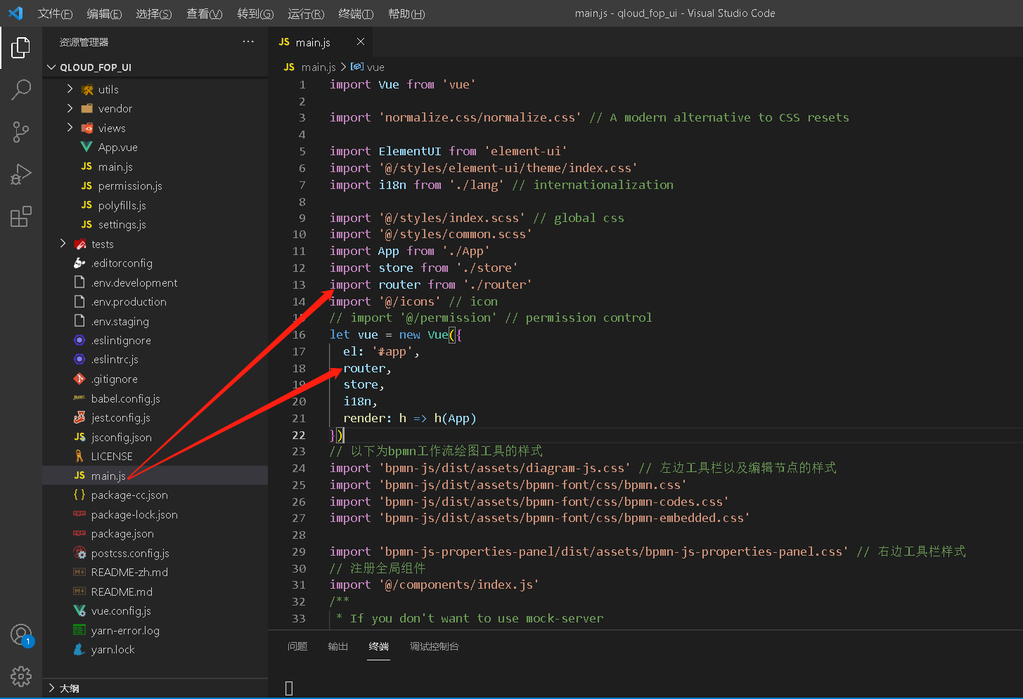
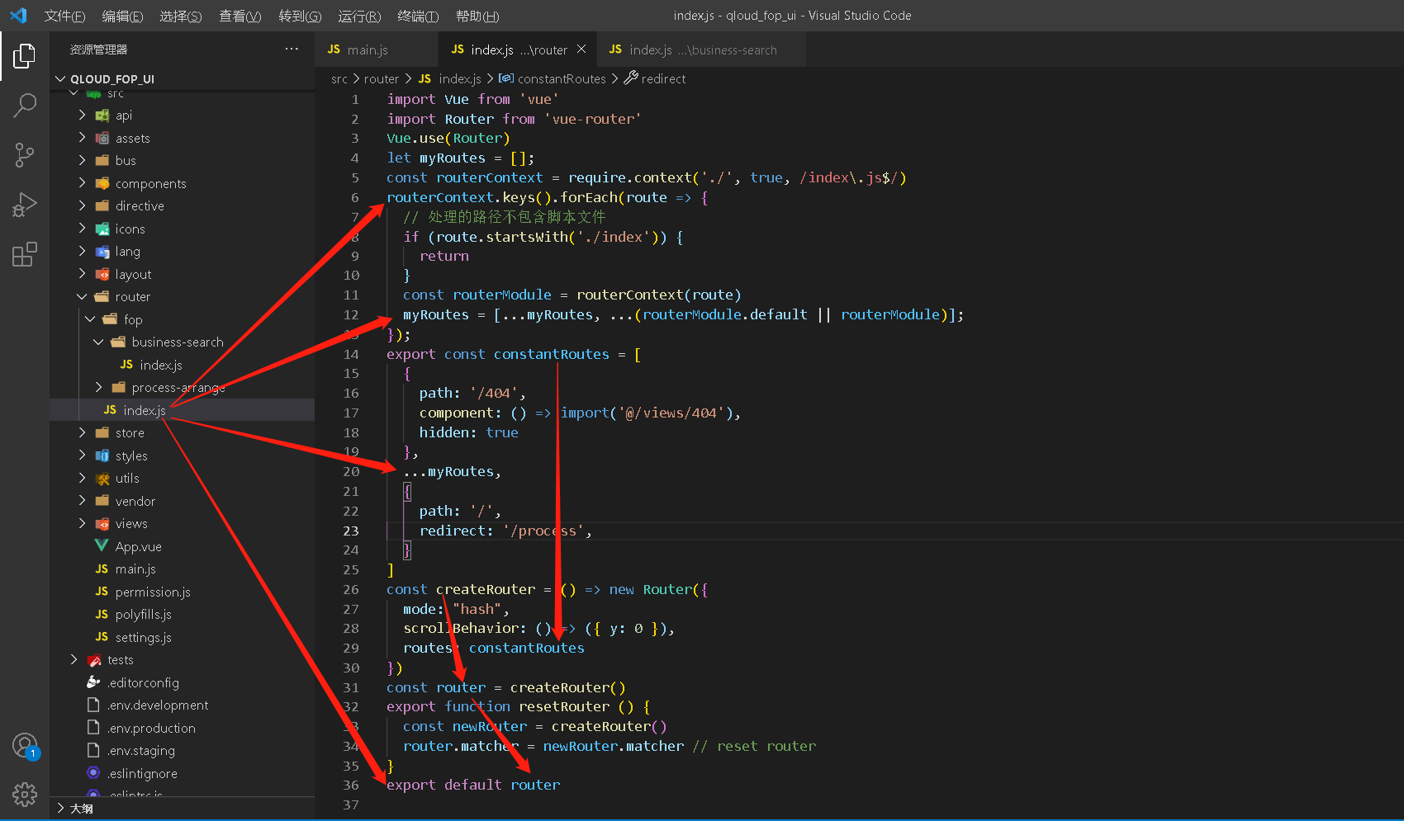

路由拦截代码
import axios from 'axios'
import {
Message
} from 'element-ui'
import router from '@/router/index.js'
import {
getToken
} from '@/utils/auth'

/**
* 防重复点击发送请求
*/
//声明一个数组用于存储每个请求的取消函数和标识
let pending = [];
let cancelToken = axios.CancelToken;
let removePending = (ever) => {
for (let p in pending) {
//当当前请求在数组中存在时执行函数体
if (`${ever.url}&${ever.method}`.endsWith(pending[p].u) && JSON.stringify(pending[p].d) === ever.data) {
//执行取消操作
// pending[p].f();
ever.cancelToken = new cancelToken(c => c());
//把这条记录从数组中移除
pending.splice(p, 1);
}
}
}
const service = axios.create({
// url = base url + request url
baseURL: process.env.VUE_APP_BASE_API,
// request timeout
timeout: 50000 // request timeout
})

// requets拦截
service.interceptors.request.use(
config => {
const token = getToken();
//在一个发送前执行一下取消操作
removePending(config);
if (typeof config.headers['Content-Type'] == 'undefined') {
config.headers['Content-Type'] = 'application/json;charset=UTF-8';
}
// if (token) {
// // config.headers['X-Token'] = getToken()
// }
config.cancelToken = new cancelToken((c) => {
pending.push({
u: `${config.url}&${config.method}`,
d: config.data,
f: c
});
});
return config
},
error => {
return Promise.reject(error)
}
)

//response 拦截
service.interceptors.response.use(
response => {
/**
* @param {statusCode} 若存在表示调用node接口，否则调用Java接口
*/
const res = Object.prototype.hasOwnProperty.call(response.data,"statusCode") ? response.data.data : response.data;
removePending(response.config);
if (response.data.code != 200) {
// Message({
// message: res.msg,
// type: 'error',
// duration: 3 * 1000
// })
}
return res
},
error => {
Message({
message: error.message,
type: 'error',
duration: 3 * 1000
})
return Promise.reject(error)
}
)
export default service

