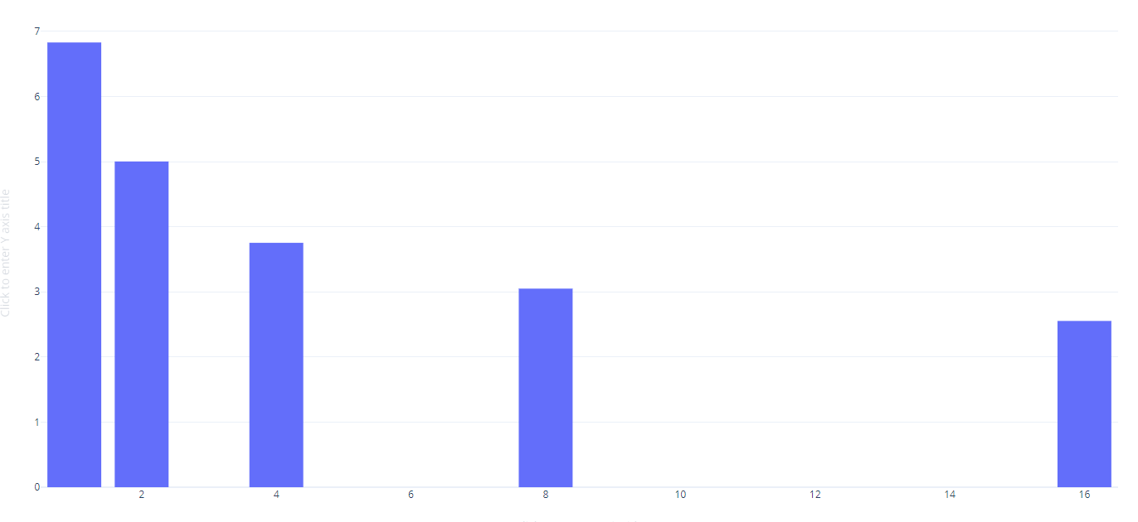

The bar plot for client number (1,2,4,8,16), the vertical download speed MB/s

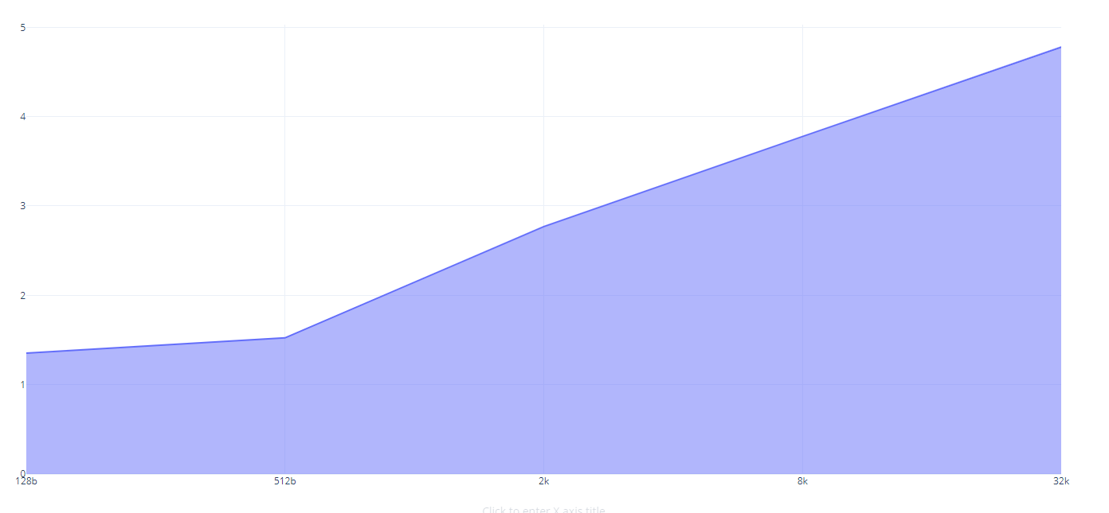

The bar plot shows different file sizes’ downloading speed.