c). after having a review on Lunar Palace 1, where many important sections have been considered so far. I may want to suggest the below sketch;
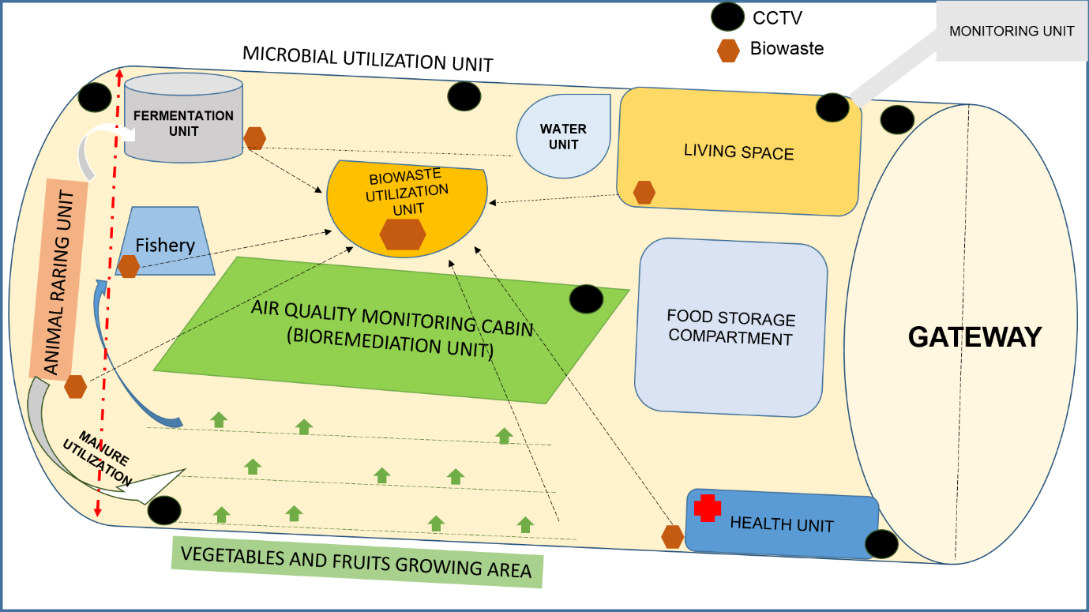

SPACE MODULE SKETCH
Physical, medical, biochemical and genetic (epigenetic) observation prior to and post cabin experience.
Including different age group volunteers
Medium and long term stay behaviour
Plant-microbe interaction analysis for space-agriculture and bioremediation
Storage and production of food with high carbohydrates, fats and proteins.

