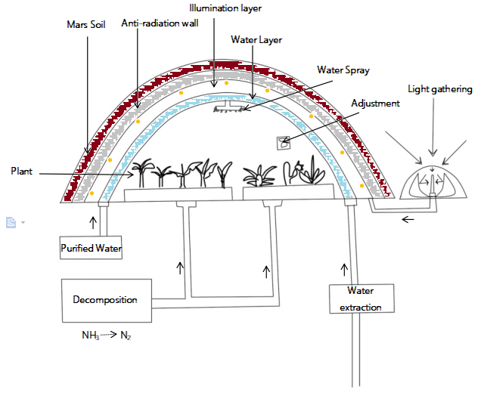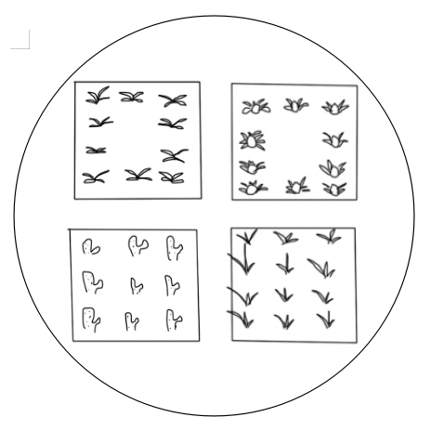
2
1
5
6
4
3
7
- Water from aquaculture can be used for plant.
- Resulted ammonia from aquaculture is changed to nitrogen with several process.
- Water also can be generated from Mars soil by using water extractor
- Light is gathered and distributed to illuminate the agricultural system
- Adjustment to make suitable condition including temperature, humidity and so on.
- Water sprayer may be able to water the plant.
- Oxygen and Carbon dioxide cycle of C3 and CAM plant under light and dark conditions.
CO₂
CO₂
O₂
O₂
C3
CAM

