myNAND

v0 = output = 75725112

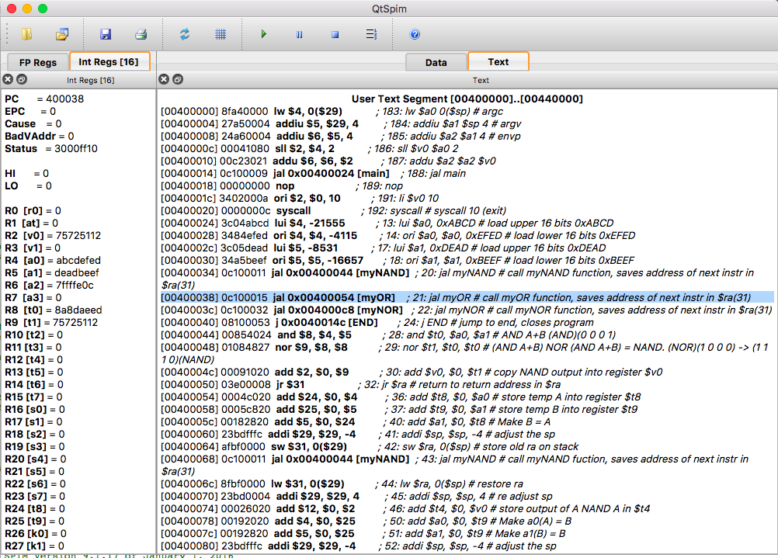

myOR

v0 = output = FFEDFFEF

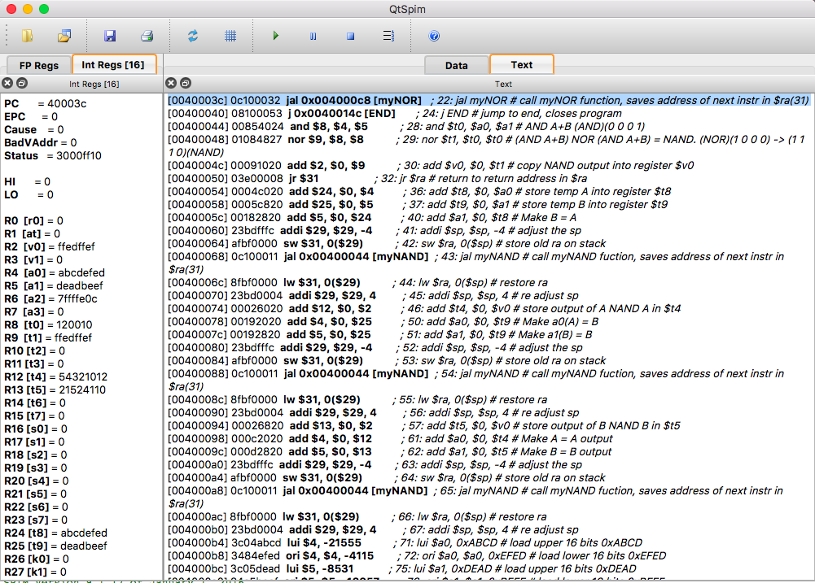

myNOR

v0 = output = 120010

