ab\*a|b\*a

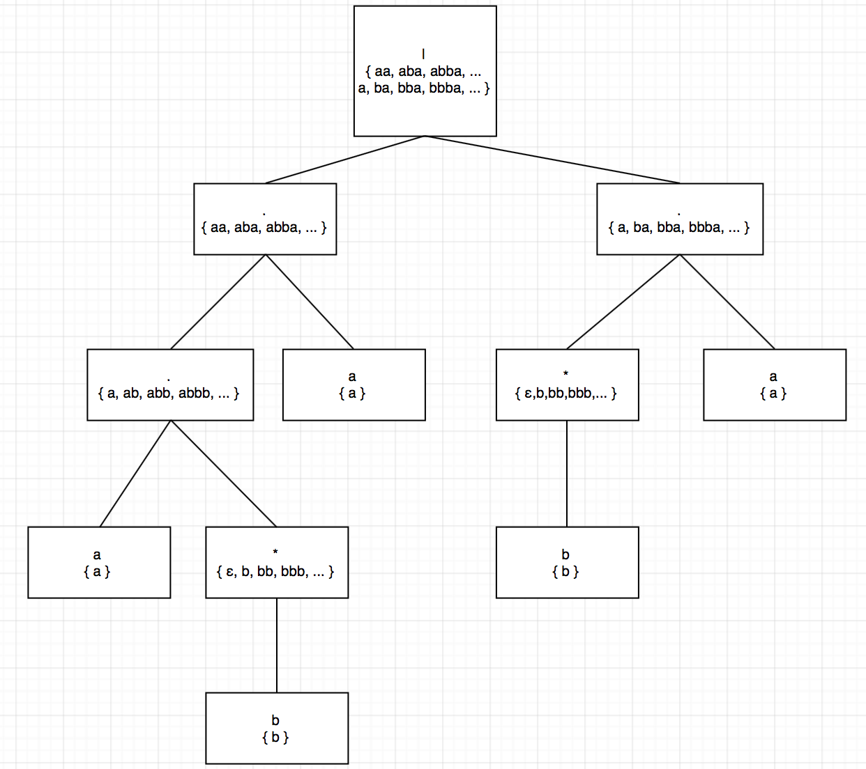

((ε | a) b\*)\*

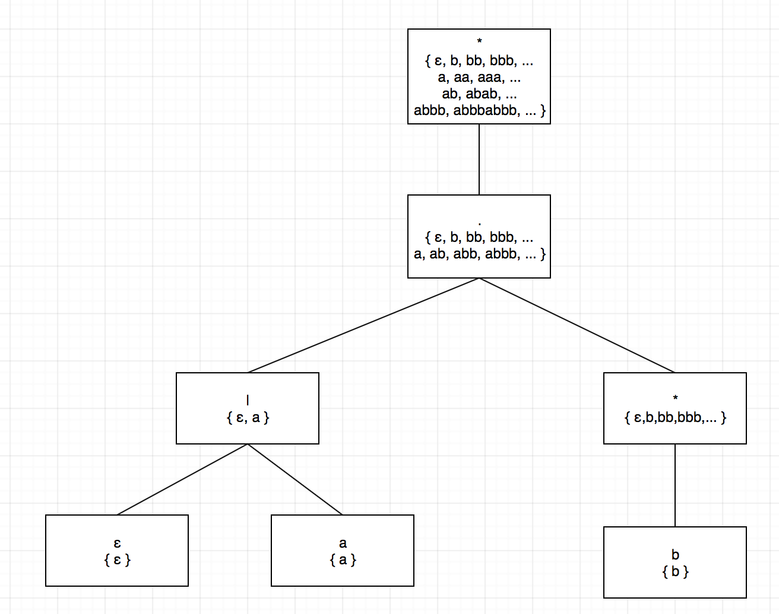

All strings of a’s and b’s with no repeated letters: (ab)\*a?|(ba)\*b?

Comments, consisting of a string surrounded by /\* and \*/, without an intervening \*/, unless it is inside double-quotes (“) : \/\\*([^\\*"]\*|"[^"]\*"|\\*+[^\/])\*\\*\/