10.13 (Project: Shape Hierarchy) Implement the shape hierarchy shown in Fig. 9.3.Each Two-DimensionalShape should contain method getArea to calculate the area of the two-dimensional shape. Each ThreeDimensionalshape should have methods getArea and getvolume calculate the surface area and volume, respectively, of the three-dimensional shape. Create a program that uses an array of shape references to objects of each concrete class in the hierarchy. The program should print a text description of the object to which each array element refers. Also, in the loop that processes all the shapes in the array, determine whether each shape is a TwoDimensionalshape or a ThreeDimensionalShape. If it's a TwoDimensionalshape, display its area. If it's a ThreeDimensionalshape, display its area and volume

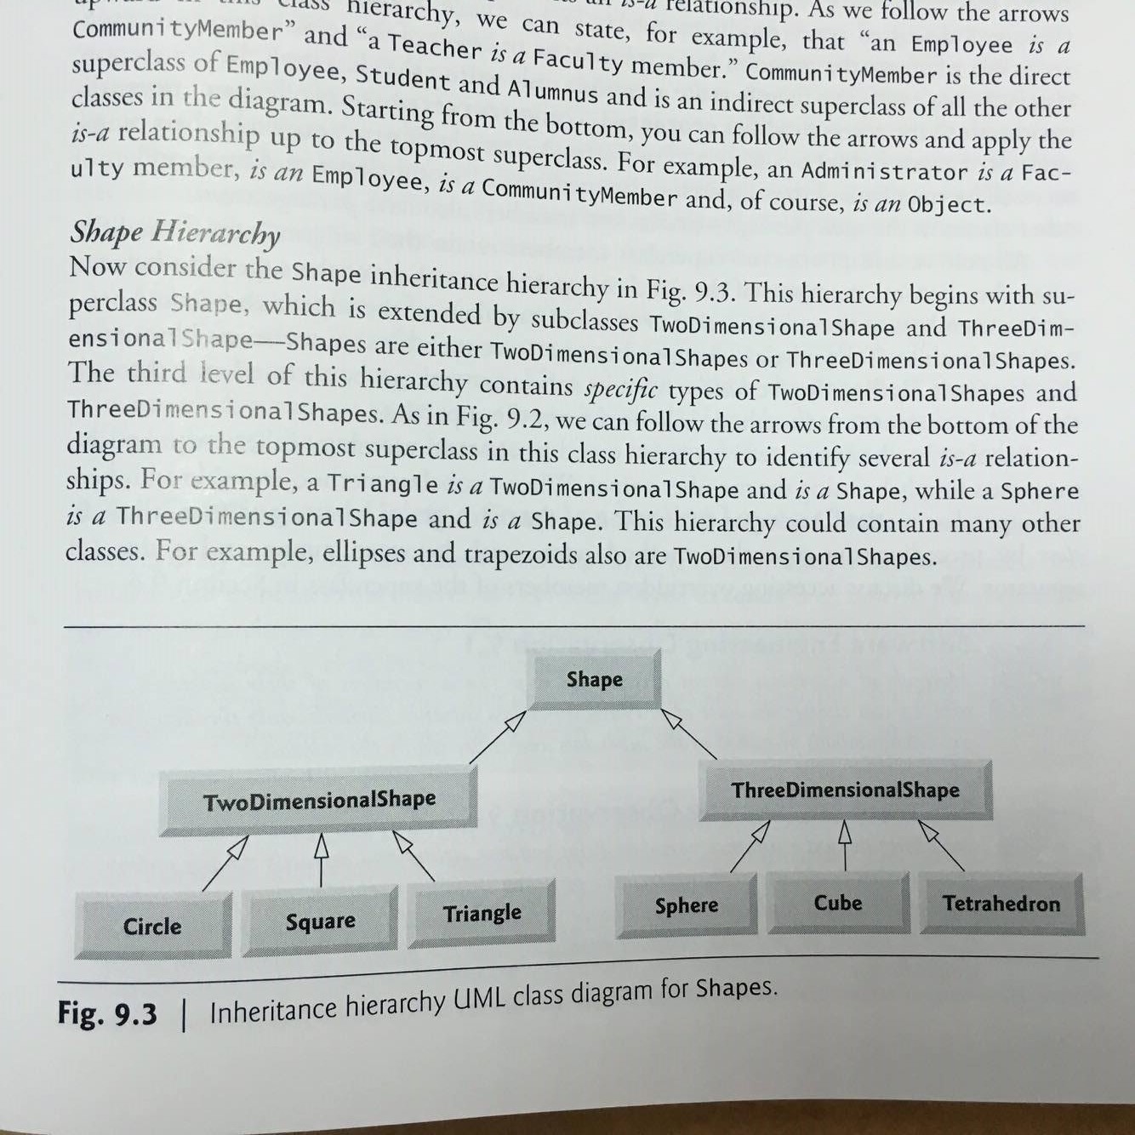

10.16 (Accounts Payable System Modification) It's possible to include the functionality of the payroll application (Figs. 10.4-10.9) in the accounts payable application without modifying Employee subclasses salaried Employee, HourlyEmployee, CommissionEmployee or Base Pluscommission- Employee. To do so, you can modify class Employee (Fig. 10.4) to implement interface Payable and declare method getPayment Amount to invoke method earnings. Method get PaymentAmount would en be inherited by the subclasses in the Employee hierarchy. When getPaymentAmount is called for a particular subclass object, it polymorphically invokes the appropriate earnings method for that subclass. Reimplement Exercise 10.15 using the original Employee hierarchy from the payroll appli- cation of Figs. 10.4-10.9. Modify class Employee as described in this exercise, and do not modify any of class Employee's subclasses.

