GRE

报名ID:71325284(Chen!940822)

查分ID:chenwei940822 (Njxzc111112)

Email: [yschen1968@qq.com](mailto:yschen1968@qq.com)

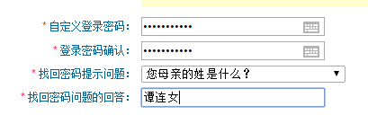

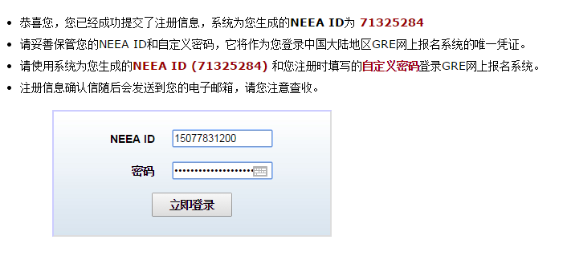

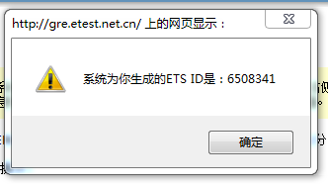

6508341