# QP

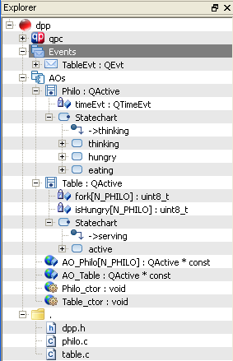

QM model



Code templates in QM filesystem

#include "qp_port.h"

#include "dpp.h"

#include "bsp.h"

Q_DEFINE_THIS_FILE

$declare(AOs::Philo)  
…

SW developer maps model to project source code composition



Other code:

BSP

Libraries

Main

Memory map

Project options

Makefile, etc

**Whole project source**

Generate code

# Aquarium

High thermal impedance material (cardboard?)

Copper plate 1.2cm thick

Copper plate

T_water (W x L x H = 24x24x20 cm^3)

T_copper

T_glass

Air above water nearly at T_water

T_air

Plexiglass

T_bottom

20Ω resistor

Air fan control



GPIO



Vdd = 12V

ref

Brushless DC motor 60Ω

1K Ω

ref

Thermistor and PWM heater

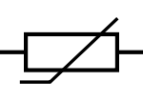

Vref

ref

10K Ω

ref



GPIO

ADC



Vdd = 12V

ref

20 Ω power resistor

ref

1K Ω

ref