Model of the Tropical Aquarium

High thermal impedance material (cardboard?)

Copper plate 1.2cm thick

Copper plate

Resistor (14 W max)

T_water (W x L x H = 24x24x20 cm^3)

T_copper

T_glass

Air above water nearly at T_water

T_air

Plexiglass

Thermistor and PWM heater

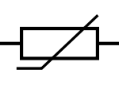

Vref

ref

10K Ω

ref



GPIO

ADC



Vdd = 12V

ref

20 Ω power resistor

ref

1K Ω

ref