Direct Ground Support and Shallow P-wave Velocity Heterogeneity at a Candidate Southern Continuation of the Porotoyacu Fault, Ecuadorian Amazon
Henry Conteron^{a,b} https://orcid.org/0009-0004-8681-3594,
Samira Llunoª https://orcid.org/0009-0002-2899-9007,
Oswaldo Guzmánª https://orcid.org/0000-0001-7326-1082,
Sebastian Araujoª https://orcid.org/0000-0002-9704-5779,
Bryan Valenciaª https://orcid.org/0000-0002-5970-4964,
Corina Camposª https://orcid.org/0000-0002-2785-5469,
Anderson Guamánª https://orcid.org/0000-0002-3500-8294,
Juan Villacresª https://orcid.org/0009-0004-2904-424X
ªEarth and Climate Sciences Research Group, Universidad Regional Amazónica Ikiam, Tena, Ecuador
^{b}Present address: Independent Researcher, Archidona, Napo, Ecuador.
*Corresponding author: Henry Conteron, Earth and Climate Sciences Research Group, Universidad Regional Amazónica Ikiam, Vía Muyuna Km 7, Tena, 150150, Ecuador. Email: Conteron86@gmail.com.

Abstract
This study evaluates direct terrain support and shallow P-wave velocity heterogeneity at a candidate southern continuation of the Porotoyacu Fault. The definitive UAV-SfM LAZ contains 13,619,241 classified points, including 2,810,862 class-2 Ground points (20.64%). Ground occurs in 47.13% of occupied 2 × 2 m cells. Thirty-two 180 m profiles were screened with raw Ground points in ±5 m swaths and 1 m bins; 12 have high or moderate direct support, whereas 20 cannot support independent morphometric measurement. A single 69 m SW–NE SRT profile was also evaluated. Smoothing tests favored wH=0.9, yielding a 3.336 ms RMS residual for 552 observed–calculated pairs. The exported nodal grid reaches 21.4–22.3 m below ground; this is not a uniform resolution depth. The observed terrain data show a local elevation transition but do not verify continuous fault-trace extension, vertical separation, or a scarp height. The strongest lateral P-wave velocity variations occur in the southwestern profile. These variations are spatially consistent with a possible deformation zone beneath the mapped scarp; however, the single two-dimensional SRT profile does not uniquely resolve a fault surface, dip angles, lithology, kinematics, an antithetic structure, or fault activity. A northeast-dipping thin-skinned backthrust remains a regional structural hypothesis that requires additional geophysical and paleoseismic evidence. Together, the terrain and velocity observations motivate further field testing; they do not establish a fault length, present activity, or a seismic-hazard parameter.
Keywords: UAV Structure-from-Motion; Ground support; classified point cloud; Seismic refraction tomography; Porotoyacu Fault

1. Introduction
Identifying and characterizing active faults is fundamental for seismic hazard assessment and risk mitigation, particularly in tectonically complex regions (McCalpin, 2009; Wu & Hu, 2019; Maldonado et al., 2021; Molins-Vigatà et al., 2022). Accurate fault mapping requires the integration of surface geomorphic observations with subsurface geophysical imaging in order to delineate fault traces and constrain their shallow geometry (McCalpin, 2009; De Bari et al., 2011; Papanikolaou et al., 2015; Butler, 2024; Galone et al., 2024).
UAV Structure-from-Motion can provide detailed surface reconstructions, but raster cell spacing is not vertical accuracy and a bare-earth model depends on where Ground-classified points actually occur. This distinction is especially important beneath tropical vegetation and on roofs or other built surfaces. Shallow seismic methods can add complementary subsurface information. Moreover, explicit sensitivity testing of smoothing choices, inspection of convergence behavior, and evaluation of travel-time residuals are important for assessing model stability and limiting overinterpretation in complex near-surface environments (Sheehan et al., 2005; Wang, 2016; Araujo et al., 2023).
In Ecuador (Figure 1A), active fault mapping has advanced considerably in the Western and Eastern Cordilleras and within the Inter-Andean Depression (Egüez et al., 2003; Alvarado et al., 2014; Baize et al., 2020; Jomard et al., 2021). In contrast, the Sub-Andean Zone, located east of the Eastern Cordillera, remains comparatively less constrained at local scales (Figure 1B). This region includes the Napo-Cutucú fault system, a major seismogenic province associated with destructive historical earthquakes, including the 1987 Baeza event (Mw 7.1) (Legrand et al., 2004; Font et al., 2013). On a broader scale, the Ecuadorian Sub-Andean Zone represents the active eastern deformation front accommodating the partitioned oblique convergence between the Nazca and South American plates, which drives the northeastward tectonic escape of the North Andean Sliver (Nocquet et al., 2014; Alvarado et al., 2016; Yepes et al., 2016). While the regional kinematics of this tectonic escape are increasingly well constrained by geodetic data (Nocquet et al., 2014), the specific role of individual transpressive and reverse faults in accommodating shallow crustal shortening remains poorly resolved (Costa et al., 2020).
The Porotoyacu Fault is mapped regionally as part of the Napo-Cutucú fault system (Figure 1C). Regional mapping motivates investigation of a possible southern continuation, but the local surface continuity and origin of nearby topographic breaks have not been independently verified. This study therefore treats the surface feature as a candidate lineament, not proof of active rupture.
To address this gap, the study combines final-cloud Ground quality control with one SRT line. Its objectives are to (1) quantify direct Ground support along 32 local profiles; and (2) describe shallow P-wave velocity variations across the mapped scarp through tomographic inversion; and (3) examine whether the local surface and velocity observations justify a testable structural hypothesis, without claiming verified fault continuity, displacement, activity, or hazard parameters.

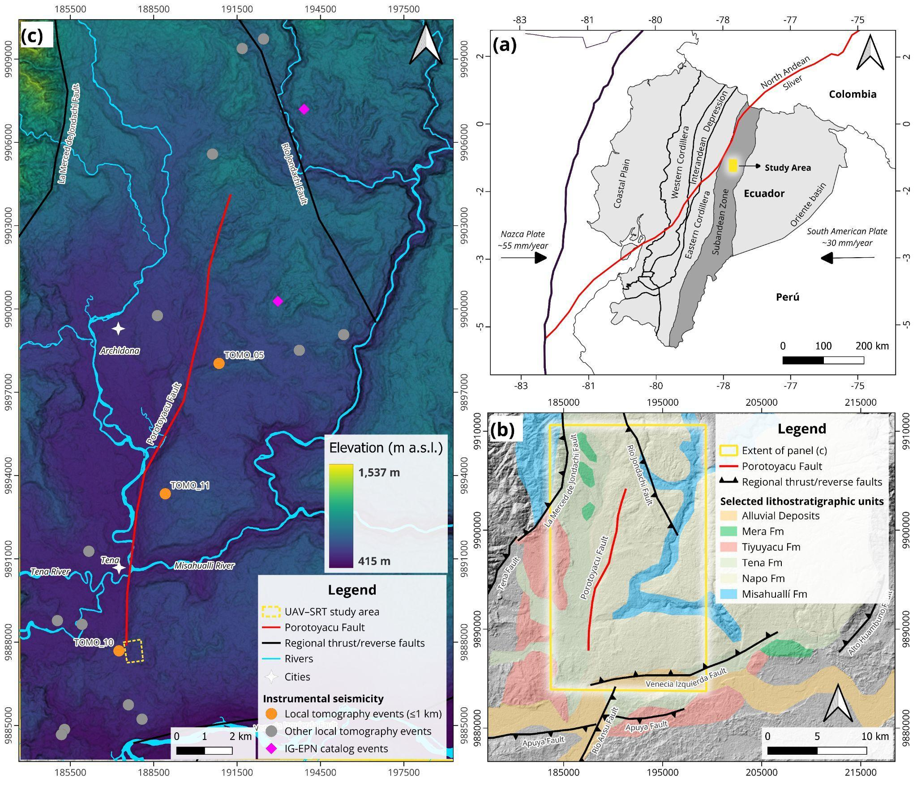
Figure 1. Location and tectonic setting of the study area. (A) Regional tectonic framework of Ecuador within the Northern Andes, showing the convergence between the Nazca and South American plates and the North Andean Sliver (Trenkamp et al., 2002; Kendrick et al., 2003; Hasterok et al., 2022; Rodríguez et al., 2024). (B) Main morphotectonic and structural domains of Ecuador, including the Coastal Plain, Western Cordillera, Interandean Depression, Eastern Cordillera, and the Sub-Andean Zone. Structural boundaries are delineated by black lines, adapted from Romero Cóndor et al. (2023). (C) Topographic expression of the study area visualized using a Red Relief Image Map (RRIM; Chiba et al., 2008) in grayscale to enhance subtle structural lineaments, derived from the 12.5 m resolution ALOS PALSAR Radiometrically Terrain Corrected (RTC) Digital Elevation Model (ASF, 2015). Mapped active faults are from Costa et al. (2020), and shallow instrumental seismicity (Mw 3.0-4.7) recorded up to 2025 was obtained from the Instituto Geofísico de la Escuela Politécnica Nacional (IGEPN, 2026). Coordinate system: WGS 84 / UTM Zone 18S.

2. Geological and Tectonic Setting
Seismic activity in continental Ecuador (Figure 1A) is primarily controlled by the subduction of the Nazca Plate beneath the South American Plate at a convergence rate of ~55 mm/yr (Trenkamp et al., 2002; Kendrick et al., 2003; Nocquet et al., 2014; Rodríguez et al., 2024). The eastward motion of the Nazca Plate results in oblique convergence along the trench (Kellogg & Vega, 1995; Trenkamp et al., 2002), promoting strain partitioning and predominantly E-W crustal shortening within the overriding plate (Ego et al., 1996; Gutscher et al., 1999). Additionally, the northeastward escape of the North Andean Sliver, together with interactions among inherited crustal structures, contributes to the high seismicity and structural complexity of the northern Andean margin (Chunga et al., 2010; Nocquet et al., 2014; Alvarado et al., 2016; Tamay, 2018).
The Sub-Andean Zone constitutes the easternmost morphotectonic domain of the Ecuadorian Andes (Figure 1B). This fold-and-thrust belt is characterized by N-S to NNE-SSW trending reverse faults accommodating significant crustal shortening. Seismic reflection data indicates that these structures are generally high angle and likely crustal scale features (Rivadeneira & Baby, 2004). Many of them correspond to inverted Mesozoic extensional faults that originally controlled Triassic-Jurassic sedimentation (Díaz et al., 2004). Morphologically, the Sub-Andean Zone is subdivided into three principal domains: the Napo Uplift (or Napo Dome), the Pastaza Depression, and the Cutucú Cordillera (Bès de Berc et al., 2004).
The Napo-Cutucú fault system represents one of the principal seismogenic sources within the Sub-Andean Zone (Bès de Berc et al., 2004; Alvarado, 2012; Alvarado et al., 2016; Yepes et al., 2016). This system has been associated with major historical earthquakes, including the 1987 Baeza event (Mw 7.1) and the 1995 Macas earthquake (Mw 7.0) (Legrand et al., 2004, 2005; Font et al., 2013). Structurally, the Napo-Cutucú system exhibits a thick-skinned deformation style related to the tectonic inversion of pre-Cretaceous extensional fault systems (Baby et al., 2013). This structural architecture involves both the basement and its sedimentary cover from the Napo Dome to the Cutucú Cordillera, exerting a strong control over the Quaternary drainage network and regional topographic development (Bès de Berc, 2003; Alvarado et al., 2016). However, how this deep crustal shortening is transferred and accommodated within the shallow, softer sedimentary cover (potentially triggering local thin-skinned deformation) remains poorly characterized.
Within the Napo-Cutucú fault system, recent sedimentological studies have documented seismically induced soft sediment deformation structures (seismites) in the Upper Cretaceous Tena Formation of the Sub-Andean Zone, indicating intraplate seismic activity associated with early Andean uplift (Cornejo et al., 2025). Specifically, the Porotoyacu Fault has been mapped with an approximate length of 16.7 km (Costa et al., 2020). It exhibits transcurrent inverse kinematics and forms part of the active deformation front of the Sub-Andean belt. Instrumental seismicity indicates ongoing activity, with at least eight recorded events of magnitudes up to Mw 5.5 in its vicinity during the past two decades (IGEPN, 2026). Notably, a Mw 4.9 earthquake on December 28, 2021, located north of the mapped trace, further highlights the active nature of this structure. Although regional mapping defines its general trend, preliminary paleoseismological observations (Cornejo et al., 2024) and continuous morphotectonic lineaments suggest that the southern segment may extend beyond the currently mapped termination, underscoring the need for detailed local scale structural characterization such as that presented in this study.
3. Methodology
We used the definitive classified UAV point cloud to quantify direct terrain support and one SRT line to describe shallow subsurface variability. The extrapolated terrain display was not treated as direct topographic measurement, while subsurface velocity variations were defined from the geometry of P-wave velocity contrasts. The resulting interpretations were subsequently compared in their spatial context without using either dataset to predetermine the interpretation of the other.
3.1. Study Area
The study area lies in the Ecuadorian Sub-Andean Zone near the mapped southern Porotoyacu Fault segment (Figure 2). The UAV survey covered a local topographic transition near latitude −1.016118°, longitude −77.805551° (WGS 84). The feature is investigated as a candidate surface lineament rather than assumed to be a fault scarp or continuous along strike.
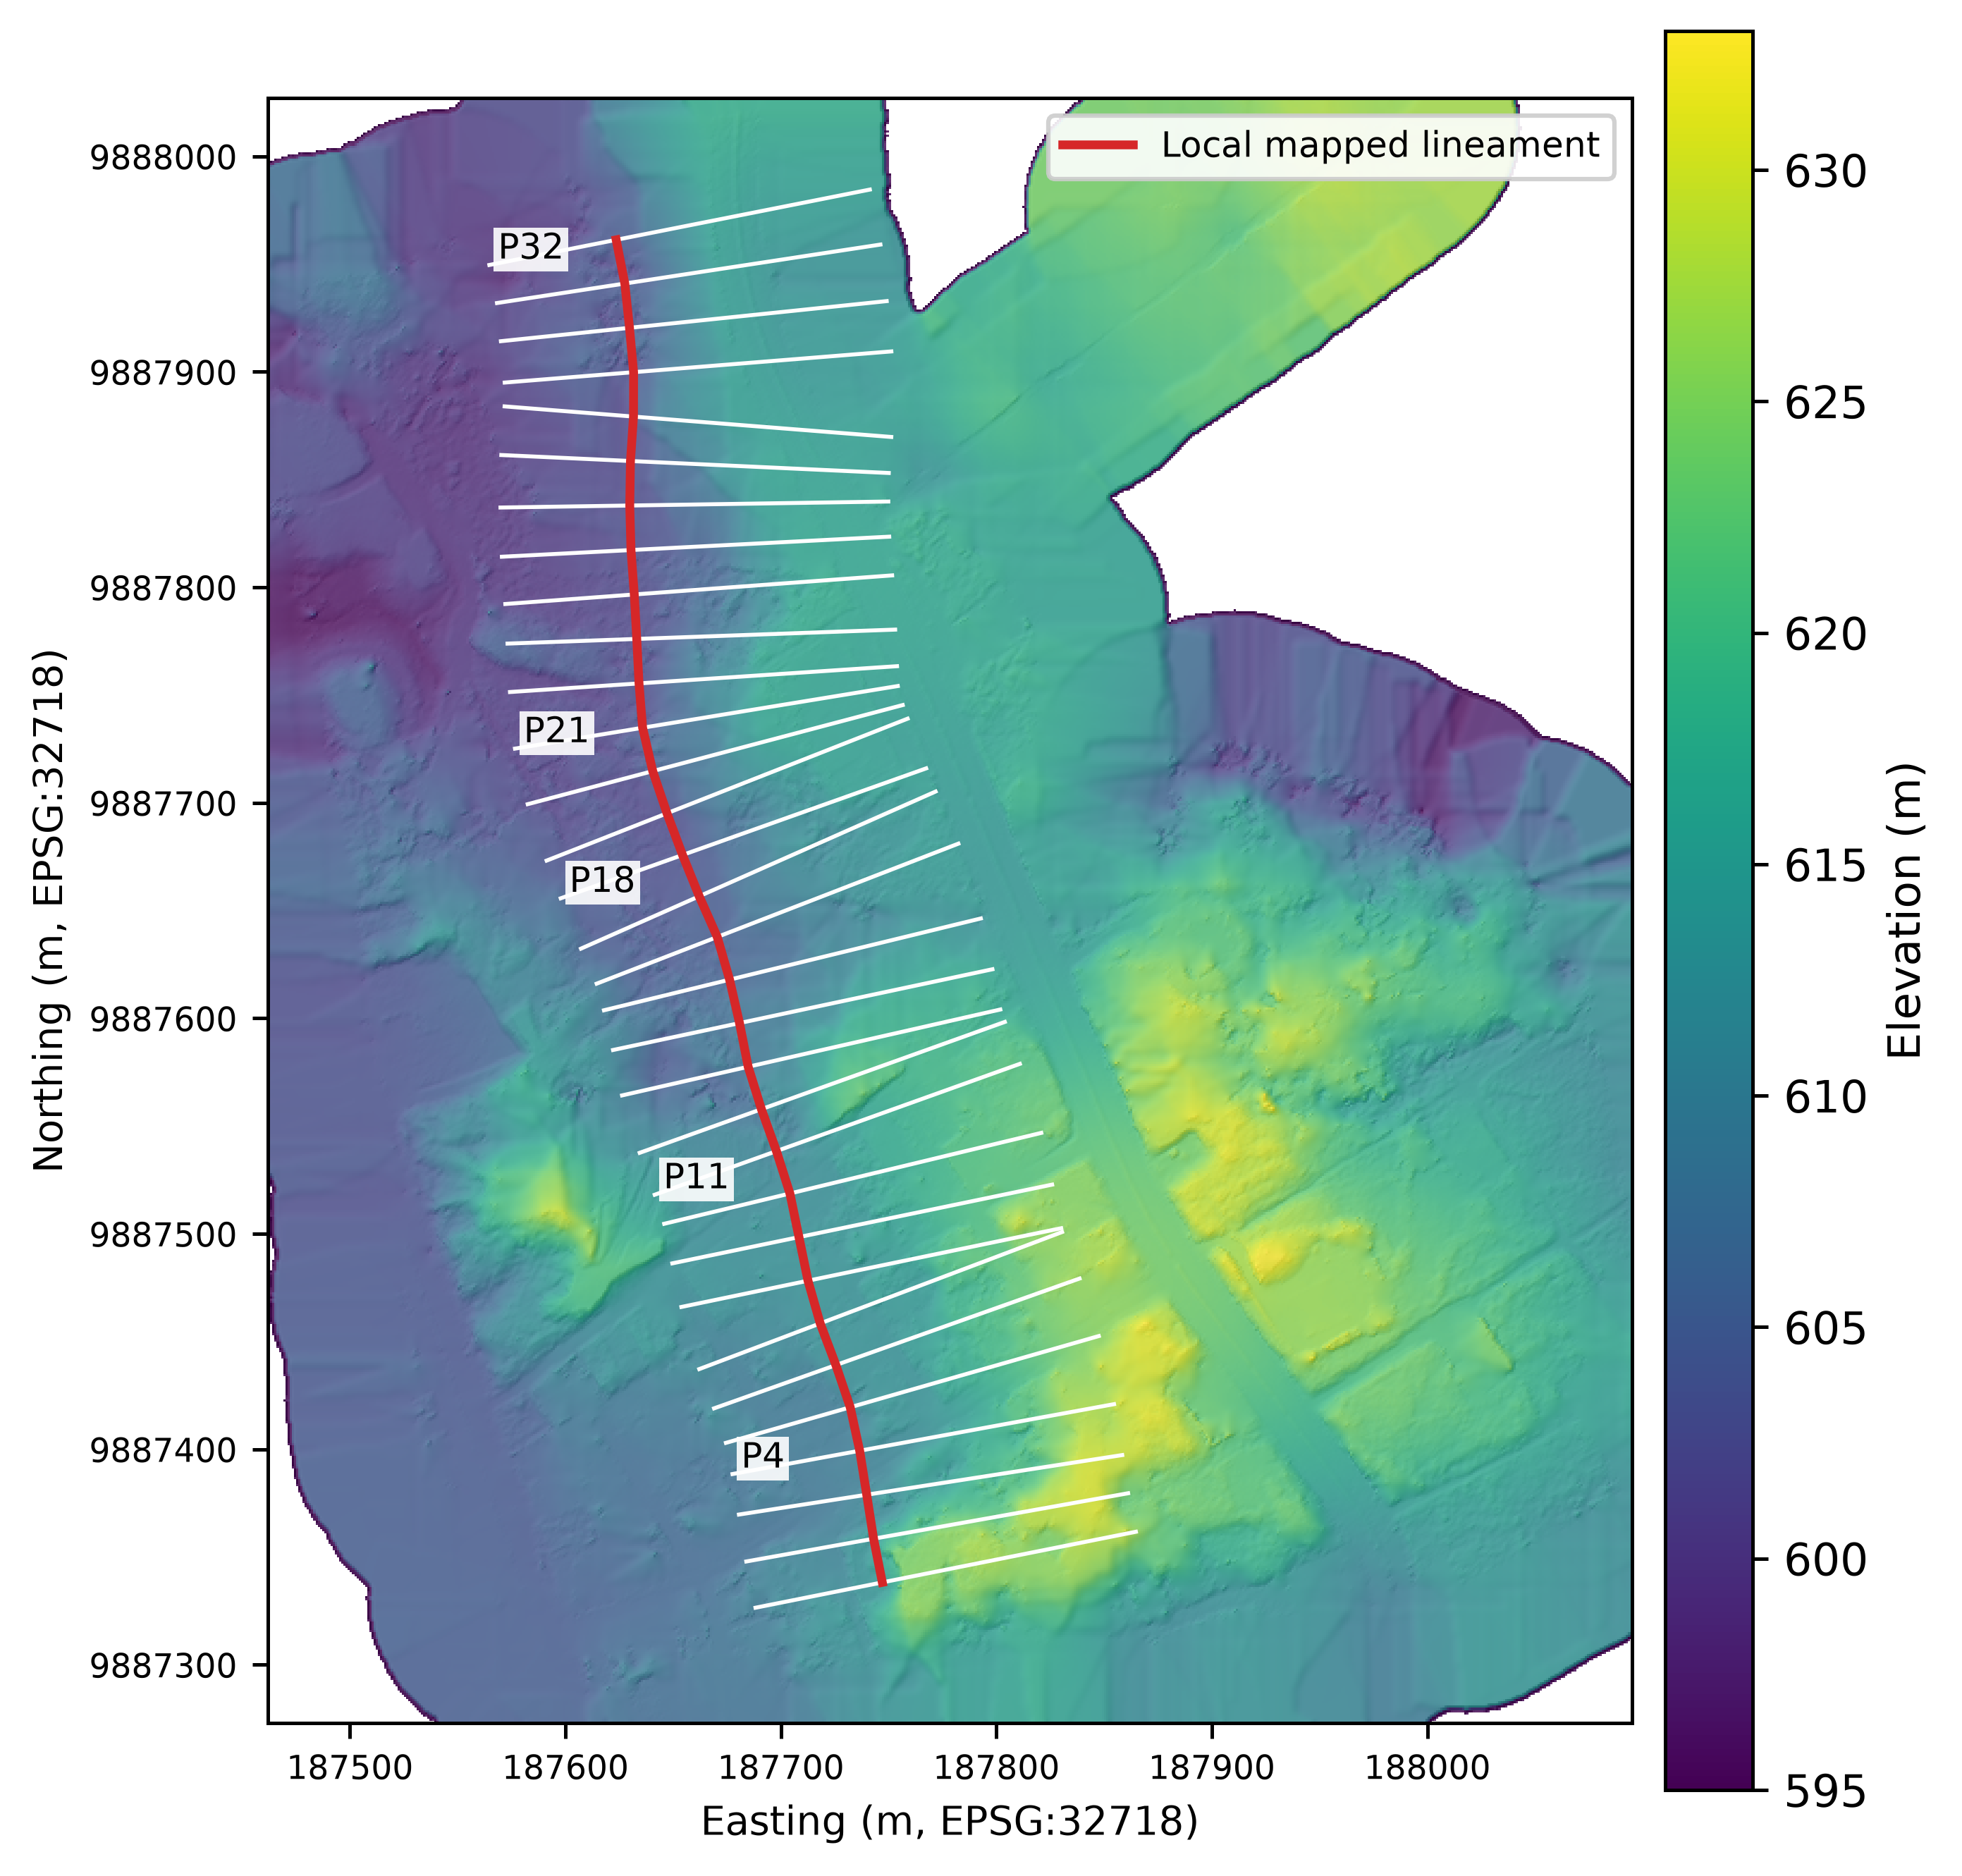
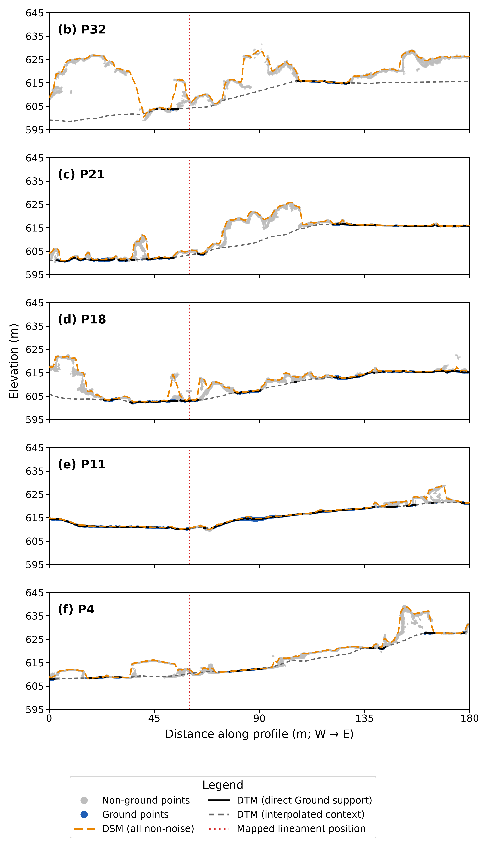
Figure 2. Final-cloud spatial context and point-cloud profile checks (WGS 84 / UTM zone 18S). (a) A 0.196717 m/pixel terrain display generated in Agisoft Metashape from class-2 Ground points in the definitive LAZ with the Extrapolated setting. The surface is used only for visual context; extrapolated cells are not direct terrain observations. The separate 1 m observed-cell raster retains NoData where Ground points are absent. Hillshade was generated with azimuth 315°, illumination altitude 45°, and vertical exaggeration 1. White lines show the 32 nominally west-to-east, 180 m profiles. The red line joins their mapped 60 m intersections as a local reference, not a demonstrated fault trace. (b–f) P32, P21, P18, P11, and P4, north to south. Gray and blue points are raw non-Ground and class-2 Ground observations within ±1 m of each line; class-7 noise is excluded. The orange dashed line samples 1 m DSM cell maxima from all non-noise classes at 0.5 m intervals. Black segments represent directly observed Ground medians in 0.5 m longitudinal bins of ±1 m swaths; empty bins are not connected. Gray dashed curves show interpolated Ground-only context. The red dotted line marks 60 m. The panels share 0–180 m and 595–645 m axes at approximately 1:1 metric scaling. P32, P21, and P4 lack sufficient direct Ground support for independent scarp measurements.

3.2. Photogrammetry
We conducted an aerial survey using a DJI Phantom 4 RTK drone, acquiring 432 images over approximately 0.36 km². Camera positions from the onboard RTK system provided direct georeferencing, but no independent ground-control checkpoints were available. Images were processed in Agisoft Metashape Professional 2.0.0. Alignment used high accuracy, generic preselection, source-reference preselection, a 40,000 key-point limit, a 10,000 tie-point limit, and adaptive camera-model fitting. All 432 cameras aligned; the internal tie-point reprojection error was 0.748 pixels. Depth maps were generated for all 432 cameras at low quality with moderate filtering and a maximum of 16 neighbors. The initial dense point cloud contained 13,619,251 points.
The initial dense cloud was classified in Agisoft Metashape Professional 2.0.0 using a maximum terrain angle of 7°, maximum distance of 0.1 m, and cell size of 25 m. At this initial stage, 2,840,463 points were labeled Ground. Subsequent manual point-level review and reclassification yielded the definitive LAZ analyzed here: 13,619,241 total points, including 2,810,862 class-2 Ground points. The final LAZ, not the initial Metashape classification, underpins the profile and density analyses. For the Figure 2a map only, a separate Ground-only terrain raster was generated in Agisoft Metashape using the Extrapolated setting and exported at a measured cell size of 0.196717 m. Its continuous coverage is visualization context, not direct Ground support or a measure of vertical accuracy. From this same LAZ, the observed 1 m terrain raster stores the median elevation of class-2 Ground points per cell and retains NoData in empty cells. The 1 m DSM stores the cell maximum of all classes except class-7 noise, including class-11 Road Surface. Interpolated terrain cells are used only as visual context, not as directly observed ground or evidence of vertical accuracy. All rasters are in EPSG:32718.
For quantitative validation, LAS classifications were preserved from the definitive LAZ. All-point and class-2 Ground counts were evaluated on one 2 × 2 m grid. The common footprint consists of cells containing at least one reconstructed point; counts divided by 4 m² give local density. Ground retention is 100 × Nground/Nall, and direct terrain support means at least one Ground point in a cell. All other LAS classes are excluded from the observed DTM, but are not all interpreted as vegetation. Class-11 Road Surface contributes to the DSM, not to the Ground-only DTM.
Thirty-two nominally transverse 180 m profiles were retained at their mapped west-to-east positions (P1 south to P32 north; azimuths 66.11°–94.52°). Each crosses the local mapped lineament position at 60 m. Class-2 points were extracted in ±5 m swaths, summarized as medians and interquartile ranges in 1 m longitudinal bins, and considered directly supported only when a bin contained at least three Ground points; empty bins were not filled. ±2.5 m and ±7.5 m swaths were retained for sensitivity checks. The five illustrative plots also show raw points in ±1 m corridors, direct 0.5 m Ground medians, and 0.5 m samples of the 1 m DSM and interpolated DTM context. The context curves are not morphometric data.

3.3. Seismic Refraction Tomography
To characterize local shallow P-wave velocity heterogeneity, a 69 m seismic refraction tomography profile was acquired in the study area. The location of the profile was determined by its position across the scarp and by field-access limitations. Dense tropical vegetation, steep intervening topography, and existing infrastructure prevented the acquisition of additional parallel or orthogonal profiles.

The acquisition array consisted of 24 geophones with a natural frequency of 4.5 Hz, positioned between 0 and 69 m at 3 m intervals and connected to a Geometrics ES-3000 seismograph. Seismic energy was generated using a 6 kg sledgehammer striking a 2.5 cm thick aluminum plate. Twenty-five shot positions were used: 23 internal shots located between adjacent geophones, from 1.5 to 67.5 m at 3 m intervals, and two off-end shots located at −2.5 and 70.5 m. A single hammer impact was recorded at each shot position, without stacking.
First-arrival times were manually picked in Pickwin and exported in the Plotrefa pick file, picks.vs. The archived file contains 600 first-arrival times from 25 shot gathers recorded by 24 receivers. Its shot-coordinate sequence matches the original unmodified .dat field records, providing traceability from each gather to the inversion input. Representative shot gathers at x = 13.5, 31.5, and 55.5 m were exported from Pickwin using increased display gain to make P-wave onsets visible relative to ground roll. This display adjustment did not alter the archived picked arrival times.
Because the shot positions did not coincide with receiver locations, true reciprocal source–receiver pairs were not acquired. Consequently, the reciprocal-check output generated by Plotrefa was treated only as an internal verification of the numerical symmetry of the calculated travel times and not as a field-repeatability test. Likewise, because only one hammer impact was recorded at each shot position, no repeatability-based picking uncertainty was calculated.

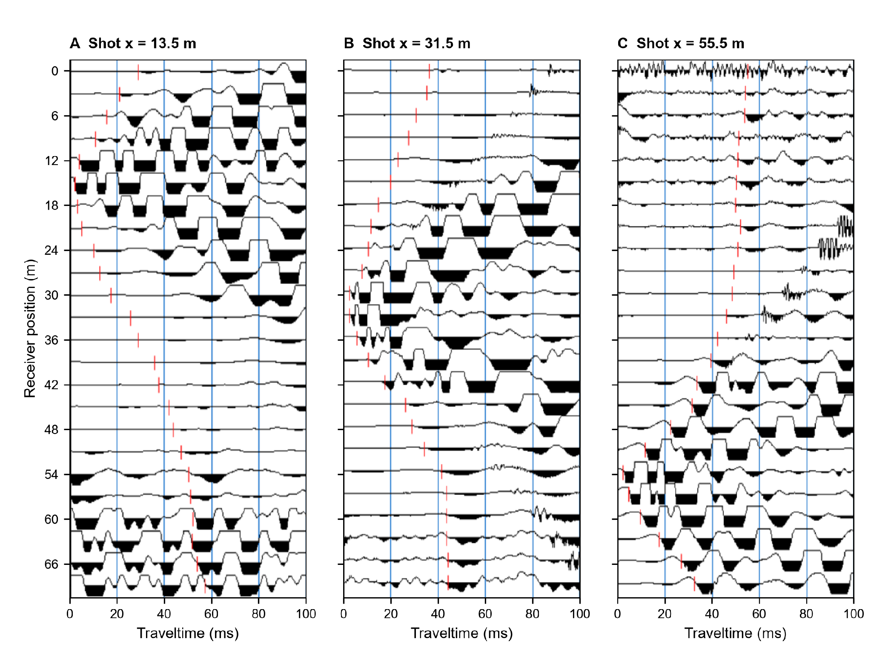
Figure 3. Representative shot gathers and manually picked first arrivals from the archived pick dataset. (A) Shot at x = 13.5 m. (B) Shot at x = 31.5 m. (C) Shot at x = 55.5 m. The horizontal axis represents traveltime (ms), and the vertical axis represents receiver position (m). Red dashed marks reproduce the manual picks retained in picks.vs. The three panels were exported from Pickwin with increased display gain to show P-wave onsets relative to ground roll; display gain did not modify pick positions or arrival times. Numerical arrival times are compared with the calculated times in Figure 4.
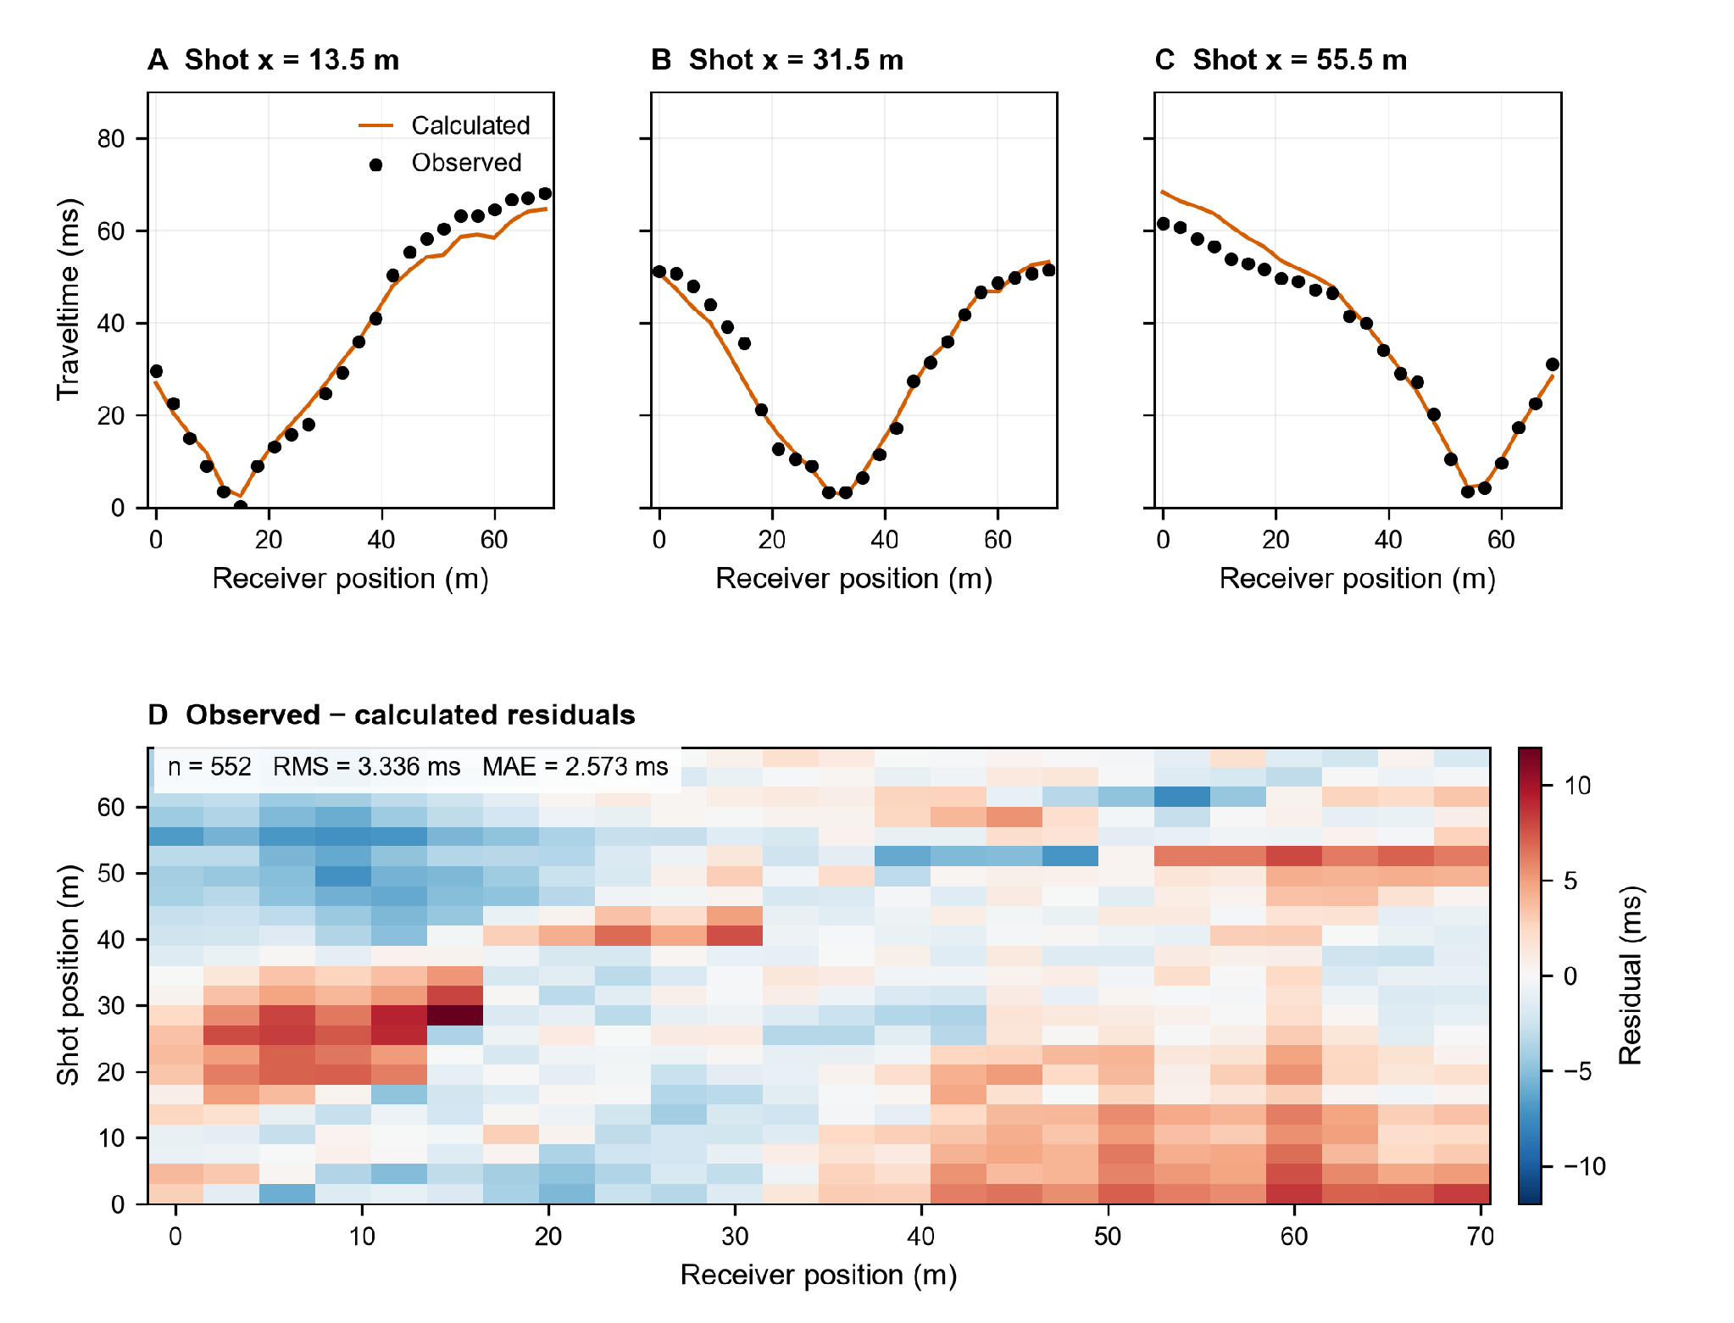
Figure 4. Observed and calculated first-arrival traveltimes for the preferred wH = 0.9 model. (A–C) Representative shots at x = 13.5, 31.5, and 55.5 m, matching Figure 3. (D) Observed-minus-calculated residuals for the 552 pairs with positive observed and calculated times in the saved native model. RMS = 3.336 ms; mean absolute error = 2.573 ms. The 48 off-end picks have no positive calculated times in that file and are omitted only from this reproduced residual analysis. Their omission here does not establish whether they were used internally by the inversion.
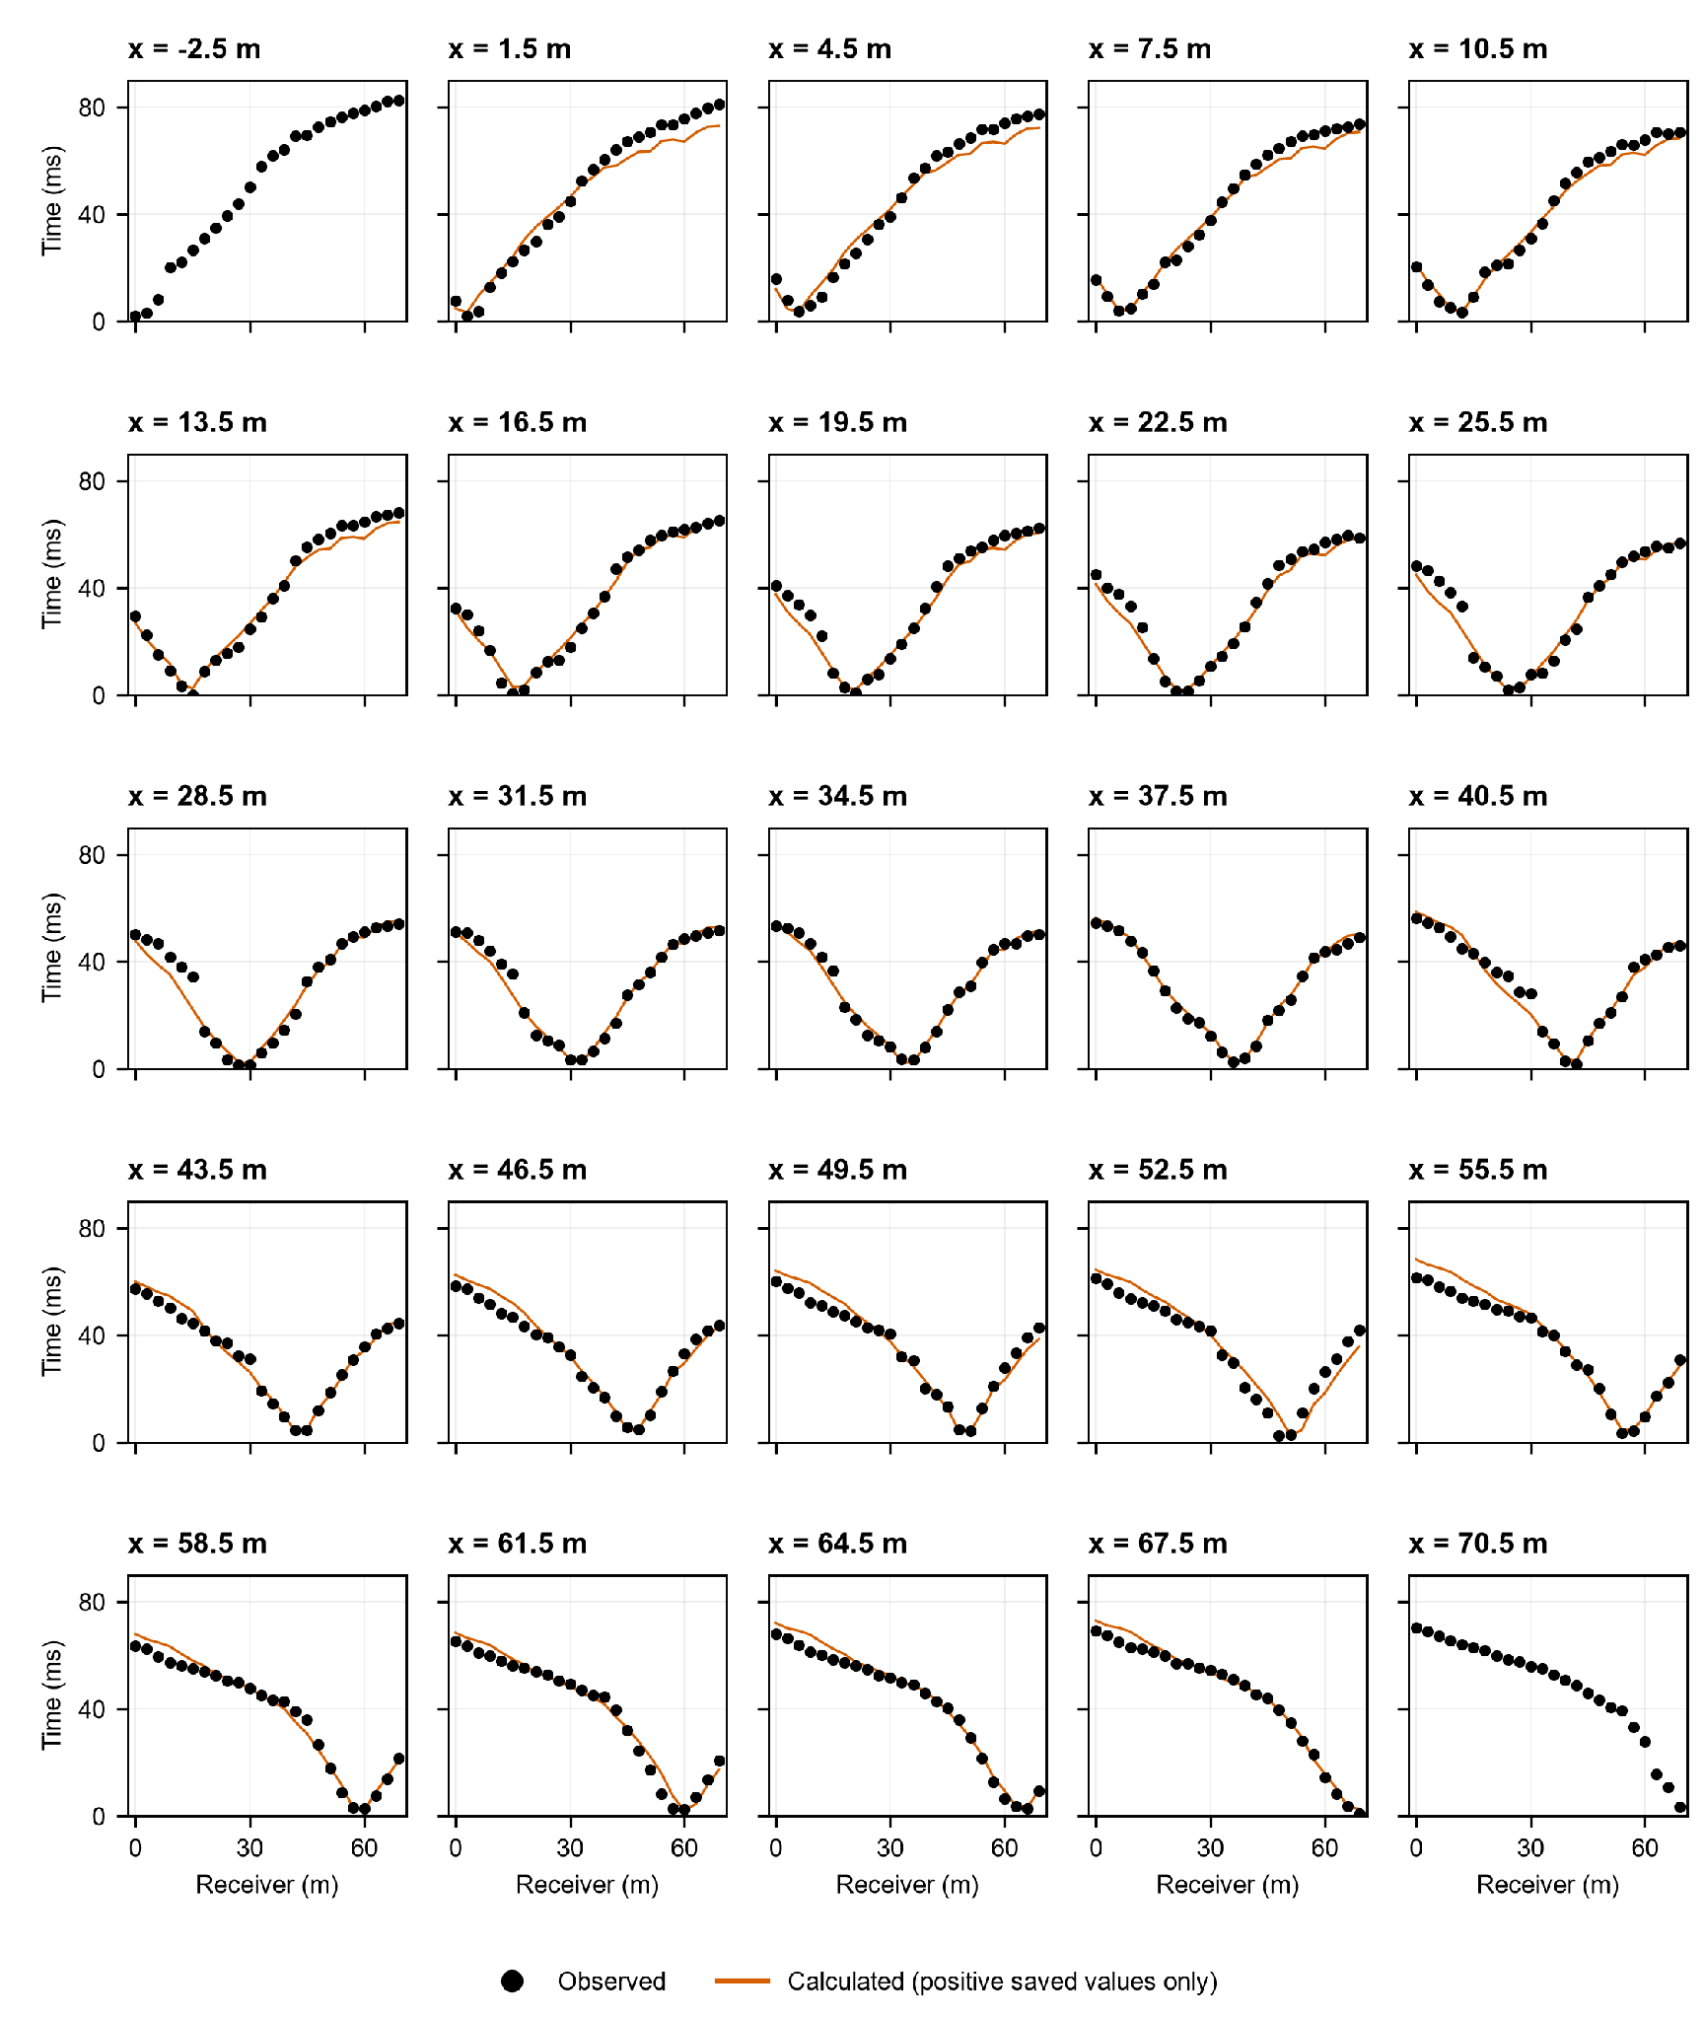
Figure S1. Observed and calculated first-arrival traveltimes for all 25 shot positions. Each panel identifies the shot coordinate. Black points represent the 24 observed arrival times, and orange lines connect positive calculated values at receiver positions in the saved wH = 0.9 native model. The two off-end panels show observations only because that file contains no positive calculated times for those shots; zero placeholders are not plotted as predictions. The curves were replotted in Python from the native numerical output.

3.3.1. Inversion Parameters and Smoothing Sensitivity
Tomographic inversion and ray tracing were performed with the Plotrefa and GeoPlot modules of SeisImager/2D (Geometrics Inc., 2009). The mathematical formulation of the inversion is described in the software documentation and is therefore not reproduced here.
A smooth, nonlayered a priori model was constructed in Plotrefa using a heuristic trial procedure in which the end-member velocities and depth of the vertical velocity gradient were varied. The retained configuration consisted of 10 vertical layers and a velocity gradient increasing from 0.3 km s⁻¹ at the surface to a configured value of 2.6 km s⁻¹ at a nominal depth of 25 m to the top of the lowest layer. These parameters defined a smooth starting condition and were not interpreted as measured stratigraphic boundaries or as an independently constrained depth to bedrock.
The exported a priori model contains 47 horizontal positions at 1.5 m spacing and 10 depth levels, corresponding to 470 model nodes between 0 and 69 m. Owing to the model geometry and surface topography, the exported grid extends approximately 21.4–22.3 m below the local ground surface. Its nodal velocities range from 0.300 to 2.508 km s⁻¹.
All inversion tests used the same a priori model, grid geometry, acquisition data, velocity limits, and reconstruction parameters. Automatic reconstruction was performed using 50 iterations and a number-of-nodes setting of 8. The minimum and maximum allowed velocities were fixed at 0.3 and 2.6 km s⁻¹, respectively, and no additional inversion constraint was activated.
The sensitivity analysis varied only the horizontal central-node weight, wH, from 0.3 to 1.0 in increments of 0.1. Two horizontal smoothing passes were applied. The vertical settings were held constant at one pass, a central-node weight wV = 1.0, and all 10 model layers included.
In the Plotrefa smoothing filter, the specified weight applies to the central model node, while each adjacent horizontal node receives a weight of (1 − wH)/2. Increasing wH therefore decreases the contribution of neighboring nodes and weakens horizontal smoothing; wH = 1.0 assigns no weight to horizontal neighbors.
Data fit was evaluated using the root-mean-square traveltime residual reported by Plotrefa. Following the model-comparison procedure of Araujo et al. (2023), each final model was compared with the common a priori model at 470 corresponding nodes. Let ΔVi be the final-minus-a-priori P-wave velocity difference at node i. The normalized L1 distance is the mean of |ΔVi|, the normalized L2 distance is the square root of the mean of ΔVi², and L∞ is the maximum of |ΔVi|. All three distances have units of km s⁻¹. They quantify departure from the a priori model, not spatial roughness, and do not represent alternative inversion constraints.
The three model-space distances were plotted on the horizontal axes against the final RMS travel-time residual on the vertical axes. Model selection jointly considered the final RMS residual, iteration-to-iteration behavior, and departure from the a priori model. The curves were not assumed to exhibit a unique idealized L-shaped corner.
Inversion and ray tracing were performed in SeisImager/2D. Python was used for reproducible post-processing: velocity comparisons and model plots use the exported three-column x–elevation–VP text files, whereas observed–calculated traveltime statistics use the saved native model. Model panels retain the exported nodal coordinates and are contoured only for visualization, without extrapolation below the deepest nodal row or outside x = 0–69 m. Python did not recompute the inversion or ray trajectories.
Ray paths and their footprint were exported from Plotrefa as graphical output and inspected qualitatively (Figure 7). Numerical ray coordinates, a cell-based hit-count matrix, and a formal resolution matrix were not retained; therefore, ray coverage is used only to delimit the qualitatively illuminated part of the model and not as a quantitative resolution test.
4. Results
This section first reports direct Ground support and the limits it places on terrain-profile interpretation. The SRT results then follow, including inversion stability and the description of the continuous P-wave velocity field and its lateral variations.
4.1. Photogrammetry and Geomorphology
4.1.1. Digital Elevation Model (DEM) Analysis
The definitive classified cloud contains 13,619,241 points and 2,810,862 class-2 Ground points (20.64%). Across 94,274 occupied 2 × 2 m cells (0.377096 km²), all-point density is 36.12 points m⁻² and Ground density is 7.45 points m⁻². Direct Ground support occurs in 44,429 cells (47.13%); the other 52.87% contain reconstructed points but no direct terrain observation (Figure 5).
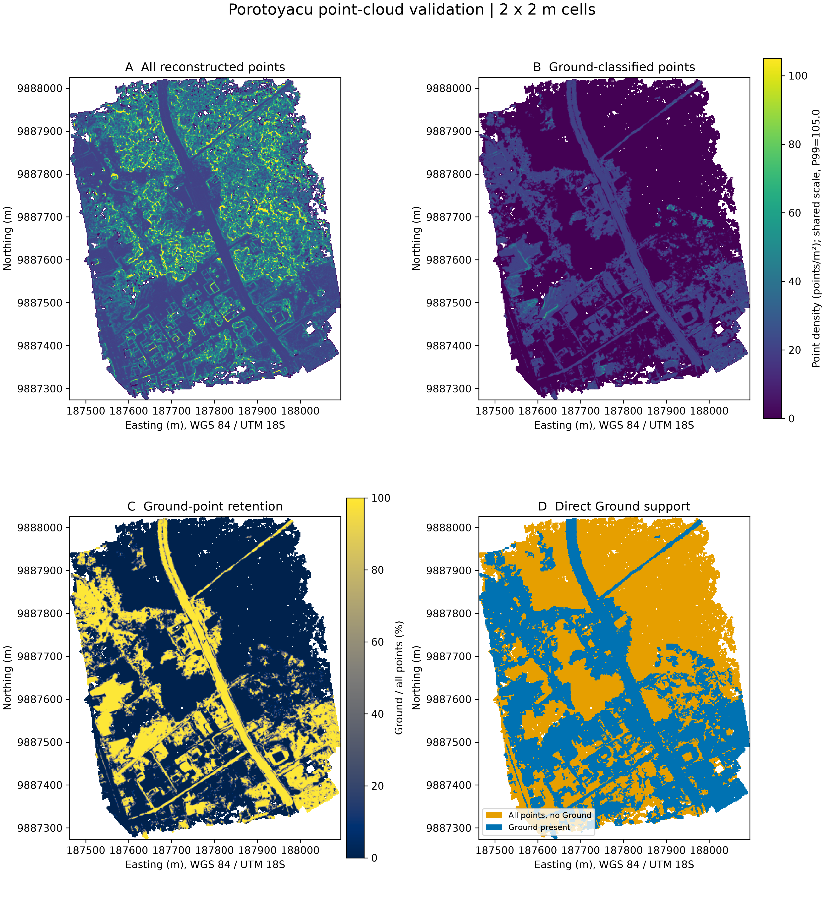
Figure 5. Quality control of the definitive UAV point cloud in 2 × 2 m cells (EPSG:32718). (A) Density of all reconstructed points; (B) class-2 Ground density; (C) Ground retention as a percentage of all points; and (D) direct Ground support. A and B use the same display scale capped at the 99th percentile of all-point density (105.0 points m⁻²). The LAZ contains 13,619,241 points, including 2,810,862 Ground (20.64%). Densities over the common occupied footprint are 36.12 and 7.45 points m⁻², respectively. Ground occurs in 44,429 of 94,274 occupied cells (47.13%); the others are not direct bare-earth observations.
The 32 profiles were screened using raw Ground observations rather than treating continuous DTM raster coverage as equivalent to direct terrain measurement. The ±5 m, 1 m-bin test classified seven profiles as A (high direct support), five as B (moderate), and 20 as C (insufficient). The A/B profiles are P1, P2, P3, P5, P6, P7, P9, P10, P11, P18, P23, and P24. Their Ground coverage in the 30–170 m search zone spans 68.6%–97.1%; near the mapped intersection (40–80 m), it spans 62.5%–100%. Full criteria and bins are provided with the profile QC files.
A/B designation supports only local description of directly observed terrain. It does not validate a base, crest, scarp height, tectonic vertical separation, or displacement because independent far-field reference surfaces and an uncertainty model are absent. No mean height or two-domain morphometric partition is calculated from these profiles.
The representative plots contrast the DSM with sparse or continuous Ground observations. P11 has high direct support and shows a local west-to-east elevation rise; P18 has moderate support. P4, P21, and P32 have insufficient support in relevant intervals, even where an interpolated DTM appears smooth. DSM–DTM differences may reflect vegetation, buildings, other above-ground objects, or Ground gaps; they are not direct measurements of fault relief.

Direct support varies markedly along the 32 lines. The 20 class-C profiles, including P21, P31, and P32, are excluded from independent morphometric interpretation. A continuous raster can depict a local transition through those gaps, but it does not establish a continuous geomorphic or tectonic feature along strike.
4.2. Seismic Refraction Tomography

4.2.1. Inversion Stability and Smoothing Selection
Eight inversion tests were performed using horizontal smoothing weights (wH) ranging from 0.3 to 1.0, while all other acquisition, grid, velocity, iteration, and vertical-filter parameters were held constant. The RMS travel-time histories provide a direct comparison of the convergence behavior of these tests (Figure 6A). All tests began with the same RMS value of 5.675619 ms and showed a rapid reduction during the initial iterations, followed by iteration-to-iteration fluctuations of different magnitudes. Therefore, the oscillatory behavior was not restricted to the wH=0.3 test.
The solutions obtained with wH=0.3–0.8 remained comparatively stable during the final iterations. The wH=0.9 solution displayed greater late-iteration variability than the wH=0.8 solution but produced the lowest final RMS residual of all tested models. Its final RMS was 3.335572 ms, compared with 3.387717 ms for wH=0.8, representing a reduction of 0.052145 ms, or 1.54%. The standard deviation of the final 10 RMS values was 0.045844 ms for wH=0.9 and 0.015559 ms for wH=0.8.
The unfiltered wH=1.0 test showed markedly different behavior. Although it reached a transient minimum RMS of 3.356242 ms at iteration 11, the residual subsequently increased and fluctuated strongly, ending at 3.747912 ms. Its standard deviation over the final 10 iterations was 0.219118 ms. This behavior indicates that removing the horizontal neighbor contribution produced an unstable final solution.
The trade-off between travel-time fit and departure from the common a priori model was evaluated using RMS–distance diagrams for the L1, L2, and L∞ model-space distances (Figures 6B–D). The resulting trajectories are non-monotonic and contain several changes in direction; consequently, they do not define a single, sharply resolved corner of an idealized classical L-curve.
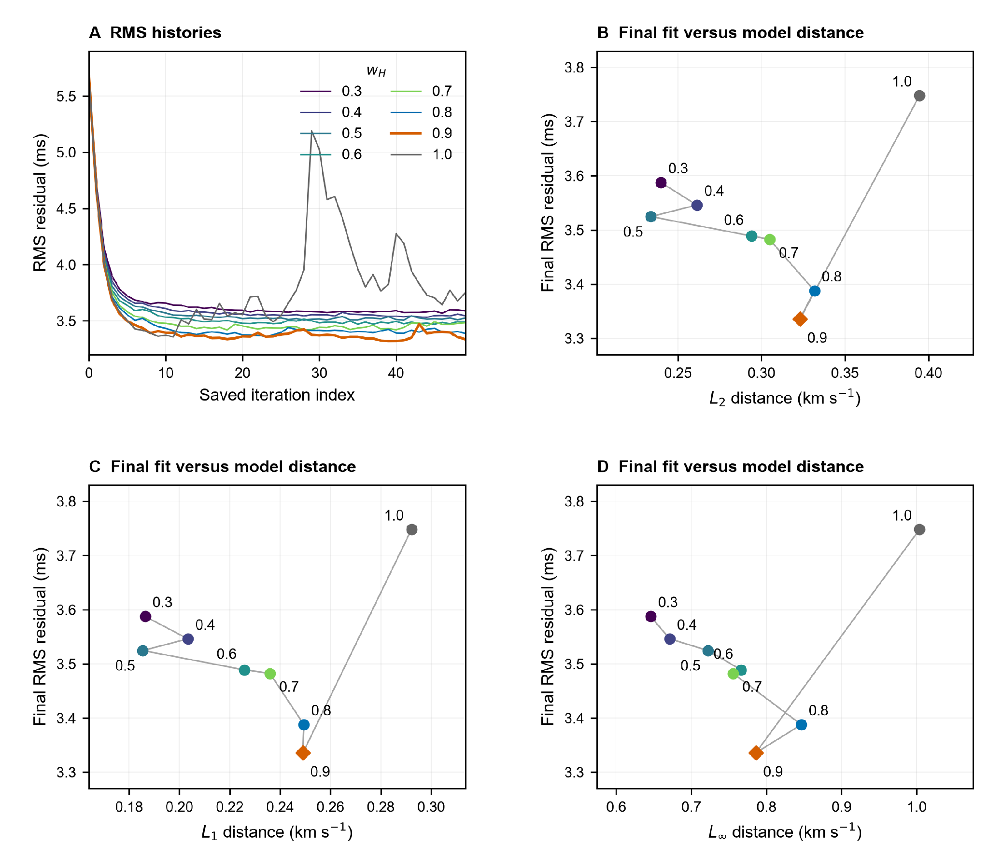
Figure 6. Horizontal-smoothing sensitivity analysis. (A) RMS traveltime histories for central-node weights wH = 0.3–1.0, with the original saved indices 0–49. All tests used the same starting model, grid, acquisition data, velocity limits, and vertical-filter settings, with two horizontal smoothing passes. (B–D) Final RMS residual against the normalized L2, normalized L1, and L∞ distances from the common a priori velocity model, respectively. Labels identify wH; the orange diamond marks the preferred wH = 0.9 solution. Connecting lines follow increasing wH and are not fitted curves. These non-monotonic trajectories do not define a unique classical L-curve corner.

For wH=0.9, the L1, L2, and L∞ distances were 0.249066, 0.323104, and 0.785827 km s⁻¹, respectively. These values are slightly smaller than those obtained for wH=0.8, which were 0.249464, 0.331753, and 0.846426 km s⁻¹. In contrast, the wH=1.0 solution produced the largest departure from the a priori model, with corresponding distances of 0.292193, 0.394678, and 1.003769 km s⁻¹.
The wH=0.9 model was therefore retained as the preferred tested solution because it combines the lowest final RMS residual with smaller model-space distances than the wH=0.8 solution, while avoiding the strong instability observed for wH=1.0. This selection is interpreted as a practical compromise among data fit, model departure, and iteration behavior rather than as a unique mathematically determined L-curve corner.
The final RMS value was independently reproduced from the observed and calculated travel times stored in the preferred model output (Figure 4). The comparison included 552 pairs with positive calculated travel times and produced an RMS residual of 3.335572 ms, a mean absolute error of 2.573010 ms, and a 95th-percentile absolute residual of 6.758092 ms. The remaining 48 picks correspond to the two off-end shots, for which the saved model output did not contain positive calculated traveltimes. They were excluded only from these reproduced statistics; this file alone does not establish their role in the internal inversion.
A node-by-node comparison between the wH=0.9 and wH=0.8 models was additionally used as a sensitivity assessment (Figure S2). The absolute velocity difference reaches a maximum of 0.479 km s⁻¹, with the largest differences concentrated near the southwestern model boundary and in deeper parts of the section. Consequently, geometries that vary substantially between these two solutions are treated more cautiously than features reproduced by both models.
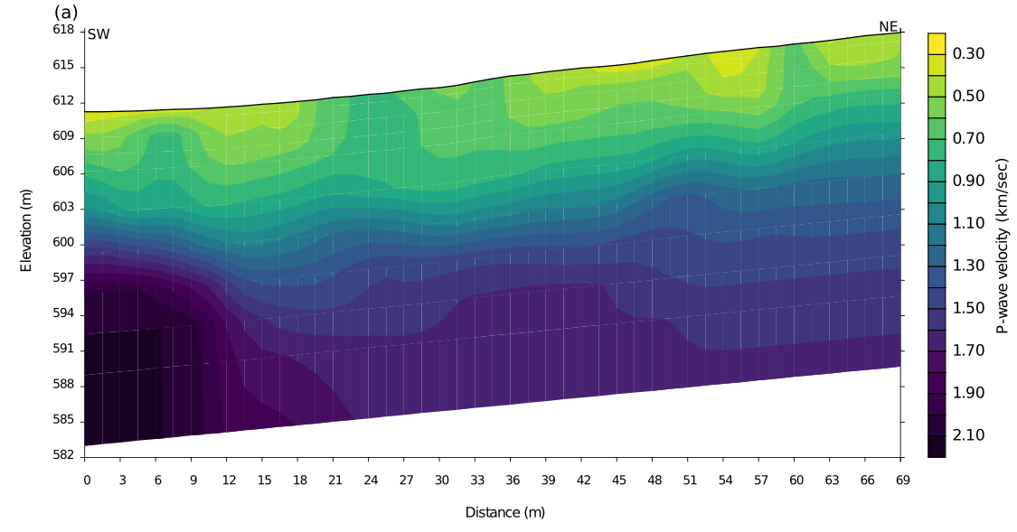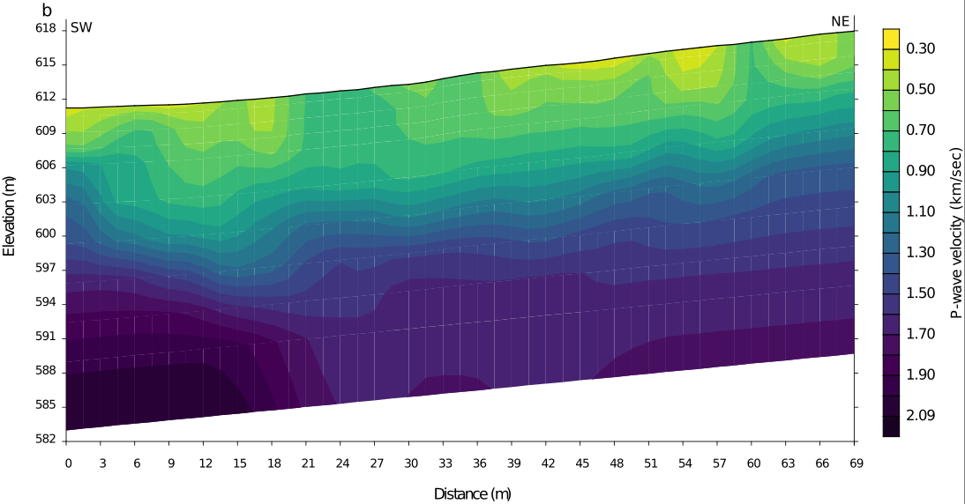Figure S2. Sensitivity to horizontal smoothing. (A) Exported velocity model for wH = 0.8. (B) Preferred wH = 0.9 model. Both use the same coordinates and reversed-Viridis scale, 0.30–2.60 km s⁻¹, as Figure 7. Black triangles and orange stars show receiver and shot coordinates in an acquisition strip, not their elevations.

4.2.2. Final P-wave Velocity Model
The preferred wH=0.9 tomographic model exhibits P-wave velocities ranging from 0.303 to 2.090 km s⁻¹ (Figure 7). Surface-node velocities range from 0.303 to 0.754 km s⁻¹, whereas velocities at the base of the exported model range from 1.680 to 2.090 km s⁻¹. The model therefore shows an overall increase in velocity with depth, superimposed on marked lateral variations in the geometry of the velocity field.
For descriptive purposes, the 0.7 and 1.1 km s⁻¹ isovelocity contours are highlighted in Figure 7B. These contours divide the continuous velocity field into shallow low-velocity, intermediate-velocity, and deeper high-velocity domains. They are used only as reference contours for describing lateral changes in the model and are not interpreted as independently validated stratigraphic or lithologic contacts.
The depth of the 0.7 km s⁻¹ contour varies from less than 1 m to approximately 5.9 m below the ground surface and locally reaches the surface where the uppermost model nodes exceed this velocity. Its geometry is laterally discontinuous and displays short-wavelength variations along the profile. The 1.1 km s⁻¹ contour occurs at depths of approximately 4.7–12.3 m. It is shallowest at the southwestern end of the profile, deepens markedly toward x ≈ 13.5 m, and subsequently becomes shallower and more gently varying toward the northeastern portion of the section.
The strongest lateral changes in contour geometry occur in the southwestern part of the model, particularly between approximately 0 and 18 m along the profile. Additional, lower-amplitude undulations are present in the central and northeastern portions. These geometries describe lateral variations in the recovered velocity field but do not, by themselves, establish a discrete fault surface, displacement direction, or lithologic boundary.
No quantitative ray-density, cell hit-count, or resolution matrix was available to define a formal depth of resolution. The Plotrefa ray-path display (Figure 7) nevertheless shows that ray coverage is concentrated in the shallow central part of the profile and decreases toward the lower model and profile ends. The shaded footprint in Figure 8 consequently identifies the part of the interpretation supported qualitatively by ray paths; it is not a quantitative resolution boundary.
The preferred model describes the recovered shallow velocity distribution and its lateral variations within the receiver footprint. Its archived picks, data fit, and ray-path coverage support interpretation in the shallow illuminated domain, but they do not establish uniform spatial resolution. A single two-dimensional profile cannot uniquely determine lithology, fault kinematics, fault-plane geometry, or continuity away from the surveyed line.
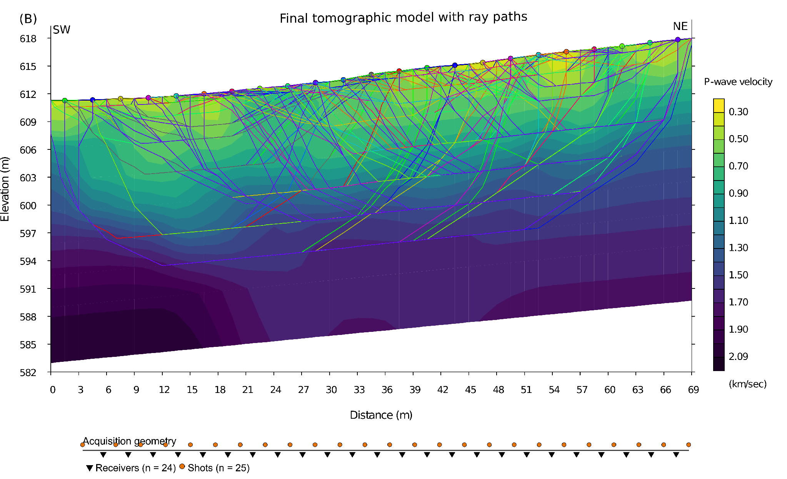
Figure 7. Preferred wH = 0.9 P-wave velocity model with ray paths, exported from Plotrefa. The profile extends from southwest (x = 0 m) to northeast (x = 69 m). Colored paths are the rays displayed by the inversion software; their distribution provides a qualitative visualization of illumination. The acquisition strip identifies the 24 receiver positions (black triangles) and the 25 shot positions (orange circles), including the two off-end shots. Ray paths are dense in the shallow central portion and sparse toward the base and profile ends. The plot is not a cell-based ray-density or resolution map, and the model boundary is not a quantitative depth-of-resolution limit.
4.2.3. Structural Interpretation
Figure 8 presents the structural interpretation together with the ray-supported domain. The shaded region follows the footprint of the Plotrefa ray-path display and indicates where the preferred velocity model is qualitatively illuminated. The interpreted deformation zone is a structural hypothesis consistent with the mapped surface slope break and lateral velocity variations in the southwestern profile. Outside the shaded domain, and toward the model base, the interpretation has increased uncertainty and does not constitute a uniquely resolved fault surface; specific dip angles, fault kinematics, and an antithetic structure cannot be assigned from SRT alone.
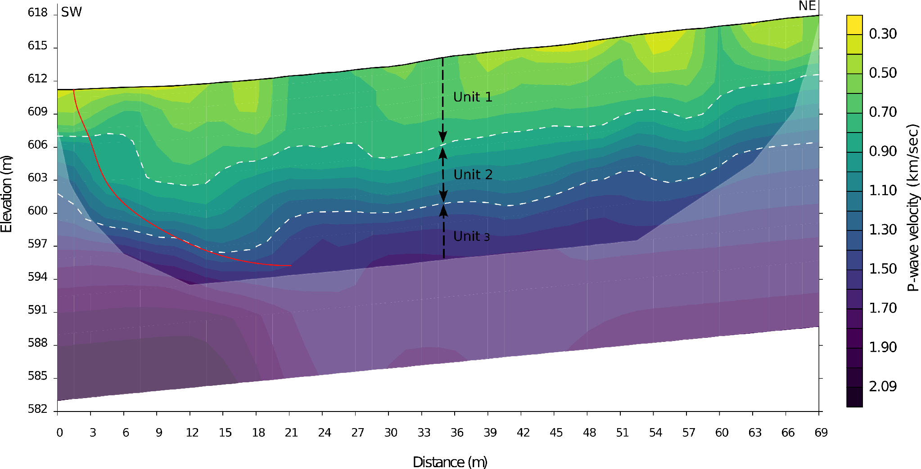
Figure 8. Structural interpretation of the preferred wH = 0.9 P-wave velocity model. The ray-supported domain is shaded, based on the footprint of ray paths displayed in Plotrefa. The surface slope break and the interpreted subsurface deformation zone are superimposed without modifying the numerical velocity model. The overlay is an interpretation constrained by the surface expression, the velocity field, and qualitative ray coverage; it is not a uniquely resolved fault geometry. The SRT profile alone does not determine fault dip, kinematics, or the existence of an antithetic structure.

5. Discussion
The combined observations allow a local, support-qualified description of terrain and a separate description of the shallow SRT velocity field. Their spatial relationship is evaluated as a working hypothesis, not as proof of fault continuity, geometry, or activity.
5.1. Direct-Ground Support and Local Surface Morphology
Only 12 of the 32 nominally transverse profiles satisfy the A/B direct-Ground support screen. They provide local observations of elevation transitions, not a complete along-strike morphometric sample. They do not establish a continuous scarp or a mean tectonic separation.
The remaining 20 profiles have substantial gaps within the search zone or near the mapped-line window. Vegetation, built surfaces, and sparse Ground observations can cause terrain rasters to interpolate across these areas. No apparent depression, step, or relief in a class-C profile is used as an independent tectonic measurement.
Consequently, the previously proposed 700 m southward continuation, 115 m positional refinement, average relative height, and two-sector morphometric partition are not retained as demonstrated results. Testing them would require independent field mapping, support-complete profiles, far-field reference surfaces, and an uncertainty assessment.
5.2. Shallow Fault Geometry and Structural Style
To our knowledge, this study provides the first high-resolution description of shallow P-wave velocity variations across the mapped Porotoyacu scarp. The 0.7 and 1.1 km s⁻¹ contours delimit descriptive velocity domains rather than independently verified seismostratigraphic units. Their lateral variations may reflect changes in material properties, weathering, saturation, or deformation, and the present SRT dataset does not uniquely distinguish among these causes.
The concave-upward traces drawn in Figure 8 constitute an interpretive structural hypothesis rather than direct geometric measurements of a fault plane. Consequently, the apparent angles of ~25°, ~52°, and ~79° should not be reported as uniquely resolved fault dips. The available model supports describing a zone of marked lateral velocity variation beneath the southwestern part of the profile, while its precise geometry and connection to the surface require independent structural or geophysical control.
A subsidiary antithetic structure may be considered as one possible explanation for part of the velocity-field complexity, but it is not uniquely identified by the tomography. Likewise, a thin-skinned structural style is compatible with the regional geological context but remains a conceptual interpretation that should be tested with additional profiles, higher-resolution imaging, or direct geological observations.
5.3. Surface Subsurface Structural Integration
The directly supported Ground points document a local topographic transition, but do not identify a unique tectonic origin or a continuous surface trace. Differential erosion and anthropogenic modification remain alternative explanations. The spatial association between the surface break and the shallow velocity variations supports possible structural control, but the SRT profile alone neither demonstrates present-day activity nor excludes a contribution from differential erosion.
As shown in Figure 8, the projected surface trace is spatially associated with pronounced shallow velocity variations in the southwestern part of the tomographic profile. This correspondence is consistent with a localized deformation zone, but it does not by itself demonstrate discrete folding and faulting or prove that the scarp is currently active. The combined geomorphic and geophysical observations therefore support a tectonic interpretation of the scarp while retaining erosion and material-property contrasts as contributing factors.
5.4. Regional Tectonic Context and Interpretation
The Porotoyacu Fault is part of the Napo-Cutucú Fault System, which developed within the transpressive convergence between the Nazca and South American plates (Nocquet et al., 2014; Yepes et al., 2016). The shallow velocity variations imaged by SRT are compatible with a northeast-dipping backthrust hypothesis (McClay, 1992; Lebinson et al., 2020), but they do not independently establish fault vergence or kinematics. The lithostratigraphic contrast shown in Figure 9 provides regional context for this hypothesis; nevertheless, the relative contributions of tectonic displacement and differential erosion cannot be quantified from the present profile.
The exported SRT grid extends approximately 21.4–22.3 m below local ground level, but decreasing ray sampling toward the model base prevents assigning a uniform depth of resolution. A thin-skinned backthrust rooted within the regional fold-and-thrust system is kinematically plausible, yet its geometry and possible detachment within the Tena Formation lie beyond what is uniquely resolved by this single shallow profile. This interpretation should therefore be presented as a regional working hypothesis rather than as a direct result of the tomography.
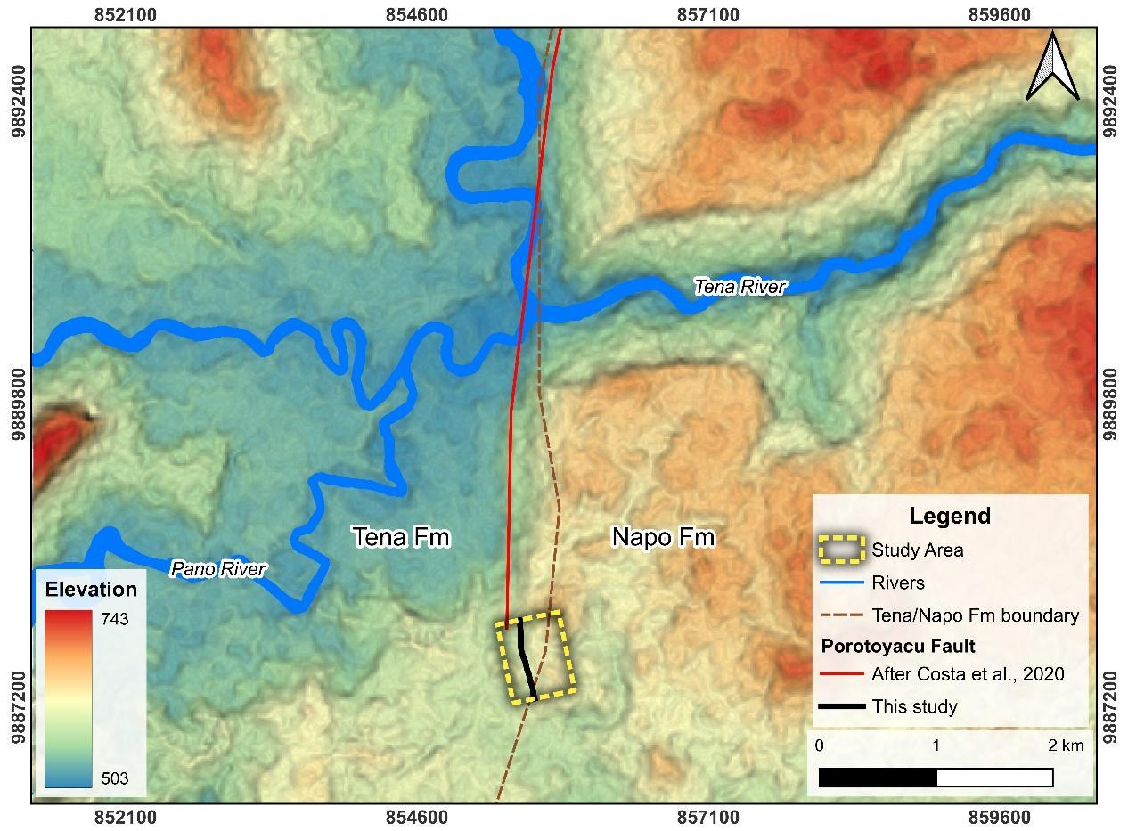
Figure 9. Topographic and lithostratigraphic context of the southern segment of the Porotoyacu Fault. Elevation model derived from the 12.5 m resolution ALOS PALSAR RTC DEM (ASF, 2015), with hillshade overlay. The topographic contrast between the Tena Formation (western block, lower elevations) and the Napo Formation (eastern block, higher elevations) documents the stratigraphic elevation difference across the fault trace. The dashed brown line indicates the mapped Tena/Napo Formation boundary within the map extent (modified from Cornejo et al., 2025; Egüez et al., 2017); the boundary continues beyond the map limits. Coordinate system: WGS 84 / UTM Zone 18S.
5.5. Limits on Fault Length and Hazard Inference
The available Ground observations do not verify a 700 m extension of the mapped fault, establish a single seismogenic segment, or supply a source geometry for hazard modeling. The local lineament remains a target for field verification.
Treating the mapped fault trace as a proxy for surface rupture length (SRL), and applying the empirical scaling relationship for reverse faults (Mw = 5.00 + 1.22 log₁₀(SRL); Wells & Coppersmith, 1994), the 700 m southward extension increases the estimated maximum credible magnitude from Mw 6.49 (SRL = 16.7 km) to Mw 6.51 (SRL ≈ 17.4 km), a difference of ΔMw = 0.02, which is negligible relative to the ±0.28 standard deviation inherent to the empirical relationship. Therefore, the primary implication of this extension is not a drastic increase in potential energy release, but rather the significantly increased spatial exposure and vulnerability of the urbanized southern sector to surface rupture.
As highlighted by regional studies, even moderate-magnitude shallow crustal events can cause severe damage near populated centers (Alvarado, 2012). The mapped continuation of the scarp is relevant to local hazard assessment, but the present SRT profile does not establish that the structure is a primary backthrust, quantify displacement, or provide fault parameters suitable for direct incorporation into hazard models. Those applications require paleoseismic constraints, additional geophysical profiles, and independent verification of fault geometry and activity.
5.6. Limitations of the Study
No independent Ground Control Points, checkpoints, or Total Station calibration were available to quantify absolute vertical accuracy. The 0.748-pixel reprojection error describes internal image alignment, not absolute elevation accuracy; neither cell size nor RTK georeferencing substitutes for an independent vertical check. Furthermore, variable Ground support and anthropogenic modification limit profile interpretation; apparent relief cannot be converted to a minimum tectonic displacement without an independent reference.
Structure-from-Motion photogrammetry cannot penetrate dense canopy as airborne LiDAR can. Ground gaps and possible residual vegetation therefore limit interpretation in the northern sector rather than merely adding a small error to a known scarp height. No geomorphic marker age or paleoseismic constraint was available to infer recent activity or a slip rate. Finally, the single two-dimensional SRT profile and the absence of quantitative ray-density or resolution tests limit three-dimensional structural interpretation and prevent assigning a uniform depth of investigation. The smoothing-sensitivity tests and residual statistics support the preferred shallow velocity model, but they do not uniquely resolve lithology, fault-plane geometry, or kinematics. Extrapolation of a thin-skinned architecture to seismogenic depths is therefore a regional hypothesis rather than a result of direct deep imaging.
6. Conclusions
This study combines final-cloud UAV photogrammetric quality control with shallow seismic refraction tomography to refine the mapped southern continuation of the Porotoyacu Fault and compare its surface expression with shallow P-wave velocity variations. The final cloud has 13,619,241 points, including 2,810,862 class-2 Ground points (20.64%); direct Ground occurs in 47.13% of occupied 2 × 2 m cells. Twelve of 32 profiles meet A/B support criteria. They record local elevation transitions but do not independently verify a continuous 700 m scarp, vertical separation, or displacement.
Within an exported grid extending approximately 21.4–22.3 m below local ground level, the preferred wH=0.9 model images an overall increase in P-wave velocity with depth and marked lateral variations in the southwestern part of the profile. Their spatial association with the mapped scarp is consistent with a shallow deformation zone. However, the single two-dimensional profile does not uniquely resolve a listric fault surface, the previously proposed dip angles, an antithetic structure, fault kinematics, or activity. A northeast-dipping thin-skinned backthrust remains a plausible regional interpretation rather than a direct tomographic result.
Accordingly, the results support prioritizing the southern Porotoyacu scarp for further tectonic and seismic-hazard investigation, but they do not by themselves demonstrate a seismogenic fault capable of surface rupture. Paleoseismic trenching, additional orthogonal and parallel geophysical profiles, quantitative resolution analysis, and deeper imaging are required to constrain activity, slip history, three-dimensional geometry, and crustal-scale structural roots.
Funding
This research did not receive any specific grant from funding agencies in the public, commercial, or not-for-profit sectors.

Acknowledgements
This research was conducted within the framework of the research project CTC-010-2024, and the OLLIN Project. We also extend our gratitude to INQUA/TERPRO, the OLLIN Network, and Universidad Regional Amazónica Ikiam for their support, which greatly facilitated this study. Special thanks to the community of Las Verónicas for generously allowing access to the study area. The corresponding author also wishes to thank his family and friends for their moral, personal and financial support during fieldwork and the development of this research.

CRediT authorship contribution statement
Henry Conteron: Writing - review & editing, Writing – original draft, Visualization, Methodology, Investigation, Conceptualization, Formal analysis, Data Curation. Samira Lluno: Writing – original draft, Investigation, Data Curation. Oswaldo Guzmán: Writing - review & editing, Supervision, Project administration, Methodology, Investigation, Conceptualization, Validation. Sebastian Araujo: Writing - review & editing, Methodology, Investigation, Formal analysis, Validation, Resources. Bryan Valencia: Writing - review & editing, Methodology, Investigation, Formal analysis, Validation, Resources. Corina Campos: Writing - review & editing, Supervision, Project administration, Methodology, Investigation, Conceptualization, Validation. Anderson Guamán: Investigation. Juan Villacres: Investigation.

Declaration of generative AI and AI-assisted technologies in the manuscript preparation process
During the preparation of this work the author(s) used AI-assisted tools in order to improve language readability and refine the structural flow of the manuscript. After using these tools/services, the author(s) reviewed and edited the content as needed and take(s) full responsibility for the content of the published article.

References
Alaska Satellite Facility [ASF]. (2015). ALOS PALSAR Radiometrically Terrain Corrected High Res. Retrieved from https://asf.alaska.edu
Alvarado, A. (2012). Néotectonique et cinématique de la déformation continentale en Equateur [Doctoral dissertation, Université de Grenoble]. HAL Theses. https://theses.hal.science/tel-00870332/
Alvarado, A., Audin, L., Nocquet, J. M., Lagreulet, S., Segovia, M., Font, Y., Lamarque, G., Yepes, H., Mothes, P., Rolandone, F., Jarrín, P., & Quidelleur, X. (2014). Active tectonics in Quito, Ecuador, assessed by geomorphological studies, GPS data, and crustal seismicity. Tectonics, 33(2), 67–83. https://doi.org/10.1002/2012TC003224
Alvarado, A., Audin, L., Nocquet, J. M., Jaillard, E., Mothes, P., Jarrín, P., Segovia, M., Rolandone, F., & Cisneros, D. (2016). Partitioning of oblique convergence in the Northern Andes subduction zone: Migration history and the present-day boundary of the North Andean Sliver in Ecuador. Tectonics, 35(5), 1048–1065. https://doi.org/10.1002/2016TC004117
Araujo, S., Guzmán, O., Guamán, A., Espín, R., García, F., & Chulde, E. (2023). Seismic refraction tomography in San Luis, headward Coca River erosion zone. Journal of Applied Geophysics, 212, 104981. https://doi.org/10.1016/j.jappgeo.2023.104981
Baby, P., Rivadeneira, M., Barragán, R., & Christophoul, F. (2013). Thick-skinned tectonics in the Oriente foreland basin of Ecuador. Geological Society, London, Special Publications, 377(1), 1–16. https://doi.org/10.1144/SP377.1
Baize, S., Audin, L., Alvarado, A., Jomard, H., Bablon, M., Champenois, J., Espin, P., Samaniego, P., Quidelleur, X., & Pennec, J. L. (2020). Active tectonics and earthquake geology along the Pallatanga Fault, Central Andes of Ecuador. Frontiers in Earth Science, 8, 193. https://doi.org/10.3389/feart.2020.00193
Bemis, S. P., Micklethwaite, S., Turner, D., James, M. R., Akciz, S., Thiele, S. T., & Bangash, H. A. (2014). Ground-based and UAV-based photogrammetry: A multi-scale, high-resolution mapping tool for structural geology and paleoseismology. Journal of Structural Geology, 69, 163–178. https://doi.org/10.1016/j.jsg.2014.10.007
Bès de Berc, S. (2003). Tectonique de chevauchement, surrection et incision fluviatile: Exemple de la zone subandine équatorienne, haut bassin amazonien [Doctoral dissertation, Université Paul Sabatier]. Institut de Recherche pour le Développement (IRD). https://www.documentation.ird.fr/hor/fdi:010044671
Bès de Berc, S., Baby, P., Soula, J., Rosero, J., Souris, M., Christophoul, F., & Vega, J. (2004). The Mera-Upano Surface: Geomorphological marker of fluvial incision and tectonic uplift in the Ecuadorian Sub-Andean Zone. In P. Baby, M. Rivadeneira, & R. Barragán (Eds.), La Cuenca Oriente: Geología y petróleo. Institut Français d’Études Andines. https://doi.org/10.4000/books.ifea.3009
Bès de Berc, S., Soula, J. C., Baby, P., Souris, M., Christophoul, F., & Rosero, J. (2005). Geomorphic evidence of active deformation and uplift in a modern continental wedge-top–foredeep transition: Example of the eastern Ecuadorian Andes. Tectonophysics, 399(1–4), 351–380. https://doi.org/10.1016/j.tecto.2004.12.030
Bi, H., Zheng, W., Ren, Z., Zeng, J., & Yu, J. (2016). Using an unmanned aerial vehicle for topography mapping of the fault zone based on structure-from-motion photogrammetry. International Journal of Remote Sensing, 38(8–10), 2495–2510. https://doi.org/10.1080/01431161.2016.1249308
Butler, R. W. H. (2024). Training the creation, visualization and interpretation of fault maps for the subsurface using tectonic geomorphology. Geological Society, London, Special Publications, 541(1), 181–205. https://doi.org/10.1144/SP541-2022-353
Cai, Y., Wu, J., Liu, Y., & Gao, S. (2024). Advances in seismological methods for characterizing fault zone structure. Earthquake Science, 37(2), 122–138. https://doi.org/10.1016/j.eqs.2024.01.019
Chiba, T., Kaneta, S., & Suzuki, Y. (2008). Red relief image map: New visualization method for three dimensional data. The International Archives of the Photogrammetry, Remote Sensing and Spatial Information Sciences, 37(B2), 1071–1076. https://www.isprs.org
Chunga, K., Michetti, A., Gorshkov, A., Panza, G. F., Soloviev, A., & Martillo, C. (2010). Identificación de nudos sismogénicos capaces de generar potenciales terremotos de M>6 y M>6.5 en la región costera y cadenas montañosas de los Andes septentrionales del Ecuador. Revista Tecnológica ESPOL - RTE, 23(3), 61–89. https://www.researchgate.net/publication/251236551_Identificacion_de_nudos_sismogenicos_capaces_de_generar_potenciales_terremotos_de_M6_y_M65_en_la_Region_costera_y_cadenas_montanosas_de_los_Andes_Septentrionales_del_Ecuador
Colavitto, B., Alcacer, J. M., Rothis, M., Haro, F., Blanc, P. A., Onorato, R., & Perucca, L. (2021). Análisis paleosismológico de la falla Acequión mediante perfiles topográficos de escarpa (Precordillera de San Juan, Argentina). Boletín de la Sociedad Geológica Mexicana, 73(2), Article A090121. https://doi.org/10.18268/BSGM2021v73n2a090121
Cornejo, C., Guzmán, O., Campos, C., & Cargua, C. J. (2024). Análisis paleosismológico en la zona subandina de Ecuador. Implicaciones para la falla Porotoyacu. En O. Guzmán & C. Campos (Eds.), Geociencias en la Amazonía Ecuatoriana: Aportes a la Planificación Sostenible (pp. 44–61). CEDIA & Universidad Regional Amazónica Ikiam. https://doi.org/10.48661/w6dc-q685
Cornejo, C., Campos, C., & Guzmán, O. (2025). Soft-sediment deformation structures induced by seismic activity in the Upper Cretaceous Tena Formation - Oriente basin of Ecuador. Journal of South American Earth Sciences, 153, 105365. https://doi.org/10.1016/j.jsames.2025.105365
Costa, C., Alvarado, A., Audemard, F., Audin, L., Benavente, C., Bezerra, F. H., Cembrano, J., González, G., López, M., Minaya, E., Santibañez, I., Garcia, J., Arcila, M., Pagani, M., Pérez, I., Delgado, F., Paolini, M., & Garro, H. (2020). Hazardous faults of South America: Compilation and overview. Journal of South American Earth Sciences, 104, 102837. https://doi.org/10.1016/j.jsames.2020.102837
De Bari, C., Lapenna, V., Perrone, A., Puglisi, C., & Sdao, F. (2011). Digital photogrammetric analysis and electrical resistivity tomography for investigating the Picerno landslide (southern Italy). Geomorphology, 133(1–2), 34–46. https://doi.org/10.1016/j.geomorph.2011.06.013
Díaz, M., Baby, P., Rivadeneira, M., & Christophoul, F. (2004). El pre-Aptense en la cuenca oriente ecuatoriana. In P. Baby, M. Rivadeneira, & R. Barragán (Eds.), La Cuenca Oriente: Geología y petróleo. Institut français d’études andines. https://doi.org/10.4000/books.ifea.2989
Ego, F., Sébrier, M., Lavenu, A., Yepes, H., & Egues, A. (1996). Quaternary state of stress in the Northern Andes and the restraining bend model for the Ecuadorian Andes. Tectonophysics, 259(1–3), 101–116. https://doi.org/10.1016/0040-1951(95)00075-5
Egüez, A., Alvarado, A., Yepes, H., Machette, M. N., Costa, C., Dart, R. L., & Bradley, L. (2003). Database and map of Quaternary faults and folds of Ecuador and its offshore regions (U.S. Geological Survey Open-File Report 03-289). U.S. Geological Survey. https://doi.org/10.13140/RG.2.2.30512.78082
Egüez, A., Gaona, M., & Albán, A. (2017). Mapa geológico de la República del Ecuador. In: Instituto de Investigación Geológico y Energético, Ecuador. Scale 1:1,000,000.
Ekaso, D., Nex, F., & Kerle, N. (2020). Accuracy assessment of real-time kinematics (RTK) measurements on unmanned aerial vehicles (UAV) for direct geo-referencing. Geo-spatial Information Science, 23(2), 165–181. https://doi.org/10.1080/10095020.2019.1710437
Font, Y., Segovia, M., Vaca, S., & Theunissen, T. (2013). Seismicity patterns along the Ecuadorian subduction zone: New constraints from earthquake location in a 3-D a priori velocity model. Geophysical Journal International, 193(1), 263–286. https://doi.org/10.1093/gji/ggs083
Galone, L., Villani, F., Colica, E., Pistillo, D., Baccheschi, P., Panzera, F., Galindo-Zaldívar, J., & D’Amico, S. (2024). Integrating near-surface geophysical methods and remote sensing techniques for reconstructing fault-bounded valleys (Malta). Tectonophysics, 875, 230263. https://doi.org/10.1016/j.tecto.2024.230263
Geometrics Inc. (2009). SeisImager/2D manual (Version 3.3) [Computer software manual]. Geometrics Inc. https://www.geometrics.com/type-of-resource/manuals/
Gutscher, M., Malavieille, J., Lallemand, S., & Collot, J. (1999). Tectonic segmentation of the North Andean margin: Impact of the Carnegie Ridge collision. Earth and Planetary Science Letters, 168(3–4), 255–270. https://doi.org/10.1016/S0012-821X(99)00060-6
Hansen, P. C. (1992). Analysis of discrete ill-posed problems by means of the L-curve. SIAM Review, 34(4), 561–580. https://doi.org/10.1137/1034115
Hasterok, D., Halpin, J. A., Collins, A. S., Hand, M., Kreemer, C., Gard, M. G., & Glorie, S. (2022). New maps of global geological provinces and tectonic plates. Earth-Science Reviews, 231, 104069. https://doi.org/10.1016/j.earscirev.2022.104069
Instituto Geofísico de la Escuela Politécnica Nacional [IGEPN]. (2026). Catálogo sísmico 2012–actualidad. Retrieved February 15, 2026, from https://www.igepn.edu.ec/catalogos-sismicos/formulario-catalogos-sismicos
Jomard, H., Saqui, D., Baize, S., Alvarado, A., Bernard, B., Audin, L., Hidalgo, S., Pacheco, D., Ruiz, M., & Segovia, M. (2021). Interactions between active tectonics and gravitational deformation along the Billecocha fault system (Northern Ecuador): Insights from morphological and paleoseismological investigations. Journal of South American Earth Sciences, 111, 103406. https://doi.org/10.1016/j.jsames.2021.103406
Kellogg, J. N., & Vega, V. (1995). Tectonic development of Panama, Costa Rica, and the Colombian Andes: Constraints from Global Positioning System geodetic studies and gravity. Geological Society of America Special Papers, 295, 75–90. https://doi.org/10.1130/SPE295-p75
Kendrick, E., Bevis, M., Smalley, R., Brooks, B., Vargas, R. B., Lauría, E., & Fortes, L. P. S. (2003). The Nazca–South America Euler vector and its rate of change. Journal of South American Earth Sciences, 16(2), 125–131. https://doi.org/10.1016/S0895-9811(03)00028-2
Lebinson, F., Turienzo, M., Sánchez, N., Cristallini, E., Araujo, V., & Dimieri, L. (2020). Kinematics of a backthrust system in the Agrio fold and thrust belt, Argentina: Insights from structural analysis and analogue models. Journal of South American Earth Sciences, 100, 102594. https://doi.org/10.1016/j.jsames.2020.102594
Legrand, D., Baby, P., Bondoux, F., Dorbath, C., Bès de Berc, S., & Rivadeneira, M. (2004). El enjambre sísmico de Macas (cordillera de Cutucú). In P. Baby, M. Rivadeneira, & R. Barragán (Eds.), La Cuenca Oriente: Geología y petróleo. Institut Français d’Études Andines. https://doi.org/10.4000/books.ifea.3013
Legrand, D., Baby, P., Bondoux, F., Dorbath, C., Bès de Berc, S., & Rivadeneira, M. (2005). The 1999–2000 seismic experiment of Macas swarm (Ecuador) in relation with rift inversion in Subandean foothills. Tectonophysics, 395(1–2), 67–80. https://doi.org/10.1016/j.tecto.2004.09.008
Maldonado, V., Contreras, M., & Melnick, D. (2021). A comprehensive database of active and potentially active continental faults in Chile at 1:25,000 scale. Scientific Data, 8, Article 20. https://doi.org/10.1038/s41597-021-00802-4
McCalpin, J. P. (Ed.). (2009). Paleoseismology (2nd ed.). Academic Press.
McClay, K. R. (Ed.). (1992). Thrust tectonics. Springer. https://doi.org/10.1007/978-94-011-3066-0
Molins-Vigatà, J., García-Mayordomo, J., Ortuño, M., García-Sellés, D., & Gómez-Novell, O. (2022). Caracterización geológica de la falla del Llano del Águila en Campo Dalías (Almería): Posible fuente sismogénica del terremoto de 1804. Revista de la Sociedad Geológica de España, 35(1), 71–83. https://doi.org/10.55407/rsge.94908
Nocquet, J.-M., Villegas-Lanza, J. C., Chlieh, M., Mothes, P., Rolandone, F., Jarrín, P., Cisneros, D., Alvarado, A., Audin, L., Bondoux, F., Martin, X., Font, Y., Régnier, M., Vallée, M., Tran, T., Beauval, C., Maguiña Mendoza, J. M., Martinez, W., Tavera, H., & Yepes, H. (2014). Motion of continental slivers and creeping subduction in the northern Andes. Nature Geoscience, 7(4), 287–291. https://doi.org/10.1038/ngeo2099
Papanikolaou, I. D., van Balen, R., Silva, P. G., & Reicherter, K. (2015). Geomorphology of active faulting and seismic hazard assessment: New tools and future challenges. Geomorphology, 237, 1–14. https://doi.org/10.1016/j.geomorph.2015.02.024
Pilarska-Mazurek, M., & Łoza, D. (2025). Analysis of the influence of RTK observations on the accuracy of UAV images. Applied Sciences, 15(19), 10559. https://doi.org/10.3390/app151910559
Punzo, M., Cianflone, G., Cavuoto, G., De Rosa, R., Dominici, R., Gallo, P., Lirer, F., Pelosi, N., & Di Fiore, V. (2021). Active and passive seismic methods to explore areas of active faulting: The case of Lamezia Terme (southern Italy). Journal of Applied Geophysics, 188, 104316. https://doi.org/10.1016/j.jappgeo.2021.104316
Ren, Z., Zhang, P., Oguchi, T., & He, Z. (2023). Remote sensing perspectives on geomorphology and tectonic processes. Remote Sensing, 15(9), 2327. https://doi.org/10.3390/rs15092327
Rivadeneira, M., & Baby, P. (2004). Características geológicas generales de los principales campos petroleros de petroproducción. In P. Baby, M. Rivadeneira, & R. Barragán (Eds.), La Cuenca Oriente: Geología y petróleo. Institut Français d’Études Andines. https://doi.org/10.4000/books.ifea.3020
Rodríguez, E. E., Beck, S. L., Ruiz, M., Meltzer, A., Portner, D. E., Hernández, S., Segovia, M., Agurto-Detzel, H., & Charvis, P. (2024). Seismic imaging of the Northern Andean subduction zone from teleseismic tomography: A torn and fragmented Nazca slab. Geophysical Journal International, 236(1), 593–606. https://doi.org/10.1093/gji/ggad421
Romero Cóndor, C., Cervantes, H., Ortiz, D., Maya, D., Pazmiño, P., Gramal, A., Carranco, F., Calderón, D., Castillo, W., Castillo Jara, M., Freire, H., Oñate, L., & Córdova Calvopiña, B. P. (2023). Catálogo de edades radiométricas de Ecuador. Geolatitud, 6(2), 56–66. https://www.researchgate.net/publication/374909919_Catalog_of_radiometric_ages_of_Ecuador
Santos, E. T. F., & Bassrei, A. (2007). L- and Θ-curve approaches for the selection of regularization parameter in geophysical diffraction tomography. Computers & Geosciences, 33(5), 618–629. https://doi.org/10.1016/j.cageo.2006.08.013
Sheehan, J. R., Doll, W. E., & Mandell, W. A. (2005). An evaluation of methods and available software for seismic refraction tomography analysis. Journal of Environmental & Engineering Geophysics, 10(1), 21–34. https://doi.org/10.2113/JEEG10.1.21
Tamay, J. V. (2018). Estructura de cuencas intramontañosas del sur de Ecuador en relación con la tectónica de la Cordillera de los Andes a partir de datos geofísicos y geológicos [Doctoral dissertation, Universidad de Granada]. Repositorio Institucional UGR. http://hdl.handle.net/10481/51634
Tarantola, A. (2005). Inverse problem theory and methods for model parameter estimation. Society for Industrial and Applied Mathematics. https://books.google.com.ec/books?id=AOWGjLQ43tYC
Trenkamp, R., Kellogg, J. N., Freymueller, J. T., & Mora, H. P. (2002). Wide plate margin deformation, southern Central America and northwestern South America, CASA GPS observations. Journal of South American Earth Sciences, 15(2), 157–171. https://doi.org/10.1016/S0895-9811(02)00018-4
Vasuki, Y., Holden, E., Kovesi, P., & Micklethwaite, S. (2014). Semi-automatic mapping of geological structures using UAV-based photogrammetric data: An image analysis approach. Computers & Geosciences, 69, 22–32. https://doi.org/10.1016/j.cageo.2014.04.012
Wang, Y. (2016). Seismic inversion: Theory and applications. Wiley. https://doi.org/10.1002/9781119258032
Wells, D. L., & Coppersmith, K. J. (1994). New empirical relationships among magnitude, rupture length, rupture width, rupture area, and surface displacement. Bulletin of the Seismological Society of America, 84(4), 974–1002. https://doi.org/10.1785/BSSA0840040974
White, D. J. (1989). Two-dimensional seismic refraction tomography. Geophysical Journal International, 97(2), 223–245. https://doi.org/10.1111/j.1365-246X.1989.tb00498.x
Wu, Z., & Hu, M. (2019). Neotectonics, active tectonics and earthquake geology: Terminology, applications and advances. Journal of Geodynamics, 127, 1–15. https://doi.org/10.1016/j.jog.2019.01.007
Xu, W., Li, J., Peng, D., Yin, H., Jiang, J., Xia, H., & Wen, D. (2024). Vertical accuracy assessment and improvement of five high-resolution open-source digital elevation models using ICESat-2 data and random forest: Case study on Chongqing, China. Remote Sensing, 16(11), Article 1903. https://doi.org/10.3390/rs16111903
Yepes, H., Audin, L., Alvarado, A., Beauval, C., Aguilar, J., Font, Y., & Cotton, F. (2016). A new view for the geodynamics of Ecuador: Implication in seismogenic source definition and seismic hazard assessment. Tectonics, 35(5), 1249–1279. https://doi.org/10.1002/2015TC003941
Zhdanov, M. S. (2015). Inverse theory and applications in geophysics (2nd ed.). Elsevier. https://doi.org/10.1016/C2012-0-03334-0

