ELEC 475

Lab 3 — Post-Lab Report
Pet Nose Localization Correction

Student: Lucas Balog
Student number: 20320245
Report date: November 5, 2026

This report describes a local patch-based correction stage for pet nose localization and evaluates its effect on the Lab 3 test predictions.

Introduction
The post-lab adds a second-stage localizer to the whole-image predictions from SnoutNet, SnoutNet-A, and SnoutNet-V. The correction model receives a 64 × 64 image patch centered on the first-stage nose prediction and returns a two-dimensional offset. Its corrected coordinate is the rounded patch center plus 64 times the predicted normalized offset. Training uses the training split only; the reported accuracy is computed on the held-out test predictions.

1. Model

1.1 CorrectionNet
CorrectionNet maps an ImageNet-normalized RGB patch of shape (3, 64, 64) to a two-element normalized offset (du/64, dv/64). Each convolution block uses a 3 × 3 convolution with padding 1, batch normalization, ReLU, and 2 × 2 max pooling with stride 2. The spatial dimensions halve at each block.
Stage | Operations | Output shape
Input | RGB patch | (3, 64, 64)
Block 1 | Conv 3→32; BN; ReLU; max-pool 2×2 | (32, 32, 32)
Block 2 | Conv 32→64; BN; ReLU; max-pool 2×2 | (64, 16, 16)
Block 3 | Conv 64→128; BN; ReLU; max-pool 2×2 | (128, 8, 8)
Block 4 | Conv 128→128; BN; ReLU; max-pool 2×2 | (128, 4, 4)
Head | Flatten 2,048; Linear 2,048→256; ReLU; Linear 256→2 | (2,)

The model has 766,594 trainable parameters. Its output is not constrained by a final activation; inference converts the two values into pixel offsets by multiplying by 64.

1.2 CorrectionNetModified
CorrectionNetModified preserves the same input, four downsampling stages, flattened feature size, and two-coordinate output. It replaces each basic convolution block with a residual block containing two 3 × 3 convolutions. Each convolution is followed by batch normalization; the first also has a ReLU. The block adds the input (or a learned 1 × 1 projection when the channel count changes), applies ReLU, and then max-pools by two. An identity skip is used when channel counts already match. Its fully connected head is 2,048→256→2, with ReLU and dropout (p=0.25) between the linear layers.
Stage | Residual block / head | Output shape
Block 1 | 3→32; two 3×3 convs; 1×1 projection skip; add; ReLU; pool | (32, 32, 32)
Block 2 | 32→64; two 3×3 convs; 1×1 projection skip; add; ReLU; pool | (64, 16, 16)
Block 3 | 64→128; two 3×3 convs; 1×1 projection skip; add; ReLU; pool | (128, 8, 8)
Block 4 | 128→128; two 3×3 convs; identity skip; add; ReLU; pool | (128, 4, 4)
Head | Flatten 2,048; Linear→256; ReLU; Dropout 0.25; Linear→2 | (2,)

CorrectionNetModified has 1,119,202 trainable parameters. Neither model uses pretrained correction weights.

2. Training
Both correction architectures were trained on the 5,494 labeled training images from the Oxford-IIIT Pet nose dataset. One patch is generated for each training image each epoch. For a nose label (u, v), the patch center is formed by adding independent random offsets sampled uniformly from [-40, 40] pixels to u and v, then rounding to the nearest pixel.
- Patch and target: crop a 128 × 128 region centered at the sampled point; pixels outside the original image are black. Resize with bilinear interpolation to 64 × 64. The regression target is ((u−cu)/64, (v−cv)/64).
- Input normalization: convert to RGB and normalize channels with ImageNet mean [0.485, 0.456, 0.406] and standard deviation [0.229, 0.224, 0.225].
- Augmented runs: with probability 0.5, horizontally flip the patch and negate the horizontal target offset; then apply ColorJitter with brightness, contrast, and saturation strengths of 0.3. No-augmentation runs omit both.
- Optimization: 20 epochs; mini-batch size 64; shuffled batches; mean squared error on the two normalized offsets; Adam with learning rate 1×10⁻³ and weight decay 1×10⁻⁵; cosine annealing with T_max=20.
- Reproducibility: random seed 42 is applied to Python, NumPy, PyTorch, and CUDA; DataLoader workers are seeded from their PyTorch worker seeds. The loader uses two workers and persistent workers when enabled.
Training uses the full training split and does not use a validation set or test-set feedback. The loss figures below show the recorded training MSE over the 20 epochs; the curves decline across training, with the largest loss reduction occurring early.

3. Outputs

3.1 Accuracy
Model | Min | Mean | Median | Max | Std
Baseline (mean) | 0.6 | 79.7 | 70.0 | 848.2 | 56.1
SnoutNet | 0.8 | 57.0 | 44.3 | 1084.5 | 57.4
SnoutNet-A | 1.8 | 44.8 | 37.0 | 690.0 | 39.6
SnoutNet-V | 0.4 | 12.9 | 8.7 | 175.5 | 17.3
Ensemble (mean) | 0.7 | 31.2 | 23.5 | 597.2 | 33.7
Ensemble (median) | 0.4 | 29.4 | 20.2 | 676.3 | 38.0
SnoutNet + corr. | 0.4 | 43.8 | 19.4 | 1062.8 | 61.1
SnoutNet + corr. (aug) | 0.2 | 43.7 | 20.9 | 1064.6 | 61.2
SnoutNet + mod. corr. | 0.7 | 50.9 | 35.9 | 1079.4 | 59.4
SnoutNet + mod. corr. (aug) | 0.8 | 50.3 | 33.1 | 1078.7 | 59.6
SnoutNet-V + corr. | 0.2 | 12.2 | 7.7 | 202.6 | 17.2
SnoutNet-V + corr. (aug) | 0.3 | 11.8 | 7.3 | 198.9 | 17.0
SnoutNet-V + mod. corr. | 0.2 | 13.6 | 9.5 | 181.2 | 17.0
SnoutNet-V + mod. corr. (aug) | 0.3 | 13.0 | 8.8 | 185.6 | 17.2
Ensemble (mean) + corr. | 0.3 | 20.5 | 10.3 | 594.8 | 34.3
Ensemble (mean) + corr. (aug) | 0.5 | 20.4 | 9.7 | 596.8 | 34.7
Ensemble (mean) + mod. corr. | 0.6 | 25.7 | 16.5 | 596.7 | 34.1
Ensemble (mean) + mod. corr. (aug) | 0.8 | 25.2 | 15.5 | 597.9 | 34.2

Table 1. Test-set Euclidean localization error in original-image pixels (lower is better). Values are reproduced from evaluate.py.
The maximum-error outliers remain large for the scratch-trained SnoutNet and for the mean ensemble. Consequently, the mean and standard deviation are strongly affected by a small number of severe misses; the median is also reported to show typical-image performance.

3.2 Computational cost
Model | Parameters | ms / image
Baseline (mean) | 0 | 0.0
SnoutNet | 5,617,794 | 9.3
SnoutNet-A | 57,012,034 | 15.5
SnoutNet-V | 134,268,738 | 124.2
Ensemble (mean) | 196,898,566 | 149.0
Ensemble (median) | 196,898,566 | 149.0
SnoutNet + corr. | 6,384,388 | 10.4
SnoutNet + corr. (aug) | 6,384,388 | 10.5
SnoutNet + mod. corr. | 6,736,996 | 12.0
SnoutNet + mod. corr. (aug) | 6,736,996 | 11.9
SnoutNet-V + corr. | 135,035,332 | 125.2
SnoutNet-V + corr. (aug) | 135,035,332 | 125.2
SnoutNet-V + mod. corr. | 135,387,940 | 126.9
SnoutNet-V + mod. corr. (aug) | 135,387,940 | 126.8
Ensemble (mean) + corr. | 197,665,160 | 150.1
Ensemble (mean) + corr. (aug) | 197,665,160 | 150.1
Ensemble (mean) + mod. corr. | 198,017,768 | 151.6
Ensemble (mean) + mod. corr. (aug) | 198,017,768 | 151.6

Table 2. Parameter count and per-image inference time reported by evaluate.py. Latency depends on the execution hardware.

3.3 Cumulative error distribution
The CED curve gives the percentage of test predictions whose localization error is no greater than the horizontal-axis value. Curves that rise more quickly and lie farther left indicate better localization. The supplied plot uses a 0–200 pixel horizontal range; the accuracy table above retains the full error range, including larger outliers.
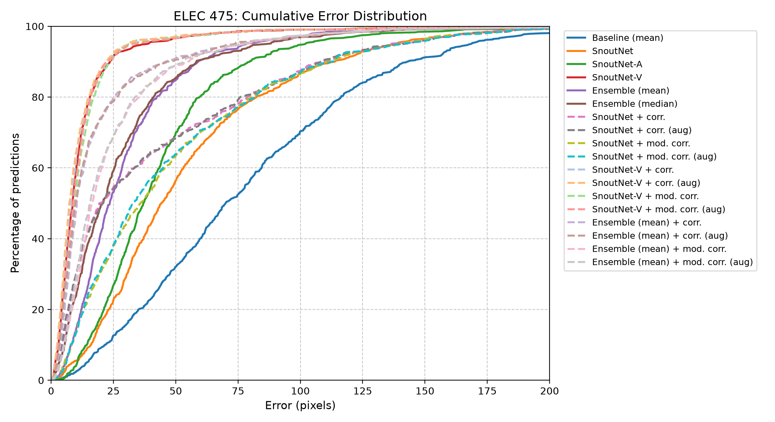
Figure 1. Cumulative error distribution for the in-lab models, baselines, ensembles, and all four correction configurations.

3.4 Best and worst SnoutNet predictions
Each panel shows the four best predictions (top row) and four worst predictions (bottom row). The red cross is the prediction and the green circle marks the ground-truth nose location.
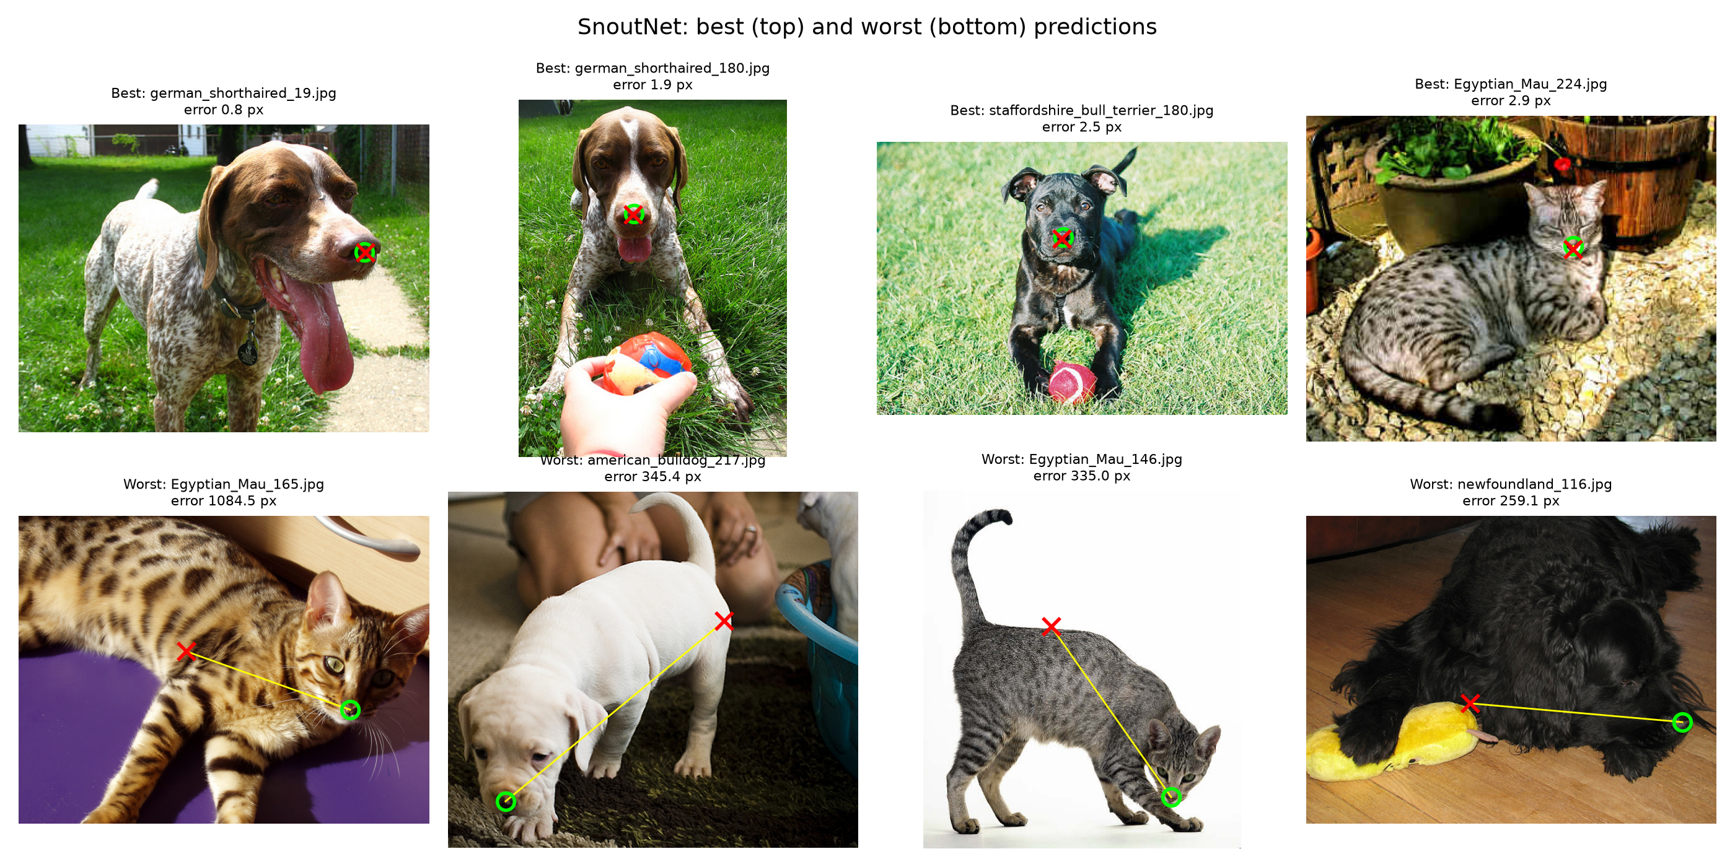
Figure 2. SnoutNet predictions before correction.
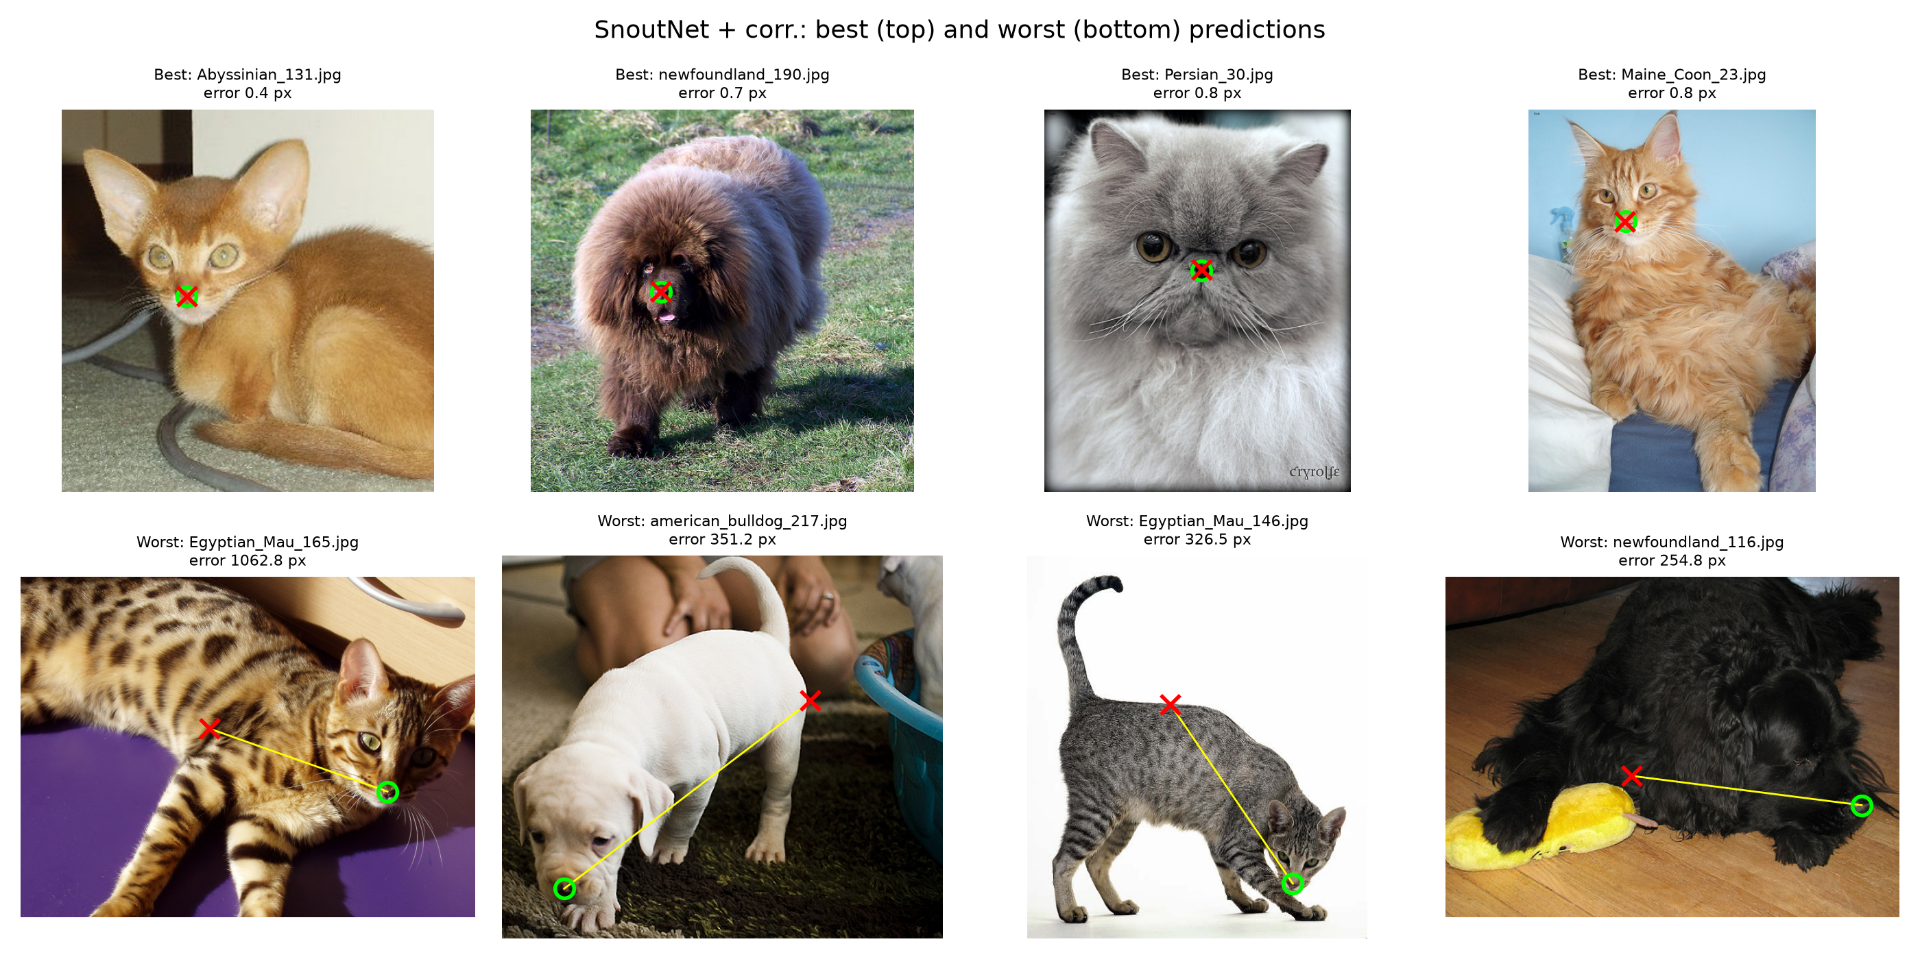
Figure 3. SnoutNet predictions corrected with CorrectionNet trained without augmentation.
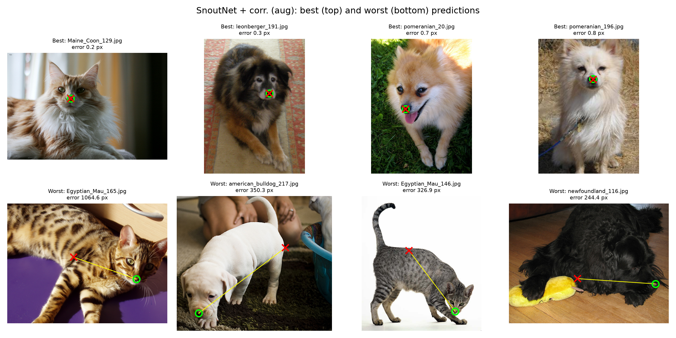
Figure 4. SnoutNet predictions corrected with augmented CorrectionNet.

3.5 Training loss curves
The following plots show training MSE on normalized offsets for all four training configurations.
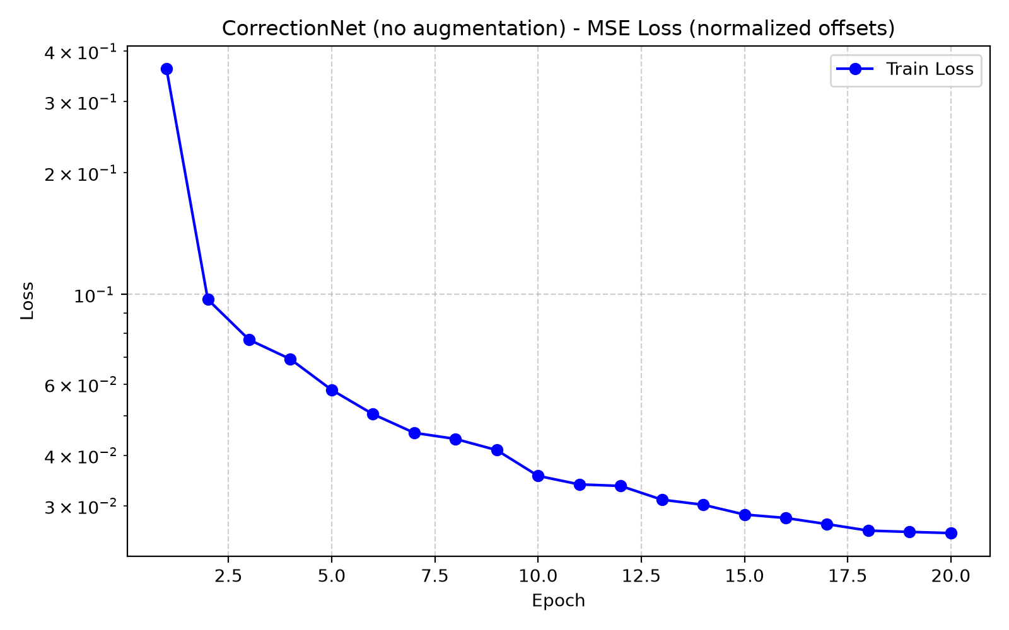
Figure 5. CorrectionNet without augmentation.
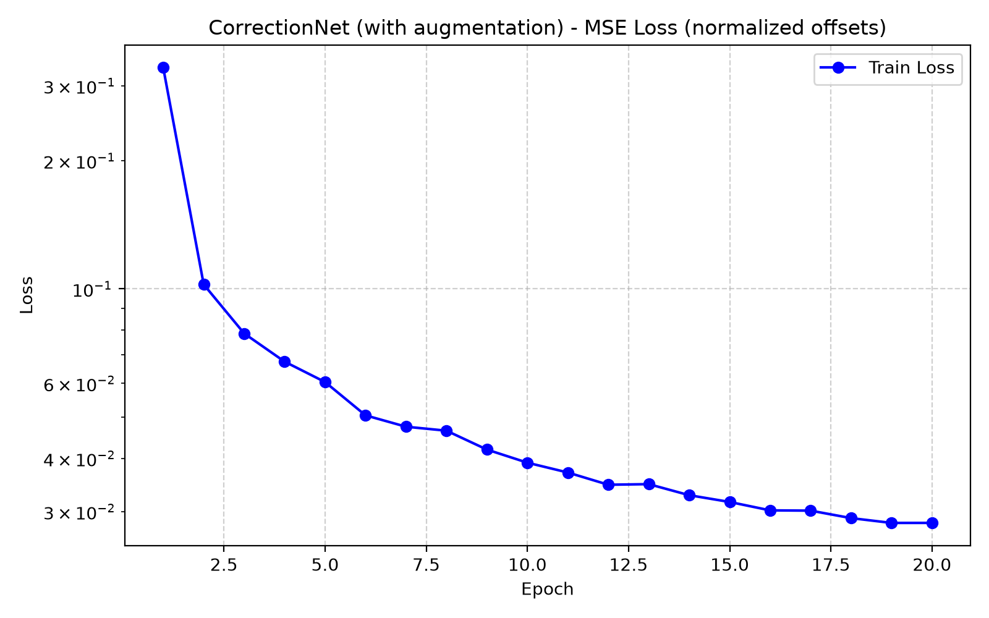
Figure 6. CorrectionNet with horizontal-flip and colour-jitter augmentation.
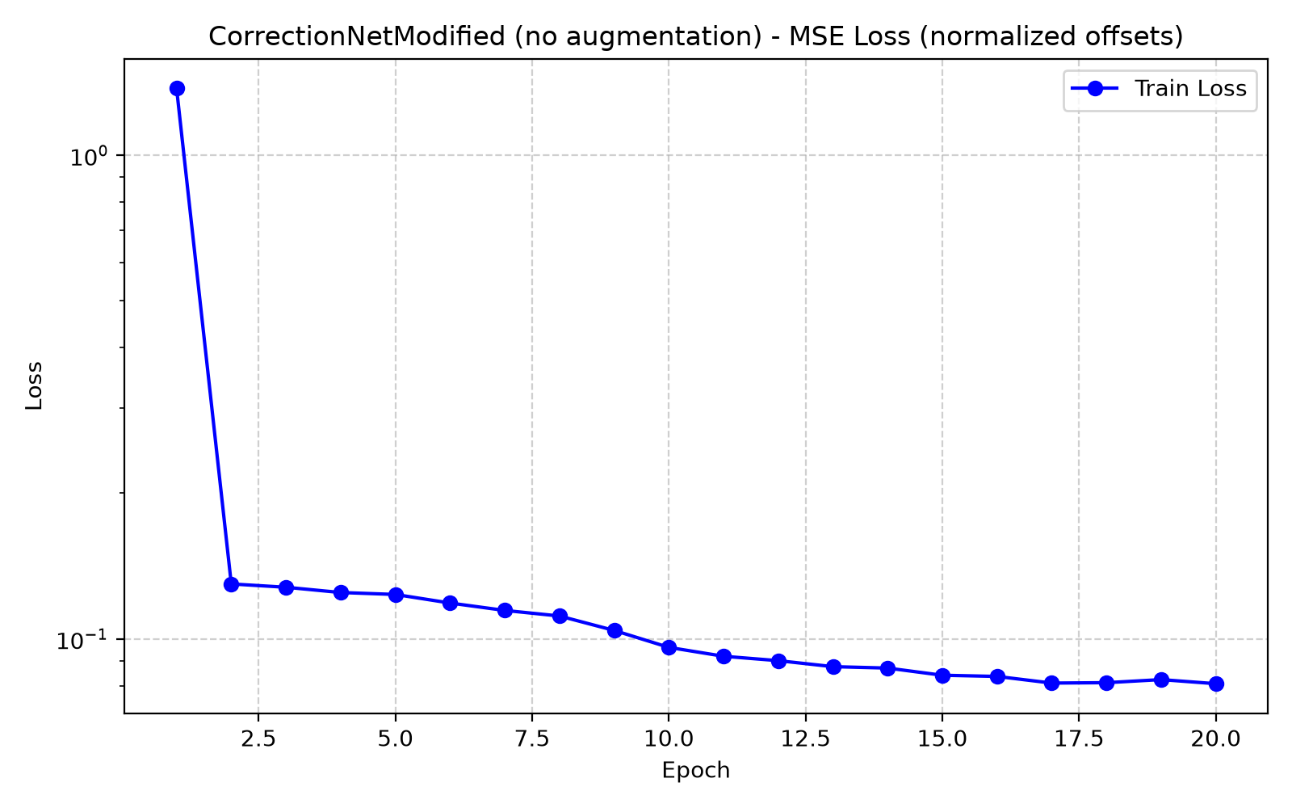
Figure 7. CorrectionNetModified without augmentation.
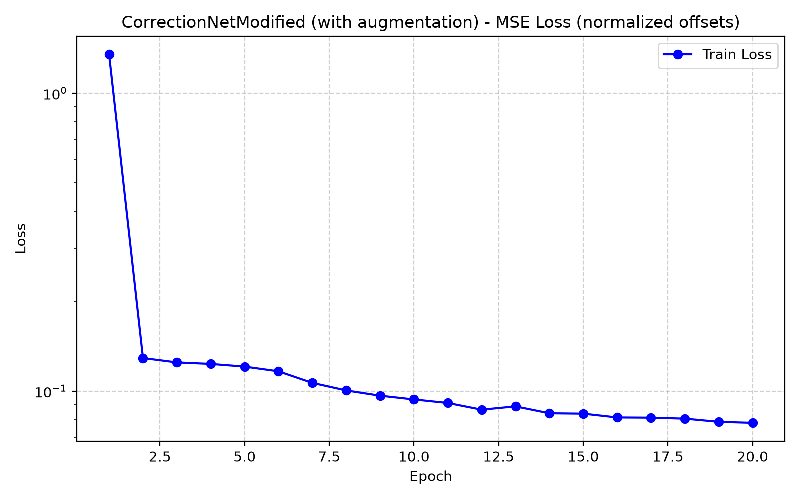
Figure 8. CorrectionNetModified with horizontal-flip and colour-jitter augmentation.

4. Analysis

4.1 Failure cases
The hardest cases are images where the nose is small, partly occluded, poorly contrasted, off-center, or presented at an unusual angle or scale. The worst SnoutNet example is Egyptian_Mau_165.jpg (1,084.5 px error); its predicted point is far from the face. The worst corrected SnoutNet example is still Egyptian_Mau_165.jpg (1,064.6 px with augmented correction). This illustrates that a local second stage cannot recover a nose that is absent from its input patch. Other severe misses include images with unusual poses or distracting background content. The model learns a typical face/nose appearance, but does not have a mechanism to reject every out-of-distribution or ambiguous image.

4.2 Effect of pretraining
Pretraining provides reusable edge, texture, shape, and object-part representations learned from ImageNet, so the model need not learn all visual features from the comparatively small task-specific dataset. This is consistent with the results: SnoutNet-V has a 12.9 px mean error, versus 57.0 px for SnoutNet trained from scratch. SnoutNet-A also improves on the scratch model (44.8 px mean). SnoutNet-V is the most accurate in-lab model, though its 124.2 ms/image cost is much higher than SnoutNet's 9.3 ms/image.

4.3 Ensembles
Averaging predictions improves on SnoutNet and SnoutNet-A alone: the mean ensemble has 31.2 px mean error, and the median ensemble 29.4 px. However, the ensemble does not outperform SnoutNet-V (12.9 px). Combining models can dilute the strongest member when the other predictions are less accurate, and errors can remain correlated because every model localizes the same feature from the same image. An ensemble is most likely to beat its best member when the members have complementary, weakly correlated errors and their outputs are comparably calibrated.

4.4 Effect of the correction model
The standard correction model reduces the mean error for all three correctable inputs. For SnoutNet, the augmented version changes mean error from 57.0 to 43.7 px; for SnoutNet-V, from 12.9 to 11.8 px; and for the mean ensemble, from 31.2 to 20.4 px. Median error also falls substantially for the VGG and ensemble inputs (8.7→7.3 px and 23.5→9.7 px, respectively). The relative gain is largest for the ensemble's median, while the VGG baseline is already close to the nose and has less room to improve.
Correction is not guaranteed to fix a bad first-stage prediction. Training offsets are sampled within ±40 pixels per coordinate, and the 128 × 128 crop spans only ±64 pixels from its center. When the initial prediction is far outside this neighborhood, the nose may not be visible in the patch or the required offset may be outside the training distribution. The remaining large maximum errors in Table 1 show that this local refinement does not remove catastrophic first-stage failures.

4.5 Effect of augmentation
Horizontal flipping with a corresponding sign change for the horizontal target preserves the label while exposing the model to both left-right orientations. Colour jitter encourages robustness to illumination and colour variation. For the standard model, augmentation has a small positive effect on the mean for SnoutNet (43.8→43.7 px), SnoutNet-V (12.2→11.8 px), and the ensemble (20.5→20.4 px). Median error improves for VGG and the ensemble, but not for corrected SnoutNet (19.4→20.9 px). Thus, augmentation is mildly beneficial overall, rather than a uniform improvement on every summary statistic.

4.6 Modified architecture
The modified model uses two-convolution residual blocks, channel-projection skip connections where necessary, and dropout before the output layer. It increases the correction model from 766,594 to 1,119,202 parameters. Under the same training recipe, it performs worse than the standard correction model for each first-stage input: with augmentation, mean errors are 50.3 versus 43.7 px for SnoutNet, 13.0 versus 11.8 px for SnoutNet-V, and 25.2 versus 20.4 px for the mean ensemble. The added capacity and residual structure therefore did not translate into better test localization in this experiment. A plausible explanation is that the local offset task and available training set do not benefit from the extra capacity under the unchanged hyperparameters; without a validation set or controlled hyperparameter search, this should be treated as an observed outcome, not a definitive explanation.

Conclusion
A patch-based correction stage improves typical test localization, most notably for the mean ensemble, while preserving the original model's catastrophic failures when the nose is outside the local crop. ImageNet pretraining remains the strongest contributor to accuracy: SnoutNet-V starts from the best in-lab performance and is further refined by the standard correction model. The augmentation gains are modest, and the larger residual correction architecture did not improve test results with the training setup used.

