Acupuncture for Treatment of Lower Back Pain

RCT Study

Dr. Liem

Table of contents

library(tidyverse)

── Attaching core tidyverse packages ──────────────────────── tidyverse 2.0.0 ──  
✔ dplyr 1.1.4 ✔ readr 2.1.5  
✔ forcats 1.0.0 ✔ stringr 1.5.1  
✔ ggplot2 3.5.1 ✔ tibble 3.2.1  
✔ lubridate 1.9.3 ✔ tidyr 1.3.1  
✔ purrr 1.0.2   
── Conflicts ────────────────────────────────────────── tidyverse_conflicts() ──  
✖ dplyr::filter() masks stats::filter()  
✖ dplyr::lag() masks stats::lag()  
ℹ Use the conflicted package (<http://conflicted.r-lib.org/>) to force all conflicts to become errors

library(officer)  
library(officedown)  
library(flextable)

Attaching package: 'flextable'  
  
The following object is masked from 'package:purrr':  
  
 compose

## Abstract

In this study, we analyze the efficiency of acupuncture for treatment of lower back pain compared to a control group receiving sham acupuncture in a randomized controlled trial (RCT) (Do, 2017). Hello

## Methods

Participants were randomly assigned to receive either real acupuncture (treatment group) or sham acupuncture (control group). Pain levels were measured using the Visual Analog Scale (VAS) before and after treatment.

## Results

# Dataset

# Dataset

df <- data.frame(  
 Name = c("patient 1", "patient 2", "patient 3", "patient 4", "patient 5", "patient 6"),  
 Group = c("treatment", "control", "treatment", "treatment", "control", "control"),  
 VAS_Pre = c(9, 8, 7, 6, 7, 5),  
 VAS_Post = c(4, 7, 3, 2, 6, 4)  
) %>%  
 mutate(VAS_Change = VAS_Pre - VAS_Post)

# Table

flextable(df) |>  
 set_caption("VAS Scores Before and After Treatment") |>  
 theme_booktabs() |>  
 autofit()

| Name | Group | VAS_Pre | VAS_Post | VAS_Change |
| --- | --- | --- | --- | --- |
| patient 1 | treatment | 9 | 4 | 5 |
| patient 2 | control | 8 | 7 | 1 |
| patient 3 | treatment | 7 | 3 | 4 |
| patient 4 | treatment | 6 | 2 | 4 |
| patient 5 | control | 7 | 6 | 1 |
| patient 6 | control | 5 | 4 | 1 |

# Bar Plot  
ggplot(df, aes(x = Name, y = VAS_Change, fill = Group)) +  
 geom_bar(stat = "identity", width = 0.6) +  
 labs(  
 title = "VAS Change After Treatment",  
 x = "Patient",  
 y = "VAS Change (Pre - Post)"  
 ) +  
 theme_minimal() +  
 theme(axis.text.x = element_text(angle = 45, hjust = 1))

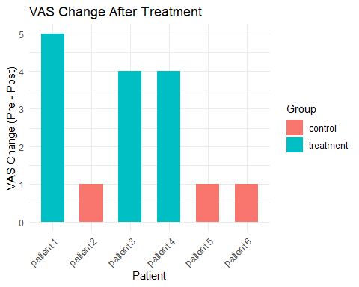

Do, T. L. (2017). Acupuncture for treatment of pain. *Acupuncture*.