# Alzheimer's Disease: A Review of Epidemiology, Pathophysiology, and Treatment

## Abstract

Alzheimer's disease (AD) is a progressive neurodegenerative disorder characterized by cognitive decline and memory loss. This article explores the epidemiology, pathophysiology, and treatment options for Alzheimer's disease. It also discusses the role of biomarkers, genetic factors, and ongoing research (Hardy & Selkoe, 2002).

## Introduction

Alzheimer's disease is one of the most common causes of dementia among the elderly. It affects millions of individuals globally and is associated with significant cognitive and functional decline (Alzheimer's Association, 2024). The underlying causes of Alzheimer's disease are complex, involving genetic, environmental, and lifestyle factors.

## Pathophysiology

The pathophysiology of Alzheimer's disease is characterized by the accumulation of amyloid plaques and tau tangles in the brain, leading to neuronal death and cognitive impairment (Jessen et al., 2020). The exact cause of this accumulation remains unclear, but genetic mutations, environmental toxins, and other factors may contribute.

## Treatment Options

Currently, there are no disease-modifying treatments for Alzheimer's disease. The treatment focuses on symptom management, including cholinesterase inhibitors (Donepezil, Rivastigmine) and NMDA receptor antagonists (Memantine). Researchers are investigating immunotherapies and other experimental treatments (Dubois & Albert, 2017).

## Conclusion

Alzheimer's disease remains a major public health challenge. While there is no cure, early diagnosis and symptom management can improve quality of life. Ongoing research into disease-modifying therapies and prevention strategies offers hope for the future (Hardy & Selkoe, 2002).

Figure 1: Prevalence of Alzheimer's Disease by Age Group

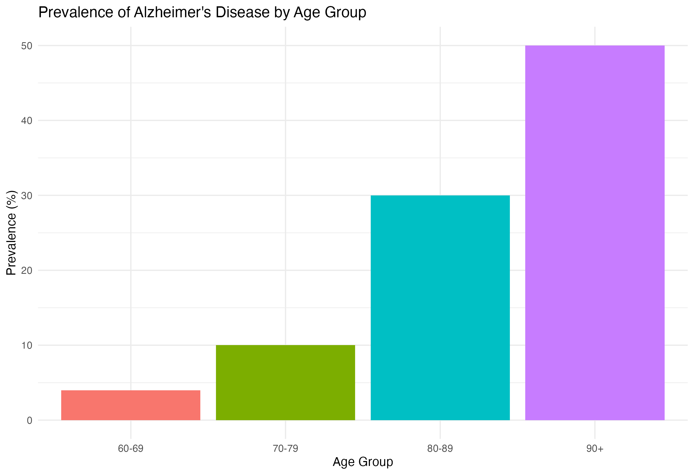

| age_group | prevalence |
| --- | --- |
| **60-69** | 4.0 |
| **70-79** | 10.0 |
| **80-89** | 30.0 |
| **90+** | 50.0 |

## References

Hardy, J., & Selkoe, D. J. (2002). The amyloid hypothesis of Alzheimer's disease. *Science*, 297(5580), 353-356.

Alzheimer's Association. (2024). 2024 Alzheimer's disease facts and figures. *Alzheimer's & Dementia*, 20(3), 1-123.

Dubois, B., & Albert, M. S. (2017). Preclinical Alzheimer's disease: Definition, natural history, and diagnostic criteria. *The Lancet Neurology*, 16(8), 658-665.

Jessen, F., et al. (2020). The role of biomarkers in the diagnosis of Alzheimer's disease: Current perspectives and future directions. *Journal of Alzheimer's Disease*, 74(2), 379-386.