RCT: Yangxin Tang vs. Acupuncture

Comparison of Sleep Quality (PSQI Outcome)

YHCT Team

Table of contents

library(pacman)  
pacman::p_load(  
 officedown, haven, tidyverse, labelled, ggplot2,  
 gt, flextable, kableExtra, officer, lubridate, glue  
)  
  
# Generate formatted datetime string  
current_datetime <- now()  
thu <- if (wday(current_datetime) == 1) "Chủ nhật" else paste("Thứ", wday(current_datetime) - 1)  
gio <- format(current_datetime, "%H:%M")  
ngay <- day(current_datetime)  
thang <- month(current_datetime)  
nam <- year(current_datetime)  
formatted_datetime <- paste0("vào lúc ", gio, ", ", thu, ", ngày ", ngay, " tháng ", thang, " năm ", nam)

## Simulate PSQI data

## Set seed and sample size  
set.seed(123)  
n <- 48  
  
## Simulate data  
data <- tibble(  
 group = rep(c("Yangxin", "Acupuncture"), each = n),  
 ## Baseline means are close to ensure no significant difference  
 pre_PSQI = c(rnorm(n, mean = 14, sd = 2), rnorm(n, mean = 14.2, sd = 2)),  
 ## Post-treatment: Yangxin improves more  
 post_PSQI = c(rnorm(n, mean = 7.5, sd = 2), rnorm(n, mean = 10.5, sd = 2))  
)  
  
## Baseline comparison  
baseline_test <- wilcox.test(pre_PSQI ~ group, data = data)  
  
## Post-treatment comparison  
post_test <- wilcox.test(post_PSQI ~ group, data = data)  
  
## Paired tests within groups  
yangxin_test <- wilcox.test(  
 data %>% filter(group == "Yangxin") %>% pull(pre_PSQI),  
 data %>% filter(group == "Yangxin") %>% pull(post_PSQI),  
 paired = TRUE  
)  
  
acupuncture_test <- wilcox.test(  
 data %>% filter(group == "Acupuncture") %>% pull(pre_PSQI),  
 data %>% filter(group == "Acupuncture") %>% pull(post_PSQI),  
 paired = TRUE  
)  
  
## Summary table  
results <- tibble(  
 Comparison = c(  
 "Baseline: Yangxin vs Acupuncture",  
 "Post-treatment: Yangxin vs Acupuncture",  
 "Yangxin: Pre vs Post",  
 "Acupuncture: Pre vs Post"  
 ),  
 `p-value` = c(  
 baseline_test$p.value,  
 post_test$p.value,  
 yangxin_test$p.value,  
 acupuncture_test$p.value  
 )  
)

## Wilcoxon rank-sum test for baseline PSQI comparison

baseline_test <- wilcox.test(pre_PSQI ~ group, data = data)

## Wilcoxon signed-rank test for within-group comparisons

yangxin_test <- wilcox.test(  
 x = data %>% filter(group == "Yangxin") %>% pull(pre_PSQI),  
 y = data %>% filter(group == "Yangxin") %>% pull(post_PSQI),  
 paired = TRUE  
)  
  
acupuncture_test <- wilcox.test(  
 x = data %>% filter(group == "Acupuncture") %>% pull(pre_PSQI),  
 y = data %>% filter(group == "Acupuncture") %>% pull(post_PSQI),  
 paired = TRUE  
)

## Prepare result summary

results <- tibble(  
 Comparison = c("Baseline (Yangxin vs Acupuncture)",  
 "Pre vs Post (Yangxin)",  
 "Pre vs Post (Acupuncture)"),  
 `p-value` = c(baseline_test$p.value,  
 yangxin_test$p.value,  
 acupuncture_test$p.value)  
)

## Show results with flextable

results %>%   
 flextable() %>%   
 autofit()

| Comparison | p-value |
| --- | --- |
| Baseline (Yangxin vs Acupuncture) | 0.220774088180969496609 |
| Pre vs Post (Yangxin) | 0.000000000000007105427 |
| Pre vs Post (Acupuncture) | 0.000000000053887561080 |

## Optional: visualize PSQI changes

data_long <- data %>%  
 pivot_longer(cols = c(pre_PSQI, post_PSQI),   
 names_to = "time", values_to = "PSQI")  
  
ggplot(data_long, aes(x = time, y = PSQI, fill = group)) +  
 geom_boxplot(position = position_dodge(width = 0.8)) +  
 labs(title = "PSQI Before and After Intervention",  
 x = "Time", y = "PSQI Score") +  
 theme_minimal()

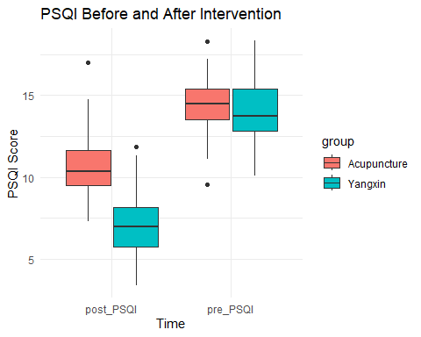

# Bàn luận

## Đặc điểm giới tính