Photo Rest API test example result.

<http://localhost:8080/api/v1/photos>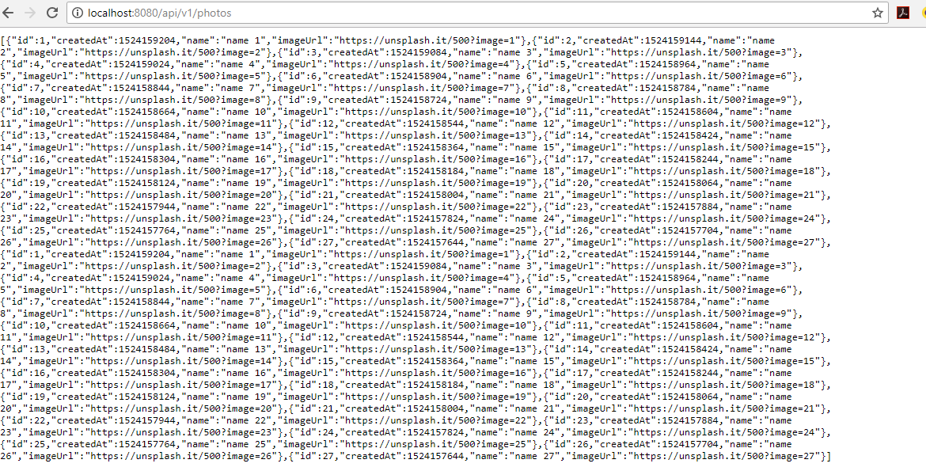

http://localhost:8080/api/v1/photos/5



[http://localhost:8080/api/v1/photos/pagnation?offset=2&limit=8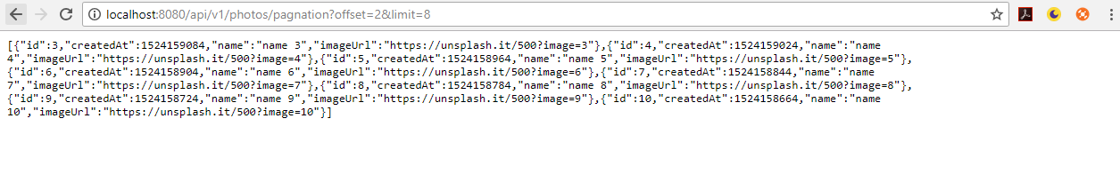](http://localhost:8080/api/v1/photos/pagnation?offset=2&limit=8#)

