Elixys Client Deployment

The Elixys client can be deployed in three ways, two intended for routine use and third only for development.

# Browser Deployment

The Elixys client can be run in a web browser on any platform that supports Flash (currently everything except iOS). This deployment method does not require anything to be installed on the client device. The user opens a web browser, types in the URL of the Elixys server, enters their username and password when prompted and the client will load and render inside the browser window. The figure below gives an overview of the HTTP requests and responses involved in establishing the connection.

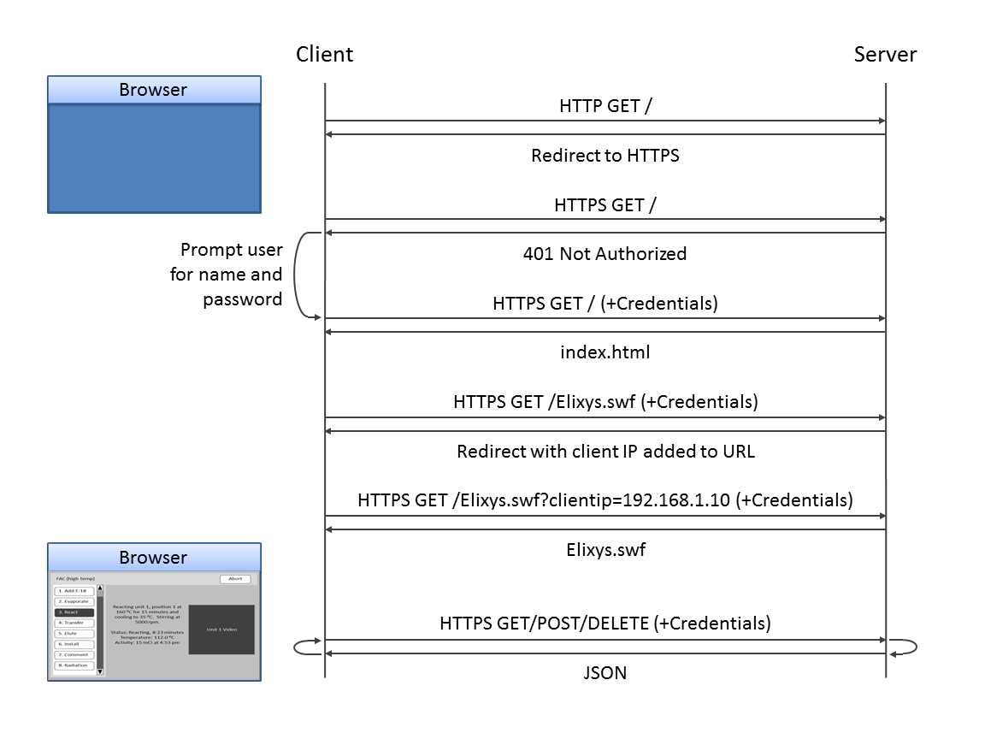

# AIR Deployment

The Elixys client can be installed on the target device like a normal application and launched from an icon on the desktop or home screen. The user launches the application, enters the server name or IP and their username or password. The application will establish a connection to the server and download the core content at runtime. The HTTP requests and responses involved in establishing the connection are shown in the figure below.

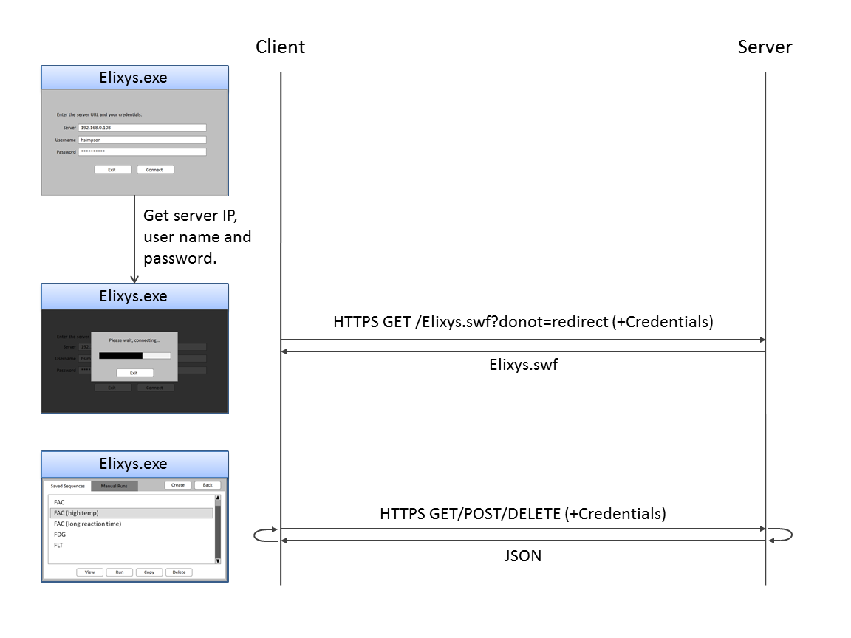

# Debug Deployment

A special build of the client allows it to be run directly against the Python WSGI interface without the need for an Apache server. This deployment method enables single-machine development without the hassle of a full deployment. Note that the core SWF is embedded in the installed application and cannot be updated dynamically like the two previous deployment methods. The figure below gives an overview of this simple method.

