 | Annual Progress Report  Henry & Mary Elliston | 27 January 2026

Executive Summary
✓ Strong Performance: Portfolio returned +23.1%, beating benchmark by +5.7%
✓ Retirement Goal: 64% complete - ahead of target
✓ Action Required: Increase school fees contributions to £1,500/month

Performance vs Benchmark
Account | Value | Growth | Benchmark | Alpha
ISA | £122.62 | +16.66% | +12.3% | +4.4%
SIPP | £31,789.00 | +23.86% | +18.2% | +5.7%

Portfolio Asset Allocation
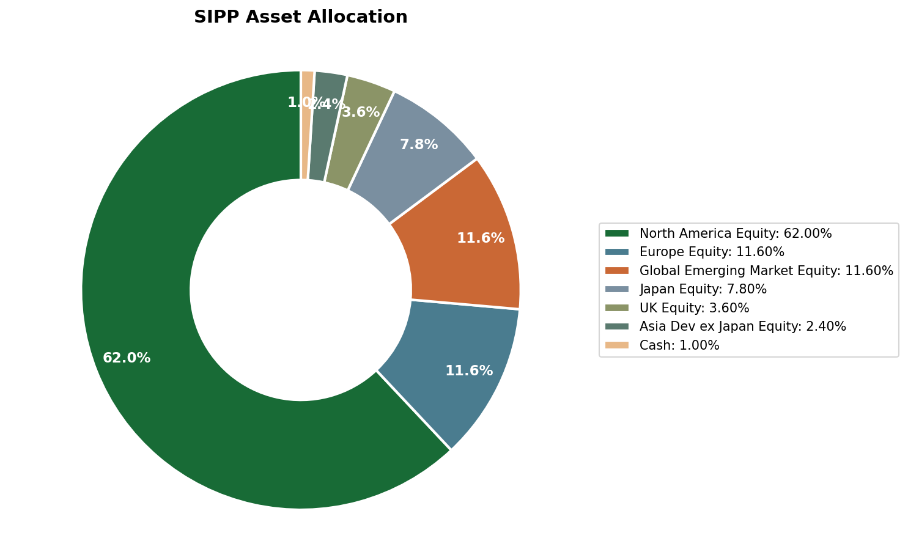

Long-Term Asset Growth Projection
Your pension assets are projected to reach £501k by age 67, exceeding the £450k target.
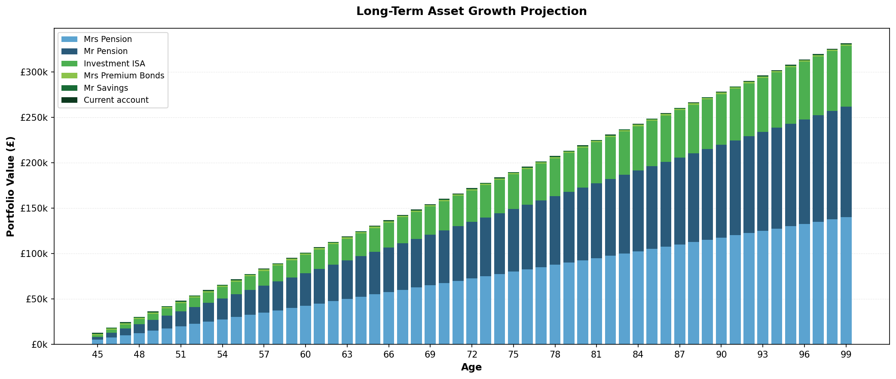

Annual Cashflow Analysis
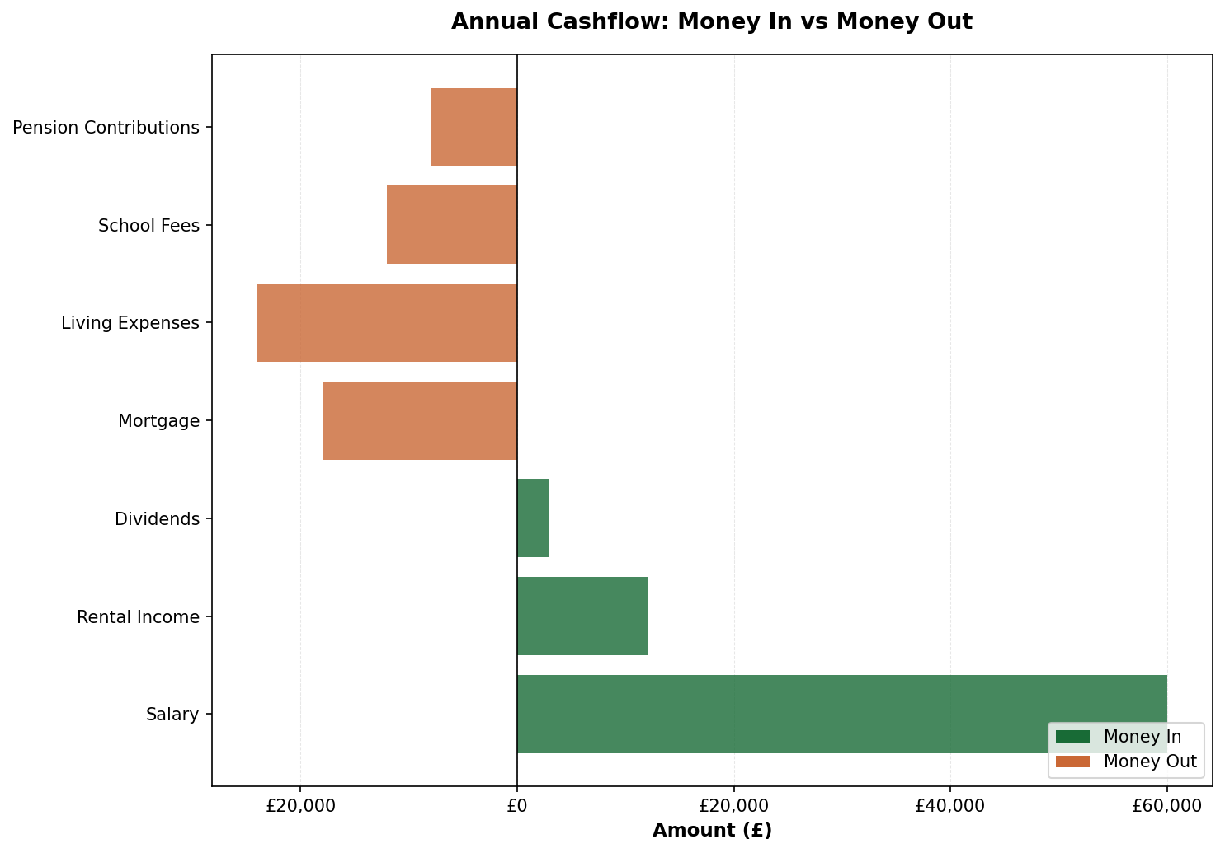

Recommendations
1. Increase School Fees Contributions
Set up £1,500/month to ISA. Target: March 2026
2. Maximize Pension Contributions
Consider utilizing full £60k annual allowance. Deadline: 5 April 2026
3. IHT Planning Review
Schedule meeting for inheritance tax strategies. Q1 2026

Adviser Notes
tax minimisation, iht concerns
The Family Wealth Partnership
henry@thefamilywealthpartnership.co.uk | 07920 050504

