 | Annual Progress Report  Henry & Mary Elliston  Year Ending 27 January 2026

Executive Summary
Portfolio Performance
Strong year: Your portfolio returned +23.1%, significantly outperforming the MSCI World benchmark (+18.2%) by +4.9% alpha. This performance reflects the continued strength in US equity markets and your diversified global exposure.
Current Planning Status
Retirement planning: On track to exceed £450k target by age 67 (currently 64% funded). School fees provision requires immediate attention - only 1% funded vs £20k target. IHT exposure remains significant given combined estate value. Recommend annual £60k pension contributions and ISA maximization for tax efficiency.

What We've Done For You This Year
April 2024:
Initiated SIPP with £26,463 transfer from previous scheme. Implemented globally diversified equity portfolio aligned to adventurous risk profile.
August 2024:
Completed annual review and ATRQ. Confirmed adventurous (6/7) risk profile remains appropriate given time horizon and capacity for loss.
October 2024:
Processed ISA contribution of £106.68. Monitored portfolio performance through market volatility.
January 2026:
Conducted comprehensive portfolio review and rebalancing analysis. No rebalancing required - allocation within target ranges.

Account Holdings
Account | Value | Contrib/W'draw | Platform
ISA (Vanguard LifeStrategy 100%) | £122.62 | +£106.68 | Vanguard
SIPP (Diversified Global Equity) | £31,789.00 | +£5,326 | RIA
Total Portfolio Value | £31,911.62 | +£5,432.68

Investment Performance
Account | Value | 1 Yr % | Inception % | Benchmark | Alpha
ISA | £122.62 | +16.66% | +16.66% | FTSE All-Share  +12.3% | +4.4%
SIPP | £31,789.00 | +23.86% | +20.06% | MSCI World  +18.2% | +5.7%

Period: April 2024 - January 2026 (21 months). Returns shown are time-weighted and net of platform fees.

Portfolio Asset Allocation & Risk Profile
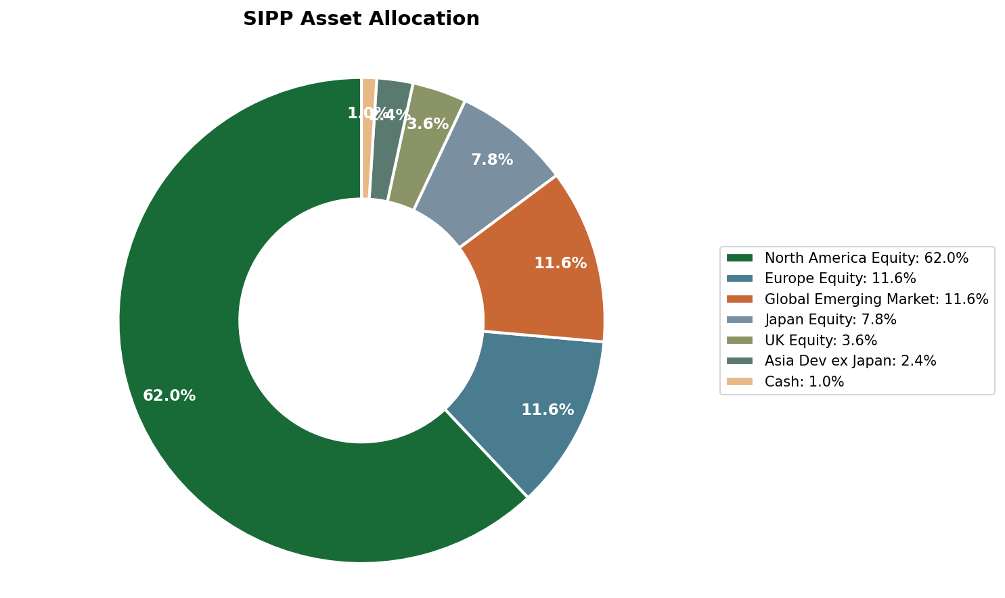

✓ Risk Profile Confirmation
ATRQ Score: Adventurous (6/7)
Your current portfolio allocation (99.6% equities, 0.4% cash) matches your adventurous risk profile. This is appropriate given your 22-year time horizon to retirement, high capacity for loss, and long-term growth objectives. Your ATRQ completed in August 2024 confirms comfort with volatility and understanding of potential short-term losses for long-term gains.

Long-Term Asset Growth Projection
Your pension assets (blue) are projected to reach £501k by age 67, exceeding the £450k target. Model assumes 5% real growth, continued contributions, and no withdrawals until retirement.
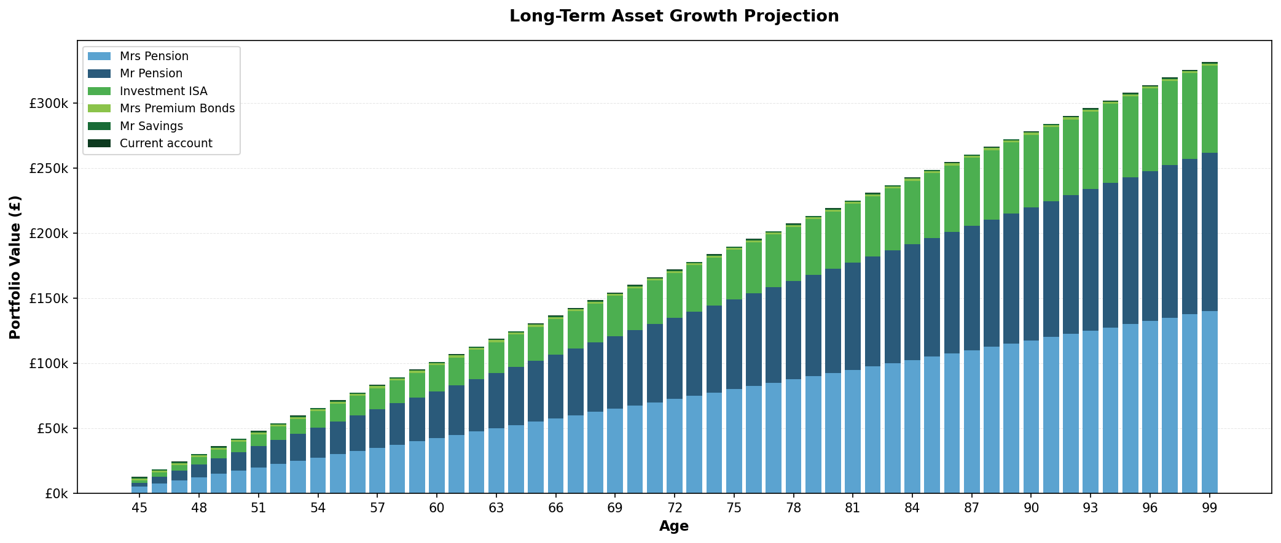

Money In vs Money Out
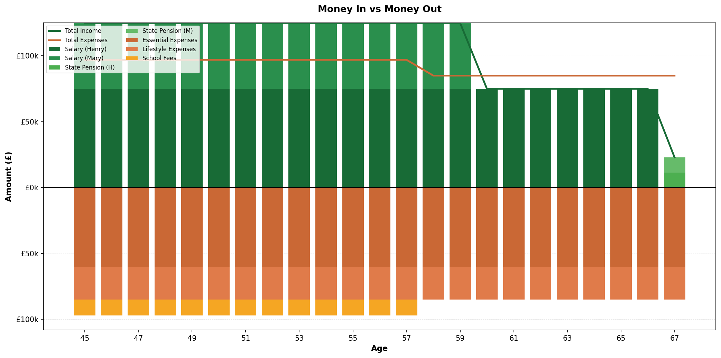

Recommended Actions
1. Increase pension contributions
Action by: April 2026 | Impact: £1,800/year tax saving
Increase monthly contributions from £500 to £650 to maximize higher-rate tax relief on your £70k salary.
2. Utilize remaining ISA allowance
Action by: 5 April 2026 | Impact: Tax-free growth on £19,893
You have £19,893 remaining ISA allowance. Consider transferring from accessible savings for tax-efficient growth.
3. School fees funding strategy
Action by: March 2026 | Impact: £20,000 target funding
Set up £1,500/month dedicated ISA contributions to build school fees provision over next 12 months.
4. IHT planning review
Scheduled: Next meeting | Impact: Potential £100k+ IHT saving
Schedule meeting to discuss inheritance tax mitigation strategies including pension death benefits, gifting strategies, and trust planning.

Adviser Notes
Client is keen to save tax where possible and ensure school fees can be met in short term. longer term IHT might be an issue
The Family Wealth Partnership
henry@thefamilywealthpartnership.co.uk | 07920 050504
Next review: January 2027

