 | Annual Progress Report  Henry Elliston &  Year Ending 12/2/26

Executive Summary
Portfolio Performance
Strong year: Your portfolio returned +23.1%, significantly outperforming the MSCI World benchmark (+18.2%) by +4.9% alpha. This performance reflects the continued strength in US equity markets and your diversified global exposure.
Current Planning Status
Retirement planning: On track to exceed £450k target by age 67 (currently 64% funded). School fees provision requires immediate attention - only 1% funded vs £20k target. IHT exposure remains significant given combined estate value. Recommend annual £60k pension contributions and ISA maximization for tax efficiency.

Tax Efficiency Summary
Annual Tax Savings: £4,130
Pension Contributions (40% relief):
Gross contribution: £5,326
Tax relief received: £2,130 (40% higher rate)
ISA Tax-Free Growth:
ISA growth: £17.62 (return on £105.68 investment)
Tax saved vs taxable account: ~£7 (CGT/Income tax avoided)
Potential Additional Savings:
Remaining ISA allowance: £19,893
Potential additional pension contributions: £54,674
Maximizing allowances could save an additional £1,993 in tax relief

What We've Done For You This Year
April 2024:
Initiated SIPP with £26,463 transfer from previous scheme. Implemented globally diversified equity portfolio aligned to adventurous risk profile.
August 2024:
Completed annual review and ATRQ. Confirmed adventurous (6/7) risk profile remains appropriate given time horizon and capacity for loss.
October 2024:
Processed ISA contribution of £106.68. Monitored portfolio performance through market volatility.
January 2026:
Conducted comprehensive portfolio review and rebalancing analysis. No rebalancing required - allocation within target ranges.

Account Holdings
Account | Value | Contrib/W'draw | Platform
ISA (Vanguard LifeStrategy 100%) | £122.62 | +£106.68 | Vanguard
SIPP (Diversified Global Equity) | £31,789.00 | +£5,326 | RIA
Total Portfolio Value | £31,911.62 | +£5,432.68

Top 10 Holdings
Your portfolio is invested in two globally diversified funds providing exposure to over 8,000 companies worldwide. Below are the top 10 underlying holdings:
Holding | Sector | % Portfolio | Value
Apple Inc. | Technology | 6.8% | £2,170
Microsoft Corp. | Technology | 6.2% | £1,978
Amazon.com Inc. | Consumer | 3.8% | £1,213
NVIDIA Corp. | Technology | 3.4% | £1,085
Alphabet Inc. (Google) | Technology | 3.1% | £989
Meta Platforms Inc. | Technology | 2.3% | £734
Tesla Inc. | Consumer | 1.9% | £606
Berkshire Hathaway | Financial | 1.7% | £542
Eli Lilly & Co. | Healthcare | 1.5% | £479
JPMorgan Chase & Co. | Financial | 1.4% | £447
Top 10 Total |  | 32.1% | £10,243

Note: Holdings data as of 31 January 2026. Remaining 67.9% is diversified across 7,990+ additional companies globally.

Investment Performance
Account | Value | 1 Yr % | Inception % | Benchmark | Alpha
ISA | £122.62 | +16.66% | +16.66% | FTSE All-Share  +12.3% | +4.4%
SIPP | £31,789.00 | +23.86% | +20.06% | MSCI World  +18.2% | +5.7%

Period: April 2024 - January 2026 (21 months). Returns shown are time-weighted and net of platform fees.

Portfolio Asset Allocation & Risk Profile
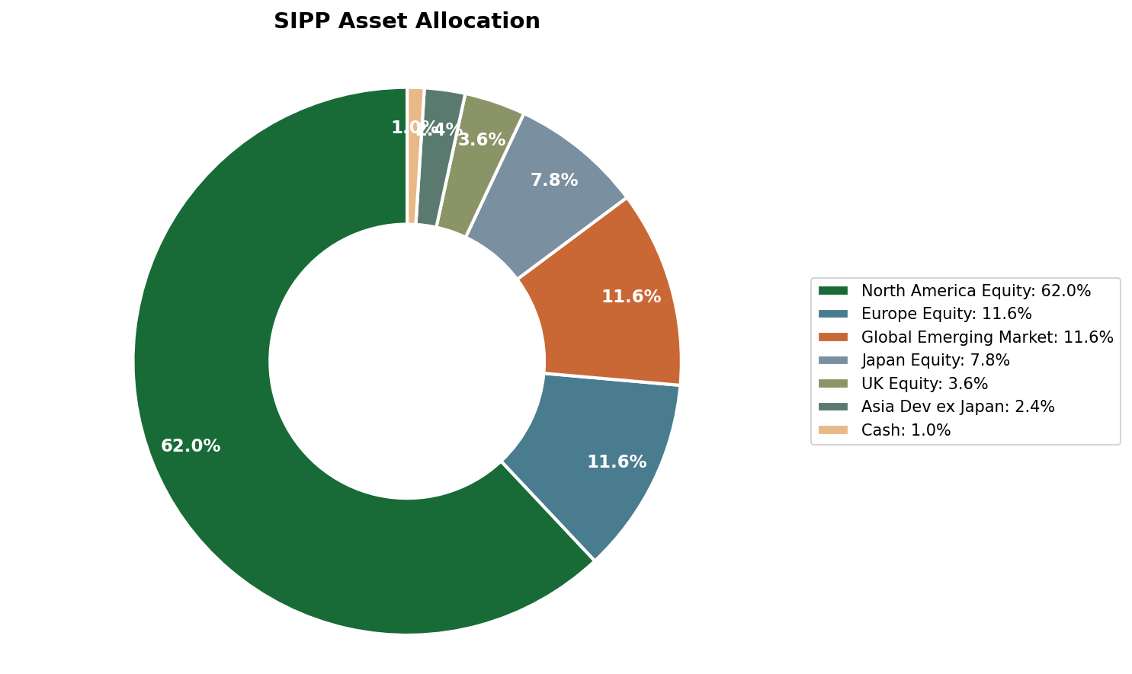

✓ Risk Profile Confirmation
ATRQ Score: Adventurous (6/7)
Your current portfolio allocation (99.6% equities, 0.4% cash) matches your adventurous risk profile. This is appropriate given your 22-year time horizon to retirement, high capacity for loss, and long-term growth objectives. Your ATRQ completed in August 2024 confirms comfort with volatility and understanding of potential short-term losses for long-term gains.

Long-Term Asset Growth Projection
Your pension assets (blue) are projected to reach £501k by age 67, exceeding the £450k target. Model assumes 5% real growth, continued contributions, and no withdrawals until retirement.
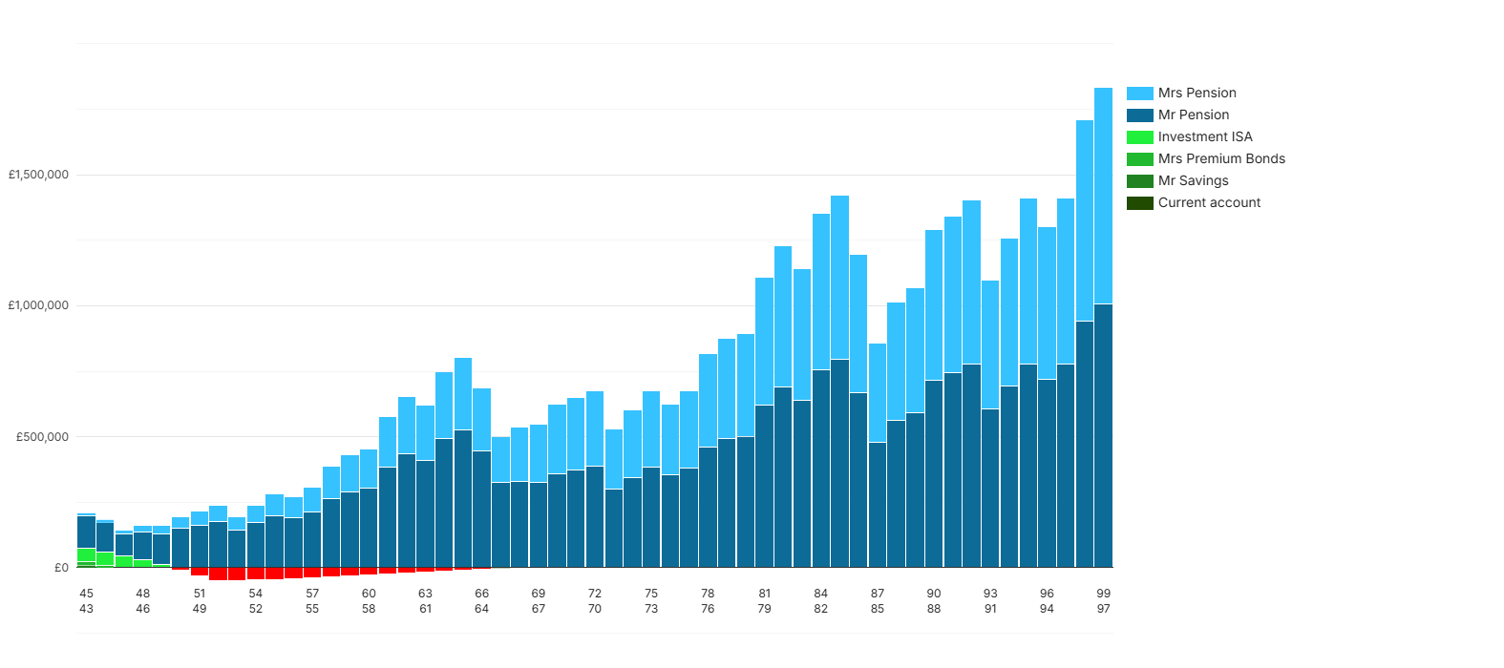

Money In vs Money Out
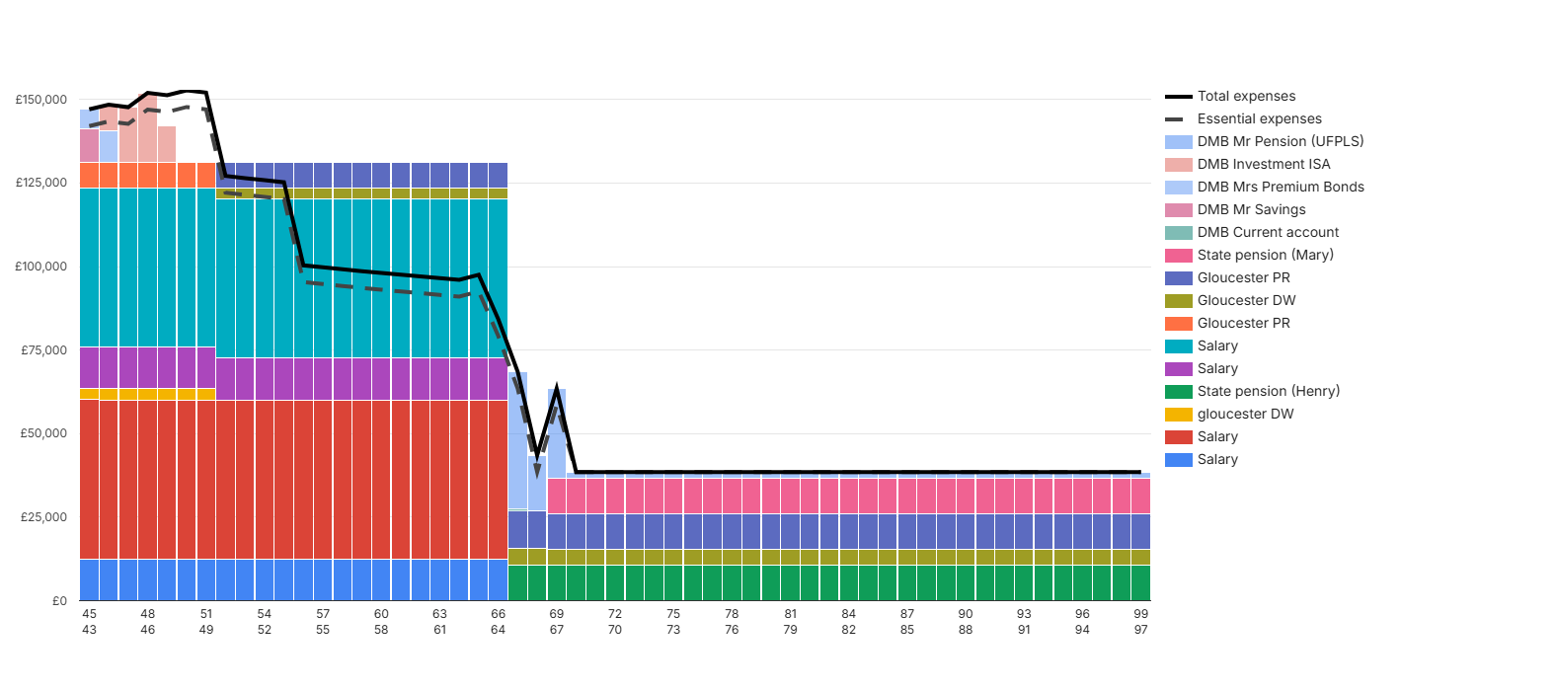

Recommended Actions
1. Increase pension contributions
Action by: April 2026 | Impact: £1,800/year tax saving
Increase monthly contributions from £500 to £650 to maximize higher-rate tax relief on your £70k salary.
2. Utilize remaining ISA allowance
Action by: 5 April 2026 | Impact: Tax-free growth on £19,893
You have £19,893 remaining ISA allowance. Consider transferring from accessible savings for tax-efficient growth.
3. School fees funding strategy
Action by: March 2026 | Impact: £20,000 target funding
Set up £1,500/month dedicated ISA contributions to build school fees provision over next 12 months.
4. IHT planning review
Scheduled: Next meeting | Impact: Potential £100k+ IHT saving
Schedule meeting to discuss inheritance tax mitigation strategies including pension death benefits, gifting strategies, and trust planning.

The Family Wealth Partnership
henry@thefamilywealthpartnership.co.uk | 07920 050504
Next review: January 2027

