**数据库实验报告**

|  |  |  |  |  |  |  |
| --- | --- | --- | --- | --- | --- | --- |
| **实 验 人：** | **伍建霖** | | **学 号：** | **20337251** | **日 期：** |  |
| **院（系）：** | **计算机学院** | | | **专业（班级）：** | **网络空间安全** | |
| **联系方式：** | QQ 773542531 | | |  |  | |
| **实验题目：** | | | **1.3 数据高级查询** | | | | | |

* + - 1. **实验目的**

掌握 SQL 嵌套查询和集合查询等各种高级查询的设计方法。

* + - 1. **实验内容和要求**

针对 TPC-H 数据库，正确分析用户查询要求，设计各种嵌套查询和集合查询。

* + - 1. **实验重点和难点**

实验重点：嵌套查询

实验难点：相关子查询、多层 exist 嵌套查询

* + - 1. **实验工具**

MySQL、SQL Server、Navicat

* + - 1. **实验过程**

（1）In 嵌套查询

查询订购了“佳能”制造的“佳能墨盒”的顾客。

方法一

SELECT *

FROM customer

WHERE customer.custkey IN (SELECT orders.custkey

FROM orders, part, lineitem

WHERE part.mfgr = '佳能' AND

part.`name` = '佳能墨盒' AND

part.partkey = lineitem.partkey AND

orders.orderkey = lineitem.orderkey

);

部分结果截屏如下：

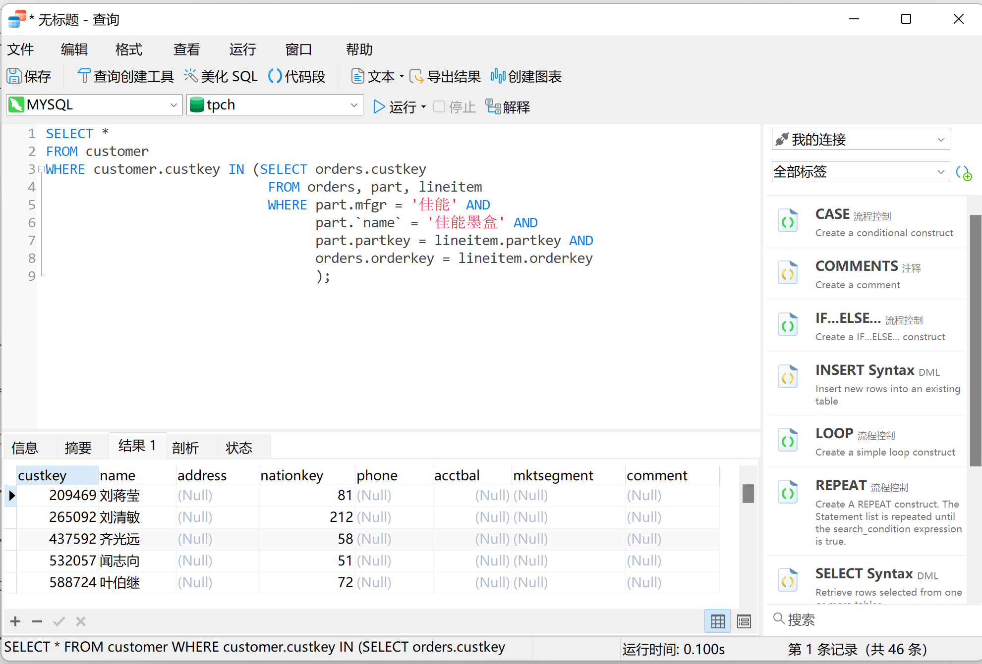

方法二

(SELECT customer.*

FROM orders, part, lineitem, customer

WHERE part.mfgr = '佳能' AND

part.`name` = '佳能墨盒' AND

part.partkey = lineitem.partkey AND

orders.orderkey = lineitem.orderkey AND

customer.custkey = orders.custkey

);

部分结果截屏如下：

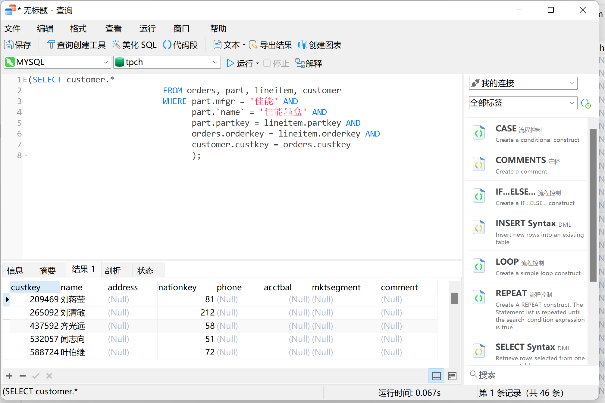

（2）单层 exists 嵌套查询

查询没有订购过“佳能”制造的“佳能墨盒”的顾客。

1111111111111111111111111111

SELECT *

FROM customer

WHERE custkey NOT IN (SELECT customer.custkey

FROM orders, part, lineitem, customer

WHERE part.mfgr = '佳能' AND

part.`name` = '佳能墨盒' AND

part.partkey = lineitem.partkey AND

orders.orderkey = lineitem.orderkey AND

customer.custkey = orders.custkey

);

222222222222222222222222222222222222

SELECT *

FROM customer

WHERE NOT EXISTS (SELECT *

FROM orders, part, lineitem

WHERE part.mfgr = '佳能' AND

part.`name` = '佳能墨盒' AND

part.partkey = lineitem.partkey AND

orders.orderkey = lineitem.orderkey AND

customer.custkey = orders.custkey

);

第一个用的是not in

第二个用的是not exists

部分结果截屏如下：

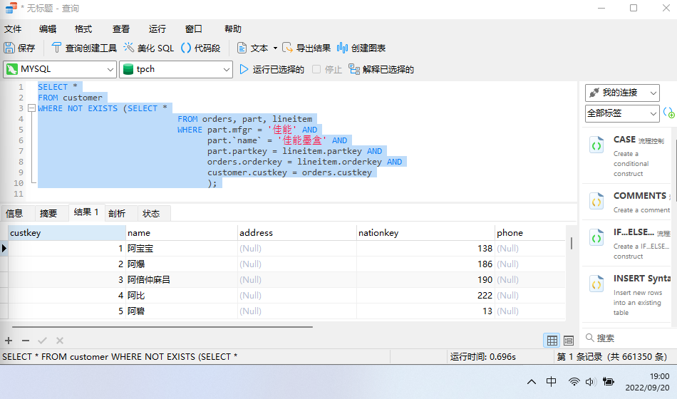

（3）双层 exists 嵌套查询（注：由于表太大，可能非常耗时！）

查询至少购买过顾客“齐光远”购买过的全部零件的顾客姓名。

SELECT customer.`name`

FROM customer

WHERE EXISTS (SELECT *

FROM

WHERE EXISTS (

SELECT *

FROM

WHERE

)

)

部分结果截屏如下：

时间过长。。。。。

（4）From 子句中的嵌套查询

查询订单平均金额超过 25 万元的顾客中的中国籍顾客信息。

SELECT customer.*

FROM nation, customer, (SELECT custkey

FROM orders

GROUP BY custkey

HAVING AVG(totalprice)>250000) AS c(ck)

WHERE (nation.`name` = '中国' AND

customer.nationkey = nation.nationkey AND

customer.custkey = ck);

部分结果截屏如下：

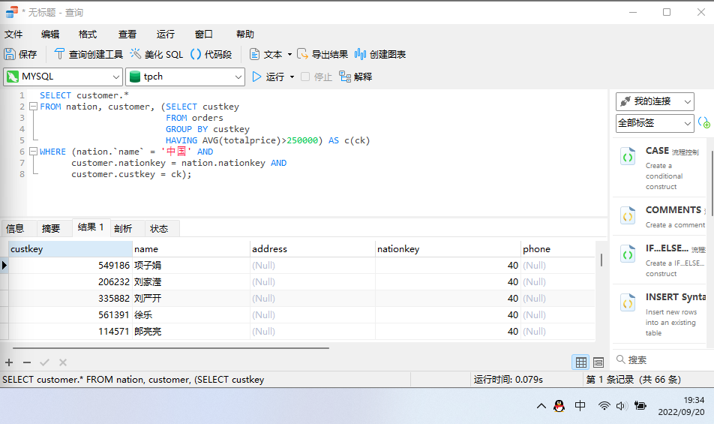

（5）集合查询（交）

查询顾客“陈朋”和“宋金保” 都订过的全部零件的信息。

( SELECT

*

FROM

Part

WHERE

partkey IN ( SELECT partkey FROM Lineitem WHERE orderkey IN ( SELECT orderkey FROM Orders WHERE custkey IN ( SELECT custkey FROM Customer WHERE name = '陈朋' ) ) )

) INTERSECT

(

SELECT

*

FROM

Part

WHERE

partkey IN ( SELECT partkey FROM Lineitem WHERE orderkey IN ( SELECT orderkey FROM Orders WHERE custkey IN ( SELECT custkey FROM Customer WHERE name = '宋金保' ) ) )

)

部分结果截屏如下：

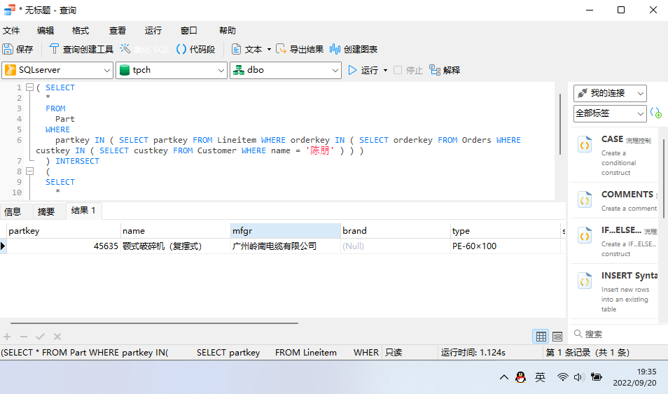

（6）集合查询（并）

查询顾客“陈朋”和“宋金保”订购的全部零件的信息。

( SELECT

*

FROM

Part

WHERE

partkey IN ( SELECT partkey FROM Lineitem WHERE orderkey IN ( SELECT orderkey FROM Orders WHERE custkey IN ( SELECT custkey FROM Customer WHERE name = '陈朋' ) ) )

) UNION

(

SELECT

*

FROM

Part

WHERE

partkey IN ( SELECT partkey FROM Lineitem WHERE orderkey IN ( SELECT orderkey FROM Orders WHERE custkey IN ( SELECT custkey FROM Customer WHERE name = '宋金保' ) ) )

)

部分结果截屏如下：

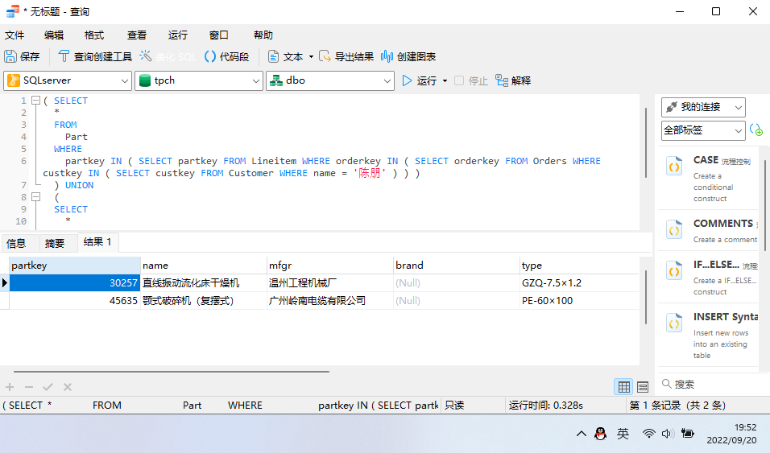

（7） 集合查询（差）

查询顾客“宋金保”订过而顾客“陈朋”没订过的零件的信息。

( SELECT

*

FROM

Part

WHERE

partkey IN ( SELECT partkey FROM Lineitem WHERE orderkey IN ( SELECT orderkey FROM Orders WHERE custkey IN ( SELECT custkey FROM Customer WHERE name = '宋金保' ) ) )

) EXCEPT

(

SELECT

*

FROM

Part

WHERE

partkey IN ( SELECT partkey FROM Lineitem WHERE orderkey IN ( SELECT orderkey FROM Orders WHERE custkey IN ( SELECT custkey FROM Customer WHERE name = '陈朋' ) ) )

)

部分结果截屏如下：

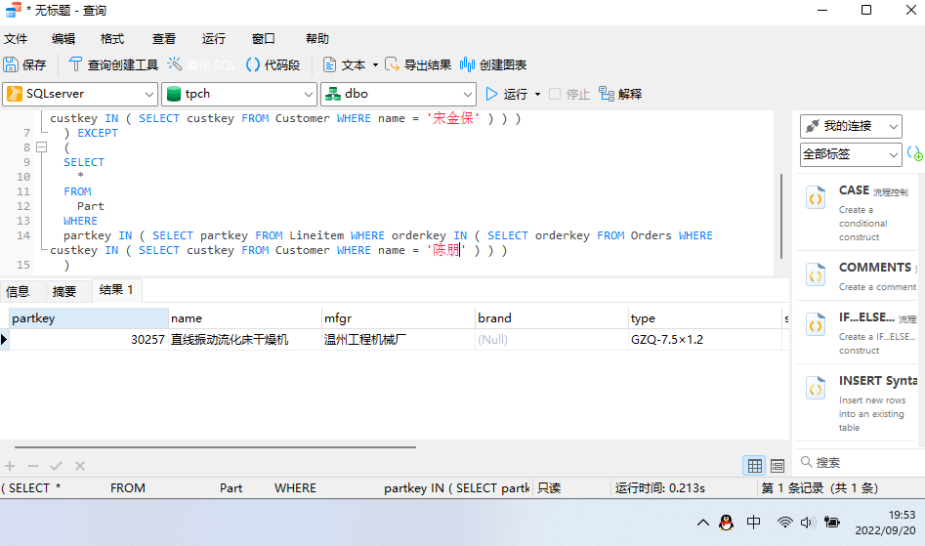

* + - 1. **与实验结果相关的文件**

无

* + - 1. **实验总结**