Unusually specific convergence of bacteriophage T4 Alc on the E. coli/Shigella H-NS dimerization-site-2 state
Henry Hardigan
A 30-residue segment of bacteriophage T4 Alc, EYRNRRLEQARDMLPDAVEEMKVFLENQLA (residues 53-82), converges on the E. coli / S. flexneri H-NS segment EERTRKLQQYREMLIADGIDPNELLNSLA (residues 52-80), spanning the H-NS dimerization-site-2 region and its immediate N-terminal flank. In a reviewed Swiss-Prot set, the primary chemistry-aware motif is restricted to T4 Alc and the E. coli/Shigella H-NS branch. Family-restricted null models and chemistry-constrained alignment analysis argue that this pattern is unusually specific and not explained by amino-acid composition alone, while AlphaFold-Multimer motif models support a related H-NS-like partner geometry. Together, these observations support the hypothesis that Alc can competitively interfere with H-NS site-2-dependent filament formation in enterobacterial hosts.
Background
Bacteriophage T4 uses the Alc protein during host takeover. Classical work showed that Alc acts as a transcription termination factor on unmodified host DNA, whereas T4 DNA is protected by hydroxymethylcytosine modification [1]. That established Alc as a host-shutoff factor, but it did not address whether Alc might also target host chromatin-like regulation more directly.
H-NS is a major nucleoid-associated protein in Escherichia coli and closely related enterobacteria. It silences AT-rich foreign DNA through oligomerization, filament formation, and bridging [2-4]. Dimerization site 2 is specifically required for the rigid H-NS nucleoprotein filaments that underlie gene silencing [2]. This makes site 2 a plausible target for phage antagonism if a viral protein were able to mimic the relevant interface.
Results
Alc converges on the E. coli/Shigella H-NS site-2 state
A 30-residue segment of Alc converges locally on the Escherichia coli/Shigella H-NS site-2 region and its immediate N-terminal flank. The direct Alc/H-NS register is shown in Figure 1. A broader family alignment ordered by similarity to Alc is shown in Figure 2, where the same H-NS sequence state is shared by E. coli and Shigella flexneri while nearby enterobacterial H-NS orthologs drift away from this exact state [2,4]. The resulting primary motif is unusually specific: in reviewed Swiss-Prot, it is found only in T4 Alc and in the E. coli/Shigella H-NS branch.
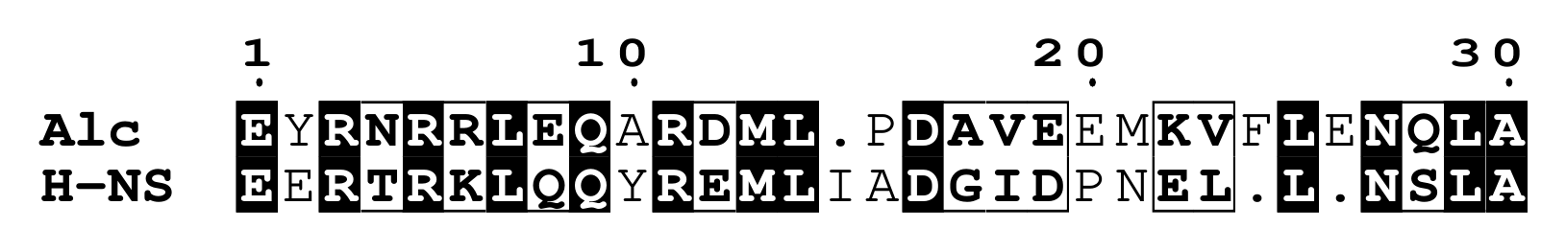
Figure 1. ESPript alignment of bacteriophage T4 Alc with the E. coli/Shigella H-NS dimerization-site-2 state. The Alc row is shown in the preferred convergence register discussed in the text.
The focused alignment preserves common features at the level of residue chemistry, including the N-terminal basic/helical block, the central D-[GA]-[IV]-[DE] core, and the C-terminal N-[QS]-L-A tail. In this reading, T4 Alc most closely matches the host-relevant state rather than H-NS proteins generally.
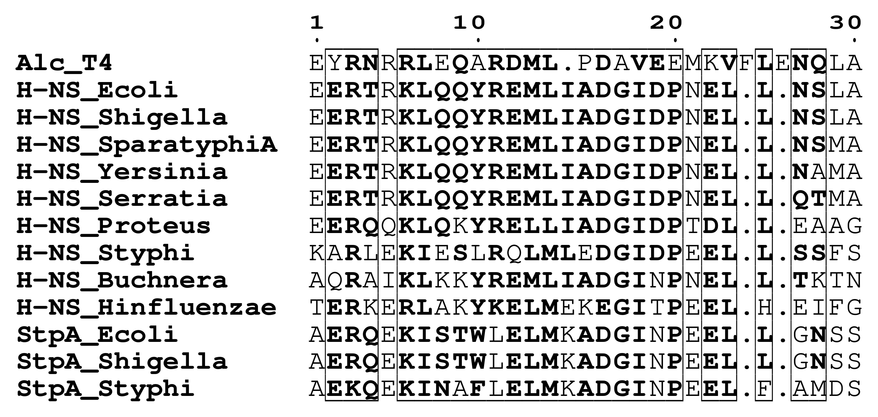
Figure 2. ESPript alignment of Alc against representative reviewed H-NS/StpA family segments, ordered by similarity to Alc. The E. coli and S. flexneri H-NS rows define the closest-matching branch, whereas other H-NS and StpA proteins progressively diverge from the Alc register.
In the family view, the E. coli and S. flexneri H-NS rows are identical and remain the closest matches to Alc. Salmonella, Yersinia, Serratia, and Proteus H-NS variants progressively lose the exact E. coli/Shigella state, and the StpA proteins fall farther away still. This family-level context is what makes the convergence specifically host-clade-focused rather than a generic resemblance to H-NS-family proteins.
This family-level concentration is stronger than expected under simple nulls. Within the reviewed H-NS/StpA family, all four exact primary-motif hits fall in the four-member E. coli/Shigella H-NS branch (uniform-placement p = 0.000206). In a composition-preserving shuffled-Alc null using 20,000 replicates, composition alone sometimes points to the host branch (1165/20000) and occasionally confines all top hits there (640/20000), but no shuffle reaches the observed best constrained family score of 51.5, and only 348/20000 reproduce both a host-branch top hit and the observed 2.0-point margin over the best non-host family member.
Structural Support
An AlphaFold multimer run on the isolated motifs produced a top-ranked Alc:H-NS model with ipTM = 0.60, pTM = 0.67, and no reported clashes. In the top model, the Alc motif is placed on the H-NS site-2 surface rather than elsewhere on the oligomerization domain. The predicted interface includes the peptide-local H-NS positions corresponding to native I70 and L75, the same site-2 residues implicated in filament formation by mutational analysis [2].
In the top model, the strongest predicted interchain contacts are concentrated between the H-NS D17/G18/I19/L24/L28 segment of the isolated site-2 peptide and the Alc R3/R6/V18/M21/F24/L25 positions of the aligned Alc motif. A structural comparison to the H-NS:H-NS motif dimer supports related geometry rather than an identical dimer state: after partner-only best-fit superposition over 28 aligned Cα positions, the Alc partner overlays the H-NS partner with RMSD 3.44 Å (Figure 3). Although these models do not prove a physiological complex, they are consistent with a competitive-mimicry interpretation of the sequence convergence.
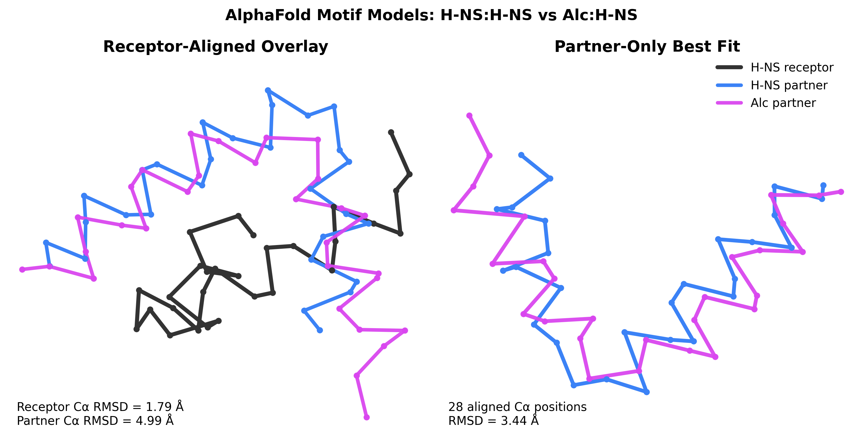
Figure 3. AlphaFold motif-model comparison between the H-NS:H-NS dimer and the Alc:H-NS complex. Left, the Alc:H-NS model is superposed on one H-NS chain from the H-NS:H-NS model, showing a related but not identical partner placement. Right, best-fit superposition of the partner chains alone over the 28 aligned Cα positions used in the preferred convergence register yields an RMSD of 3.44 Å.
Interpretation
Reviews of H-NS-dependent gene regulation argue that higher-order oligomerization, nucleoprotein filament formation, and filament-mediated bridging are central to silencing, especially xenogeneic silencing of AT-rich foreign DNA [3,4]. The site-2 study shows that H-NS dimerization site 2 is required for formation of the rigid nucleoprotein filaments needed for gene silencing [2]. The Shigella literature further places H-NS-mediated silencing at the center of control over horizontally acquired virulence loci and notes that E. coli and Shigella H-NS are identical, making the E. coli site-2 results directly relevant to both hosts [4].
In this context, T4 Alc is plausibly interpreted as a competitive mimic of the dimerization interface, able to interfere with higher-order H-NS assembly and thereby inhibit formation of the stiffened filaments required for silencing [2-4]. Such an activity would directly benefit the phage by weakening bacterial repression of foreign DNA while Alc terminates transcription on host DNA [1]. Existing literature also notes that the H-NS N terminus interacts with other proteins, including the phage protein gp5.5, establishing precedent for phage interference with H-NS regulation [3].
While an Alc:H-NS complex has not yet been experimentally proven, an unusually specific convergence between the two maps to the functionally critical site-2 region, and a biologically plausible explanation is competitive interference with H-NS filament assembly by T4 Alc in enterobacterial hosts. The exact family-hit pattern, the shuffled-sequence branch null, and the chemistry-optimal alignment-space null all argue against amino-acid composition alone or generic H-NS-family similarity as sufficient explanations for this convergence.
Methods
Sequence sources and reviewed set. Alc was analyzed from the reviewed UniProt entry P04546. The H-NS reference segment was taken from the reviewed Escherichia coli H-NS entry P0ACF8, and family comparisons and motif scans were performed against a reviewed Swiss-Prot set containing 573,661 proteins. Family-level analyses were restricted to reviewed H-NS-, StpA-, and VicH-annotated proteins.
Family alignment and ranking. The family figure uses the fixed convergence register Alc EYRNRRLEQARDML-PDAVEEMKVFLENQLA versus
H-NS EERTRKLQQYREMLIADGIDPNEL-L-NSLA, with homologous H-NS/StpA windows aligned in the same 31-column frame. Family rows were ordered by the best constrained family score, defined as the BLOSUM62 score obtained by comparing Alc residues 53-82 to each family window (H-NS positions 52-80) under a four-block constrained model with fixed block lengths 14/4/2/4 residues and bridge lengths 1/4/1 in Alc versus 2/3/0 in H-NS. Block positions were scored directly with BLOSUM62, whereas bridge segments were aligned globally with affine gap penalties of -5.0 for gap opening and -0.5 for gap extension. Under this score, the top family matches were the identical E. coli and Shigella H-NS sequences (observed best constrained family score 51.5).
Primary motif and rarity. The primary chemistry-aware motif used for rarity analysis was E-X-R-[NT]-R-[RK]-L-[QE]-Q-X-R-[DE]-M-[LI]{1,2}-[AP]-D-[GA]-[IV]-[DE]-[EP]-X-[EK]-[VFL]{2,3}-X{0,1}-N-[QS]-L-A. Here X denotes a mismatched residue rather than a gap, [LI]{1,2} and [VFL]{2,3} denote short hydrophobic runs, and X{0,1} denotes the sole true indel tolerance. Exact motif occurrences were tabulated against the same 573,661-entry reviewed Swiss-Prot set used for the family screen.
AlphaFold-Multimer setup. AlphaFold Server jobs were run on the isolated motifs with useStructureTemplate enabled for every chain. The Alc:H-NS job used one copy each of H-NS EERTRKLQQYREMLIADGIDPNELLNSLA and Alc EYRNRRLEQARDMLPDAVEEMKVFLENQLA with model seed 956451627; the comparison H-NS:H-NS job used two copies of the H-NS sequence with model seed 1597668213. In both cases the server returned five ranked models, and the top-ranked models were used for the manuscript figures and structure comparisons. The manuscript reports the top Alc:H-NS model metrics (ipTM 0.60, pTM 0.67, no reported clashes) and the partner-only best-fit overlay of the Alc:H-NS and H-NS:H-NS motif dimers over the 28 aligned Cα positions in the preferred convergence register. Large language model assistance was used for manuscript drafting and editing and for scripting or supporting computational analyses; all outputs were reviewed and validated by the author.
References
1. Kashlev, M., Nudler, E., Goldfarb, A., White, T. & Kutter, E. Bacteriophage T4 Alc protein: a transcription termination factor sensing local modification of DNA. Cell 75(1), 147-154 (1993). PMID: 8402894.
2. Yamanaka, Y., Winardhi, R. S., Yamauchi, E., Nishiyama, S.-I., Sowa, Y., Yan, J., Kawagishi, I., Ishihama, A. & Yamamoto, K. Dimerization site 2 of the bacterial DNA-binding protein H-NS is required for gene silencing and stiffened nucleoprotein filament formation. J Biol Chem 293(24), 9496-9505 (2018). doi:10.1074/jbc.RA117.001425.
3. Winardhi, R. S., Yan, J. & Kenney, L. J. H-NS Regulates Gene Expression and Compacts the Nucleoid: Insights from Single-Molecule Experiments. Biophys J 109(7), 1321-1329 (2015). doi:10.1016/j.bpj.2015.08.016.
4. Picker, M. A. & Wing, H. J. H-NS, Its Family Members and Their Regulation of Virulence Genes in Shigella Species. Genes (Basel) 7(12), 112 (2016). doi:10.3390/genes7120112.

