Section B: An N-gram Language Model for Twi (Akan)
Code: github.com/henryhkb/prosit1-language-models

Q1. What data did you use in building your model?
We used the Twi portion of MasakhaNER 2.0 (Adelani et al., 2022), a peer-reviewed dataset of Ghanaian news sentences annotated by native speakers. We chose it because it contains modern, non-religious Twi (the course excluded Bible text, which dominates freely available Twi corpora) and is openly available on Hugging Face, so our notebook downloads it directly and the work is fully reproducible. The dataset contains 6,056 sentences, pre-split into 4,240 for training, 605 for validation and 1,211 for testing (70/10/20). The training set has 112,160 tokens and 11,610 word types; its frequency distribution follows Zipf’s law, with a long tail in which 54% of word types occur only once (Figure 1). Although the dataset was built for named entity recognition, we used only its tokenised sentences and ignored the entity labels. We lowercased all tokens, removed punctuation (since the target application is speech recognition, where punctuation is not spoken), added the sentence boundary markers <s> and </s>, and replaced every word seen fewer than twice in training with <UNK>. This gave a vocabulary of 4,971 types and an out-of-vocabulary rate of 9.8% on the test set.
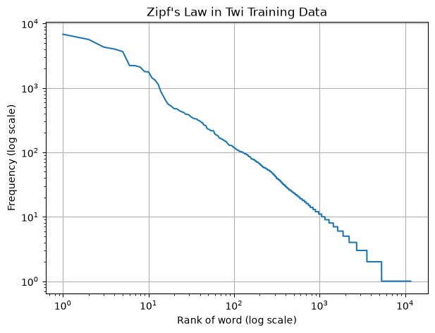
Figure 1. Rank–frequency plot of the Twi training data on log–log axes. The near-straight line follows Zipf’s law; the flat step at frequency 1 covers the 6,305 words seen only once.

Q2. Do you agree that N-gram models are better than neural models for a low-resource language?
We partly agree. When a model must be trained from scratch on very little text, N-gram models are often the more practical choice: they need no specialised hardware, train in seconds, are fully interpretable, and can learn useful patterns from small corpora. Our Twi model learned meaningful word patterns from only 112,160 training tokens, reaching a test perplexity of 150.6 compared with 4,971 for random guessing, whereas a neural network with millions of parameters would risk overfitting on so little data. However, our results also expose the core weakness of N-grams, data sparsity: 54% of word types appeared only once, 9.8% of test tokens were out of vocabulary, and moving from a bigram to a trigram improved perplexity by only about 10% because longer word sequences were too rare to estimate reliably.
Neural models address these weaknesses in ways N-grams cannot. They represent words as embeddings, so knowledge generalises across words used in similar contexts, and they can use much longer contexts than the one or two previous words our model relied on, which is why its generated sentences lost coherence after a few words. Most importantly, a pretrained multilingual neural model can transfer knowledge from other languages and then be fine-tuned on a small amount of Twi, avoiding the need for a large Twi corpus. We therefore conclude that N-gram models are a strong, low-cost baseline for low-resource languages, but a pretrained neural model adapted to the language is likely to outperform them where such models and computing resources are available.

Q3. How did you train your model and what convinced you your model was learning?
Training an N-gram model means counting. Using only the training set, we cut every sentence into overlapping unigrams, bigrams and trigrams with a sliding window and counted each one, giving 4,971 unique unigrams, 43,507 bigrams and 80,012 trigrams. From these counts we computed maximum likelihood estimates, for example P(mu | no) = count(no mu) ÷ count(no) = 0.093. Because MLE assigns zero probability to any unseen sequence, which would make the probability of a whole sentence zero and perplexity infinite, we applied smoothing. We first tried Laplace (add-one) smoothing, then linear interpolation (Jelinek and Mercer, 1980), which blends trigram, bigram and unigram estimates with weights λ that sum to one. The weights were tuned on the validation set: λ = 0.5 for the interpolated bigram, and λ₃ = 0.1, λ₂ = 0.4, λ₁ = 0.5 for the interpolated trigram.
Three kinds of evidence convinced us the model was learning. First, the learned probabilities capture real Twi structure: the most frequent bigrams include “no mu” (“in the”), “wɔn a” (“those who”) and sentence endings after the definite marker “no”, none of which we programmed in. Second, and most importantly, a learning curve (Figure 2) shows that validation perplexity fell steadily as training data grew, from 343.8 with 10% of the data to 254.2 (25%), 210.6 (50%), 186.0 (75%) and 174.2 (100%). A model that merely memorised its training sentences would not keep improving on unseen validation sentences; the steady fall shows it generalises. The curve has not flattened at 100%, so more Twi data would improve the model further.
Third, sentences sampled from the model use genuine Twi vocabulary typical of news text (for example aban, mansin, mpontuo, sikasɛm) and are locally fluent over short spans, such as “ɔman yi ɛkɔnomi” (“this country’s economy”), although whole sentences drift between topics. This is exactly what the Markov assumption predicts: each word depends only on the one or two words before it, so short-range patterns are learned but long-range meaning is not.
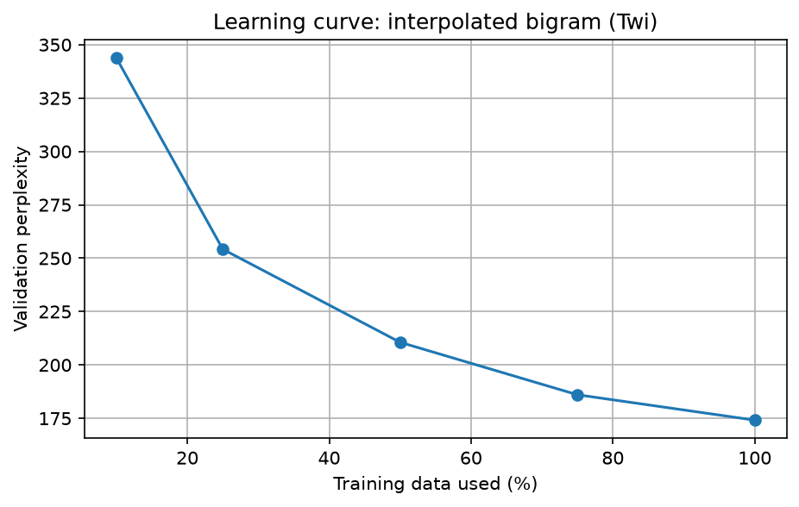
Figure 2. Learning curve for the interpolated bigram: validation perplexity falls as more training data is used.

Q4. How did you evaluate your model?
We evaluated the models intrinsically with perplexity, the inverse probability of held-out text normalised by its length, which can be read as the average number of equally likely words the model is choosing between at each step (lower is better). We computed it in log space to avoid numerical underflow, counting </s> but not <s> as a predicted token. We kept the three data splits strictly separate: counts came only from the training set, all design choices (the interpolation weights) were made on the validation set, and the test set was used once at the end to report final results, so there was no data leakage. All models share the same vocabulary, so their perplexities are directly comparable.
We compared five settings on the same test set: a unigram model, a Laplace-smoothed bigram, an interpolated bigram and an interpolated trigram, against the uniform baseline of random guessing (perplexity = vocabulary size = 4,971). We complemented these numbers with two further checks: the learning curve described in Q3, and a qualitative inspection of sampled sentences for Twi fluency.

Q5. What results did you get?
The interpolated trigram achieved the lowest test perplexity, 150.6, about 33 times lower than random guessing (Table 1, Figure 3). The choice of smoothing mattered far more than the order of the model: replacing Laplace with interpolation cut bigram perplexity about five-fold (838.3 to 167.0), whereas moving from bigram to trigram improved it by only about 10% (167.0 to 150.6). Laplace smoothing even performed worse than the unigram, because adding one count to all 4,971 possible next words moved too much probability to unseen pairs. For example, P(a | wɔn) fell from 0.157 under MLE to 0.043. Validation and test results agreed closely (e.g. 157.4 and 150.6 for the trigram), showing that the tuned settings generalise.
Model | Settings (tuned on validation) | Validation PP | Test PP
Random guessing (uniform) | — | 4,971 | 4,971
Bigram, Laplace (add-one) | — | 870.3 | 838.3
Unigram | — | 353.7 | 338.1
Bigram, interpolated | λ = 0.5 | 174.6 | 167.0
Trigram, interpolated | λ₃ = 0.1, λ₂ = 0.4, λ₁ = 0.5 | 157.4 | 150.6
Table 1. Perplexity (PP) of each model. Lower is better; the best model is the interpolated trigram.
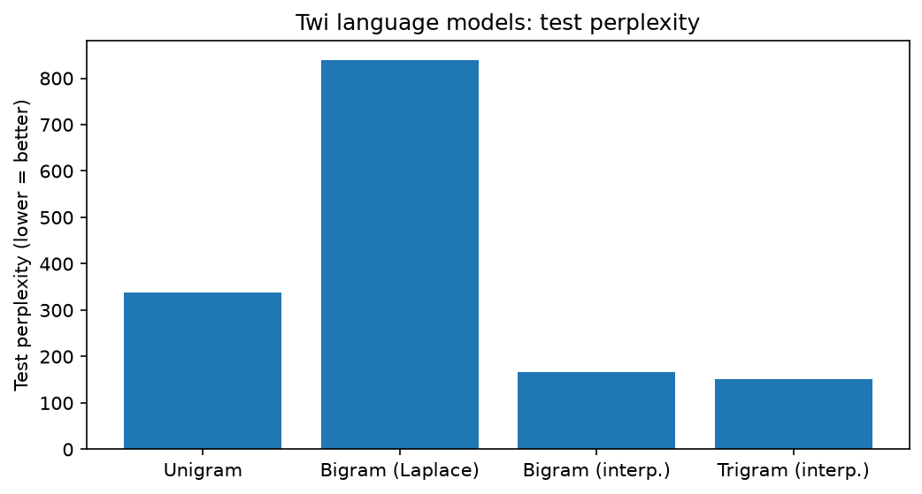
Figure 3. Test perplexity by model.

Q6. What should we know about the work you did that is not captured above?
Data constraints shaped the model. Most freely available Twi text is religious (the Bible and JW300), which the course excluded; a large corpus we considered, Twi Text C3, is largely drawn from these sources. We therefore traded quantity for quality, choosing a smaller but credible news corpus. As a result, the model reflects the news domain, with vocabulary such as aban (government) and mpontuo (development), and may not match everyday conversational Twi, which matters for a speech recognition system. Adding cleaned Twi Wikipedia text or transcribed speech would broaden coverage.
Twi morphology amplifies sparsity. Twi builds words from meaningful parts; for example, obesua (“he/she will learn”) combines o- (he/she), be- (will) and sua (learn). One verb therefore appears in many rare forms, many of which became <UNK>. Names are similarly rare, which is why <UNK> frequently begins generated sentences: news sentences often open with a person’s or place’s name. Subword tokenization such as Byte-Pair Encoding could handle rare names and inflected forms by splitting them into known pieces, and stronger smoothing such as Kneser-Ney could further reduce perplexity.
Reproducibility. All code is in a single Jupyter notebook on GitHub, the data is downloaded directly from Hugging Face, and random choices use fixed seeds, so every result in this section can be regenerated exactly. Because our N-gram pipeline is language-independent, the same notebook can be applied to other languages in MasakhaNER 2.0 (such as Ewe) by changing a single language code.

References
Adelani, D. I., et al. (2022). MasakhaNER 2.0: Africa-centric transfer learning for named entity recognition. Proceedings of EMNLP 2022.
Jelinek, F., & Mercer, R. L. (1980). Interpolated estimation of Markov source parameters from sparse data. Proceedings, Workshop on Pattern Recognition in Practice, 381–397.
Jurafsky, D., & Martin, J. H. (2026). Speech and Language Processing (3rd ed. draft, August 2026). Chapters 2 and 3.

