Portfolio Assessment 3
  - Machine Learning and Deep Learning
Electrical grid stability classification
Explanations and rubric evidence review
Student: Hoang Huu Hoan
Student ID: 105732188
Unit: COS40007 Artificial Intelligence Engineering
Task number: Portfolio Assessment 3
Prepared: 27 October 2026
Submission date: TBD
GitHub repository

Acknowledgement of Country
This report recognises the Wurundjeri People of the Kulin Nation as the Traditional Owners of the Country where Swinburne’s Melbourne campuses stand. Respect is offered to Elders past and present and to the enduring cultures and custodianship of Aboriginal and Torres Strait Islander peoples across Australia.
The acknowledgement refers to Swinburne’s institutional context; it does not assume the student’s current physical location. The university source is listed at the end of this report.

Report status
The current implementation contains evidence for every scored rubric criterion at the Excellent level. The maximum available score is 68, but this review is not an awarded or guaranteed 68 out of 68. The marker decides the grade.
The report includes six original figures from the saved experiment outputs and editable Word tables for the notebook results and ANN model summary. Three manual evidence screenshots remain, with exact capture instructions. The submission date, Canvas details and personal learning statements remain deferred. The original brief’s restriction on whole-code generation remains unresolved; actual AI assistance is disclosed.

Rubric evidence review
Scope: the supplied task text and two rubric images are assessment evidence. The user requested an audit and an explanatory Word document with screenshot placeholders. The applicable branch is tabular ANN classification. CNN, LSTM and regression alternatives are not additional mandatory models.
Criterion | Max | Evidence and assessment
Traditional ML models | 10 | Excellent evidence: fitted Random Forest and MLP; test accuracy and weighted F1; five-fold CV; comparison and best traditional model.
Traditional ML visualisation | 6 | Excellent evidence: labelled four-model accuracy chart, values and majority baseline. This report adds the three-case-gap interpretation.
Deep learning data preparation | 12 | Excellent evidence: 11 inputs, stratified fit/validation/test partitions and fit-only scaling; identical final development and test arrays.
Deep learning architecture and training | 16 | Excellent evidence: 64/32/16 dense units, dropout, two-class Softmax, Adam, callbacks, batch trials and saved H5 models.
Deep learning evaluation | 12 | Excellent evidence: accuracy, loss, weighted and class F1, confusion matrices, accuracy/loss curves and comparison with MLP.
Final summary and reflection | 8 | Excellent technical evidence: four-row master table, best-model caveats and answers to all three model reflection questions. Personal GenAI learning remains TBD separately.
GitHub repository | 4 | Excellent evidence: models, results, comments and genuine phased commit history. Repository link appears on the cover.
Cover page | 0 | Existing PDF lacks a submission date. This document supplies cover details; actual submission date is still TBD.
Acknowledgement of Country | 0 | Missing from the existing PDF; included in this document with institutional context and source.

Scored total: 68. The architecture row appears in both attached images and is counted once. No numerical deduction is invented for the two zero-point criteria.
Assessment limits: this is an evidence-based band assessment, not official marking. Three manual evidence screenshots and submission details remain unfinished. The authorship concern arises from the earlier brief and is separate from the seven visible scored criteria. Honest AI disclosure alone does not resolve that concern.

Part A Traditional machine learning
The cleaned electrical-grid dataset has 10,000 rows and 14 columns. The target stabf is categorical: stable is encoded 0 and unstable 1, so accuracy and F1 are appropriate. Regression R squared, RMSE and MAE are not applicable. There are 3,620 stable and 6,380 unstable cases; always predicting unstable would achieve 63.8% accuracy.
Eleven features are retained: tau1 to tau4, p2 to p4, and g1 to g4. The continuous stab value is excluded because its sign determines the target. The redundant p1 column is also excluded because it equals the negative sum of p2, p3 and p4. No missing values or duplicate rows were found, and all rows were retained.
A stratified 70% development and 30% test split uses seed 42. Shapes are X development (7000, 11), y development (7000,), X test (3000, 11) and y test (3000,). StandardScaler is fitted only on the training portion at each stage. Cross-validation uses pipelines so each fold learns its own scaler.
Model | Main settings | CV accuracy mean and SD | CV weighted F1 mean and SD | Test accuracy | Test weighted F1
RF | 300 trees; seed 42 | 91.69% ± 0.65 pp | 0.9163 ± 0.0064 | 92.73% | 0.9268
MLP | 64/32/16 ReLU; Adam 0.001; max 500 iterations | 95.41% ± 0.59 pp | 0.9541 ± 0.0059 | 96.47% | 0.9646

Five shuffled stratified folds use seed 42 on the 7,000 development rows. Weighted F1 means and sample standard deviations are 0.9163 ± 0.0064 for Random Forest and 0.9541 ± 0.0059 for MLP. Fold SD describes fold variation, not a confidence interval. The final MLP stops after 128 iterations without convergence warnings. MLP is the strongest traditional model by both development CV and test accuracy.
Dataset check | Observed result
Rows and original columns | 10,000 rows and 14 columns
Retained predictors | 11 ordered numeric features; all 10,000 rows retained
Missing and duplicate checks | 0 missing cells; 0 duplicate rows; 0 duplicate predictor rows
Numeric and target checks | All numeric values finite; target agrees with stability sign; power balance confirmed

Part B Data preparation and architecture
This dataset contains independent tabular rows, with no sequence or image structure. No sequence creation, reshaping to time steps, or image preprocessing is required. Both core ANNs consume the same 11 ordered numeric features and predict the same two classes.
Partition | X shape | y shape | Stable | Unstable
development | (7000, 11) | (7000,) | 2534 | 4466
ANN fit | (5600, 11) | (5600,) | 2027 | 3573
ANN validation | (1400, 11) | (1400,) | 507 | 893
test | (3000, 11) | (3000,) | 1086 | 1914

The validation reserve is 20% of development data, selected by a stratified split with seed 43. Its scaler is fitted on the 5,600 fit rows only. Validation and test rows never fit that scaler. After the recipe is frozen, a separate common scaler is fitted to all 7,000 development rows and reused by all four final models. Features are standardised; class labels remain integers.
Layer | Output shape | Activation or rate | Parameters
Input | (None, 11) | Numeric features | 0
Dense | (None, 64) | ReLU | 768
Dropout | (None, 64) | 0.2 | 0
Dense | (None, 32) | ReLU | 2080
Dropout | (None, 32) | 0.2 | 0
Dense | (None, 16) | ReLU | 528
Output Dense | (None, 2) | Softmax | 34
Trainable parameters |  |  | 3410
Non trainable parameters |  |  | 0
Total parameters |  |  | 3410

Model summary reproduced from notebook cell 10. None denotes a variable batch dimension. All 3,410 network parameters are trainable; dropout adds no parameters.
ReLU supports nonlinear feature interactions. The shrinking hidden layers compress the representation. Dropout randomly suppresses 20% of hidden activations during training, which can reduce overfitting but cannot guarantee its prevention. Softmax gives two class probabilities; argmax produces the class label. A tie selects class 0. Adam begins at 0.001; sparse categorical crossentropy matches integer labels, and accuracy is monitored. Layer width and dropout were fixed, so these experiments do not isolate their individual causal effect.

Part B Training and configuration selection
A batch-32 pilot first runs for 10 epochs. Its lowest validation loss is 0.1830 at epoch 8, with validation accuracy 91.50%. Fresh batch-size trials then run for at most 50 epochs, using the same fit and validation rows, the same fit-only scaler and seed 42. Batch size is the deliberate trial difference; training starts from a fresh model each time.
Phase and batch | Epochs run | Best epoch | Best validation loss | Accuracy at best loss | Minimum LR
Pilot 32 | 10 | 8 | 0.1830 | 91.50% | 0.0010000
Trial 16 | 50 | 40 | 0.1055 | 96.07% | 0.0000625
Trial 32 | 49 | 39 | 0.1070 | 95.86% | 0.0001250
Trial 64 | 50 | 46 | 0.1080 | 95.93% | 0.0005000

EarlyStopping monitors validation loss with patience 10, min_delta 0 and restore_best_weights enabled. ReduceLROnPlateau monitors the same loss, halves the learning rate after five plateau epochs, uses min_delta 0, and has a minimum rate of 0.000001. Restored-model evaluation is checked against the lowest validation loss recorded in history.
Batch 32 reaches its best epoch at 39 and stops at 49 after ten epochs without improvement. Batches 16 and 64 reach the 50-epoch cap; a cap does not mean their best weights came from epoch 50. Learning rates are reduced four, three and one times for batches 16, 32 and 64 respectively.
ANN-1 is the batch-32 recipe, and ANN-2 is batch 64. Batch 16 is an additional development experiment and has the lowest validation loss. It is retained in the trial table; no final test result is claimed for it. These required two core configurations were fixed before final test inference. A batch-16 final model is a possible future, predeclared experiment, not a change justified by this test comparison.
For the final comparison, every model is refitted on all 7,000 common-scaled development rows. The ANNs use the selected 39 and 46 epochs with constant Adam 0.001 and no validation callbacks. These are newly fitted final models. The reduced-learning-rate development models and the final fixed-rate models are different fitted objects; their histories must not be mixed.
Insert screenshot S04 here
S04. Training callback settings
Capture from physical cell 10, code In [5], function train_trial. Include both callback definitions, monitor, patience, restore_best_weights, factor and minimum learning rate.

Part B Learning curves
The plotted development curves describe the fit and validation experiment, not the final 7,000-row refit. Lower crossentropy indicates better probability assignments; validation loss is used to choose epochs. Neither the test set nor the final accuracy bar chart is used to choose an epoch.
For batch 32, fit loss falls from 0.5096 at the first epoch to 0.1077 at the last recorded epoch; the best validation loss is 0.1070. For batch 64, fit loss falls from 0.5522 to 0.1236, and the best validation loss is 0.1080. The overall loss trends support learning, with ordinary epoch-to-epoch fluctuations rather than a requirement for every point to decrease.
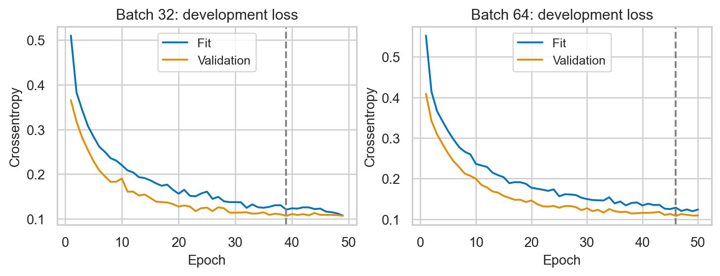
Figure 1. ANN development loss. Dashed markers show the selected epochs 39 and 46. These are trial histories, not the final 7,000-row refit histories.
Source: figures/ann_core_development_loss.png. Embedded directly from the saved experiment output.

Training and validation accuracy
Fit accuracy rises from 74.89% to 95.77% for batch 32 and from 72.00% to 94.98% for batch 64. Validation accuracy at the minimum-loss epoch is 95.86% and 95.93%, respectively. Validation accuracy can exceed fit accuracy because dropout is disabled during validation and the samples differ. This pattern alone is not proof of leakage.
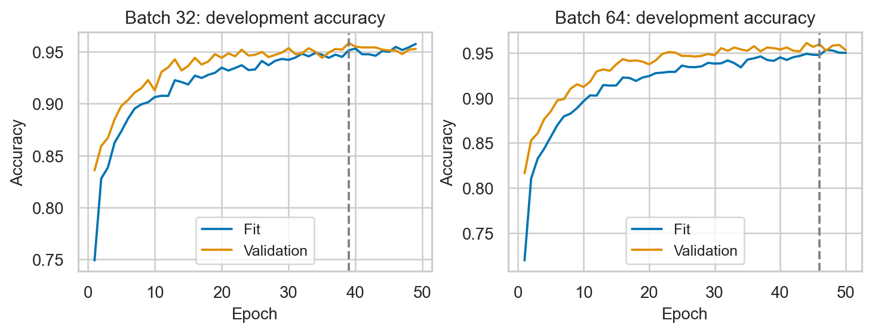
Figure 2. ANN development accuracy for batches 32 and 64 using the same fit and validation partitions.
Source: figures/ann_core_development_accuracy.png. Embedded directly from the saved experiment output.

Learning rate schedule
The learning-rate curves make the plateau response visible. Smaller batches make more updates per epoch: approximately 350 for batch 16, 175 for batch 32 and 88 for batch 64 on 5,600 rows. Equal epoch caps therefore do not provide equal update budgets. Different stopping epochs and learning-rate schedules also limit causal conclusions about batch size alone.
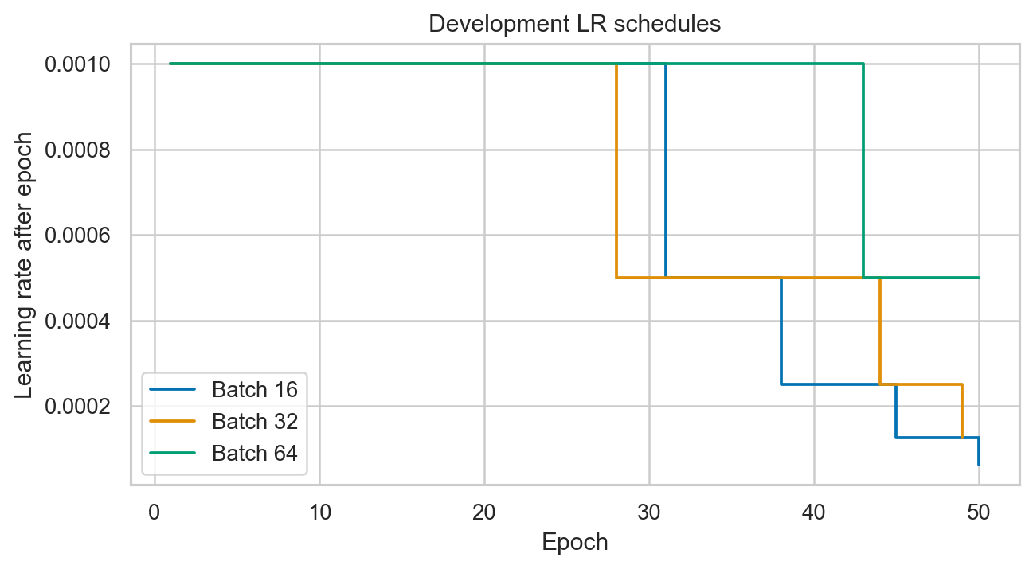
Figure 3. Development learning rates for batches 16, 32 and 64. Plateau callbacks halve the learning rate.
Source: figures/ann_development_learning_rate.png. Embedded directly from the saved experiment output.

Part B Classification evaluation
All results below use the same 3,000 fixed test rows and final saved model recipes. Weighted F1 accounts for class support; the per-class report reveals performance that a single accuracy value can hide. Test crossentropy is evaluated for each Keras ANN. ANN five-fold cross-validation was not performed and is not implied by the holdout validation results.
Model | Test accuracy | Weighted F1 | Test loss | Unstable recall
ANN-1 | 95.57% | 0.9552 | 0.1023 | 98.80%
ANN-2 | 96.57% | 0.9655 | 0.0915 | 98.59%

Model and class | Precision | Recall | F1 | Support
ANN-1 stable | 0.9770 | 0.8987 | 0.9362 | 1086
ANN-1 unstable | 0.9450 | 0.9880 | 0.9660 | 1914
ANN-1 macro avg | 0.9610 | 0.9433 | 0.9511 | 3000
ANN-1 weighted avg | 0.9566 | 0.9557 | 0.9552 | 3000
ANN-2 stable | 0.9740 | 0.9300 | 0.9515 | 1086
ANN-2 unstable | 0.9613 | 0.9859 | 0.9734 | 1914
ANN-2 macro avg | 0.9676 | 0.9580 | 0.9625 | 3000
ANN-2 weighted avg | 0.9659 | 0.9657 | 0.9655 | 3000

Confusion matrix rows are true stable and unstable; columns are predicted stable and unstable. ANN-1 has counts [[976, 110], [23, 1891]], and ANN-2 has [[1010, 76], [27, 1887]]. ANN-1 misses fewer unstable cases, but classifies more stable cases as unstable. ANN-2 improves stable recall, which raises overall accuracy. The class supports are 1,086 stable and 1,914 unstable.

Confusion matrices
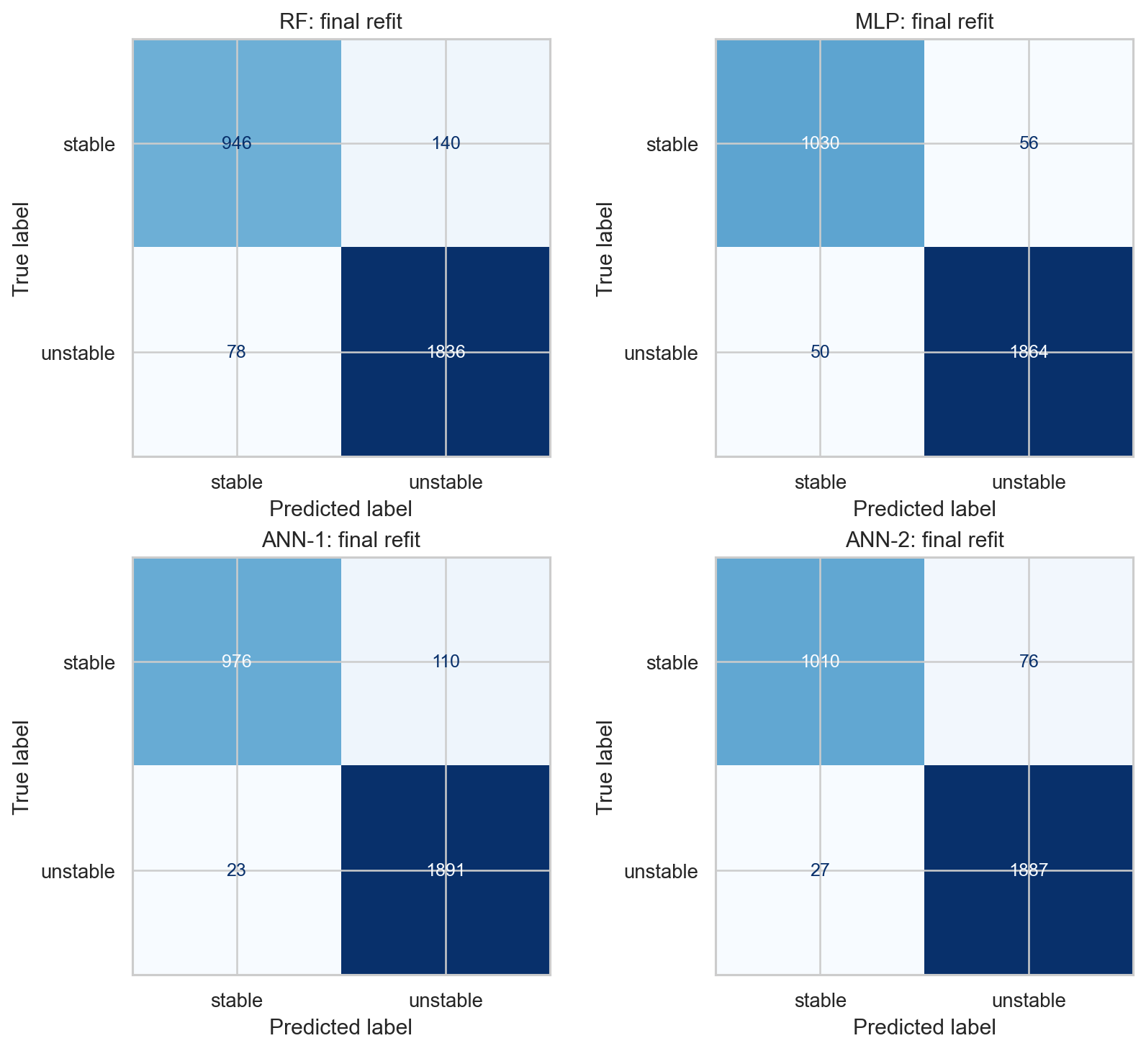
Figure 4. Final confusion matrices on the same 3,000 test cases. Rows are true labels and columns are predicted labels.
Source: figures/final_confusion_matrices.png. Embedded directly from the saved experiment output.
The best traditional MLP achieves 96.47% accuracy and weighted F1 0.9646. ANN-2 achieves 96.57% and 0.9655, while ANN-1 achieves 95.57% and 0.9552. Deep learning therefore improves the primary metric only for ANN-2, by a small observed margin; it is not uniformly superior.

Part B Saved models and verification
Artifact relative to portfolio_task3 | Purpose
models/ann_batch32.h5 | Whole final ANN-1 model; 39-epoch refit.
models/ann_batch64.h5 | Whole final ANN-2 model; 46-epoch refit.
models/standard_scaler.pkl | Common scaler fitted to the 7,000 development rows.
models/random_forest.pkl and mlp_classifier.pkl | Compressed joblib pipelines containing fitted scaling and traditional estimators; accept raw ordered features.
results/ann_batch32_development_history.pkl and ann_batch64_development_history.pkl | Validation trial histories used for the core learning curves.
results/ann_batch32_final_history.pkl and ann_batch64_final_history.pkl | Separate histories for the final refits.
results/ann_pilot_history.pkl and ann_batch16_development_history.pkl | Pilot and extra batch-16 development history.
models/model_metadata.json | Feature order, class map, data hash, versions, architecture and final recipe.

The H5 files contain model configuration, training configuration, weights and optimiser state. Both saved models have the expected two-class architecture. The scaler and traditional pipelines use joblib-compressed pickle format and should be loaded with joblib.load. Raw data must follow the documented order of the 11 predictors. Scaling is applied once: directly for the ANNs, internally by the traditional pipelines.
The independent verify_artifacts.py check reconstructs the test split and evaluates all 3,000 raw test rows for every model. It checks saved labels, probabilities, metrics, fitted scaler values and configuration metadata. This check passed again during this report audit. Reloaded class predictions matched exactly; probabilities matched within absolute and relative tolerances of 0.000001.
Earlier verification also executed all ten notebook code cells in a fresh environment without error outputs and reproduced the numerical results. A separate GitHub clone passed the dataset and artifact checks. These are execution and reproducibility checks, not evidence of real-grid safety or unseen-population generalisation.
Insert screenshot S11 here
S11. Saved files and independent reload check
Capture from the models folder and physical cell 16, output In [8]. Include both H5 names, traditional pipelines, scaler and metadata; in a second crop include the passed independent reload output for all four models.
Evidence files: results/artifact_verification.json, fresh_environment_verification.json, fresh_reproduction_verification.json, model_artifact_manifest.json and remote_verification.json. No new training or model selection was performed for this explanation document.

Part C Master comparison and reflection
Type and model | Accuracy | Weighted F1 | Balanced accuracy | Unstable as stable
Traditional ML RF | 92.73% | 0.9268 | 91.52% | 78
Traditional ML MLP | 96.47% | 0.9646 | 96.12% | 50
Deep Learning ANN-1 | 95.57% | 0.9552 | 94.33% | 23
Deep Learning ANN-2 | 96.57% | 0.9655 | 95.80% | 27

ANN-2 is the best observed model by the specified primary metric, accuracy. It classifies 2,897 of 3,000 cases correctly versus 2,894 for MLP: a difference of three cases, or 0.10 percentage points. MLP has the highest balanced accuracy, 96.12%, while ANN-1 makes the fewest unstable-as-stable errors, 23. The preferred model changes with the operational objective.

How architecture choices affected performance
The 64/32/16 dense network can represent nonlinear interactions among response times, powers and gains. Dropout encourages distributed representations. Two Softmax outputs match the categorical target. These choices are structurally suitable, but no width or dropout ablation was run, so the data do not show how much each choice changed performance. Batch-size trials changed optimisation behaviour; they did not change the layer architecture.

Whether deep learning outperformed traditional models
ANN-2 narrowly exceeds the strongest traditional MLP in accuracy and weighted F1; ANN-1 does not. Different optimisation and regularisation can explain plausible differences, but the comparison does not establish a causal explanation or statistical superiority. The scikit-learn MLP is itself a neural network, so the coursework groups distinguish implementations and training recipes rather than entirely unrelated model families.

Further improvements with more time
Use a genuinely new external or simulation-regime holdout, repeat development across seeds, and tune within development data only. Predeclare comparisons of dropout, widths and learning-rate schedules; include batch 16 in a future final comparison if justified independently. Assess probability calibration and cost-based thresholds using development data, then evaluate once on new data. Report uncertainty and training cost alongside accuracy.

Comparison visualisations and deployment
Figure 5 compares all four core configurations and includes the 63.8% majority baseline. The MLP and ANN-2 bars are almost identical at this scale. The three-case difference is stated in the caption so the small observed gap is not presented as a decisive win.
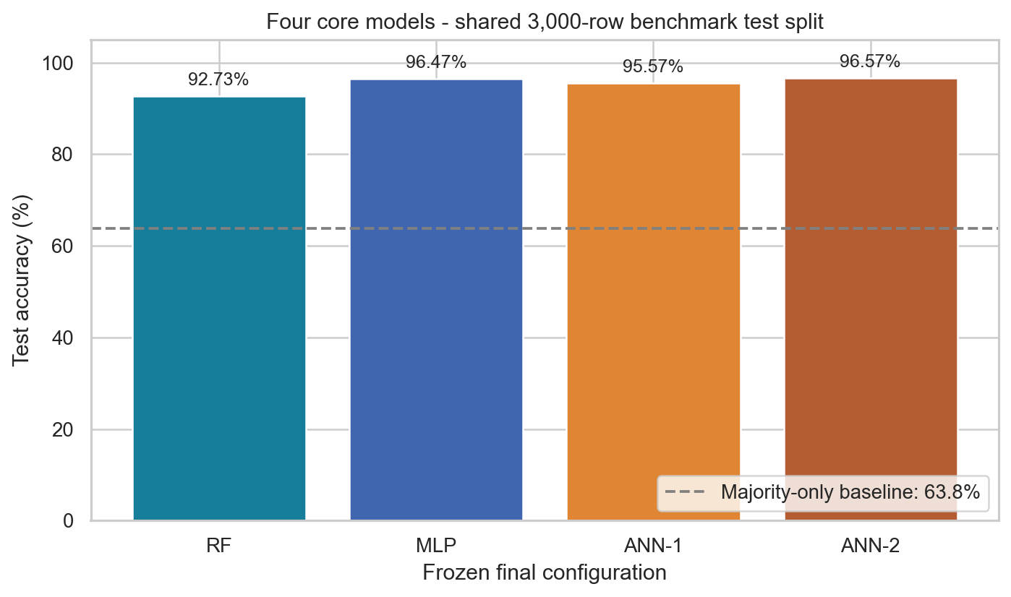
Figure 5. Final test accuracy and the 63.8% majority baseline. ANN-2 exceeds MLP by only three cases, or 0.10 percentage points.
Source: figures/final_accuracy_comparison.png. Embedded directly from the saved experiment output.

Production recommendation
Do not deploy any model directly to control a real electricity grid from this experiment alone. The data describe a simplified simulation. The split reproduces Portfolio 2 and has been inspected before, so it is a benchmark rather than untouched external validation. New operating regimes, calibrated probabilities, error costs, failure handling and monitored evaluation would be needed. An unstable case called stable may be more consequential than a false alarm, making accuracy alone an inadequate deployment rule.
The report’s answers above are technical interpretations grounded in measured outputs. They do not claim the student personally learned or independently wrote the implementation. The student’s GenAI learning reflection remains TBD in SUBMISSION_TODO.md, as requested.

Classification probability diagnostic
The requested scatter visualisation is supplied as a classification probability diagnostic. Each point is one fixed test case; the horizontal position is the true class with cosmetic jitter, and the vertical position is the predicted probability of unstable. The same 3,000 cases appear in every panel. Jitter does not alter labels or predictions. Red points show errors and the dashed line marks probability 0.5; argmax tie behaviour remains class 0.
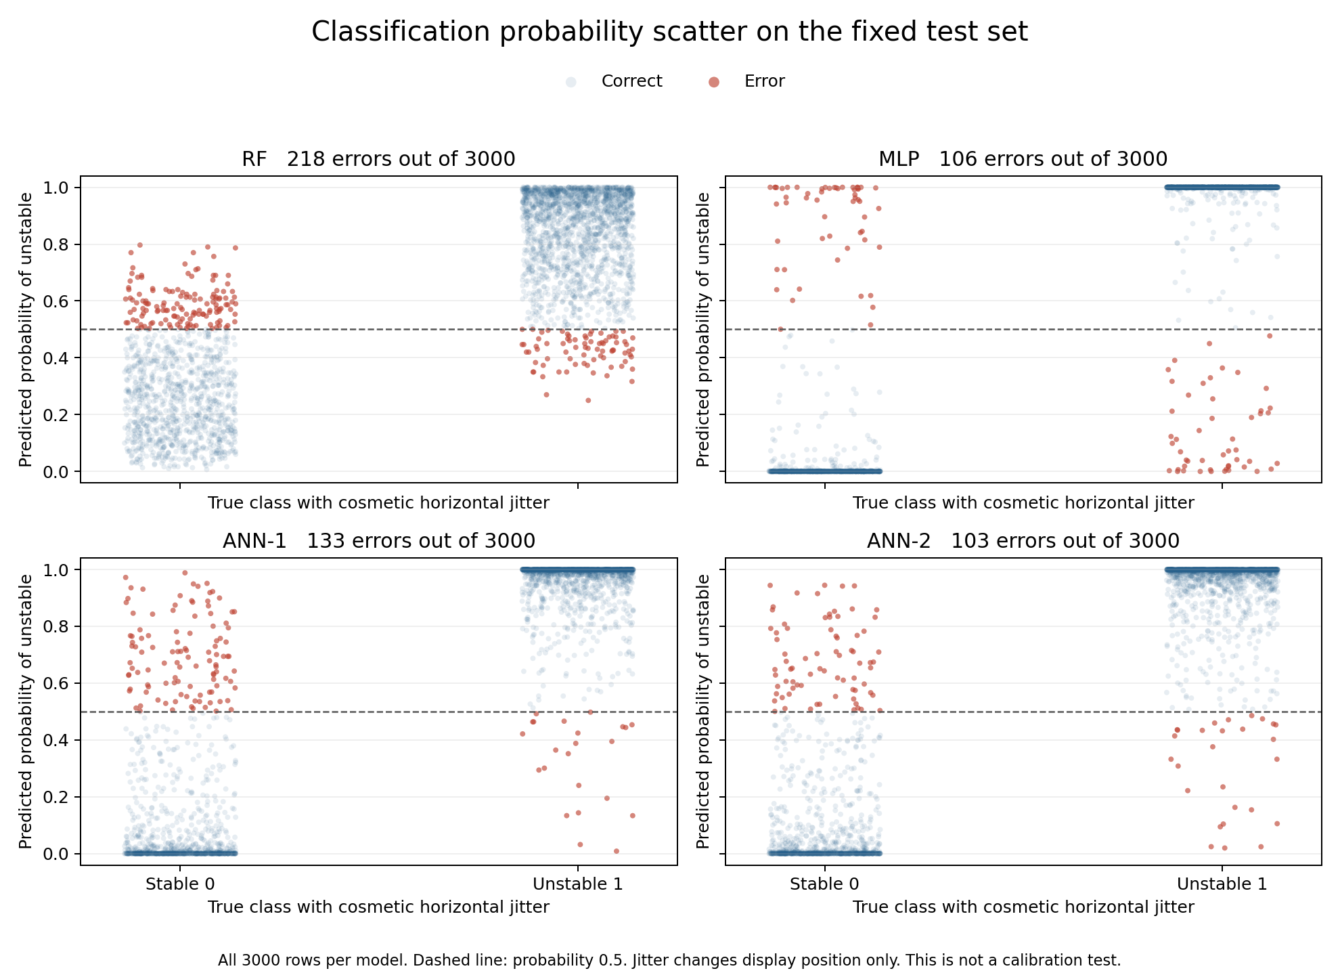
Figure 6. Classification probability scatter for all 3,000 test cases per model. Horizontal jitter affects display only; this is not a calibration test.
Source: report/supporting_figures/classification_probability_scatter.png. Embedded directly from the saved experiment output.
Stable cases should generally have low unstable probability and unstable cases high probability. Errors near the boundary show uncertain decisions; errors far from it indicate confident mistakes. This plot does not measure calibration. A continuous actual-versus-predicted diagonal scatter, R squared, RMSE and MAE belong to the regression branch and would be misleading for these categorical labels.

Part D GitHub integration
Repository containing notebook models results and reports
Incremental commit history on main
The original implementation was published in eight genuine stages. The history contains setup, data preparation, traditional models, ANN development, final evaluation, model persistence, report packaging and remote verification. This satisfies the evidence requirement for progressive work; it was not reconstructed as a single bulk implementation commit.
Commit | Meaningful stage
8ba1262 | Set up Portfolio 3 analysis and verified Python environment
56d0d69 | Prepare grid classification data and verified splits
f190a5f | Compare Random Forest and MLP with five-fold cross-validation
855b701 | Evaluate ANN batch configurations and validation histories
27542d6 | Complete frozen final model comparison
3c2f8bb | Save trained models and verify independent reload predictions
362a63b | Package executed Portfolio 3 analysis and report
4768cce | Verify published artifacts from a fresh GitHub checkout

Insert screenshot S15 here
S15. Repository and phased history
Capture from the GitHub links above, open portfolio_task3 and then Commits on main. Include the repository name, task folder and models/results/report files in one crop; in another crop include the dated implementation commit messages.
This Word explanation, the rubric audit and the supplemental probability plot are a later documentation update. They do not change the frozen model recipes or replace the original model history. The notebook remains the executable source of the core experiments.

Remaining evidence screenshots
Only S04, S11 and S15 still require manual capture. S04 shows the callback code in notebook cell 10; S11 shows the saved model files and successful reload output; S15 shows the GitHub files and phased history. Physical cell numbers count Markdown and code cells, whereas In [n] counts executed code cells. Insert the requested crops at these three placeholders, then remove the capture instruction. Figures 1 to 6 and all result tables are already included.
Source paths are relative to portfolio_task3. The six figures are embedded from the original PNG files without image generation. Dataset audit, split shapes, traditional comparison, ANN model summary, pilot/trials, classification reports and master results are native editable Word content.

Task coverage checklist
This checklist maps every requested step to current evidence. It records implementation coverage separately from the screenshot insertion and student-only items still pending.
Step | Current evidence | Status
A1 Load and analyse | Cells 5 and 6; audit and feature list; categorical stabf target. | Covered
A2 Preprocess | Cell 6; split shapes; StandardScaler fitted on training data only. | Covered
A3 Train two models | Cell 8 CV and cell 12 final refits; RF and MLP. | Covered
A4 Evaluate and compare | Cells 8 and 14; accuracy, weighted F1, 5-fold CV and best-model explanation. | Covered
A5 Visualise | Cell 14; labelled four-model accuracy bar chart. Embedded Figure 5. | Covered
B1 Prepare tabular data | Cell 6; 11 inputs, stratified 5600/1400/3000 splits; same final arrays. | Covered
B2 Build ANN | Cells 3 and 10; 64/32/16, dropout, Softmax, compile and 3410-parameter summary. | Covered
B3 Train ANN | Cell 10; 10-epoch pilot; batches 16/32/64; max 50; validation and callbacks. | Covered
B4 Evaluate ANN | Cell 14 and saved figures; accuracy/loss/F1, class reports, confusion matrices and curves. | Covered
B5 Save ANN and history | Cell 16; two whole H5 models, pickle histories, independent reload verification. | Covered
C1 Master table | Cell 14 and master_results.csv; RF, MLP, ANN-1 and ANN-2. | Covered
C2 Best and deployment | Cells 14 and 18; metric-dependent winner, small gap, no production readiness. | Covered
C3 Model reflections | Cell 18; architecture, traditional comparison and future improvement. Personal GenAI reflection deferred separately. | Covered technically
D GitHub | Eight phased implementation commits; models, results and repository/report links. | Covered

Interpretation of templates: the instructions ask for two traditional models and at least two deep-learning parameter configurations. The current four-row comparison meets this. The CNN/LSTM wording in the generic master-table template does not require changing a tabular classification task into an image or sequence problem. The applicable rubric explicitly permits the MLP branch.
Verification basis: source code inspection, saved output and metric checks, existing clean-environment full execution, fresh remote-clone verification and a current independent saved-model reload audit. Full retraining was unnecessary for this documentation audit; no new performance claims depend on retraining.

Assistance sources and remaining items

GenAI Tools Used
OpenAI Codex inspected the current work, checked the supplied task text and rubric, verified existing model artifacts, drafted this explanation, created the report-only probability visualisation and formatted the Word document. Earlier notebook code and verification helpers were also AI-generated and executed; they are not represented as independently authored by the student.

Specific Tasks and Prompts
The user requested verification against all task steps and the maximum rubric band, followed by a DOCX with a brief Part A, an in-depth Part B and comparison visualisations. The later request explicitly asked to insert existing figures and reproduce notebook tables and the model summary as editable Word content. The earlier request authorised incremental GitHub publication. ASSISTANCE_LOG.md records the requests and actual assistance.

Code Attribution
The earlier brief permits brainstorming, debugging, comments and report organisation while prohibiting whole-code generation. Actual assistance exceeded debugging-only use. This discrepancy remains for student/instructor resolution. It is not removed by disclosure, and this document does not certify authorship compliance. This is distinct from the technical rubric coverage.

Learning Reflection
The user explicitly deferred personal learning statements. How GenAI helped the student learn, what challenges it created, and which personal skills developed are TBD in SUBMISSION_TODO.md. No first-person experience has been fabricated. The technical model reflection questions are answered in Part C and the notebook.

Source and evidence register
Assessment sources: the user’s supplied A to D task text and the two attached Portfolio Assessment 3 rubric screenshots. Local evidence: the executed notebook; results/master_results.csv; traditional_cv_summary.csv; ann_development_results.csv; classification_reports.json; confusion_matrices.json; frozen_configurations.json; saved histories; metadata; and verification records listed in Part B. These sources support the numeric and coverage claims.
Dataset source and licence recorded in the repository
Swinburne acknowledgement context
Dataset provenance is retained in data/README.md. The copied dataset hash, feature order and split indices permit traceability. This report uses existing measured evidence and does not introduce new external model-performance claims.

Remaining student actions
Insert the three remaining evidence screenshots S04, S11 and S15 and supply the actual submission date. Review the personal learning and current Canvas deadline/file requirements in SUBMISSION_TODO.md. Resolve the stated GenAI authorship restriction before representing the work as compliant. Final Canvas submission and receipt remain TBD; no submission is claimed.

