Description of Our Website Plan:

* Logo in top left with a welcome message
* Current score and highest score below
* Instructions button that makes instructions text appear/disappear
* Doodle jump themed game in the middle
* Share with friends button at the button that copies text of your highest score and link to website

Website Includes:

* Index html page
* Css for style elements
* Index javascript file that includes all code for the game elements
* Resources folder that includes the sprites for the platforms and character sprites

Target Audience:

* Overwhelmed college students who need a break
* Anyone else with spare time who wants to relax

Model:

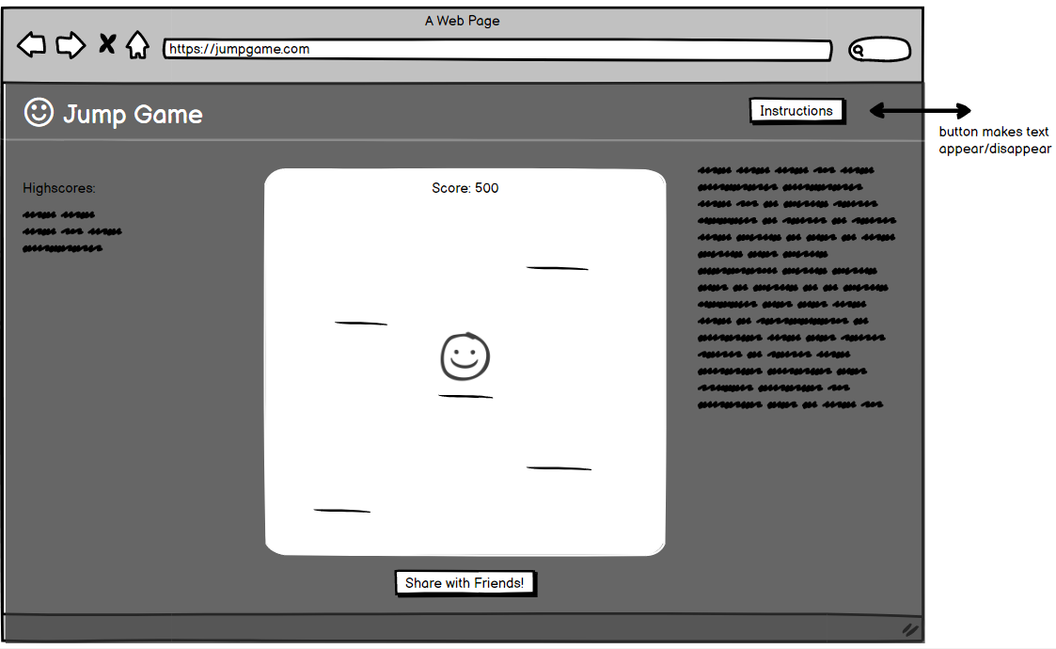

User Examples:

* Name: Ludwig
* Occupation: College student
* How they’d use the website: Ludwig frequently finds himself stressed over his college courses and has been unsuccessful in finding a good way to restore his energy. Our website, jumpgame.com, aims to help students like Ludwig unwind after a long day of homework and studying. Jumpgame.com uses satisfying gameplay mechanics (hitting the left and right arrow keys) to provide users with a simple yet fulfilling way to relax. Ludwig can even share this new game with his friends and invite them to beat his high score to momentarily distract him from his overwhelmingly large workload.
* Benefits: Ludwig has a great way to destress and unwind after tests, quizzes, and studying so he can get back on the grind tomorrow.